NORTH WEST GROWTH AREA

Marsden Park North – State-led rezoning

Finalisation Report
August 2023

NSW Department of Planning and Environment | dpie.nsw.gov.au

Published by NSW Department of Planning and Environment dpie.nsw.gov.au
Title: Marsden Park North – State-led rezoning Subtitle: Finalisation Report

© State of New South Wales through Department of Planning and Environment 2023. You may copy, distribute, display, download and otherwise freely deal with this publication for any purpose, provided that you attribute the Department of Planning and Environment as the owner. However, you must obtain permission if you wish to charge others for access to the publication (other than at cost); include the publication in advertising or a product for sale; modify the publication; or republish the publication on a website. You may freely link to the publication on a departmental website.

Disclaimer: The information contained in this publication is based on knowledge and understanding at the time of writing August 2023 and may not be accurate, current or complete. The State of New South Wales (including the NSW Department of Planning and Environment), the author and the publisher take no responsibility, and will accept no liability, for the accuracy, currency, reliability or correctness of any information included in the document (including material provided by third parties). Readers should make their own inquiries and rely on their own advice when making decisions related to material contained in this publication.

Contents
- Introduction 1
- Exhibition Details 3
  - Exhibition Period 3
  - Exhibited Materials 3
  - Exhibition Venues 3
  - Media Release 4
  - Landowner Notification 4
  - Key Stakeholder Notification 4
  - Information Sessions. 4
- Submissions Summary 4
  - Submissions received 4
  - Issues Raised in Submissions 4
- Flood Risk Management Considerations 5
  - Flood Affectation 5
  - 2022 NSW Independent Flood Inquiry 6
  - Flood Evacuation 7
  - Flood Advisory Panel 8
  - Department’s Response 9
- Conclusion. 10
Figures
Figure 1 Extract of Marsden Park North draft Land Zoning plan with 1 in 100 and PMF extents 2

Introduction
The Marsden Park North Precinct (the Precinct) is one of 16 precincts within the North West Growth Area (NWGA). The NWGA was established under State Environmental Planning Policy (Sydney Region Growth Centres) 2006 (Growth Centres SEPP) as an area for greenfield urban development.
The Site is approximately 1,227 hectares (ha) in area bound by South Creek on the northwest, Eastern Creek and Bells Creek to the east, Excelsior Avenue to the south, and Richmond Road to the west.
The dominant land use within the precinct consists of large and small lot rural-residential properties. There are approximately 4,000 existing properties across the precinct owned by approximately 500 landholders.
The site is within the Hawkesbury - Nepean River floodplain, which is one of the highest risk floodplains in Australia, and where there is a known existing risk to life in an emergency flood event. The site is impacted by the 1 in 100 year flood1 (also known as the 1% Annual Exceedance Probability (AEP) flood) and the Probable Maximum Flood2 (PMF). Refer to Figure 1 overleaf.
A draft Precinct plan, prepared by the NSW Department of Planning and Environment (the Department) was exhibited September - October 2018 and included amendments to the Growth Centres SEPP (now State Environmental Planning Policy (Precincts - Central River City) 2021) (Central River City SEPP) and associated amendments to the Blacktown City Council Growth Centre Precincts Development Control Plan (DCP), Blacktown Local Environmental Plan 2015 (BLEP 2015) and Hawkesbury Local Environmental Plan 2012 (HLEP 2012).
In summary the draft Precinct plan proposed:
- approximately 6200 low to medium density dwellings, including 4100 dwellings between the 1 in 100 chance per year flood and the PMF levels
- land for shops, schools, community facilities, open space, road and drainage infrastructure
- residential density, subdivision and urban development controls
- infrastructure to support the proposed development
- establishment of a new migratory shorebird habitat
- protection of significant vegetation, riparian and wetland areas
- protection of indigenous and non-indigenous heritage items
- retention of existing rural lands on the periphery of the Precinct.

¹ The 1 in 100 chance per year flood is a flood event that has, on average, a 1 in 100 chance of being equalled or exceeded in any given year.
² Probable Maximum Flood is the largest flood that could conceivably occur at a particular location. The PMF defines the extent of flood prone land, that is, the floodplain

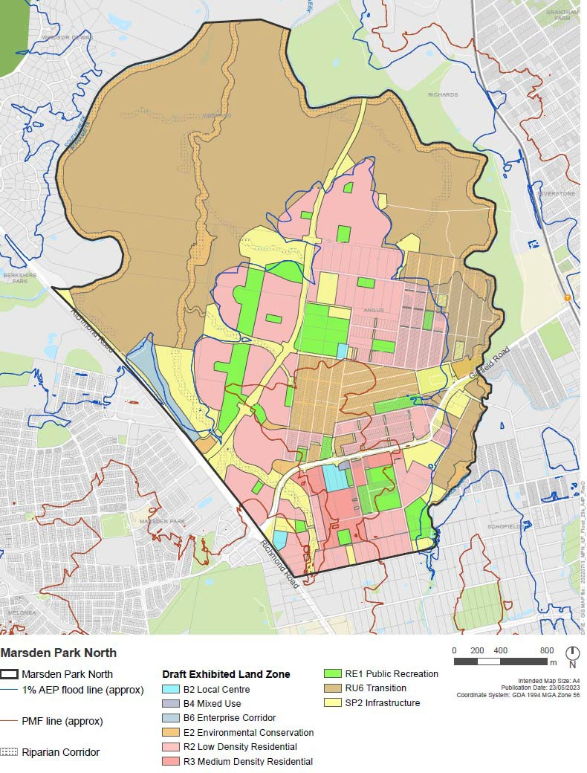
Figure 1 Extract of Marsden Park North draft Land Zoning plan with 1 in 100 and PMF extents

In response the public exhibition of the draft Precinct Plan, 276 submissions were received. The major issues raised are summarised in Section 3 of this report.
Following exhibition of the draft Precinct plan major flooding occurred across widespread areas of Western Sydney, including parts of the Precinct, and further analysis was undertaken with respect to flood evacuation route capacities, flood levels and flood risk management.
Major flooding throughout NSW in 2022 led to the establishment of the 2022 NSW Flood Inquiry which made a series of recommendations, including several that are particularly relevant to planning and development within the Hawkesbury – Nepean Valley (the Valley). The Department’s response to the Flood Inquiry included the creation of a Flood Advisory Panel to consider ‘high risk’ proposals, including the draft Precinct plan for Marsden Park North.
This report documents the exhibition of the draft Precinct plan, summarises the issues raised in submissions and discusses a number of flood risk considerations.
Due to potential significant increases to flood related risk to life and property, and in accordance with the advice of the Flood Advisory Panel, the Deputy Secretary, Planning, Land Use Strategy and Housing, as delegate of the Minister for Planning has decided not to proceed with finalising the draft Precinct plan and the associated amendments to the Central River City SEPP, BLEP 2015 and HLEP 2012.

Exhibition Details

Exhibition Period
The draft Precinct plan was exhibited from 10 September to 26 October 2018.

Exhibited Materials
The following documentation was exhibited:
    - Marsden Park North Precinct Exhibition Discussion Paper
    - draft Indicative Layout Plan
    - draft amendments to the Growth Centres SEPP (now Central River City SEPP)
    - draft DCP amendments
    - supporting technical studies

Exhibition Venues
The draft Precinct plan was available to the public at the following locations:
    - Blacktown City Council, 62 Flushcombe Road, Blacktown
    - Riverstone Library, 1st Floor, Riverstone Village, corner of Market Street and Riverstone Parade, Riverstone
    - at community information sessions (listed below)
    - online at the department’s website - www.planning.nsw.gov.au

Media Release
A media release announcing the start of exhibition was issued on 10 September 2018.

Landowner Notification
The Department wrote to landowners within the Precinct advising of the exhibition of the draft Precinct plan and invited submissions.

Key Stakeholder Notification
The Department advised a wide range of key stakeholders of the exhibition of the draft Precinct plan, including local councils, NSW Government agencies, and environmental, community and development interest groups.

Information Sessions
The Department hosted 2 information sessions at the Riverstone Neighbourhood Centre. The sessions were held on:
    - 20 September 2018 from 4:00pm - 7:00pm
    - 22 September 2018 from 10:00am - 1:00pm
The sessions were an opportunity for members of the public to meet with the project team and discuss the draft Precinct plan. Sydney Water, Transport for NSW and Blacktown City Council were also represented at the sessions.
Over 140 landowners and community members attended the information sessions.

Submissions Summary

Submissions received
276 submissions were received as result of exhibition of the draft Precinct plan, including:
- 255 submissions from landowners, community groups and other interested parties
- 4 submissions from developers and industry groups
- 17 submissions from Government agencies and utility providers, including Blacktown City Council.
The Department acknowledges and thanks all those who made a submission.

Issues Raised in Submissions
The main issues raised in submissions included:

    - the future of the “Scheduled Lands”3
    - impacts of future development on migratory shorebirds and the Green and Golden Bell frog
    - environmental conservation and the amount and location of existing native vegetation to be retained and protected
    - traffic impacts and traffic management
    - the location of open space, roads and drainage lands
    - the timing of land acquisition and value of compensation
    - the proposed RU6 Transition zone and associated permitted land uses
    - flood affectation and proposed flood related development controls
    - the provision of public infrastructure and services.

While the issues raised in the submissions have informed post-exhibition consideration of the draft Precinct Plan, the significance of the flood risk for the precinct has elevated flood evacuation and risk to be a threshold issue for the Marsden Park North precinct.
The Department’s primary focus has been on understanding and responding to the flood risk management considerations addressed in Section 4.

Flood Risk Management Considerations

Flood Affectation
The Marsden Park North Precinct is subject to flooding from the Hawkesbury River, South Creek, Eastern Creek and localised flooding.
The dominant flooding source is from the Hawkesbury River. Figure 1 (Page 2) shows the Precinct’s draft Land Zoning Plan with the Hawkesbury River 1 in 100 chance per year flood and Probable Maximum Flood (PMF) extents.
The draft Precinct plan proposed no new dwellings below the 1 in 100 chance per year flood level and an upper limit of 4100 dwellings for land generally between the 1 in 100 chance per year flood level and the PMF. The 4100 dwelling upper limit was based on the Department’s understanding of regional flood evacuation capacities at the time of preparation of the draft Precinct plan.
In March 2021, late February/early March 2022 and July 2022 major flooding occurred throughout the Hawkesbury - Nepean River floodplain. These floods inundated widespread areas of Western Sydney, including parts of the Precinct.
The 2022 floods reached heights (at Windsor) of 13.8m Australian Height Datum (AHD) and 13.9m AHD respectively and were marginally higher than a 1 in 20 chance per year flood level (13.7m AHD).
The March 2021 flood reached a height (at Windsor) of 12.9m AHD and was approximately half- way between the height of a 1 in 10 chance per year flood level (11.9m AHD) and a 1 in 20 chance per year flood level.

3 The Scheduled Lands are a group of approximately 3800 small properties in the Precinct. The properties were created from the 1880s, typically range in size from 290m2 to 405m2 and under current planning controls dwellings cannot be built on these lands. The Scheduled Lands have limited power and water services, and no sewer services, as is the case for the majority of the Precinct.

2022 NSW Independent Flood Inquiry
In March 2022, the NSW Government commissioned an independent expert inquiry into the preparation for, causes of, response to and recovery from flood events across the state of NSW that occurred in early 2022.
The Inquiry was led by Professor Mary O’Kane AC and Michael Fuller APM. The Inquiry’s report was published in July 2022 and can be accessed at https://www.nsw.gov.au/nsw- government/projects-and-initiatives/floodinquiry.
The Inquiry was asked to consider and, if warranted, make recommendations on:
    - the safety of emergency services and community first responders
    - current and future land use planning and management and building standards in flood prone locations across NSW
    - appropriate action to adapt to future flood risks to communities and their surrounds
    - coordination and collaboration between all levels of government.
The Inquiry included a review into planning rules for developing on flood-prone land and highlighted the importance of NSW taking a more proactive, risk-based approach to flooding and land use planning decisions.
The Inquiry identified the Hawkesbury Nepean Valley as one of 8 high risk catchments and recommended the preparation of disaster adaptation plans discouraging or prohibiting development in disaster likely areas (Recommendation 19) and review of existing flood planning levels (Recommendation 18). The Inquiry recommended this work be undertaken by the NSW Reconstruction Authority and, in the case of high-risk catchments, be completed by July 2025.
Implementing these recommendations may result in different flood planning levels across catchments with the higher risk catchments likely to be subject to increased flood planning levels and reduced areas suitable for urban development.
In response to the Inquiry, the Department has applied an enhanced risk-based approach to considering development of flood prone lands with greater assessment of proposals in high risk locations. To assist with this the Department established the Flood Advisory Panel (FAP), comprising department staff and independent experts, and advised by a Technical Advisory Group comprising relevant state agencies. The findings of the FAP are discussed in Section 4.4 of this report.

Flood Evacuation
The Valley covers approximately 500km2 of floodplain in Western Sydney and comprises 3 main floodplains – Wallacia; Penrith/ Emu Plains; and Richmond/Windsor (including backwater flooding in South Creek and Eastern Creek). These floodplains are highly interconnected, with flood events occurring almost simultaneously.
Floods pose a serious risk to life in the Valley because many areas are low-lying areas which can become surrounded by floodwaters during a flood event. As floodwaters rise, these areas become isolated when low lying roads are cut, creating flood islands. Some of these islands may then become fully submerged as the waters continue to rise, putting many lives at risk. Additionally, major flooding events can result in a widespread 'inland sea' many kilometres across, with the potential for waves up to 1-2m high under storm conditions. These factors combined mean that shelter in place is not an option and the safest option for people during a flood event is to evacuate before roads are cut by floodwaters.
Evacuating during a flood event and planning for these potential events to occur can be challenging because the evacuation road network is shared across multiple communities in the Valley. Evacuation often needs to occur at short notice, meaning that large numbers of people may try to evacuate via the same roads, often around the same time. The primary regional evacuation route for Marsden Park North is Richmond Road to the M7. This route is also the evacuation route for other nearby suburbs, including Bligh Park, Windsor Downs and Marsden Park.
In response to these evacuation challenges, Infrastructure NSW and Transport for NSW developed a flood evacuation model (FEM) to assess the cumulative impact of growth across the Valley on risk to life associated with evacuation.
The FEM does this by evaluating the capacity of the evacuation road network to evacuate existing and future populations across the Valley and models how different road and development scenarios change the flood risk to life based on the NSW SES evacuation timelines and arrangements. Modelling was undertaken for existing and committed development (referred to as “baseline” development) and potential development (including Marsden Park North) for the years 2018, 2026 and 2041. The proposed development within the Precinct was included as a potential development scenario.
The results of the FEM show that:
- the Valley’s evacuation road network is highly interconnected and growth in one area can have significant consequences on risk to life for other populations across the floodplain
- the capacity of the evacuation road network to enable evacuation of the Precinct in a major or extreme flood event is a key barrier to potential development
- the proposed development within the Marsden Park North Precinct would, if it was to occur, more than double the baseline risk to life in an extreme flood by 2041
- developing up to 1700 dwellings in the Precinct below the PMF (including existing dwellings) produced a similar risk to life outcome to the baseline risk to life. This scenario relied on a package of significant and costly road upgrades including upgrades to Richmond Road and Garfield Road and established that this development cannot proceed without these road upgrades.
The FEM approach is consistent with the Flood Inquiry’s proposed approach to understanding and managing catchment specific risk. Work on the FEM is ongoing and is forecast to be updated based on the results of the 2021 census and finalisation of an updated Hawkesbury – Nepean River flood study. The update to FEM may result in further reductions to possible development in the Precinct.

Flood Advisory Panel
In response to the recommendations of the 2022 Independent Flood Inquiry the Department established Flood Advisory Panels (the Panel) to provide advice regarding flood risks associated with selected development proposals in high-risk areas. The Panel’s review of the proposals was intended as an interim measure pending the establishment of the NSW Reconstruction Authority and completion of the disaster adaptation plans and revised flood planning levels referred to in section 4.2.
The Panel consulted with Blacktown City Council, Transport for NSW, Infrastructure NSW, the NSW State Emergency Service and the Precinct’s major developer group. The Panel was supported by a Technical Advisory Group consisting of independent experts.
The Panel was requested to provide advice on how to proceed with the draft Marsden Park North Precinct plan in relation to flood and evacuation matters, in advance of implementation of the Inquiry’s recommendations.
The Panel considered the draft Precinct Plan, against the findings of the FEM and the interim results of updated Hawkesbury - Nepean River flood modelling (Draft Hawkesbury - Nepean Flood Study – Interim Results, Infrastructure NSW, April 2022).
Of particular relevance to the Panel’s considerations was advice that the Interim Results of the updated flood modelling show an increase in flood levels across the Precinct and most significantly a possible 3.9m increase in the PMF level.
The Panel advised that the department could proceed with rezoning the Precinct under the following conditions and in the following sequence:
- proceed with rezoning for up to 1700 dwellings above the currently defined PMF
- once a revised PMF has been adopted all dwellings proposed above the revised PMF may proceed (no limit on the number of dwellings above the new PMF from a flood perspective)
- to progress additional dwellings below the new PMF, updated flood modelling and hazard analysis is required for a range of flood events (including the 1 in 100,1 in 500 and 1 in 5000 chance per year flood events) to inform a risk-based approach to the location of dwellings below the revised PMF
- rezoning of any further dwellings below the revised PMF can proceed with a cap of 1700 dwellings. The location of development is to be determined by the updated flood modelling and hazard analysis
- public recreation land uses should be shifted to lower land subject to higher flood risk
- the provision of dwellings beyond the 1700 cap, below the new PMF line, is dependent on the provision of additional infrastructure commensurate evacuation capacity.

Department’s Response
In considering whether to proceed with the draft Precinct plan, the department must be satisfied that future development is appropriately located with respect to flood hazards and that the capacity of the evacuation road network will not be exceeded.
The Department agrees with the Panel’s findings that increases in flood heights and extents forecast by the interim results of updated Hawkesbury - Nepean River flood modelling creates significant uncertainty regarding future flood hazard areas and the capacity of the evacuation road network to enable evacuation of existing and future populations. Increases in flood heights and extents will result in an increase in the baseline number of people requiring evacuation. Most significantly for the Precinct, this will include people within the neighbouring suburbs of Marsden Park, Windsor Downs and Berkshire Park. The magnitude of this increase and impact on evacuation capacities is to be determined.
The Department supports the Panel’s position that only 1700 dwellings above the PMF, and no development below the PMF is supportable at this time, and ahead of the Reconstruction Authority’s response to the Flood Inquiry.
The Department looked closely at the impacts of this dwelling cap on the publicly exhibited plans for the Marsden North Precinct and found that:
    - Only 113 hectares of the 1,227 hectare precinct (9.2%) is above the current PMF. This land has capacity for approximately 2191 dwellings. The land above the PMF is largely fragmented and less than 300 of these dwellings are in the large landholdings in the precinct.
    - Significant lead-in infrastructure is required to support the development of the precinct, including water and sewer services and new local streets. Some of these services could have been feasibly delivered by the major landholders as works in kind as part of their development under the publicly exhibited Precinct plan, which allowed for approximately 2400 dwellings on the large landholdings. This private investment is no longer feasible, and it is not reasonable to assume that this significant amount of local infrastructure could be forward funded the from a contributions plan.
    - The Scheduled Lands are almost entirely below the current PMF, and therefore any rezoning would not provide for the residential capacity required to resolve long standing issues for the owners of these properties.
    - A significant proportion (approximately 63%) of the land within the Precinct that is above the current PMF is below the Interim Results PMF.
    - Although the Flood Advisory Panel advised that there may be additional residential capacity, following further flood studies and evacuation modelling, that work is not due to be completed for 2-3 years. It is not appropriate that the Marsden Park North State-led rezoning be on hold for this time, particularly when there is no certainty of the likely outcomes for the Marsden Park North precinct.
In light of these findings, the rezoning of the Precinct should not proceed.

Conclusion
The Nepean Valley is a unique floodplain in terms of flood hazard, existing settlement patterns, existing and future population pressures and evacuation capacities.
Managing existing and future flood risk in the Valley requires an integrated approach to decisions on land use and emergency management planning and supporting infrastructure. Achieving this integrated approach will require finalisation of the interim results of updated flood modelling, updating of flood evacuation capacity modelling and preparation of disaster adaptation plans and new flood planning levels, and the identification and funding of supporting infrastructure, in particular, upgrades to evacuation routes.
These tasks, led by the NSW Reconstruction Authority, are expected to take up to 3 years to complete. It is almost 5 years since the draft Precinct plan was exhibited. During this time many landowners and stakeholders have experienced uncertainty and have had to put their personal and property plans on hold and pending finalisation of the Precinct planning process. A further extended delay in decision making regarding the draft Precinct plan is not an appropriate resolution.
The Department has considered the potential for a partial rezoning of the Marsden Park North Precinct, e.g. land above the PMF, however this is not recommended due to the above mentioned flood risk concerns and the challenges for servicing this land.
Rezoning of the Precinct, as exhibited, would pose unacceptable risks to life and property. It is therefore concluded that the rezoning of the Precinct does not proceed.
In not proceeding with the draft Precinct plan, the primary planning instruments that will apply to the land within the Precinct4 are the Blacktown Local Environmental Plan 2015 and Blacktown Development Control Plan 2015. As further flooding, evacuation and risk management information becomes available the Department will explore development opportunities for the Precinct and engage with landowners and stakeholders.

⁴ Excluding land within the Precinct currently zoned Environmental Conservation under the Central River City SEPP

