


Productivity Commission

Philanthropy Inquiry

The briefing will commence shortly, please keep your microphone on mute

Philanthropy Inquiry webinar
Alex Robson, Commissioner
Julie Abramson, Commissioner
Krystian Seibert, Associate Commissioner

Acknowledgment of Country

I'd like to begin by acknowledging the Traditional Custodians of the lands on which we meet today. I would also like to pay my respects to Elders past and present.

A snapshot of the Commission

Independent research and advisory body
Economic, social and environmental issues



Policy ideas ↔ actionable outcomes
\

Inform and educate

Evidence-based analysis
Better policies in the long-term interest of the Australian community

Key operating principles


Open and transparent
Independent

Evidence based
Economy and commun\ity-wide perspective
Public consultation

Testing policy ideas
Educate and inform

What we will cover today

- Brief overview of the inquiry scope
- Introduce the inquiry process
- Explain the different ways you can contribute to the inquiry

- Respond to your questions and answers

This presentation, without the Q and A, is being recorded and will be placed on the website

Scope: Terms of Reference


1
Trends and motivations for giving in Australia
2
Identify opportunities for, and obstacles to increasing philanthropic giving in Australia
3
Recommend ways to respond to these opportunities and obstacles
Guided by terms of reference, past reviews and participant input and feedback

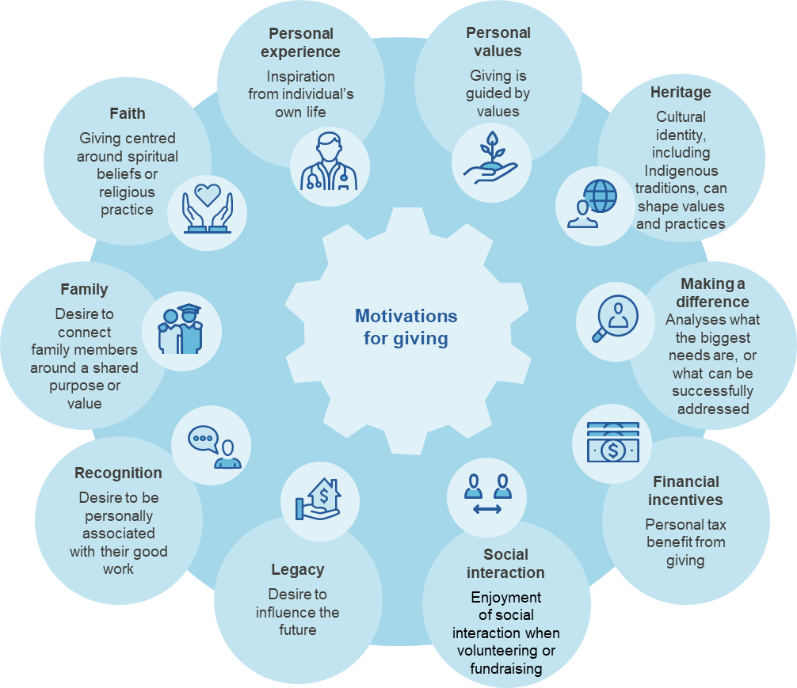
- Trends and motivations for giving
2
3
Identify opportunities for, Recommend ways to
and obstacles to respond to these
increasing philanthropic opportunities and
giving in Australia obstacles
1

Trends and motivations for giving in Australia

Topics of interest
  - Why people do (and do not) give
  - Who gives, including different characteristics (age, gender, income)
  - Advantages and disadvantages of philanthropy as a source of revenue
  - Data, insights and case studies including those that are not publicly available
  - Alternative giving vehicles currently unavailable in Australia
Figure 1. Motivations for giving

Opportunities and obstacles
1
Trends and motivations for giving in Australia
3
Recommend ways to respond to these opportunities and obstacles
2
Identify opportunities for, and obstacles to increasing philanthropic giving in Australia


Topics of interest
  - Regulatory issues and barriers to giving including:
─ regulatory burden
─ any gaps in regulation
─ regulator roles and responsibilities
  - Deductible gift recipient framework
─ issues and opportunities
  - Tax concessions available to not for profits
  - Ability of donors to assess charity effectiveness
  - Other issues you identify


Reform opportunities
1
Trends and motivations for giving in Australia
2
Identify opportunities for, and obstacles to increasing philanthropic giving in Australia
3
Recommend ways to respond to these opportunities and obstacles

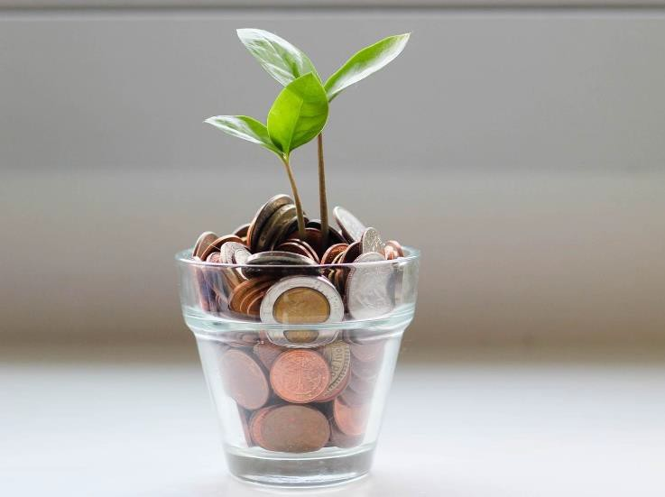
Topics of interest
  - Data and information gaps about
philanthropy
  - Public strategies to increase the status of giving
  - Evidence on the impacts, costs and benefits of reform opportunities
  - Other measures to support philanthropy in
Australia

Inquiry process and milestones






START
Public hearings
February 2024
Roundtable sessions
June/July 2023
Call for submissions paper released
March 2023
Commission publishes draft report and invites further submissions
November
Initial submissions due
5 May 2023
Final report to Government
By 11 May

2023 2024
END

How you can contribute

Speak with us at a round table or public hearing

Call or meet with us

Leave a comment
Make a submission:
- Individual or organisation
- Any length
- Written or video
- Covering as few or many issues you wish
- Submissions are made public

Register your interest to receive
updates


Questions

Please use the comment box to alert the moderator that you have a question

Further questions can be directed to philanthropy@pc.gov.au

If you have joined by phone: *6 to mute/unmute






philanthropy@pc.gov.au @ozprodcom @productivitycommission @productivity-commission

