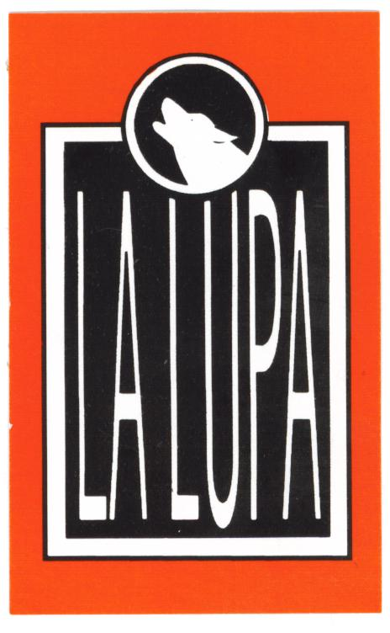

La Lupa Function Menu

$35 Set Menu
Garlic and herb bread, choice of two shared
entrees and two main courses.

$45 Set Menu
Garlic and herb bread, choice of three shared
entrees and three main courses.

$55 Set Menu
Garlic and herb bread, choice of three shared
entrees, three main courses and three desserts.

Entrees on set menus are served on a shared basis.

Prices are subject to increases with certain seafood items.

$3.00 per person corkage on BYO wine.

Contact Denise or Ben for further inquiries or to book
your function now please phone 9818 1645.

La Lupa Function Menu

$35 Set Menu

Shared Entrees

Soup of the day
Chef’s choice of home made soup

Antipasto platter
Chef’s selection of delicacies

Grilled field mushroom
Field mushroom topped with silver beet, tomatoes, sea salt and grilled mozzarella, finished with char grilled lime

Garlic prawns
King prawns simmered in napolitana
sauce with garlic, chilli and parsley

Tomato fetta tapenade
Tomato, fetta and red onion salad with olive tapenade

Carpaccio
Your selection of beef fillet carpaccio
served with fresh lemon, olive oil, rocket and parmesan

La Lupa Function Menu

$35 Set Menu

Mains

Veal Ragout
Red wine veal ragout tossed through spaghettini
pasta in a tomato and basil sauce

Chicken breast
Polenta crusted chicken served on stuffed breaded zucchini’s topped with a garlic and flat leaf parsley compound butter

Lamb shanks
Slow baked lamb shank in balsamic jus served with
whipped potatoes and caramelized baby carrots

Veal Roberto
Veal escallopes topped with pancetta, anchovies, basil, napoli sauce and finished with grilled mozzarella cheese

Vegetable filo
Fresh seasonal vegetables tossed through a garlic sauce
wrapped in pastry and baked with sea salt and poppy seeds

Pan fried salmon steak
Pan fried salmon steak served on parmesan mash, drizzled
with an asparagus and cracked pepper vinaigrette

Wild mushroom risotto
A selection of wild field mushrooms tossed through
Arborio rice with white wine, dill and fresh cream
tossed with shaved parmesan
La Lupa Function Menu

$45 - $55 set Menu

Shared Entrees

Soup of the day
Chef’s choice of home made soup

Brie cheese tart
Roasted red onion, potato and brie cheese tart
with garlic marscapone and peppery roquette oil

Bruschetta
Pancetta, baby spinach, pimento and semi dried tomato bruschetta

Antipasto platter
Chef’s selection of delicacies

Grilled field mushroom
Field mushroom topped with silver beet, tomatoes, sea salt
and grilled mozzarella, finished with char grilled lime

Garlic prawns
King prawns simmered in napolitana
sauce with garlic, chilli and parsley

Bacon prawns
Pan fried green prawns with smokey bacon, garlic and
fresh cream finished with parmigiano reggiano

Tomato fetta tapenade
Tomato, fetta and red onion salad with olive tapenade

Carpaccio
Your selection of beef fillet carpaccio
served with fresh lemon, olive oil, rocket and parmesan

La Lupa Function Menu

$45 - $55 set Menu

Mains

Veal Ragout
Red wine veal ragout tossed through spaghettini
pasta in a tomato and basil sauce

Chicken breast
Polenta crusted chicken served on stuffed breaded zucchini’s
topped with a garlic and flat leaf parsley compound butter

Lamb shanks
Slow baked lamb shank in balsamic jus served with
whipped potatoes and caramelized baby carrots

Veal Roberto
Veal escallopes topped with pancetta, anchovies, basil,
napoli sauce and finished with grilled mozzarella cheese

Vegetable filo
Fresh seasonal vegetables tossed through a garlic sauce
wrapped in pastry and baked with sea salt and poppy seeds

Pan fried salmon steak
Pan fried salmon steak served on parmesan mash, drizzled
with an asparagus and cracked pepper vinaigrette

Wild mushroom risotto
A selection of wild field mushrooms tossed through Arborio rice with
white wine, dill and fresh cream tossed with shaved parmesan

Roast scotch fillet
Pepper crusted roast scotch fillet served with Bernaise
sauce, baby potatoes and red wine jus

Veal campari
Veal topped with king prawns and avocado, finished
with a creamy parmesan and chive sauce

Roast stuffed capsicum
Roasted capsicum stuffed with a string cheese, asparagus and
leek risotto, served on a roast capsicum and tomato coulis
La Lupa Function Menu

Desserts

traditional Italian tiramisu

wild berry panna cotta

chocolate mud cake served with whipped cream

bread and butter pudding served
with vanilla bean gelato

crème caramel served with fresh strawberries

