

PEDESTRIAN DISTRACTION FROM SMARTPHONES

RACHEL OSBORNE PROFESSOR TIM HORBERRY DR KRISTIE YOUNG

OCTOBER 2020

(RELEASED JULY, 2022)

REPORT NO. 349

PEDESTRIAN DISTRACTION FROM SMARTPHONES | i

# MONASH UNIVERSITY ACCIDENT RESEARCH CENTRE REPORT DOCUMENTATION PAGE

|  |  |  |  |  |  |
| --- | --- | --- | --- | --- | --- |
| **Report No.** | **Report Date** | **Release Date** | **ISBN** | **ISSN** | **Pages** |
| 349 | October 2020 | July 2022 | 978-1-925413-19-9 | 1835-4815 (On-Line) | 80+ Appendices |

**Title and sub-title:**

**PEDESTRIAN DISTRACTION FROM SMARTPHONES**

**Author(s) Type of Report & Period Covered**

Osborne, R., Horberry, T., & Young, K. Final Report, 2017-2019

**Sponsoring Organisations -** This project was funded through the Monash University Accident Research Centre’s Baseline Research Program for which grants have been received from: the Department of Justice and Community Safety, the Department of Transport, and the Transport Accident Commission.

#### Abstract:

This report documents the pedestrian distraction and smartphone use project undertaken by MUARC over the period September 2017 to June 2019. It presents the literature review undertaken of previous research in the area, the review of countermeasures and regulations around the world, the observational study completed of actual smartphone use by pedestrians in Melbourne, the pedestrian interviews conducted, the focus group undertaken, and the road safety expert workshop held. It then presents discussion, possible actions and conclusions based on the findings from the project. Situated within a safe systems framework, the possible actions include additional separation and other infrastructure initiatives, encouraging safe walking, greater use of ground signage, and better education in schools and the wider community about the risks of walking whilst being distracted by a smartphone.

**Disclaimer:**

This report is disseminated in the interest of information exchange. The views expressed here are those of the authors, and not necessarily those of Monash University.

Reproduction of this page is authorised Monash University Accident Research Centre Building 70, Monash University Victoria 3800, Australia. Telephone: +61 3 9905 4371, Fax: +61 3 9905 4363

# PREFACE

#### Project Manager / Team Leader:

Professor Tim Horberry

#### Research Team:

* Rachel Osborne
* Professor Tim Horberry
* Dr Kristie Young

#### Contributorship Statement

Rachel Osborne conducted the literature searches, identified and reviewed relevant studies and took the lead role in drafting the report. She undertook the interview, focus group, road safety expert workshop and observational data collection with Professor Horberry.

Professor Tim Horberry scoped and defined the project with the client, provided guidance on research direction and reviewed the report. He undertook the interview, focus group, road safety expert workshop and observational data collection with Ms Osborne.

Kristie Young provided assistance with project scoping, focus group support, and reviewed the report.

#### Ethics Statement

Ethics approval was granted by Monash University Human Ethics Low Risk Review Committee (approval number 10876).

#### Acknowledgements

The project team wish to thank the following people for their contributions to the project: Associate Professor Jennie Oxley, Dr Patricie Mertova, Associate Professor Stuart Newstead, members of the Baseline PAC, focus group participants, interviewees, road safety expert workshop delegates, and other colleagues from MUARC.

# CONTENTS

PREFACE iv

CONTENTS v

FIGURES viii

TABLES ix

EXECUTIVE SUMMARY x

1. INTRODUCTION 1
2. LITERATURE REVIEW 5
   1. METHOD 5
   2. SURVEY BASED STUDIES 5
      1. Self-Reported Survey Studies 5
      2. Phone Based Survey Study 6
   3. OBSERVATIONAL AND EXPERIMENTAL STUDIES 7
      1. Naturalistic Observational Studies 7
      2. Experimental Observational Studies 12
      3. Experimental Simulation Observational Studies 16
   4. OTHER DATA SOURCES 19
      1. Australia 19
      2. Rest of the world 19
   5. SUMMARY OF PEDESTRIAN DISTRACTION LITERATURE 21
3. COUNTERMEASURE AND REGULATORY REVIEW 24
   1. METHOD 24
   2. TYPES OF COUNTERMEASURES AND THE SAFE SYSTEM FRAMEWORK 24
      1. Behavioural (advertising, publicity and education) countermeasures 24
      2. Legislation/Regulation Countermeasures 28
      3. Infrastructure initiatives 29
      4. Technology initiatives 33
   3. DISTRACTION COUNTERMEASURE MATRIX 34
4. MUARC PEDESTRIAN DISTRACTION STUDY: OBSERVATIONS 36
   1. BACKGROUND 36
   2. AIMS 36
   3. OBSERVATIONAL STUDY METHOD 36
      1. Site locations 36
      2. Participants 37
      3. Procedure 37
      4. Coding and analysis 38
   4. OBSERVATIONAL DATA RESULTS 38
      1. Overall data findings 39
      2. Individual site locations 42
      3. Critical Events Data 43
   5. SUMMARY AND DISCUSSION OF THE OBSERVATIONAL STUDY 50
5. MUARC PEDESTRIAN DISTRACTION STUDY: INTERVIEWS 52
   1. BACKGROUND 52
   2. AIMS 52
   3. INTERVIEW METHOD 52
      1. Participants 52
      2. Procedure 52
      3. Interview questions 52
      4. Analysis 53
   4. INTERVIEW DATA RESULTS 53
      1. What are your thoughts about people using their smartphones whilst walking in busy locations e.g. city centre? 54
      2. Are there any specific situations that you feel it may be more risky (to use a mobile phone)? 54
      3. Do you think it is more risky for people to use a smartphone at a signalised or unsignalised crossing? 55
      4. Have you ever seen any occurrences from a pedestrian using a smartphone? For example, a near miss involving a car whilst a pedestrian was using their smartphone? 55
      5. Have you physically bumped into another person or object while you were distracted by talking or texting on your phone? 55
      6. What could be done to promote safer smartphone use in busy locations? e.g. education (posters), technology, engineering or regulations? 55
6. END-USER FOCUS GROUP 61
   1. AIMS 61
   2. METHOD 61
      1. Participants 61
      2. Procedure 61
      3. Materials 61
   3. RESULTS 61
      1. Group Discussion of Four Countermeasures 61
      2. Overall group general discussion: key themes emerging 64
7. ROAD SAFETY EXPERT WORKSHOP 67
   1. AIMS 67
   2. METHOD 67
      1. Participants 67
      2. Procedure 67
   3. RESULTS 67
      1. Group Discussion of Four Countermeasures 67
8. OVERALL DISCUSSION 69
   1. KEY FINDINGS 69
   2. FUTURE WORK WITHIN THE SAFE SYSTEM FRAMEWORK 69
   3. POSSIBLE ACTIONS FOR FUTURE WORK 71
   4. CONCLUSIONS 75

REFERENCES 76

APPENDIX A. Pedestrian observational site locations 81

APPENDIX B. Pedestrian Observation Data Collection Sheet 91

APPENDIX C. Intercept Interview Schedule 92

APPENDIX D. Countermeasures and Regulations 93

APPENDIX E. End User Focus Group: raw outcomes 102

APPENDIX F. Group Discussion of Four Countermeasures: raw outcomes 104

# FIGURES

Figure 1. Road deaths by road user group: 12 months to August 2018 2

Figure 2. Annual pedestrian and total traffic hospitalised injuries in Australia over time, June 2005-2012 3

Figure 3. Pedestrian injury trend over time 3

Figure 4. Illustration and image of experimental setting in the laboratory including the walking route 14

Figure 5. ‘Heads up, Phones down’ campaign 16

Figure 6. Pedestrian Council of Australia campaign 25

Figure 7. Transport for NSW Centre for Road Safety Campaign 25

Figure 8. Swiss Lausanne police pedestrian campaign 26

Figure 9. #YOLOwalksafe campaign 27

Figure 10. Chongqing, China special pedestrian phone lane 32

Figure 11. Stockholm, Sweden, street signs to warn of texting pedestrian 32

Figure 12. Signalised crossings at Flinders Street (incorporating the tram stop to the West and signalised crossing to the East), Melbourne CBD 37

Figure 13. Comparison of phone and non-phone users across sites 41

Figure 14. Mobile device use 41

Figure 15. Smartphone use at individual observation site locations 43

Figure 16. Critical events for smartphone and non-smartphone users 44

Figure 17. Spencer Street (signalised pedestrian crossing) 44

Figure 18. Critical Events for smartphone and non-smartphone users 45

Figure 19. Critical events observed for smartphone and non-smartphone users by age group 45

Figure 20. Demographics for smartphone and non-smartphone users 46

Figure 21. Gender specific smartphone use by age demographics 47

Figure 22 Percentage of pedestrians not looking/head checking prior to crossing 47

Figure 23. Number of critical events instances by type of phone distraction 48

Figure 24. Number of critical event instances for all pedestrians observed 49

Figure 25. Results from the pedestrian interviews 54

Figure 26. Interview countermeasure response suggestions 60

Figure 27. Key themes obtained from focus group discussion 65

Figure 28. A comprehensive framework for safe walking 70

# TABLES

Table 1. Pedestrian Fatalities by Age Group, 2005-2014 2

Table 2. Pedestrians’ Smartphone Use by Age Group 10

Table 3. National Estimate of Pedestrian Phone Related Injuries (2004-2010) by Age 21

Table 4. Intervention and Type of Distraction Use (Headphone/Mobile phones) 29

Table 5. Distraction Countermeasure Matrix 34

Table 6. Number of Pedestrians Using Their Smartphones at Each Site Location 40

Table 7. Participant Interview Countermeasure Suggestions Transcript 57

# EXECUTIVE SUMMARY

The aims of this research project were to:

1. Identify the main smartphone-related distractions for pedestrians, and to quantify their impacts upon the safety of pedestrians and other road users; and
2. Identify and describe current, and future, potential countermeasures to minimise the occurrence of pedestrian distraction and reduce its impact on road trauma for all road users.

To meet these aims, the research undertaken by MUARC included   
* a literature review of previous research in the area,   
* a targeted review of countermeasures and regulations around the world,  
* the observational study of actual smartphone use by pedestrians in Melbourne,   
* pedestrian interviews,   
* a focus group; and   
* a road safety expert workshop.

There is an emerging body of literature on pedestrian smartphone distraction: this includes * observational studies,   
* laboratory experiments; and   
* surveys.   
In general, most of this research finds a negative impact on smartphone use on pedestrian safety; for example, smartphone using pedestrians tend to walk slower and more unevenly, pay less attention to their environment and have more safety-related incidents.

The countermeasure and regulatory review found that there is no single effective approach to manage the issue, and most countermeasures tend to fall into four categories:   
1. education/publicity,   
2. infrastructure,   
3. regulation and legislation, and   
4. technology (e.g., camera and smartphone Apps).

This report argues that countermeasures should be considered within the Safe System framework, where it is recognised that road users such as pedestrians will make mistakes, thus, an error-tolerant road system and an integrated approach to countermeasures in this area is required.

The observational study found that, on average, **20%** of pedestrians observed were using a smartphone when crossing a road in a city location. The main smartphone functions used were listening to music via headphones, phone calls, texting/accessing the internet. The study also examined ‘critical events’ such as near misses (e.g. nearly hitting another pedestrian, vehicle or object). It was found that smartphone using pedestrians had a significantly higher proportion of critical events compared with non-smartphone users: this shows the additional risk to safety of using a smartphone whilst crossing a road.

The pedestrian interviews, end-user focus groups and road safety expert workshop all highlighted the growing awareness of pedestrian smartphone distraction and its potential risks. Additional countermeasure ideas were generated from the interviews, focus group and workshop. As with the countermeasure review undertaken earlier in the project, the participants considered that there was no single ‘silver bullet’ to solve the pedestrian distraction issue, and that managing the issue to reduce the risks involved, rather than trying to fully prevent distraction, might be the most effective. The road safety expert workshop further highlighted the need for countermeasures to be developed and implemented within the safe system framework: recognising a shared responsibility for road safety instead of simply focusing on trying to eliminate pedestrian error.

The report concludes by presenting a discussion section and then provides possible actions and conclusions based on the overall findings from the project.

# INTRODUCTION

Road user distraction is often defined as diversion of attention away from activities critical for safety in the road environment towards a competing activity (Lee, Young & Regan, 2009). Road user distraction is a growing threat to road safety worldwide; for driver distraction alone, studies from the USA has been shown distraction to contribute to approximately one quarter of all crashes (Klauer et al., 2006; Stutts et al., 2001). In Australia, Beanland et al. (2013) study found distraction was present in 16% of the 340 coded crashes investigated (in which a vehicle occupant was admitted to hospital for at least 24 hours). Internal distractions (cognitive distractions such as thinking or feeling stressed) were present in 4% of these crashes and in-vehicle distractions were present in 9% of these crashes. The most frequent sources of in-vehicle, non-driving related, distractions included interactions with passengers and using mobile phones.

The nature and extent of *driver* distraction has been well documented in research over the past ten years. However, much less is known about how to reduce the occurrence of *pedestrian* distraction and minimise its impact on road trauma. This is critical as the number and complexity of potentially distracting technologies used by pedestrians (e.g. smartphones) is likely to rise over the next decade and, as a road user group, pedestrians are particularly vulnerable to being fatally or seriously injured in collisions with other road users.

Approximately 273,000 pedestrians worldwide are killed on roads each year, this represents approximately 22% of all road traffic deaths globally (WHO, 2013). Pedestrian fatalities accounted for 16% of the U.S. total traffic fatalities in 2016 (Retting, 2018). Similarly, in Australia, pedestrians accounted for approximately 14% of road fatalities in the ten-year period from 2003 to 2012 inclusive (Williamson & Lennon, 2015), with recent Australian data reporting 174 pedestrian fatalities in 2016 and 160 in 2017. (BITRE, 2017). On average, between 2004 to 2009, pedestrian fatalities figures have shown a decrease. However, there was a gradual increase again from 2009-2012 (NHTSA 2014, as cited in Mwakalonge, Siuhi & White, 2015). The OECD/ITF 2015 Road Safety Annual report reiterated these findings that, in Australia, there had also been a decrease in pedestrian fatalities compared with vehicle occupancy deaths. The authors reported on these findings:

*“Since 1990, the percentage reduction in pedestrian fatalities (-64%) has been considerably larger than that for vehicle occupant fatalities (-51%). There is evidence that lower urban travel speeds have been particularly important in cutting pedestrian fatalities. There is also some evidence that speed enforcement measures have been more effective on urban arterial roads than on rural roads. Although there is no national exposure data for pedestrians, it is likely that pedestrian traffic has not increased to anything like the same extent as vehicular traffic. Increasing urban congestion and development of urban motorways may have benefited pedestrian safety even more than they have benefited vehicle occupant safety, though there is no direct evidence to that effect.”* (OECD/ITF, 2015, p.50).

In Australia, pedestrians accounted for approximately 14% of road fatalities in the ten-year period from 2003 to 2012 inclusive (Williamson & Lennon, 2015), with the latest Australian road fatality data, for the 12-month period ending August 2018, reporting: 182 pedestrian fatalities, an increase from previous years: 162 and 160 from 2017 and 2016 respectively (BITRE, 2018) as can be seen in Figure 1.

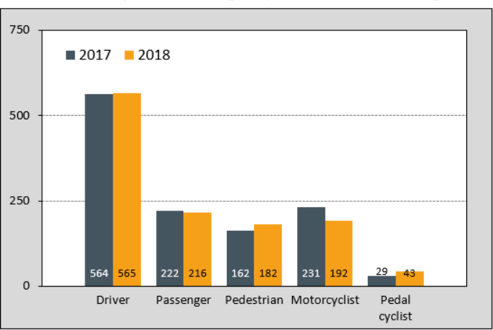

*Figure 1. Road deaths by road user group: 12 months to August 2018*

Source: BITRE, 2018. Pedestrians and Road Safety Statistics.

The most recent published Government report, incorporating the 10-year period from 2005-2014, found the age groups 65-75 years (and older) to have the highest pedestrian fatality rate per (100,000 deaths); with the age group 17 to 25 year-olds having the next highest rate (BITRE, 2015) as can be seen in Table 1.

## TABLE 1. PEDESTRIAN FATALITIES BY AGE GROUP, 2005-2014

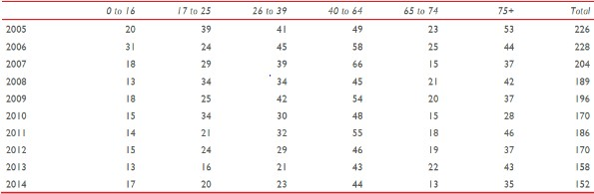

Source: BITRE, 2015. Pedestrians and Road Safety Report.

Annual pedestrian hospitalised injuries in Australia were shown to be relatively stable between 2005-06 and 2012 (Figure 2), with between approximately 2,400-2,800 cases reported between 2005-2009. (There was insufficient data for the year 2010 so data was interpolated based on the figures from 2008-2009 and 2011). This data is dependent on hospital databases and possible self-reporting, so it is recognised to be potentially less reliable than fatality data (BITRE, 2015).

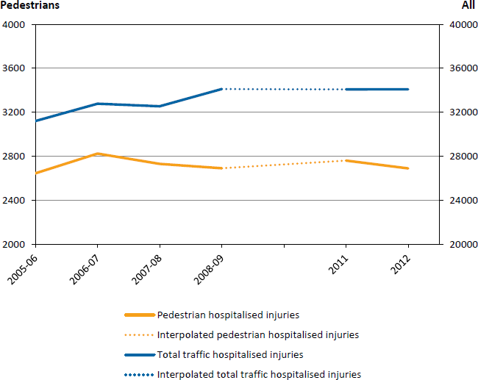

*Figure 2. Annual pedestrian and total traffic hospitalised injuries in Australia over time, June 2005-2012*

Source: BITRE, 2015, Pedestrians and Road Safety Report.

More recent data from 2012 – (October) 2017 from Victoria, show the number of pedestrians injury levels have remained relatively stable over time with a total of 2,951 serious injuries to pedestrians over this period (Figure 3).

Pedestrians who conduct illegal activities (such as jay walking) exacerbate their risks as vulnerable road users. However, enforcement of such activities is rare due to logistical and resourcing reasons. Pedestrians decision making may be impaired if they have the added visual and auditory distractions from using a smartphone.

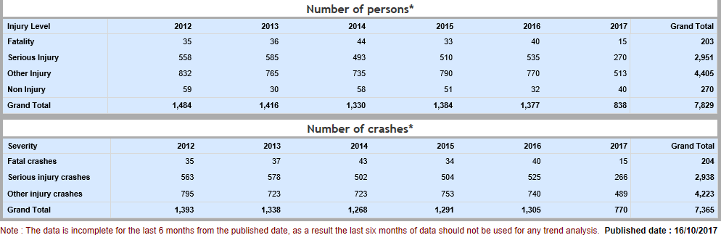

*Figure 3. Pedestrian injury trend over time*

Source: VicRoads interactive crash statistics application (date of access 19th September 2018).

It is argued here that it is not feasible or practical to simply expect road users to never become distracted. Instead, it is important to develop strategies, technologies and countermeasures that minimise the impact of distraction on safety, rather than attempt to eliminate it altogether.

As much work regarding driver distraction has already been done or is underway, the focus for this project is on distractions for pedestrians - particularly smartphone use. With the increased use of mobile technology, smartphones are in essence a mobile computer and, as such, increase the chance of pedestrians attempting to multi-task while walking, which may inevitably lead to switching of attention between tasks: this may have a detrimental impact upon the safety of pedestrians and other road users.

# LITERATURE REVIEW

With the increased use of mobile technology, particularly smartphones, in daily life it is important to review how this technology may impact on pedestrian distraction and road trauma. The following section of the report reviews current literature to establish what is currently known in terms of pedestrian distraction, focusing on smartphone use, and the associated risks involved. This literature review also assisted with potential methods to better understand the level of pedestrian distraction for data collection and coding for the observational study.

## METHOD

The first stage of the project reviewed the current international literature to identify what research has been conducted to determine the contributing factors for pedestrian distraction. A range of databases and resources were searched as part of the review: Monash University Library data base search, SafetyLit, ScienceDirect, PubMed, Scopus, ProQuest Health & Medicine, SpringerLink, TRID (the Transportation Research Information Services (TRIS) and International Transport Research Documentation (ITRD) combined database, TRANSPORT, Ingentaconnect, and Tandfonline, as well as ResearchGate and search engines Google and Google Scholar. Key Intelligent Transport Systems (ITS) and transport websites were also reviewed, including ITS Australia, ITS America, ITS Europe (Ertico), ITS UK, US Department of Transportation (ITS Joint Program Office), NHTSA, EC Europa as well as the major C-ITS and AV project websites.

The search terms used were: pedestrian distraction, pedestrian smartphone distraction, pedestrian behaviour distraction, text messaging, cell phone, smartphone and mobile phones, combined with terms such as safety, pedestrian safety, injury, injury prevention, street crossing, crossing behaviour and human factors. The reference lists of papers, identified through these searches, were also reviewed and any additional relevant papers were identified and obtained.

For ease of reading, the studies have been grouped according to the different methodologies used.

## SURVEY BASED STUDIES

Survey based research generally involves the collection of data from a population sample via a questionnaire that can either be administered verbally or in a written format online or by phone.

### Self-Reported Survey Studies

Research has shown that pedestrians are likely to use mobile technology whilst walking, which increases their crash risk. Williamson and Lennon (2015) conducted short, 10-minute intercept interviews with 211 pedestrians, aged between 18-65 years old, in Brisbane’s CBD. In order to keep the interview brief three levels of potentially distracting smartphone activities were investigated (cognitive only i.e.: talking on a smartphone; cognitive plus visual i.e.: texting and/or using the internet facility on a smartphone; and audio only i.e.: listening to music/radio with earphones/buds). Data were collected for both walking and crossing behaviour and, in order to differentiate between levels of exposure, participants were also asked to indicate whether they initiated, monitored or responded to the different phone activities. Four research officers, working in pairs, approached pedestrians at two busy intersections in Brisbane CBD. The locations were selected based on previously reported high pedestrian crash numbers and high pedestrian volumes. Pedestrians were invited to participate if they appeared to be between 17 and 65 years old (adolescents’ responses were excluded for ethical reasons) regardless of whether they were using a mobile device or not. One of the screening criteria was that the participant owned a smartphone, which only deemed a few participants ineligible. Participants were asked, for both scenarios ’whilst walking’ and ‘whilst crossing the road’, how often they used their smartphone for the following activities: 1) Initiate a text; 2) Monitoring text messages; 3) Respond to a text; 4) Initiate a call; 5) Answer a call; 6) Initiate an internet search or interaction; 7) Monitor internet (e.g. Facebook); 8) Respond to internet (e.g. email); 9) Use an audio-

only device to listen to music/radio with earphone/buds. Two categories of exposure to smartphones were then differentiated: high exposure, where the respondent indicated ’more than once per day’, ‘once per day’ and ‘several times per week’ and low exposure, where responses of ‘less than once per week’ or ‘never’. As expected, the results indicated that smartphone use for potentially distracting activities whilst walking or crossing a road was high, especially among 18 to 30 year-olds. Thirty percent of this age group indicated they engaged in texting or accessed the internet on their smartphones at least once a week whilst crossing the road, if not daily or more often.

White et al.’s (2017) online self-report survey of 297 students at South Carolina State University (conducted between February and April, 2013) revealed 55% of respondents always checked their electronic devices (defined as taking or making calls and listening to music) whilst walking, with 85% reporting they texted whilst walking at least once a week. Results revealed that individuals aged 17 to 22 (59.9%) were more likely to engage in distracting behaviours and habits while walking than other age groups (22.2% and 9.1% for 23-30 and over 30- year olds respectively). Results from participants’ perception of distracted walking revealed that 47% believed it was a major problem but 51% did not. However, over half of all respondents said they had seen pedestrians distracted near crashes (53%) or themselves been in an accident due to being distracted whilst walking (53%). Or reported sustaining injuries themselves (4%) or a family member (4%) had sustained injuries because of distracted walking (including pedestrian crossings, parking lots and pavements). In addition, others mentioned tripping but not sustaining injuries. Participants were also asked, as part of the survey, whether interventions or countermeasures would be beneficial to curb or ban distracted walking. Fifty-seven percent of respondents said they did not believe action was needed to prevent distracted walking (41% thought it was required), 64% believed distracted walking, whilst crossing a street, should receive a summons (be cited) and 52% thought it should be banned. The most common responses for interventions or countermeasures were: education, outreach programs, citations and legislation. Other suggestions include infrastructure (widening pavements) and technology initiatives such as hands-free and voice activated technologies.

### Phone Based Survey Study

In April 2013, Liberty Mutual Insurance conducted an American country-wide phone survey of 1,004 adults (aged 18-65 years). According to the survey, 60% of pedestrians walk whilst texting, emailing, talking on the phone or listening to music. The breakdown of activities participants admitted to engaging in, despite knowing the risk, whilst crossing the street were (Liberty Mutual Insurance, 2013):

* + - * 51% talked on the phone
      * 34% listened to music
      * 26% texted or emailed
      * 46% indicated they ran across the street to beat oncoming traffic.

A telephone survey of 2,252 adults living in the United States conducted in 2010, by the Pew Research Center’s Internet & American Life Project, revealed that 14% of American adults admitted to physically bumping into an object or person while walking because they were distracted by talking or texting on their phone (Madden & Rainie, 2010).

A survey of smartphone users found that 83% of Romanians admitted to crossing the street while using a mobile device or phone, and 79% continued their phone call when crossing the street (Ford, 2015; as cited in Hamann et al., 2017).

A Korean online questionnaire-based survey of 608 students conducted in 2016, revealed that smartphone addiction/problematic smartphone use was associated with greater accident occurrences (falling, slipping, bumps and collisions). Smartphone addiction/problematic smartphone use was assessed using the Smartphone

Addiction Proneness Scale (SAPS; a standardized measure developed by the National Institution in Korea) with participants being classified with problematic smartphone use or normal users. Twenty eight percent of problematic smartphone users reported experiencing some sort of accident, or more specifically suffering more bumps/collisions (22%) compared with the normal users (17% and 14% respectively) (Kim, Min, Kim & Min, 2017).

Lennon, Oviedo-Trespalacios and Matthews’ (2017) online self-report survey of 363 participants (aged 17-65 years) revealed 20% of the participants reported high exposure of smartphone distracting behaviour while crossing the road. Audio only (listening to music/radio with earphone/buds) was the most prevalently reported smartphone behaviour. With high exposure frequency (more than once a day/once a day/once a week) reported by 51.1% of participants, followed by texting (monitoring 37.2%, responding 27.5%, initiating 23.5%), web based activities (monitoring the internet e.g. Facebook 25.5%, initiating or interaction 23.5%, responding e.g. Emails 14.4%) and calls (answering 26.3%, initiating 20.3%). In order to determine pedestrians’ intentions to cross the road whilst distracted, questions incorporated the Mobile Phone Involvement questionnaire (MPIQ) to help ascertain addiction/problematic smartphone use. Results indicated that 18-30 year olds were significantly more likely to score high on the MPIQ than the other age groups (χ  = 9.347, *p*= 0.009 Cramer’s V = 0.16). In addition, for this group, Theory of Panned Behaviour (TPB) construct variables: attitude (*p*<0.001), subjective norms (*p*<0.01), perceived behavioural control (*p*<0.05) were found to be significant predictors of intention to use a smart phone while crossing the road, with attitude the strongest predictor (41%), as well as the variables of MPIQ and group norm/friends explaining an additional 6% of the variance in intention. Indicating those individuals with positive attitudes and norms toward smartphone use while crossing a road (including friends’ positive attitudes influences) are more likely to do it even when they know the associated risks.

## OBSERVATIONAL AND EXPERIMENTAL STUDIES

Throughout the literature review different methods of observational studies on pedestrian distraction have been observed. Observational research is generally categorised as either naturalistic observational or experimental/simulation observational studies. The following subsections describe the different observational methods used in the literature and the outcomes from each study.

### Naturalistic Observational Studies

Naturalistic observational studies generally aim to unobtrusively observe pedestrian behaviour in real-life settings. Most of the studies have been undertaken in North America or Australia, although some more recent studies have been conducted in Europe.

The Bungum, Day and Henry (2005) study near a large university in Las Vegas, Nevada, used trained observers to record the behaviour of 866 pedestrians as they walked across a signalised pedestrian crossing intersection. The intersection had auditory beeping noises to indicate when it is safe to cross. The researchers defined distracted pedestrians as those wearing headphones, talking on a mobile phone, eating, drinking, smoking or talking with another pedestrian whilst crossing the street. Each data collector only observed one pedestrian per light change and watched them as they crossed all the way to the other side of the street. Inter-rater reliability was ascertained utilising detailed operational definitions for each observation to be reported. The recorded cautionary behaviours of pedestrians included: whether they looked left and right (defined as a noticeable chin turn), stayed within the markings of the crossing walk way (defined as those who did not step outside of the crosswalk markings on two or more consecutive steps), waited on the curb side until the green light/white illuminated ‘walk’ hand signal was lit (defined as both feet remaining on the curb until the illumination of the signal) and not entering the crossing walkway when the signal turned orange. Demographic variables including gender and estimated age were also collected. Results indicated that approximately 20% of pedestrians were distracted in one form or

another as they crossed the street, with 5.7% of pedestrians crossed the street whilst talking on the phone or wearing headphones. Results indicated a reduced lack of overall pedestrian cautionary behaviour, with only 13.5% of all pedestrians observed waited for the light and looked left and right before crossing the street.

Distraction was found to be a significant predictor of displayed cautionary behaviours, with the observed distracted pedestrians displaying less cautionary behaviours in this study. No gender discrepancy was found, with results indicating no significant difference in cautionary behaviour between males or females.

Hatfield and Murphy (2007) noted from their observations at three Sydney suburban locations that not only were pedestrians visually distracted whilst using a phone, even if they did look up periodically, incidents could occur unexpectedly and there was also an increased falls or trip risk. In the study’s observational field survey of 546 pedestrians (270 female and 276 male) crossing the road, they found gender specific differences in unsafe mobile phone practices at road crossings. The study used a case-control design (time and demographic matched control) at the three Sydney sites that included signalised and un-signalised crossings. Data collection observational methodology consisted of an observer recording the behaviour of pedestrians who were using their mobile phone (regardless of how they were being used: whether talking using hand-held or hands-free; or text messaging). The observer recorded the behaviour of the first pedestrian, who was using a mobile phone as well as the behaviour of another non-phone user pedestrian (time-matched control), who was the same gender and presumed age (demographic-matched control) for the control group. The study found that all of the 182 pedestrians using their phone whilst crossing the road, were observed to have increased cognitive distraction and disregard for surrounds which led to unsafe road crossing practices, compared with the control group. The authors also noted that pedestrians’ walking speed decreased when using a mobile phone and, as such, increased the potential exposure to risk. The results revealed that female pedestrians (but not male) who crossed at signalised crossings whilst on their mobile phones, crossed more slowly than the control group. Female pedestrians who utilised a mobile phone whilst crossing, were less likely than those pedestrians not using a mobile phone (the demographic matched control group) to look at traffic before crossing (at signalised and un-signalised crossings); less likely to stop for traffic (at un-signalised crossings) and less likely to look at traffic whilst crossing (at signalised crossings). Male pedestrians, who crossed whilst on their mobile phones, crossed more slowly at un-signalised crossings compared with the control group. However, the authors did caution against generalising results beyond the three- environments tested and that the locations observed may have been areas that were known for poor pedestrian behaviour and as such the study sample may not necessarily be representative of the general population.

Nasar, Hecht and Wener (2008) observed and recorded demographic and distraction behavioural data for 127 pedestrians at three intersections at an American University campus during a pre-determined peak period for pedestrian activity (between noon and 2 pm). It was found that those pedestrians using a mobile phone exhibited a higher percentage of unsafe behaviours compared with those pedestrians using an alternate distracting device (e.g. an iPod) or no distraction device at all (no mobile or iPod). The authors also cautioned about generalising the findings beyond the three observation areas.

Hyman, Boss, Wise, McKenzie, and Caggiano (2010) observed the effects of pedestrian divided attention whilst using an electronic device (including talking on a mobile phone) in two studies. They observed 196 pedestrians walking through the central plaza of an American University and it was found that persons using a mobile phone walked slower, were more likely to weave, change route direction, stop or be involved in a near collision and were less likely to acknowledge other people than non-distracted walkers. Gender was found to play no significant role in the results.

Brumfield and Pulugurtha (2011) observed behaviours of driver and pedestrians at seven pedestrian crossing sites at a University campus in North Carolina. Data collected on pedestrian distraction behaviour was broken

down into three categories: talking on a mobile phone, texting or ‘other’ (which included anything that may affect road user attention). Data was only collected when pedestrians crossed and there was vehicle interaction (i.e. giving way to a pedestrian at the crossing). In a large pedestrian stream, data was only collected on the first pedestrian to cross. Results revealed that 29% of pedestrians observed were noticeably distracted while crossing the road. About 16% (54% of distracted pedestrians) were talking on a mobile phone, 7% (23% of distracted pedestrians) were texting and 6% were otherwise distracted (such as eating, listening to music etc.). The authors also collected vehicle-pedestrian conflict data for the pedestrian or the driver (for example, the most commonly noted conflict was a pedestrian entering the crosswalk and then stepping back because the vehicle did not give way). Study results revealed that the percentage of drivers yielding was much higher when there were distracted pedestrians present. In fact, study results showed that drivers were 40% more likely to give way to distracted pedestrians than to those who were attentive. The researchers observed that the distracted pedestrians made aggressive crossing manoeuvres, failed to make eye contact with approaching drivers and darted in front of traffic.

Cooper, Schneider, Ryan and Co (2012) observational study included a review of 12 intersections near transit stations in San Francisco. Field data collection observations were made between spring 2011 and autumn 2012. A total of 1,144 pedestrians were observed and the results revealed that at all 12 of the sites, there were pedestrians observed using their mobile phones while crossing the intersections. Eight percent of pedestrians overall used their mobile phones while crossing the road (the proportion of the observed behaviour varied from site to site with one behaviour-observation study site showing 19% of pedestrians using their phones while crossing at the intersection). Female pedestrians were more likely to talk on their phones while crossing the street than males. Age was also found to play a part, with more than 11% of younger pedestrians (18-34 year olds) exhibiting this behaviour whilst crossing the road, in contrast to those aged 35-49 years (8%) and 50-64 years old (3%). Also, pedestrians walking alone were found to be twice as likely, than those in a group, to use their phones while crossing the street.

Thompson, Rivara, Ayyagari, and Ebel (2013) conducted an observational study of 1,102 pedestrians at 20 Seattle, Washington intersections. Two trained observers recorded demographic and behavioural information as well as coding variables for pedestrian distraction including: listening to music; talking on a hand-held mobile phone or with an ear piece; text messaging as well as additional distraction tasks (talking with another person, carrying a baby or pushing a stroller, etc.). Additional information was reported such as: which direction the pedestrian walked, whether they used the crossing, whether they turned their heads to look left and right, and whether or not they jaywalked at a signalised crossing. The authors reported that 29.8% of the observed pedestrians were performing a distracting activity whilst crossing the road. The study results revealed that pedestrians who were using the text message facility of their phones took longer to cross and were significantly more likely to display unsafe crossing behaviour than undistracted pedestrians. A gender discrepancy was also found with females found to be twice as likely to exhibit unsafe crossing behaviour as males.

A Ferguson et al. (2013) study observed 34,325 middle and high school students (from 68 schools across 17 states in America) crossing streets, near schools, during a school year in 2012-2013. Distraction data was only collected for student pedestrians using an electronic device (e.g. a mobile phone) and not from other distractions (such as talking with friends, reading a book etc). The results revealed that one in five high school and one in eight middle student pedestrian were distracted, with the greatest distractions being texting/typing on their phone (39%) and headphones (39%) followed by talking on the phone (20%) and playing games (2%). A gender difference was also found, female students were 1.2 times more likely to be distracted whilst walking than their male counterparts. The study results also indicated that students were 26% more likely to be distracted at

signalised crossings (where they perceive it to be safer). No statistically significant difference was found between the seasons and distraction rates were similar. In addition, 2,441 students participated in a discussion group at the schools where the observations were conducted. The results revealed that 49% admitted to using their mobile phones whilst walking to school with 40% saying they listened to music and 6% using an alternate device (such as gaming device or tablet). Interestingly, the majority (78%) of the students interviewed did not believe it was a risk for their age group only for younger children. Fifty percent of the middle and high school students said the most at risk group was someone younger than themselves, twenty eight thought older teenagers were more at risk and only 22% believed it was an issue for people their own age.

Basch, Ethan, Rajan and Basch (2014) observed 3,784 pedestrians that were: using headphones, using a mobile phone or smartphone (which included talking on the device or looking down/interacting with the device) or any combination of the aforementioned. Observation data collection was conducted at 10 signalised intersections (with the highest known frequency of pedestrian-vehicle collisions) in Manhattan, New York. Pedestrians were only coded if they walked within the area of the crossing. More than one in four of the observed pedestrians were distracted by technology-related interactions while crossing during the ‘walk’ (28.8%) and ‘don’t walk’ (26.3%) intersections, with a statistically significant difference (χ  =25.9; *p*<0.001) found between pedestrians talking on their mobile phones during the ‘walk’ compared with the ‘don’t walk’ signal. The use of headphones was the most frequently observed distractor for both the ‘walk’ and ‘don’t walk’ signals, 16.3% and 15.6% respectively, but these differences were not statistically significant.

DEKRA (Deutscher Kraftfahrzeug-Überwachungs-Verein) Accident Research (2016) conducted a study at six European capital cities (Amsterdam, Berlin, Brussels, Paris, Rome and Stockholm) where pedestrians’ smartphone use was observed at busy intersections and pedestrian crossings near each city centre, public- transport stops and train stations. The observations of 13,822 pedestrians (aged 15-60 years old) across all cities revealed that pedestrians were seen texting while crossing the street (8%) on a call (2.6%) or both at the same time (1.4%). Five percent of pedestrians were observed wearing earplugs or headphones without speaking (so were probably listening to music). Results also concluded that, as expected, younger pedestrians (15-35 years) tended to use their smartphone (for calls, music, texting, using apps and/or combinations) more frequently than the older age groups (35 years plus) as can be seen in Table 2.

## TABLE 2. PEDESTRIANS’ SMARTPHONE USE BY AGE GROUP

|  |  |  |  |  |
| --- | --- | --- | --- | --- |
| Age groups | 15-25 years | 25-35 years | 35-45years | 45-60 years |
| **Pedestrians smartphone use** | 18.83% | 22.48% | 15.83% | 10.88% |
| **No use** | 81.17% | 77.52% | 84.17% | 89.12% |

Source: Adapted from DEKRA (2016) report.

Gender differences were also observed, with female pedestrians more likely to be texting, whereas males were more likely to be wearing headphones/earplugs. It was also noted that there was a difference between the cities across all age groups. Amsterdam had the lowest frequency of pedestrian smartphone use (8.2%), compared with Rome (10.6%), Brussels (14.12%), Paris (14.53%) and Berlin (14.9 %) with the highest use being found in Stockholm (23.55%).

Pešić, Antić, Glavić and Milenković (2016) study of 1,194 pedestrians crossing at two unsignalised crossings in Serbia, found 398 pedestrians to be using their mobile phone as they crossed. Demographics (gender and

estimated age) as well as mobile phone use (talking, texting or viewing content or listening to music) was recorded by six research observers. Demographic and time-matched control groups were used to compare phone use on pedestrian behaviour. The results indicated a significant difference between phone users and non-phone users, such that phone user pedestrians did not look at traffic before crossing (*p*<0.001), did not wait for the traffic to stop before crossing (*p*<0.001), did not look at the traffic whilst crossing (*p*<0.001) and did not finish crossing at the marked pedestrian crossing (*p*= 0.009). Eighty percent of mobile phone users displayed at least one unsafe behaviour (compared with 61% of unsafe behaviours displayed by the demographic matched group and 64% from the time matched group) demonstrating the influence of mobile phone use on pedestrians crossing.

Hamann et al. (2017) (using a sample of 100 PMVC Romanian site locations chosen from a 2010 police crash data base) observed the behaviour of 1,711 pedestrians regarding: illegal crossing (going against a red light, or not use available crosswalk), unpredictable crossing (partial use of crosswalk) and distraction (from child, other pedestrian, reading, electronic devices: held to head, headphones or manipulation of an electronic device).

Distraction was measured from the time the pedestrian entered and exited the roadway. The results indicated 6% of pedestrians were distracted with the most common type of distraction using an electronic device (hand-held device - 4.6%, followed by manipulating an electronic device - 1.1%). Over 24% of the observed pedestrians displayed risky behaviours of crossing unpredictably or illegally (primarily unpredictable crossing behaviour). The authors also reported that pedestrian distraction rates were higher within the city locations and at sites with traffic lights. However, pedestrian’s risky behaviour was found to be higher outside the city locations and lower at intersections compared with non-intersections. Hamann et al. (2017) noted that although results from their observation study indicated that pedestrian distraction was only 6%, a survey of smartphone users found that 83% of Romanians admitted to crossing the street while using a mobile device or phone and 79% had continued their phone call when crossing the street (Ford, 2015; as cited in Hamann et al., 2017).

Chen and Pai (2018) study of 2,345 smart phone distracted pedestrians (observed via four hidden video cameras) at an unsignalised pedestrian crossing in Taiwan, revealed approximately 7% were listening to music whilst crossing; 21% were talking on a phone; 15% texting; 5% web-surfing and 26% were gaming (majority Pokémon Go). The study compared crossing time and unsafe crossing behaviours of distracted and undistracted pedestrians. The study’s results indicated there was a statistically significant difference by those distracted by gaming (*p*<0.01) compared with the non-distracted pedestrians and those talking, texting or web-surfing (*p*<0.05) compared with the non-distracted pedestrians. Smartphone gaming was also associated with less head turning behaviour (average head-turning frequency, not looking before stepping out into traffic and looking the wrong way) with approximately 22% of those pedestrians gaming not looking before stepping out onto the crossing (followed by those 17% web-surfing and 11% texting). In addition, 10% looked the wrong way at traffic (followed by 8% web-surfing and 6% texting).

Observational studies conducted at two railway crossing locations in Melbourne, Australia both found pedestrians to be non-compliant (that is breaking current road rules) and displaying undesirable behaviours (including engaging with a mobile phone while crossing). At the Diggers Rest site 16.3% (70 out of 427) pedestrians observed displayed undesirable behaviours (e.g. mobile phone/tablet use) while crossing. Whereas, at the Greville Street (Prahran) site 163 pedestrians (from 3,914 pedestrians observed) were engaged in technology whilst traversing the crossing. Both studies also found females were somewhat more likely to be engaged with technology than males, while crossing (93 out of 163; and 42 out of 70 respectively) (Read, Beanland & Salmon, 2018).

Undesirable behaviours of 1,995 pedestrians were also observed in a study by Chen, Saleh and Pai (2018), conducted in Taiwan, using hidden video cameras. This study was conducted at a signalised intersection and, as

such, unsafe and illegal crossing behaviours (crossing at a red/do not cross signal) were accounted for. The results of the study revealed approximately 7% were listening to music whilst crossing; 26% were talking on a phone; 21% texting; 5% web-surfing (e.g. using Facebook, Instagram etc.) and 42% were gaming. The study findings concluded that distracting activities such as smartphone gaming do contribute to unsafe and illegal crossing behaviours. The study’s findings revealed a significant number of pedestrians who were gaming crossed against a red signal (19.4%: *p*<0.01) followed by those texting (8.9%; *p*<0.05), in addition both of these groups average crossing speed time decreased.

A variety of different methodological approaches were found in the studies. For example, pedestrian sampling or gender comparisons. Selection of participants from a potential large pedestrian presence (at the chosen observation sites) varied across studies. These ranged from selecting the first person to arrive at the intersection (Brumfield and Pulugurtha, 2011; Bungum, Day & Henry, 2005); random selection criteria (Cooper at al., 2012); selecting one pedestrian to observed as they approached the intersection prior to crossing (Nasar et al., 2008); and fixed interval selection or case controlled design (Hatfield & Murphy, 2007; Thompson et al., 2013) methodologies. Usually only one pedestrian, out of a stream of pedestrians, were observed by each data collector. However, the results across the studies varied even when similar methodologies are used, indicating the complexity of human behaviour in this context.

#### Summary of Naturalistic Observational Study Literature

The current review of literature, for naturalistic observational studies, revealed that distracting activities, from smartphone use, was found to contribute to unsafe and illegal crossing behaviours and a reduced lack of overall pedestrian cautionary behaviour. Distracted pedestrians were found to walk slower, were more likely to weave, change route or stop. They were less likely to stop for traffic (at un-signalised crossings), less likely to look at traffic whilst crossing, or in fact look the wrong way at traffic or not look at all. They took longer to cross; made aggressive crossing manoeuvres; failed to make eye contact with approaching drivers and darted in front of traffic.

### Experimental Observational Studies

Experimental studies generally involve a controlled manipulation of different variables, often to the physical environment (e.g., manipulating a door way size or stencilling instructions on the pavement), and then examination of the impact of those changes on pedestrian behaviour.

Nasar, Hecht and Wener (2008) conducted a study of 60 university pedestrians to observe if their mobile phone use whilst walking along a prescribed route where five ‘out of place’ objects had been placed to cause distraction. Three were placed at eye level (a sign reading UNSAFE!, a boot, and a cup) and two placed at ground level (two pieces of fake vomit, and a chalk sketch of an Ostrich with its head in the ground). Thirty participants were allocated to a conversation group where they spoke on a phone and 30 participants were in the non-conversation group (the participants were told to hold their phones by their side awaiting a potential call, but no communication or interaction actually took place). It was found that those who engaged in conversations on their mobile phone whilst walking were less aware of their environment and their recall of the ‘out of place’ objects along their route than the non-conversation (Means 1.58 and 1.15 respectively, *p*<0.05) suggesting a reduced situational awareness for those participants utilising their phone. However, the authors also caution about the generalisability of the study outside a university environment.

Hyman et al. (2010) reiterated the findings by Nasar et al. (2008) concluding that mobile phone usage may cause inattentional blindness, which is the failure to detect an unexpected object or event. A total of 161 participants, observed using their mobile phones, were interviewed at the end of a route, where they had walked past a

colourful clown on a unicycle. Mobile phone users were found to be less likely to notice an unusual event (the unicycling clown) than those not utilising a mobile phone while walking, 25% of mobile phone users had not noticed the clown whereas 51% of single non-phone users did (χ  =12.319, *p*= 0.006).

Lamberg and Muratori (2012) also found mobile phone use, such as talking or texting, influences walking, can impair pedestrians’ situation awareness and walking behaviour. They found that of the 33 participants observed those using a mobile phone, to talk or text, whilst walking all displayed an inability for retention of spatial information and were unable to maintain a walking speed. At baseline, participants were instructed to visually locate a target 8m ahead and then, with their vision of the floor and target obscured, asked to walk and stop when they believed they had reached the target. One week later the participants were randomly assigned to three groups (walk, walk and talk, or walk and text on a mobile phone) and asked to again walk, with their vision obscured, towards the target. Compared with baseline, those in the walk only group showed no decrease in speed. However, those in the walk and text group demonstrated a 61% increase in lateral deviation and 13% increase in linear distance travelled.

Thirty-six students from a Korean university participated in the study comparing dynamic balance involving a single task (the star excursion balance test-SEBT) compared with dual tasks (involving the use of a smartphone whilst performing the SEBT). The smartphone dual tasks involved listening to music (with ear phones), sending a message, internet web searches and playing game. A statistically significant difference was found between SEBT results for all the smartphone conditions compared with not using a phone (*p*<0.05), dynamic balance decreased for all the smartphone tasks compared with the single task alone (Hyong, 2015).

Lopresti-Goodman, Rivera and Dressel (2012) studied the impact of texting on walking behaviour whilst navigating through manipulated doorways (whereby the width of the doorway could be adjusted) on 25 American university students. Participants were randomly allocated to texting (13 participants) or non-texting/control (12 participants) conditions. Results of an independent samples t-test revealed a statistically significant difference between the two groups, *t*(23) = 3.03, *p*= 0.006, with the texting group having a larger mean (M= 1.43, SD= 0.10) than the non-texting group (M=1.32, SD= 0.09). The results indicated that participants who were texting were more cautious than the control group, walked slower (*p*<0.001) and rotating their bodies through doorways that were in fact wide enough to walk through unhindered.

Haga et al.’s (2015) laboratory experimental study reviewed the effects of using a smartphone (other than for talking) whilst walking. Twenty-four university students (12 male and 12 female), from a Japanese University participated utilising their own iPhone 5 smartphones (to enable familiarity with the device). The participants walked clockwise along a prescribed route for one minute whilst either: sending a text message (texting the lyrics of a popular Japanese song); watching a YouTube video (with no sound); playing a game (where they were encouraged to beat their previously recorded high score, which was obtained previously whilst being seated); or just holding their phone (control condition). Each participant completed each of the four conditions (with the order of performance varied for the participants). At the same time, they performed a visual and auditory task where by the participants clicked a wireless mouse (being held in the opposite hand to their phone) as quickly as they could once the auditory or visual cue was presented (these were in the form of a loud speaker placed in the corner of the laboratory and four 16-inch video displays placed around the outside perimeter of the walking route-refer to Figure 4). The results revealed that both auditory and visual reaction times were impaired when participants were using their smartphone, whilst walking, in the laboratory setting. The gaming condition was shown to be the most significant (*p*<0.001), in comparison to the control group, with a large number of visual tasks missed. Also mobile phone use was found to negatively affect walking itself. Post-hoc analyses showed significant differences

between the control condition and the movie, texting, and game conditions (*p*<0.001) and between the movie condition and the game condition (*p*<0.05).

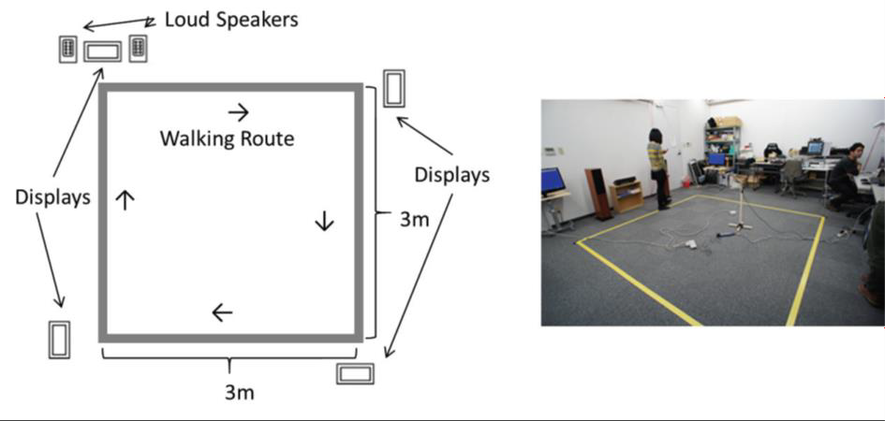

*Figure 4. Illustration and image of experimental setting in the laboratory including the walking route*

Source: Haga et al. (2015).

(Hyman, Boss, Wise, McKenzie & Caggiano, 2010; Lamberg & Muratori, 2012; Nasar, Hecht & Wener, 2008; Schabrun, van den Hoorn, Moorcroft, Greenland & Hodges, 2014; Timmis et al., 2017) study found participants gait was impaired when texting or reading on a mobile phone. Twenty-six participants, were observed walking in a straight line for 8.5m under three experimental conditions (walking whilst reading; walking whilst texting on a mobile phone or walking at a comfortable pace). Participants mean walking speed was found to be slower when texting, 1.01 (SD= 0.17) and reading, 1.16 (SD= 0.14) compared with without a phone 1.33 (SD= 0.15). Thirty five percent of the study participants reported a previous accident occurrence whilst walking and texting (such as falls, trips and collisions with objects or other people). Along with this information and study results the authors concluded that texting and walking could pose an additional safety risk to participants crossing a road or navigating obstacles.

Timmis et al.’s (2017) study found similar results whereby participants gait, and visual search behaviour were compromised when using a phone, to text or talk. Twenty-one participants were observed, under experimental conditions. Each completed tasks while walking and negotiating an obstacle (to step over) and a step-up box (surface height change) under four randomised conditions. These being: walking as they talked, read, or wrote a text on their phones verses a no phone condition (the phone was placed in their pocket). Results revealed that phone use (either reading, writing or talking) whilst walking significantly reduced walking speed (indicated by increased trial times, *p*<0.001) and visual search behaviour. The change in visual search behaviour was verified with a reduction in the number of environmental fixations (surface height change; *p*<0.05 and intended travel path; *p*<0.001) and the reduced duration of fixation time (surface height change; *p*<0.001). However, the authors concluded that participants adapted their behaviour (including visual search and gait) to safely negotiate static floor-based objects when using their mobile phone and suggested that real world accidents may be attributed to unexpected environmental events.

Violano, Roney and Bechtel (2015) observed 1,362 pedestrians at two urban intersections in New Haven, Connecticut. One of the intersections had instructions to put down a digital device stencilled onto the pavement (intersection A), the other intersection had no changes made (intersection B). Stencilled instructions (*Don’t read this look up!*) was chosen from options provided by participants of a previous focus group. Two observers were stationed at each intersection, one at each corner. One observer was allocated the role of a ‘person counter’ and the other a ‘behaviour counter’. The exhibited behaviours that were recorded were 1) eating, 2) drinking, 3) wearing ear buds/headphones, 4) texting, 5) looking at or reading something on a mobile phone, and 6) talking on a mobile phone. There was an observed difference in the rate of distraction across the two intersections, most notably less people talking on their mobile whilst crossing at intersection A that had the stencilled warning markings (2% as opposed to 4.5%; χ  = 0.090; *p*= 0.009; OR 0.437; 95 % CI 0.232–0.828). However, the authors acknowledged that they were unsure whether other factors (such as demographic and racial differences of the observed participants) could have influenced the findings also there was no previous data collected at intersection A, prior to markings being stencilled on the pavement, for comparison. As such, it was unclear whether the safety message was successful or not and the authors concluded that further evaluation is required.

Jiang et al.’s (2018) study of 28 Chinese University student participants (17 male and 11 female) with a mean age of 20.6 years (SD= 2.23), investigated how mobile phone distractions (music distraction, phone and texting) affected pedestrian behaviour while crossing the street, utilising hidden high definition video recording devices and eye tracking glasses (that recorded the participants’ eye movements on a Secure Digital [SD] memory card). The results of the research revealed the greatest effect to be text distraction (particularly visual attention), followed by phone conversations distractions and music distractions. There was found to be a statistically significant difference between all variables (crossing behaviour and visual attention) for the text distraction compared with the un-distracted condition. The text distracted participants experienced more difficulties; they crossed later compared with the undistracted group (*p*<0.001); look left and right less often than those engaging in phone conversation (*p*= 0.005) or when undistracted (*p*= 0.001); walked more slowly than when undistracted (*p*= 0.032) and maintained less visual attention on the traffic environment compared with the undistracted group (*p*<0.001). The pedestrians distracted by phone conversation were also found to cross the street more slowly than undistracted participants (*p*= 0.015). Of least influence was music distraction, this is most likely because listening to music is less cognitively complex and participants may have compensated for the loss of auditory cues by engaging in greater visual attention. The authors acknowledged limitations of their study including the small sample size used and that under non-experimental conditions participants phone behaviour use may be affected by self-regulation and behavioural adaptations.

Barin and colleagues (2018) prospective cohort study examined the behaviour of 11,533 pedestrians, including school children (71%) pre and post-intervention. Sidewalk stencils were painted on the curbs at pre-determined study cross-walks and selected building entrances, which read ‘Heads up, Phones down’ (Figure 5).

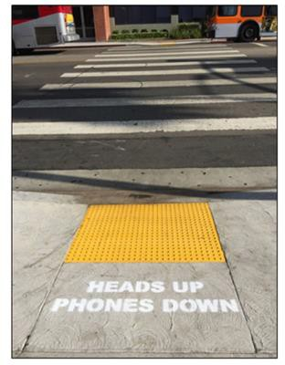

*Figure 5. ‘Heads up, Phones down’ campaign*

Source: Barin et al. (2018) study

A similar distribution of pedestrians was observed pre-intervention (3,990 pedestrians) and then again at one week (4,166 pedestrians) and four weeks post-intervention (3,377). The results demonstrated short-term distracted street crossing behaviour improvements. One week after the intervention a decrease in total distracted behaviours was noted (from 23% to 17%, *p*<0.01) including talking on a mobile phone, texting or wearing headphones while crossing the street. But at the four months post-intervention mark there was no significant difference found in total distracted behaviours from post intervention (23%, *p*= 0.4). However, specific distractions such as texting (8.5% vs. 6.8%, *p*<0.01) and headphone use (12% vs. 10%, *p*<0.01) sustained a decrease, whereas the frequency of talking actually increased (from 3.4% to 5.1%, *p*<0.01). The authors acknowledged limitations in their study, but the findings suggest that stencilled sidewalk reminders may effectively decrease the frequency of certain distracted crosswalk behaviours, but the intervention may require further reinforcement over time to maintain its effect.

#### Summary of Experimental Observational Study Literature

This review of the experimental studies provided evidence that the use of a mobile phone whilst walking may impact situational awareness and gait (Jiang et al., 2018; Lamberg & Muratori, 2012; Timmis et al., 2017), contribute to inattentional blindness (Hyman et al., 2010; Nasar, Hecht & Wener, 2008); influence walking speed (Lopresti-Goodman, Rivera & Dressel, 2012) and increase the number of errors made (Haga et al., 2015).

### Experimental Simulation Observational Studies

Experimental simulation observational studies generally require participants to undertake tasks in a virtual environmental, where distractions can be manipulated by the experimenter, and as such, risky behaviours can be observed in a safe environment.

Stavrinos, Byington and Schwebel (2009) observed 77 children, aged 10 to 11 years old, in a virtual pedestrian environment whilst being distracted by talking on a mobile phone. The results indicated that when distracted by a mobile phone conversation, children were less attentive to the traffic, left less of a safety gap before crossing the street, encountered more virtual collisions and close calls and waited longer before beginning to cross the street. The results suggest that preadolescent pedestrian safety can be affected by distractions from mobile phone use regardless of their level of experience.

Neider et al.’s (2010) study utilised an unsigned road intersection in a virtual environment. Thirty-six students from the University of Illinois participated and were observed crossing at the virtual intersection under three separate conditions: no distraction, listening to music with headphones and talking on a mobile phone using a hands-free device. Participants were classified as failing to have crossed the street if they were either ‘hit’ by a car or took too long to cross the road (timed-out). Data collection variables included: crossing success rate, collision rate versus time-out rate and behaviour while crossing (such as the number of head turns). The study conclusions indicated that distractions, such as talking on a mobile phone, increase participants’ unsafe crossing decisions.

Undistracted participants crossing success rate was 84% compared with 80% for those talking on a mobile phone (*p*<0.05). There was also a statistically significant difference for timed-out rates between participants talking on a mobile phone compared with the undistracted group (*p*<0.0167) or those listening to music (*p*<0.005). Talking on a mobile phone showed increased crossing times compared with the undistracted (*p*<0.005) or music (*p*<0.001) groups and participants also walked more slowly when talking on a phone compared with the undistracted (*p*<0.01) or music (*p*<0.01) groups.

Stavrinos, Byington and Schwebel (2011) conducted two experimental simulation studies with college student participants who were distracted by talking on mobile phones whilst crossing a virtual pedestrian environment. In the first experiment 108 university student participants were observed to see if they would exhibit riskier road crossing behaviours across conditions (whilst completing 12 road crossings, six being distracted by a mobile phone conversation and six undistracted) while being coding for four behaviour variables. These variables were:

(1) time left to spare [time left, in seconds, after the participant safely crossed until the next vehicle arrive] (2) missed opportunities [safe gaps in the traffic where the participant did not cross] (3) attention to traffic [number of times the pedestrian looked left and right, before crossing, divided by the average time, in seconds, waiting to cross (4) hits/close calls [where a pedestrian would have been hit in a real scenario / where the gap between the pedestrian and the vehicle was less than 1 second]. The results indicated that the pedestrians observed did exhibit significantly risker behaviour (*p*<0.01) for three of the four variables measured (attention to traffic was not affected by distraction). In the second experiment pedestrians were observed to investigate the impacts of different types of distraction on injury levels. Three forms of distraction were observed for 95 university student participants: 1) engaging in a verbal mobile phone conversation with a research assistant (the same as for experiment one); 2) engaging in a verbal phone conversation spatial task and; 3) engaging in a verbal phone conversation arithmetic task, whilst being observed using the same four crossing behaviour conditions (time left to spare, missed opportunities, attention to traffic and hits/close calls) as in experiment one. The results indicated that all conditions may increase unsafe crossing behaviour for pedestrians for all four of the aforementioned variables measured (time left to spare: *F* (3, 42) =51.75, *p*<0.01; missed opportunities: *F* (3, 42) =5.26, *p*<0.01; attention to traffic: *F* (3, 42) =31.68, *p*<0.01; hits and close calls: *F* (3, 42) =3.72, *p*<0.05). The results of both experiments indicated that all forms of distraction, but especially mobile phone conversation (whichever verbal task was performed), may elicit risky pedestrian behaviour and compromise safety.

Schwebel et al. (2012) examined pedestrian behaviour in a controlled virtual pedestrian environment representative of real world situations. In the experimental condition, 138 college students from an American

university, were randomly allocated to one of three distraction conditions: 1) listening to music, 2) talking on a phone or 3) texting on a phone. These were compared with a control group with no distractions. Five indicators to measure safe street crossing were used: 1) average time left to spare (time in seconds that remained after a participant safely crossed the street before a vehicle reached the crossing), 2) how many times the participant looked left and right before crossing, 3) looks away (based on the number of seconds participants looked away from the virtual environment), 4) hits (where a participant would have been struck by a vehicle in a real environment) and 5) missed opportunities (gaps in the traffic where a participant could have safely crossed). The results revealed that participants looked away more often from the street view whilst waiting to cross, in the distraction groups (Music distraction M=0.03, SD= 0.05, *p*<0.01; talking on the phone M=0.01, SD= 0.01, *p*<0.05; texting distraction M=0.23 SD= 0.11, *p*<0.01) than those pedestrians with no distraction (M=0.00, SD= 0.00).

Findings revealed that those participants in the texting or music distraction groups experience more hits by the virtual vehicle (25% and 32% respectively) than those in the control group (6%) but contrary to expectations, there was no significant association found for those in the phone conversation group (OR=2.00, 95% CI 0.34-11.79, *p*>0.5). The authors suggested that texting may be more cognitively demanding that talking on a phone (it involves visual elements-reading as well as tactile elements-typing); and the music group may have been unable to hear aural cues over their music in the virtual environment set up. There were no behavioural differences between male and female participants.

Byington and Schwebel (2013) conducted a further study within the same experimental condition of the virtual pedestrian street used in a previous study. However, in this study they extended previous findings, investigating phone internet browsing as this encompassed both cognitive and visual distractions. Ninety-two American college students participated in the study, and the results revealed that accessing the phones internet applications whilst crossing the street in the virtual environment increased risky behaviours. Pedestrians were significantly less likely to look left and right before crossing the road (*F* (1,90) = 124.68, *p*<0.01), spent longer looking away from the road (*F* (1,89) = 1959.78, *p*<0.01), waited longer to cross (*F* (1,90) = 42.37, *p*<0.01), took longer to navigate gaps in the traffic to safely cross (*F* (1,90) = 42.63, *p*<0.01) and missed opportunities when they arose (*F* (1,90) = 53.03, *p*<0.01), and were more likely to experience a hit/close call from an oncoming vehicle (*F* (1,90) = 29.54, *p*<0.01) regardless of the internet browsing expertise, gender, ethnicity or age of the participants.

Lin and Huang’s (2017) study conducted in a virtual pedestrian walking environment condition aimed to ascertain the extent to which motor-cognitive interference from smartphones affected pedestrians’ situational awareness to environmental targets/roadside events (e.g. pedestrian traffic lights, stop sign, pedestrians and vehicles) pertinent to pedestrian safety. Twenty-four young students from local Taiwanese Universities participated in a virtual environment, which was composed of television screens set up in front of a treadmill. The participants were instructed to monitor different locations, on the screens, for a variety of road side events whilst walking on the treadmill and responding to stimuli with hand gestures. A mobile eye-tracking system was used to record participants’ ocular movements. The participants completed six treadmill walking tasks whilst engaging in concurrent pre-determined tasks on their mobile phones. The results indicated that multi-tasking using a smartphone was found to have detrimental influences for pedestrians. More specifically, the adverse effects of texting or reading news from social networking sites on a smartphone were found to significantly impair pedestrian awareness of the surrounding environment (*p*<0.001). The results from the texting condition also indicated that pedestrians relied heavily on their central vision during road-event detection (more so than for other task conditions), indicating the effect of inattentional blindness or tunnel vision. On average 93% of the gaze time was spent on the phone and only 7% elsewhere.

Sobhani and Farooq’s (2018) study, conducted in a virtual environment, utilised head mounted VIRE (virtual immersive/interactive reality environment) technology to simulate a real world environment (a replica of a Montreal urban road), and thus to evaluate pedestrian behaviour, in a more realistic way due to a sense of immersion. Forty-two participants’ behaviour was evaluated as they engaged in one of three scenarios (for which there were ten successfully completed trials for each scenario): (1) crossing a virtual street with no distractions x10 successful crossings, (2) crossing and whilst solving a maze puzzle on a smartphone x10 successful crossings and (3) crossing and whilst solving a maze puzzle on a smartphone x10 successful crossings with an implemented LED safety measure in place (flashing coloured LED lights on the crosswalk to alert distracted pedestrians). Participants were instructed to cross at the crossing when they felt it as safe to do so. Overall, the results indicated that distracted participants waited 18%-19% longer to cross than non-distracted participants.

Interestingly distracted participants took less time to cross the street than undistracted participants (undistracted 4.4s compared with distracted 4.2s and distracted with safety measure 3.8s). The safety measures (smart LED flashing lights), it was found, made distracted pedestrians’ more aware of their environment compared with those distracted participants’ with no safety measures in place (the percentage of time the participants spent looking at their phone while crossing in the two scenarios was 69.6% and 73.5% respectively). Successful crossing rates were also seen to improve (by 7.4%) when safety measures were in place for distracted pedestrians.

#### Summary of Experimental Simulation Observational Study Literature

The review of the literature for experimental simulator observations suggests that there is an increased safety risk for pedestrians using their mobile phones whilst crossing the road. These findings are similar to those of naturalistic observations. However, it is important to note that most of the pedestrian distraction studies to date were conducted using small sample sizes and controlled environments and, thus, may not be directly generalisable to a wider population.

## OTHER DATA SOURCES

An alternate method to determine the safety implications for distracted pedestrians is a review of the various crash and injury databases studies. These studies are advantageous in that they provide real world implications for pedestrian distraction and potentially describe the situation and causality of the injury/fatality occurrence.

### Australia

Oxley et al. (2013) reviewed Victorian police-reported mass crash data for serious pedestrian collisions in Melbourne CBD (for the period January 2000 to December 2011). Serious pedestrian causalities were defined as fatalities or those pedestrians taken to hospital as a result of a road crash involvement. The results revealed that there were 17,301 pedestrian collisions in Victoria and of these 451 were reported in the CBD (2.2% fatalities, 70% serious injuries and 27.7% other injuries). There was found to be a higher proportion of male pedestrian collisions (53.6%) than females (46.4%), with the majority being aged between 18-34 years old. Most pedestrian collisions occurring while crossing (73.3%) or walking on a carriageway (6.5%), followed by walking to/from or boarding tram/vehicle (7.2%). Location results revealed that nearly half of all collisions occurred at cross intersections (48.8%) with the remainder at mid-block locations (39.4%) and T-intersections (12%). With regards to time of day, collisions were found to be spread across multiple locations during weekday business hours, more prevalent around intersections and public transport facilities. Whereas during night hours (and particularly weekends) collisions occurred at intersections near bars and nightclubs. The cause of pedestrian injury or fatality was not an identified variable for analysis in this report.

### Rest of the world

In a paper by the American College of Surgeons (2012), trauma surgeons identified distraction due to mobile devices and poor guardian supervision as two reasons why young pedestrians were struck by motor vehicles. A

prospective study, between December 2008 and June 2011, collected data from over 1,400 patients who presented to an American trauma centre emergency department after being struck by a vehicle. From the police data the researchers examined how often patients were using mobile devices (such as MP3 players and cell phones). However, they did not have enough police data to determine each drivers’ liability. Thirteen percent of the study population was younger than 18 and nearly one in five patients aged 13 to 17 were sending text messages, listening to music, or otherwise distracted by a mobile device at the time of the crash. The percentage of adults was lower at 10%.

The lead author of the study, Dr N.E Glass, concluded:

*“In paediatric medicine as a whole, prevention is important….. Emphasizing safety tips, such as not texting while walking in city traffic, needs to be worked into preventive health care measures”*

Lichenstein et al.’s (2012) study using retrospective data of cases involving injury or fatalities from pedestrians using headphones was obtained from various sources (including the National Electronic Injury Surveillance System, United States Consumer Product Safety Commission, Google News Archives and reports- published between 2004 and 2011- from Westlaw Campus research databases, containing details of pedestrian injuries or fatalities from crashes involving trains or motor vehicles). Results revealed that the majority (68%) were male and under the age of 30 years old (67%); in fact a third of the victims were 18 years or younger, with a very large proportion (91%) of these incidents occurring during the school year (with only 9% of incidences occurring over the summer school holidays). The authors suggest that student pedestrians traveling to school may be at increased risk due to inattentional blindness and or sensory deprivation.

Nasar and Troyer’s (2013) study used the National Electronic Injury Surveillance System data base to ascertain the number of reported injuries due to mobile phone use among pedestrians and drivers for the period between 2004 and 2010 (coded in the hospital admissions records to be caused by mobile phone use and with details of the location of the incident. The narrative provided further details on how the injury occurred). The results revealed that in the US in 2010 there was an estimated 1,506 injuries due to mobile phone use among pedestrians (3.67% of the total number of pedestrian injuries reported during that year), even though this figure may have been higher as not all injuries were reported. As expected, the number of injuries to pedestrians have increased over time. The authors investigated data, collected in 2009 and 2010, to see what the pedestrians were doing at the time they were injured. Pedestrians talking on the phone accounted for 69.5% of pedestrian estimated injuries and texting 9.1% of estimated injures. It was also found that male pedestrians accounted for a higher percentage of reported injures (52.9%) than females. The national estimates also showed that 54.7% of pedestrians injured were aged under 31 years old.

## TABLE 3. NATIONAL ESTIMATE OF PEDESTRIAN PHONE RELATED INJURIES (2004-2010) BY AGE

|  |  |
| --- | --- |
| National estimate of cases by age (n=5482) | |
| **Age range** | **National estimate if injury cases** |
| <16 | 9.32% |
| 16-20 | 17.97% |
| 21-25 | 18.30% |
| 26-30 | 5.56% |
| 31-35 | 5.73% |
| 36-40 | 6.24% |
| 41-45 | 10.25% |
| 46-50 | 8.25% |
| 51-55 | 2.50% |
| 56-60 | 1.66% |
| 61-65 | 5.24% |

Source: Adapted from “Pedestrian injuries due to mobile phone use in public places”, by J.L. Nasar and D. Troyer, 2013, Accident Analysis & Prevention, 57, 91-95.

## SUMMARY OF PEDESTRIAN DISTRACTION LITERATURE

Studies have demonstrated a variety of different methodologies to review risky behaviour and compare distracted and non-distracted pedestrians. From the review of current literature there appears to be evidence to suggest safety risks (such as falls, trips and collisions with objects or other people) exist for distracted pedestrians. For example, pedestrians on mobile phones:

* Tend to walk slower
* Are more likely to weave, change route direction, stop, or be involved in a near collision
* Are less likely to acknowledge other pedestrians
* Are less likely to look left and right when crossing a road
* Are less likely to look at traffic before preceding to cross and (in experimental conditions) make more errors than non-distracted pedestrians.

Studies of children in virtual pedestrian environments, representative of real-world situations (Stavrinos, Byington & Schwebel, 2009), have found that they were:

* Less attentive to the traffic.
* Left less of a safety gap before crossing the street.
* Encountered more virtual collisions and close calls and waited longer before beginning to cross the street when distracted talking on a mobile phone.

For those aged 18-30 years old, distractions such as talking on a mobile phone resulted in:

* Increase unsafe crossing decisions (Neider et al., 2010).
* Increased crossing times as participants walked more slowly (Neider et al., 2010).
* Riskier road crossing behaviours exhibited (Stavrinos, Byington & Schwebel, 2011). such as:
  + Having less time left to spare (time in seconds that elapsed after a participant safely crossed the street until the next vehicle arrived at the crosswalk).
  + Missing opportunities (gaps between vehicles in which participants could have crossed safely but chose not to cross).
  + Experiencing hits/close calls.

Pedestrian accessing the phone’s internet applications whilst crossing street were found to:

* Look left and right before crossing the road less often.
* Spent longer looking away from the road.
* Waited longer to cross and missed opportunities to cross safely (Stavrinos, Byington & Schwebel, 2011; Schwebel et al., 2012; Byington & Schwebel, 2013; Sobhani & Farooq, 2018).
* Were more likely to be hit or nearly hit by an oncoming vehicle - regardless of the internet browsing expertise of the participants (Byington & Schwebel, 2013).
* Crossed more slowly (Parr, Hass & Tillman, 2014).
* Significantly impair pedestrian awareness of the surrounding environment (Lin and Huang, 2017).

Virtual or simulator environments have the ability to record the amount of ‘hits’ (where a participant would have been struck by a vehicle in a real environment) and missed opportunities (gaps in the traffic where a participant could have safely crossed). However, it is difficult to determine how generalisable these results are to real world settings. Also, participants may not necessarily (either consciously or unconsciously) respond to situations accurately as there is no real consequences for their actions and the experiments may be considered ‘just a game’.

Experimental studies, although useful, are also limited in their generalisability to real world situations. For example, often participants are provided with multi-tasking situations to complete whilst walking which may not be representative of a scenario that may be present in the real world. However, mobile phone distractions (such as talking or texting; gaming; listening to music; and internet browsing) have demonstrated impairments such as:

* Crossing later, look left and right less often, walked more slowly and maintained less visual attention on the traffic environment (Jiang et al., 2018).
* Impaired situation awareness and may cause inattentional blindness, which is a failure to detect an unexpected object or event (Hyman et al., 2010; Lamberg & Muratori, 2012; Nasar et al., 2008; Schabrun et al., 2014; Timmis et al., 2017).
* Pedestrians texting, whilst navigating through manipulated door ways of different widths, were also found to be more cautious than a control group (Lopresti‐ Goodman, Rivera & Dressel, 2012).
* Impaired auditory and visual reaction times. In particular, pedestrian smartphone gaming revealed decreased cognitive ability, decreased dynamic balance, poor gait and a large number of visual tasks missed (Haga et al., 2015; Hyong, 2015).
* Behavioural and neurophysiology are also found to be affected by dual activities such as walking and smartphone email corresponding or gaming (Pizzamiglio et al., 2017; Takeuchi, Mori, Suzukamo, Tanaka & Izumi, 2016).
* Pedestrians distracted by listening to music or texting on a phone, revealed participants looked away more often from the street view whilst waiting to cross (compared with those groups with no distraction) and were more likely to be hit by a virtual vehicle than those in the control group (Schwebel et al., 2012).
* Pedestrian using smartphone internet capabilities whilst crossing street, look left and right less often before crossing the road, spent longer looking away from the road, waited longer to cross and missed opportunities to cross safely, and were more likely to be hit or nearly hit by an oncoming vehicle (Byington & Schwebel, 2013), and crossed more slowly (Parr et al., 2014). Lin and Huang (2017) also found texting or reading news from social networking sites on a smartphone significantly impaired pedestrians’ environmental awareness of their surroundings.

Distraction conditions such as listening to music or texting on a phone revealed that participants looked away more often from the street view whilst waiting to cross (compared with those groups with no distraction) and were more likely to be hit by a virtual vehicle than those in the control group (Schwebel et al., 2012). As such, these results indicate auditory and visual behaviours for safe crossing behaviour are likely to be impaired, which would pose risks in the real-world environment.

Naturalistic observational studies seem to offer a larger and more diverse pedestrian population range and possibly provide a more reliable data source to predict the extent to which a particular distraction may result in more risky crossing behaviours. The results are indicative of real world scenarios as the data is collected in real world situations. However, the varying methods of data collection observed in the current literature review indicate that reviewing pedestrians based on a predetermined set of selection criteria or randomly selecting a subject to observe; or observing pedestrians at a pre-determined time of the day, location or season may not be generalisable to the wider population. Also, pure observational studies results are limited in terms of determining why pedestrians perform these behaviours and can only be based on inference, unless pedestrians are interviewed at the observation site to glean such information.

In summary, naturalistic observational literature typically suggests that distracted pedestrians were less likely to wait for the crossing light, to look left and right before crossing the street or to make eye contact with approaching

drivers. They also made aggressive crossing manoeuvres, darted in front of traffic or crossed illegally (Basch, Ethan, Rajan & Basch, 2014; Brumfield & Pulugurtha, 2011; Bungum, Day & Henry, 2005; Cooper, Schneider, Ryan & Co, 2012; Hamann, Dulf, Baragan-Andrada, Price & Peek-Asa, 2017; Thompson, Rivara, Ayyagari & Ebel, 2013).

Other studies have demonstrated that distraction whilst walking:

* Reduces lack of cautionary behaviours.
* Increases cognitive distraction.
* Reduces situation awareness, less disregard for surrounds, and decreases walking speed which can lead to unsafe road crossing practices and a higher risk of being involved in an accident/near accident with increased risk of injury. (Hatfield & Murphy, 2007; Nasar, Hecht & Wener, 2008).
* Pedestrians using a mobile phone are also more likely to weave, change direction suddenly, stop, be involved in a near collision and are less likely to acknowledge other people than non-distracted walkers (Hyman, Boss, Wise, McKenzie & Caggiano, 2010).
* Pedestrians exhibited a higher percentage of unsafe behaviour compared with those pedestrians using an alternate distracting device (e.g. an iPod) or no distraction device at all, Nasar et al. (2008).

Pedestrians engaged in smartphone gaming (e.g. Pokemon Go) internet browsing and texting have also been show to exhibit:

* Sudden movements.
* Not looking at traffic prior to crossing.
* Running red lights.
* Making fewer head turns and walk outside the crosswalk (Chen, Saleh, and Pai (2018); Chen and Pai (2018).

Brumfield and Pulugurtha (2011) noted drivers were more likely to give way to distracted pedestrians than to those who were attentive. Talking or texting on a smartphone was not significantly associated with walking speed per se, but pedestrians who were texting were more likely to commit crosswalk violations (Russo, James, Aguilar & Smaglik, 2018).

In addition, addiction/problematic smartphone use has been shown to lead to increased injury occurrence (Kim et al., 2017), as well as attitudes and risk perception playing a part in intention to use a smartphone while crossing the road, which is particularly prevalent in those aged 18-30 years old (Lennon et al., 2017).

Sidewalk stencilling safety messages have been found to be effective in curbing mobile phone use while crossing intersections (Violano, Roney & Bechtel, 2015) as well as having potential long-term effectiveness in decrease the frequency of certain distracted crosswalk behaviours (Barin et al., 2018).

Based on the above findings, it is argued that it is not feasible nor practical to simply expect pedestrian road users to never become distracted. Instead, it is important to develop strategies, technologies and other countermeasures that minimise the impact of distraction on road safety, rather than attempt to eliminate it altogether. One step toward this is to better understand the incidence and severity of pedestrian smartphone distraction. Following Byington and Schwebel (2013), who recommended future investigation in a naturalistic setting, this study will conduct a naturalistic study to observe pedestrians crossing roads at varying city centre locations. To understand the impact, ‘critical events’ for both smartphone and non-smartphone users will be collected: an example of such critical events is the pedestrian nearly hitting another pedestrian or a vehicle.

# COUNTERMEASURE AND REGULATORY REVIEW

Pedestrian distraction from smartphone use has gained increased awareness recently. However, current regulations and countermeasures vary greatly around the world. An international review of current regulations and countermeasures, specifically tailored to pedestrian smartphone use, was conducted.

## METHOD

This followed the literature review, previously described, and used the following search terms: pedestrian distraction, pedestrian smartphone distraction, pedestrian behaviour distraction, text messaging, cell phone, smartphone and mobile phones, combined with terms such as safety, pedestrian safety, injury, injury prevention, street crossing, crossing behaviour and human factors. The reference lists of identified papers were also reviewed for any additional relevant papers. In addition, web reviews from search engine Google, online newspaper articles, media release and social media sources such as Linkedin, Twitter and Facebook. As well as approaching personal contacts and other international organisations (e.g. Queensland University of Technology; The Centre for Accident Research and Road Safety-Queensland (CARRS-Q); Centre for Mobility and Transport-Coventry University, UK; International Federation of Pedestrians and Living Streets-London, UK as some examples).

## TYPES OF COUNTERMEASURES AND THE SAFE SYSTEM FRAMEWORK

The descriptive findings are broken down into four subcategories comprising: behavioural countermeasures (education and publicity), legislation/regulation, infrastructure initiatives and technology advances.

The countermeasures presented are compatible with the Safe System approach that aims for a more forgiving road system by taking into account human fallibility and vulnerability. For example, it should be recognised that road users (in this case pedestrians) will still occasionally make mistakes, so infrastructure and the road safety system should be error tolerant.

### Behavioural (advertising, publicity and education) countermeasures

Providing education and information is a key input to the Safe System approach. This helps to produce ‘Safe People’: that is, safe road users. In the context being considered here, this includes pedestrians and other road users who are likely to encounter pedestrians.

Pedestrian safety advertising and publicity campaigns around the world vary. However, the majority target distraction caused by a mobile devices (such as headphone use, texting or talking on a mobile phone).

In Australia, the Pedestrian Council of Australia (PCA) launched two campaigns, one in 2010 entitled ‘*Lambs to the slaughter- wait for the green*’ targeting pedestrian behaviour whereby many pedestrians often act like sheep when crossing the road, particularly at traffic lights. The second awareness campaign, from 2017, launched in conjunction with the New South Wales (NSW) Centre for Road Safety and the State Insurance Regulatory Authority SIRA, entitled ‘*Don’t tune out - stop look listen think*’ targeting pedestrians engrossed in their phones and wearing headphones (Figure 6).

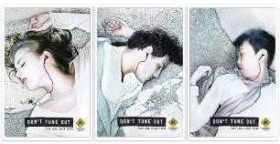

*Figure 6. Pedestrian Council of Australia campaign*

Source: Pedestrian Council of Australia (2010 & 2017).

The NSW Government (Transport for NSW Centre for Road Safety) ‘*Look before you step out*’ campaign was launched in 2016 and targeted high pedestrian areas across Sydney, Newcastle and Wollongong. The campaign included an advertising message marked on the ground in some locations, on the radio, in print and digital advertising, as well as social media channels. This campaign was not specifically aimed at smartphone users, but the message was for all pedestrians to be more mindful (Figure 7).



*Figure 7. Transport for NSW Centre for Road Safety Campaign*

Source: Transport for NSW Centre for Road Safety (2016).

Also in New South Wales, eight Sydney councils (including Hornsby Shire, Ku-ring-gai, North Sydney, Lane Cove, Mosman, Northern Beaches, Ryde and Willoughby) in partnership with the Roads & Maritime Services (RMS) released The ‘*Distracted…?*’ campaign urging pedestrians to take ownership of their own safety, concentrate and pay attention to the road before stepping out. The campaign included: pavement decals; posters, banners and outdoor advertising; face-to-face promotions and social media promotion. (Hornsby Shire Council, n.d). The Queensland Government also launched the ‘*Be aware - Cross with care*’ campaign urging pedestrians to be vigilant and to put their phones away whilst crossing roads. Safety decals and billboards were placed at several locations in Brisbane’s CBD (Queensland Government, 2018).

Internationally, similar campaigns have been launched depicting shocking images targeting younger pedestrians to inform them of the dangers of pedestrian distraction whist crossing the road. The campaign launched by the

Swiss Lausanne police in 2015, was broadcast in French and German to highlight the risks from distraction (Figure 8). There is a video that mixes shock images (pedestrian being run over) and black humour (AEC, 2015).



*Figure 8. Swiss Lausanne police pedestrian campaign*

Source: Retrieved from AEC (2015).

In 1999 Safe Kids Worldwide piloted the ‘*Walk This Way*’ pedestrian safety initiative to improve children’s pedestrian safety in three US cities. The program has grown to include initiatives such as awareness and advocacy actives (such as international walk to school day); infrastructure improvements (such as pedestrian lights and countdown timers); research and education programs. Education programs include training on pedestrian safety for school staff, parents and caregivers, as well as in-school road safety education and materials including initiated a campaign to stop distracted walking (one of which is the Moment of Science Campaign, whereby students are urged to not use electronic devices whilst crossing the road). In addition to America, the program is now available in several countries around the world including– Australia, Brazil, Canada, China, India, the Philippines, South Africa, South Korea, Thailand, and Vietnam (Safe Kids Worldwide, n.d.).

In Australia, the NSW Department of Education learning curriculum, aimed at teenagers, NSW statistics revealing that almost 30% of teenagers (aged 10-14) serious road causalities were pedestrians and were predominately prevalent around school travel times. Education reminders for teenagers to put away their electronic devices when walking, riding or skating (among other road safety initiatives) is featured on the webpage (NSW Department of Education, 2018).

Also targeting younger pedestrian road users, campaigns such as the Montgomery County Department of Transportation (MCDOT), in partnership with Montgomery County Public Schools (MCPS), *#YOLOwalksafe* campaign aimed to raise awareness of the risks of distracted walking and other dangerous pedestrian behaviours (Figure 9). Many of the resources can be customised for a particular school (Montgomery County Public Schools, 2018).

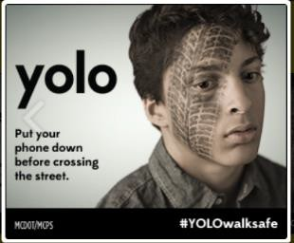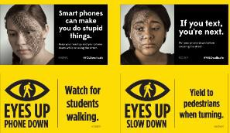

*Figure 9. #YOLOwalksafe campaign*

Source: MCPS and MCDOT website (2018).

Additional road safety campaigns have been implemented in some counties with protective lamppost padding, printed with slogans, being added to some streets scenes; for example, Brick Lane in London (UK) temporarily implemented a safe text street, whereby padding was placed around lampposts to help prevent mobile phone related, injuries from pedestrians walking and texting (“Brick Lane made Britain’s first ‘Safe Text’ street,” 2008). This initiative was also implemented by the Austrian Road Safety Board (Kuratorium für Verkehrssicherheit - KFV) in cities across Austria, whereby padded lampposts printed with a slogan ‘Will the next car be so well padded?

Look where you're going, not at your mobile phone!’ were placed on busy pedestrian streets to promote awareness and highlight the dangers of not paying attention as a distracted pedestrians and to prevent potential injury. Also, it was hoped the campaign could change behaviours (KFV, 2017). The authors of this report were unable to find any published literature as to the effectiveness of this campaign and if an evaluation has been conducted.

In Australia, pedestrian safety education programs aimed at school aged children varies across states. In NSW, Youthsave (supported by NSW Centre for Road Safety RTA and NSW Health) created a parent factsheet aimed at safe travel for teenage students. Mobile phone distraction (talking/texting/using MP3 players) was mentioned as one of the possible contributing factors of risky travel for new high school students and recommendations were for parents to discuss risks with their teenagers (NSW Department of Education, 2011). The NSW Department of Education also teaches road safety as part of its curriculum in secondary schools and defining risk factors and behaviours, from distractions such as handheld devices and mobile phones, are listed as stage 4 on the road safety syllabus (NSW Department of Education, n.d). In Tasmania, a RACT (Royal Automobile Club of Tasmania) press release urged for a public education campaigns and education to warn pedestrians of the danger of using their mobile phones whilst crossing the roads, as well as engineering interventions in areas with high pedestrian activity (RACT, 2016).

In Western Australia, pedestrian safety is taught as part of the SDERA (School Drug Education and Road Awareness) program in grade 6, whereby risks for pedestrians (including using mobile phones and wearing earphones) are discussed with students. Student are each given a family information sheet ‘*Headphones, mobile phones and pedestrians*’ to also take home (SDERA, 2013). As far as the authors of this report are aware these are the only states in Australia to teach road safety as part of the school curriculum. In addition, there are initiatives offered by organisations such as: the Transport Accident Commission (TAC) Road Safety in Schools initiative has a range of resources for primary and secondary schools. These are designed to be taught alongside the core road safety program and incorporated into school education AusVELS (Victorian Essential Learning Standards) VCE (Victorian Certificate of Education) subjects. These incorporate an element of pedestrian safety under “kids on the move” core traffic safety education resource which has a component where students explore and discuss risky pedestrian behaviours-that is those that have a high likelihood of a negative outcome (TAC, n.d). RACV (Royal Automobile Club of Victoria) also offers free primary school road safety visits, under the Street Scene program, which includes an element of pedestrian safety (RACV, 2018).

### Legislation/Regulation Countermeasures

Developing road rules and enforcement strategies to encourage compliance and manage non-compliance with these road rules is a key input into the Safe System approach. Pedestrians and other road users are still responsible for complying with traffic laws and behaving in a safe manner; however, the Safe System approach recognises a shared responsibility for road safety beyond just the individual road user.

In Australia there are no specific regulations or legislation in place that target pedestrians utilising a smartphone device whilst crossing the street (National Road Transport Commission, 2017). However, all states have individual regulations concerning general pedestrian behaviour (including jaywalking offences).

Internationally, however, there is legislation in place for texting while walking using a crosswalk. In the United States of America several states have legislation in place, for example; the city of Rexburg, Idaho impose a USD$101.50 fine for the first offence and USD$201.50 for second offence, thereafter a USD$51.50 court cost will also be added to the previous amount (Retting & Schwartz, 2016; Rexburg Police Department, n.d). In Hawaii, Honolulu the fine is USD$35 for the first offence, USD$75 for the second offence and USD$99 for a third offence if cited in the same year. In Salt Lake City, Utah distracted pedestrians are subject to a USD$50 fine with repeated offences incurring a USD$100 fee (Northwest staff, 2017).

In Toronto Canada, a private bill has been submitted to create a law to fine pedestrians who use their mobile phones whilst crossing the street (“Un projet de loi pour” 2017).

To our knowledge, the United States and Canada are the only countries that have legislations/fines in place for pedestrians using their phones while walking. Other countries have tended to adopt other approaches (such as infrastructure measures or campaigns).

In Victoria, Australia a PTV (Public Transport Victoria, 2018) study revealed that interventions aimed at reducing pedestrian risk taking at rail crossings (such as crossing safety officer-encouraging safe crossing behaviours, penalty communications-fixed signage waring pedestrians of fines for illegal behaviour, plain clothed police enforcement blitz-fining pedestrians for illegal behaviour), had immediate and long-lasting effect on pedestrian behaviour even four weeks after the intervention. With regards to pedestrians using headphones/mobile phones, almost all initiatives had immediate and relatively prolonged effect on pedestrian behaviour even four weeks after the intervention (as shown in table 4).

## TABLE 4. INTERVENTION AND TYPE OF DISTRACTION USE (HEADPHONE/MOBILE PHONES)

|  |  |  |  |  |
| --- | --- | --- | --- | --- |
| Intervention type | Percentage of pedestrians using headphone/mobile phones while crossing and  intervention period | | | |
|  | Before | During | After two weeks | After four weeks |
| **Crossing Safety officer (CSO)** | 17.3% | 9.7% | 7.7% | 12.1% |
| **Penalty communication** | 12.3% | 2.4% | 12.2% | 13.6% |
| **Police enforcement** | 9.9% | 7.5% | 9.3% | 10.6% |

Source: Adapted from PTV (2018) report.

This may indicate that legislation/regulation initiatives may be beneficial at road crossings and any raised awareness was seen as effective.

### Infrastructure initiatives

Safe roads and other infrastructure are a key aspect of the Safe System approach. For example, by creating a forgiving system that ensures that the forces in collisions do not exceed the limits of human tolerance. Sobhani and Farooq (2018) (in a virtual environment) revealed that such safety initiatives were beneficial, with distracted pedestrians being more aware of their environment. However, as described below, real world infrastructure initiatives have been trialled around the world.

In Australia, infrastructure measures have been implemented in several states to assist with pedestrian safety. In New South Wales a six-month trial was conducted, in December 2016, with in-ground pedestrian traffic light technology installed in pavements at five locations in Sydney’s CBD. An evaluation, involving pedestrian observations and interviews, is underway by Transport for NSW as to their effectiveness, the results of which are currently not available. The New South Wales government has installed pedestrian countdown timers, across NSW, whereby a yellow countdown timer displays how many seconds remain before the red “do not walk” signal appears. This initiative was implemented after a successful trial of the timers’ at six locations- two CBD, Chatswood and Parramatta. Cameras that monitored pedestrian, driver and road user activity, revealed increased pedestrian safety as the number of pedestrians still crossing during the red signal decreased post installation (Transport for NSW, 2016; Sanda, 2016).

A 12-month trial was also conducted in Melbourne with pavement lights being placed at an intersection, the corner of Swanston and Little Collins streets, chosen due to pedestrian crossing signal incompliance (Victoria State Government, 2017), as far as the authors of this report are aware the evaluation of this trial is not complete. Also, in Melbourne (at the Southern Cross vicinity) pedestrian crossings have been raised at Spencer St and Little Collins Street as well as Spencer St and Francis Street to increase pedestrian visibility. Crossings have been widened and pedestrian light countdown timers have been placed at Spencer Street and Collins Street. As well as signal timers being reprogrammed, to increase crossing times, at Spencer Street and Bourke Street (VicRoads, 2018).

In Brisbane, Queensland Greens Councillor Jonathan Sri is pushing for pedestrian crossing signal reforms. Requesting Brisbane city council to follow the idea being proposed in London, UK of conducting peak period trials of permanently green crossing signals which would only be affected if a vehicle approached the intersection and

altering crossing signals to be activated as soon as the button is pressed (McKay, 2018). As far as the authors of this paper are aware the results of these trials have not been published.

Internationally, experimental in-ground flashing traffic lights have been installed in Augsburg and Cologne, Germany near tram stops. The LEDs flash red when the pedestrian lights are red or when a tram/vehicle is approaching to warn pedestrians before they step out (Timson, 2016). In Bodegraven, the Netherlands, LED strip installation (that are synchronized with traffic light signal) has been piloted in pavements, at pedestrian crossings, that turn green or red as applicable (Bagri, 2017). In St Petersburg, Florida USA, motion detectors were implemented at some unsignalised crossings, such that when a pedestrian approaches a squawkbox (intercom speaker) alerts the pedestrians to press a button, prior to crossing, which then sets of flashing lights to alert drivers of the pedestrians crossing the road. In addition, in Boulder, Colorado, audible warnings (stating ‘use the crossing with caution’) and flashing lights have been placed at busy crosswalk locations which are triggered when the crosswalk button is pressed (Hylton, 2008). As far as the authors of this report are aware there is no published information available on the effectiveness of these initiatives.

Countdown timers (showing how long until the next green walk man is displayed) on road crossings have been found to be effective in reducing pedestrians walking on the red signal. Studies of rail crossings have revealed that non-compliance also a concern in these locations and that pedestrians are also distracted (including by mobile phones). There was no evidence to suggest whether countdown timers would be beneficial or not at rail crossings, but the authors suggested it as a possible countermeasure recommendation (Edquist, Hughes & Rudin‐Brown, 2011).

With regard to rail crossing initiatives, in New Zealand infrastructure measures have been implemented to evaluate whether LED visual warning devices installed to assess if it is effective at attracting inattentive pedestrians’ attention (who are distracted by mobile devices or headphones) at rail level crossings. (CARRS-Q, n.d). In September 2016 KiwiRail installed a prototype of seven red and yellow imbedded LED luminaires at both ends of the Collins Avenue (Tawa, Wellington) pedestrian crossing. These were connected to the trains’ detection system and flashed as the train approached. In addition, due to safety concerns from pedestrians using mobile device and headphones at level crossings, recommendations were made (following two focus group workshops) to trial flashing LED lights on an imbedded footpath sign (incorporating an image of a train) at six level crossings (between July 2017 and March 2018). These LED warning signs were activated when the level crossing alarms are activated to provide visual and audio warnings for those pedestrians that may be unable to hear the warning bell. Video cameras were installed prior to the trial intervention to observe pedestrians’ behaviour, both before and after the intervention, as well as quantitative and qualitative surveys to ascertain human behaviour and options of the trialled devices, as far as the authors of this paper could ascertain the results of this study are yet to be published (TrackSAFE NZ, n.d).

The Australian Centre for Rail Innovation conducted a study to understand how effective pedestrian illuminated in- ground signage pads are for pedestrians distracted (visually or auditory) by a mobile device. Twenty pedestrian participants (11 female and 9 male, with an average age of 31.2 years), from Brisbane Australia, that were regular smartphone users (whilst walking), undertook a task where they detected randomly activated flashing LED lights. These lights were installed in the floor as well as a set of wall mounted lights. The participants were equipped with an eye tracking device to record their gaze. The participants completed the tasks under three conditions (no distraction, visual distraction using a smartphone, auditory distraction using a smartphone with headphones).

Participants’ reaction times and accuracy were recorded using a button they were requested to press when they detected the lights. The results indicated the in-ground LED were very effective in attracting the attention of participants, including distracted (visually or auditory) participants, but most specifically a statistically significant

difference was found when the LED’s were placed on the floor and close (1 metre) from the participant (*p*<0.001). The results of the eye tracking data revealed that most participants (n=15) were able to detect the lights without looking at the LED suggesting peripheral vision was used. The eye tracking results based on the location of the lights also varied depend on the task being performed. For the no distraction and audio conditions, participants mainly looked straight ahead – allowing the distant and wall LED’s to be visible. However, in the visual condition the position participants held their phones, and as such their eye tracking results, varied. Some participants held their phone higher allowing them to see allowing the distant and wall LED’s. But those who held their phones lower only saw the LED’s closest to them. Based on the results of this study, a field trial is being proposed where eye tracking technology will analyse the effectiveness of illuminated in-ground pads, placed at one of the New Zealand level crossings (ACRI, 2018).

Luke and Welle (2018) referenced European cities (such as Amsterdam or Copenhagen) having implemented good urban street design practices for decades and that other cities worldwide are now following suit. Cities such as São Paulo, Brazil have redesigned Joel Carlos Borges Street (a road connecting the train station to the CBD) providing more pedestrian space by increasing the width of the sidewalk (by 3.5m) and narrowing vehicle lanes, lowering speed limits, adding street furniture, green infrastructure and placing bollards along the sidewalk to protect pedestrians form the traffic. It has been well received by the public and the city is considering expanding this initiative to other areas. Cidade 2000 (a residential suburb in Fortaleza) Brazil created a temporary intervention by decreasing the speed limit (to 30 km/h), removing a traffic lane, widening sidewalks (with curb extensions) and added five new pedestrian crossings with street art, green infrastructure and street furniture. The temporary initiative was so widely received, by the public, that it is now being implemented permanently with similar initiatives in other areas of the city. In Mumbai, India one of its busy roads was redesigned to accommodate a pedestrian plaza as a permanent initiative. In Bogotá, Colombia and Shanghai, China improvements to bicycle lanes and pedestrian sidewalks have been made. In Shanghai on Zhengtong Road (a busy road near a university and high school) changes were made to the road and pavements to increase pedestrian safety. The street was narrowed to make it easier for pedestrians to safety cross and solar powered reflective materials were added to the stop and warning signs in front of the schools. Zhengtong Road is now being used as an example of road safety around schools in other districts of Shanghai.

In addition, some cities around the world: Chongqing, China (Garfield, 2017); Washington DC's 18th Street (Associated press & Elliott, 2014) and Antwerp, Belgium (Dore, 2015) have experimented with special phone lanes for pedestrians (Figure 10). As far as the authors of this paper are aware, there has been no evaluation conducted into the effectiveness of these infrastructure measures.

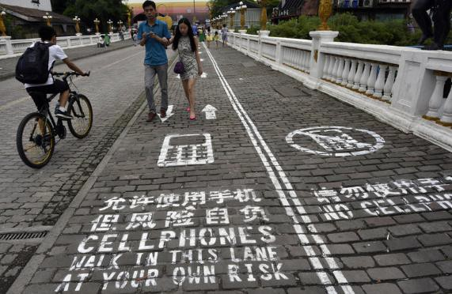

*Figure 10. Chongqing, China special pedestrian phone lane*

Source: Business Insider (25 October 2017).

In Stockholm, Sweden, signs were commissioned by local artists to warn drivers about texting pedestrians. One of the artists (Jacob Sempler) came up with the idea after he was nearly run over by a car whilst walking and texting on his mobile phone and after looking around realised he was not the only one (Garfield, 2017).

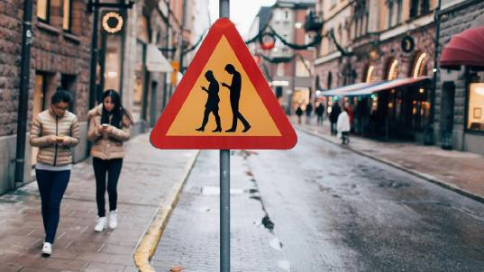

*Figure 11. Stockholm, Sweden, street signs to warn of texting pedestrian*

Source: The Australian newspaper (2 March 2016).

Pau et al. (2018) proposed approaches to improve pedestrian crossing safety such as changes to the phases of the traffic lights (dependant on the time of the day and the number of pedestrians about to cross the road) for better pedestrian safety. Also by utilising Information and Communication Technologies (ICT) and referenced initiatives such as crosswalk detection measures for vehicles such as, Intelligent Vehicle Systems as follows: vehicle cross walk marking detection by way of laser beam measurements (LMS laser measurement systems) which reflect off the cross walks road surface in three ways (1. LSI Lane Surface Identification, 2. LMR Lane Marking Recognition and 3. CMD Crosswalk Marking Detection) to aid a driver in determining the presence or absence of a crosswalk ahead (Hernandez et al., 2015). Another possibility for crosswalk detection has been proposed based on Maximally-Stable Extremal Regions (MSER) algorithms and extended Random Sample Consensus (ERANSAC) whereby making crosswalks more accurately detected by camera-based vehicle detection systems. A study by Zhai et al. (2015) found that compared with current methods this system was more accurate at detecting crosswalks from different angles and under different illuminated conditions. These Intelligent Transportation Management System (ITMS) would need to be made in conjunction with Intelligent Vehicle Systems with vehicle manufacturers to be viable However, the experimental results demonstrated crosswalks can be accurately detected which could contribute towards pedestrian safety.

### Technology initiatives

Being open to, and seeking, innovation is a fundamental aspect of the Safe System approach. For pedestrian smartphone distraction this includes technology, cameras and Apps that help produce ‘Safe People’ in a safe road system.

Nasar, Hecht and Wener (2008) proposed that mobile phones could possibly be used to illuminate potential risks rather than causing them. A mobile phone could possibility alert pedestrians that they are approaching a crossing or that a car is approaching. However, a study of this technological alert system may need to be conducted to see if it would be beneficial and if pedestrians would heed the warnings.

There are several smartphone applications that are now available on both Apple and Android devices to help reduce user distraction. These include software installations that read out messages to you, and voice recognition typing so that you can give commands with your voice instead of having to continually look at your screen.

However, Strayer, Turill and Cooper (2015) and Strayer et al. (2015) studies found that speech to text application (to send and receive a text or email) led to high levels of driver cognitive distraction, so it could be assumed that even as a pedestrian cognitive distraction would still be a consideration.

Applications that show a live video feed from the phone’s rear facing camera, transparent screens or adjustable resizable floating camera window that shows you the road in real time (to enable the user to see where they are going as they type) are now available. Also, applications can provide a warning notice to prevent crashes from texting while walking or detect if the user is walking or running and shows a warning screen that blocks the normal view of the phone. Research has been conducted into the effectiveness and some evidence suggests that they do assist the pedestrian but it still limits multi-tasking and as such the user may still be at risk (Wang et al., 2012).

Three cities in USA (Portland, Seattle and Cleveland) have experimented with talking buses that alert pedestrians with external speakers announcing, in English and Spanish, a cautionary warning that a bus is turning. The Greater Cleveland Regional Transit Authority installed the technology in all its trolleys, buses and coaches in 2010 and since then pedestrians accidents (injuries or deaths) related to collisions involving buses and coaches has shown a decline (seven accidents between 2010-2017 compared with 30 in 2005-2009). The technology has also been piloted by the York region bus company in Ontario Canada (Schmidt, 2016; Winsa, 2017).

To summarise and help prioritise the above information, Section 3.3 further explores how the types of countermeasures might be suitable for different categories of distraction related to smartphone use. A detailed table of all initiatives, both in Australia and worldwide, can also be found in Appendix D.

## DISTRACTION COUNTERMEASURE MATRIX

The review of distraction countermeasures presented earlier has placed them into four broad types that are compatible with the Safe System approach: regulation/legislation, education/publicity, infrastructure and technology. To better understand the countermeasures that may be suitable for different types of smartphone distraction, the matrix in Table 5 was created. The countermeasure types appear in the columns and smartphone distraction types appear in the rows (the first four of these are ‘pure’ distraction types, whereas the final four are distraction types related to different smartphone functions).

## TABLE 5. DISTRACTION COUNTERMEASURE MATRIX

|  |  |  |  |  |  |
| --- | --- | --- | --- | --- | --- |
| Distraction Type | Counter Measure Type | | | | |
|  | Regulation/ Legislation | Education/Publicity Campaign | Infrastructure | Technology |
| **Visual only** |  | Checkmark | Checkmark | Checkmark | Checkmark |
| **Auditory only** |  | **?** | Checkmark | **?** | **?** |
| **Physical only** |  | Checkmark | Checkmark | Checkmark | Checkmark |
| **Cognitive only** |  | Add | Checkmark | **?** | **?** |
|  | **Hand-held** (Auditory + Physical +  Cognitive) | Checkmark | Checkmark | Checkmark | Checkmark |
|  | **Film**  (Auditory +  Visual) | Checkmark | Checkmark | **?** | Checkmark |
| **Combinations (of distraction types with phone function)** |  |  |  |  |
| **Game** (Auditory + Visual + Physical +  Cognitive) | Checkmark | Checkmark | Checkmark | Checkmark |
| Key: Suitable = | **Texting** (Visual+ Physical + Cognitive)  Not suitabl | Checkmark  e =  Un | Checkmark  defined = **?** | Checkmark | Checkmark |

Table 5 shows most types of countermeasures are applicable to most types of smartphone-related distraction. The main exception is cognitive distraction (i.e. thinking about something else not related to the task of walking safely): this would be almost impossible to alter except potentially by education/publicity. The other possible exception regarding cognitive distraction is watching a film on a smartphone: in cases where this has already been downloaded to the phone then infrastructure that might block a phone signal might not be effective.



In summary, using a variety of methods including web searches and international consultation, the research has identified four broad classes of countermeasures that are compatible with the Safe System approach. It is argued here that no single countermeasure is likely to be the silver bullet for preventing pedestrian distraction from smartphones, and a combination of techniques within a safe system framework is the most effective and

achievable solution. This issue will be further explored in the focus group section below, and then considered in the road safety expert workshop section.

# MUARC PEDESTRIAN DISTRACTION STUDY: OBSERVATIONS

As reviewed in the pedestrian distraction literature there appears to be an increased use of mobile technology, particularly smartphones, in daily life. This may present distractions and added safety risk for pedestrians using their mobile phones whilst crossing the road.

## BACKGROUND

Byington and Schwebel (2013) study findings, that pedestrians engaging with technology whilst walking evoked riskier behaviours, warranted future investigation in a naturalistic setting (as opposed to the virtual environment). The authors recommended the study be undertaken with a larger demographic population and compare risks involved in crossing the street whilst being distracted from internet phone browsing (e.g., email, social media, web browsing, maps or other such applications) with other distractions such as talking, texting or listening to music. As such, it is proposed to investigate these behaviours, using a large sample size, as part of our observational study.

## AIMS

The aim of the pedestrian distraction study was to conduct a naturalistic study to observe all pedestrians crossing roads or walking in a pedestrianised area (where there may be risks from sources other than vehicles e.g. trams) and at varying locations. Distracting behaviours engaged in by pedestrians would then be coded during the period of observation, e.g. talking on a smartphone.

## OBSERVATIONAL STUDY METHOD

To aid in accurate data collection (and to be able to account for all pedestrians) data was collected via a video recording device. The field data collected in the observation areas was coded at a later date by trained observers where inter-rater reliability had previously been assessed.

### Site locations

Eight sites located in Melbourne suburbs and around the Melbourne Central Business District (CBD) were chosen, after collaboration with Baseline Committee members, as potentially relevant areas for high pedestrian and traffic intercept locations.

The sites chosen were:

* + - * The vicinity of Flinders street station, Melbourne CBD – surrounding streets included: two signalised crossings at Flinders Street (which incorporates the tram stop to the west and the signalised crossing to the East); the signalised crossing at Swanston Street and Flinders Street; and the signalised

crossing at Flinders Street and St Kilda Road (incorporating the tram stop to the south) (Figure 12).1

1 All observation site figures can be found in Appendix A of this document.

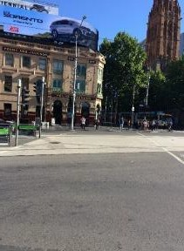 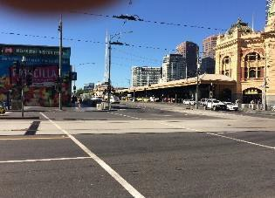

*Figure 12. Signalised crossings at Flinders Street (incorporating the tram stop to the West and signalised crossing to the East), Melbourne CBD*

* + - * The vicinity of Bourke Street, Melbourne CBD – surrounding streets included: Bourke Street pedestrian mall; the signalised crossing at Bourke Street and Elizabeth Street (incorporating the tram stop); and the signalised crossing at Bourke Street and Swanston Street (incorporating the tram stop to the North and West) and the signalised crossing at Bourke Street and Swanston Street.
      * The vicinity of Spring Street, Melbourne CBD – surrounding streets included: the unsignalised crossing at Little Collins Street and Spring Street; signalised crossing at Spring Street and Little Collins Streets; signalised crossing at Spring Street and Bourke Street (incorporating the tram stop).
      * The vicinity of Spencer Street and Southern Cross Station, Melbourne CBD – surrounding streets included: signalised crossing at Collins Street and Spencer Street (to the East, and incorporating a tram stop to the West); and signalised crossing at Spencer Street and Collins street (incorporating a tram stop).
      * The vicinity of Collins and Russell Streets, Melbourne CBD – surrounding streets included: signalised crossings at Collins Street and Russell Street; and 101 Collins Street tram stop unsignalised pedestrian crossing.
      * The vicinity of South Melbourne Market, Melbourne – surrounding streets included: unsignalised pedestrian roundabout crossing at Cecil Street and Coventry Street; and unsignalised pedestrian roundabout crossing at Cecil Street and York Street.
      * Monash University, Clayton Campus. Locations included: an unsignalised crossing at Scenic Boulevard; an unsignalised crossing at Scenic Boulevard and Sports Walk; and a signalised crossing at the Monash bus loop.
      * Monash University, Caulfield Campus. Location included: unsignalised crossing at Sir John Monash Drive at Caulfield train station.

### Participants

Data footage was collected via video of all pedestrians (those using a smartphone and non-phone user pedestrians) at each of the eight site locations. However, only pedestrians deemed to be over 18 years old were coding at the data analysis stage.

### Procedure

Observational video footage was captured using the video recording feature on two hand held Apple iPhone devices (5S and 6), to enable footage to be collected as surreptitiously and unobtrusively as possible.

Two experienced research data collectors recorded video footage, at the eight designated sites, of pedestrians crossing at either signalised or unsignalised intersections; or crossing in pedestrian mall areas where trams were

located. At a minimum, at the signalised intersection sites, footage was collected for the duration of the lights sequence (approximately three minutes per cycle included the time proceeding and following a green walk signal). This allowed footage to be collected for pedestrians ‘crossing at the wrong time’ (which was defined as any time other than starting to cross during a green ‘walk’ signal for signalised crossings).

Observational data was captured at a safe location and without obstructing the flow of the pedestrian traffic, whilst also capturing the light signal sequence (where applicable). Where possible the two data collectors recorded the same signalised intersection or un-signalised pedestrian crossing with each observer recording from the opposite side of the intersection so both directions of pedestrian traffic could be captured. The observations took place on week days (either a Tuesday, Wednesday, Thursday or Friday) on a weekly basis for the month of February and first two weeks of March between the hours of 8 am and 3 pm with the intention of capturing not only commuters, but a wider demographic population.

### Coding and analysis

Once data collection was complete, footage was then coded by two trained observers to review pedestrian smartphone use and any potential critical events such as near misses (e.g. nearly hitting another pedestrian, vehicle or object). The observers manually viewed the footage (frame by frame or in real time as applicable) using QuickTime media software and coded events manually on a hardcopy form. Only those pedestrians walking towards the field of view were coded on each video to avoid potential duplication of results (as previously mentioned data was collected from both sides of the intersection). If a pedestrian was obviously talking on the phone using headphones this was coded as being on a hand-held call, otherwise if it was unclear all other headphone use was coded accordingly. The total number of hours of footage viewed, and subsequently coded across the eight sites, was 4 hours 1 minute and 42 seconds (approximately 30 minutes of footage per site). At each of the eight site locations pedestrians were observed for instances of possible distraction (e.g. talking on smartphone whilst crossing road) and critical event instances (as follows).

Critical events were coded for both smartphone users and non-smartphone users. These were defined as the following (or a combination of):

* + - * crossing at the wrong time
      * crossing at the wrong place / cutting a corner
      * not looking / not head checking
      * nearly hit another pedestrian
      * nearly hit a vehicle
      * nearly hit an object (e.g. lamp-post)
      * other, specify.

The demographic characteristic of each critical event were also coded according to gender and three age categories (18-30 years old, 31-60 years old and 61+ years). These were based on subjective observations by the research data coders. There was found to be good inter-rater reliability with an agreement on age of 94.9%.

The Observation Data collection sheet is included in Appendix B.

## OBSERVATIONAL DATA RESULTS

Data was combined from the eight observational sites to ascertain the extent to which observed pedestrians used their smartphone devices whilst walking in busy locations and/or whilst crossing roads (either signalised or unsignalised).

### Overall data findings

A total of 4,129 pedestrians were observed across the eight sites (located in Melbourne suburbs and around the Melbourne CBD). Table 6 displays the total number of pedestrians observed at each site, the total number of pedestrians utilising smartphone devices and the way the device was being used.



## TABLE 6. NUMBER OF PEDESTRIANS USING THEIR SMARTPHONES AT EACH SITE LOCATION

|  |  |  |  |  |  |  |  |  |  |  |  |  |  |  |  |
| --- | --- | --- | --- | --- | --- | --- | --- | --- | --- | --- | --- | --- | --- | --- | --- |
| With headphones | | | | | | | | | | | | | | | |
| Location | Total number of pedestrians observed | Number using a portable device | **%**  **using a portable device** | Number on a hand-held call | % on a hand- held call | Number Auditory only | **%**  **Auditory only** | Auditory plus visual | **%**  **Auditory plus visual** | Auditory plus manipulating | **%**  **Auditory plus manipulating** | Texting/ interaction with device | **% Texting/ interaction with device** | # other (smart watch) | **%**  **other (smart watch)** |
| Flinders St | 678 | 104 | **15%** | 16 | 15% | 53 | **51%** | 0 |  | 1 | **1%** | 34 | **33%** |  |  |
| Bourke St | 900 | 170 | **19%** | 39 | 23% | 60 | **35%** | 2 | **1.18%** | 10 | **6%** | 58 | **34%** | 1 | **0.59%** |
| Little Collins | 417 | 81 | **19%** | 18 | 22% | 22 | **27%** | 1 | **1.23%** | 4 | **5%** | 36 | **44%** |  |  |
| Monash Clayton | 447 | 105 | **23%** | 15 | 14% | 26 | **25%** | 0 |  | 3 | **3%** | 61 | **58%** |  |  |
| Spencer St | 1152 | 243 | **21%** | 41 | 17% | 97 | **40%** | 3 | **1.23%** | 17 | **7%** | 85 | **35%** |  |  |
| Monash Caulfield | 76 | 39 | **51%** | 2 | 5% | 25 | **64%** | 0 |  | 4 | **10%** | 8 | **21%** |  |  |
| South Melbourne Market | 300 | 35 | **12%** | 12 | 34% | 12 | **34%** | 0 |  | 2 | **6%** | 9 | **26%** |  |  |
| Collins & Russell | 159 | 38 | **24%** | 11 | 29% | 12 | **32%** | 1 | **2.63%** | 2 | **5%** | 12 | **32%** |  |  |
|  |  |  |  |  |  |  |  |  |  |  |  |  |  |  |  |
| **Total** | **4129** | **815** | **20%** | **154** | **19%** | **307** | **38%** | **7** | **0.86%** | **43** | **5%** | **303** | **37%** | **1** | **0.12%** |

Across the eight sites a total of 815 (20%) of pedestrians were observed to be using a portable device whilst walking. A breakdown of the phone and non-phone use across the eight sites is shown in Figure 13.

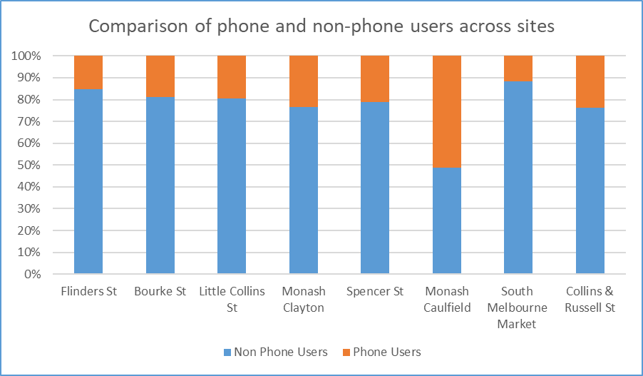

*Figure 13. Comparison of phone and non-phone users across sites*

For the 20% of pedestrians observed using a portable device (this included smartphones and smart watches), this was then broken down further to determine the way the device was being utilised. The results indicated that head phone use (auditory only) and texting/interacting with a device (38% and 37% respectively) were the two highest observed behaviours. This was followed by 19% of observed pedestrians on a hand-held call, presented in Figure 14.

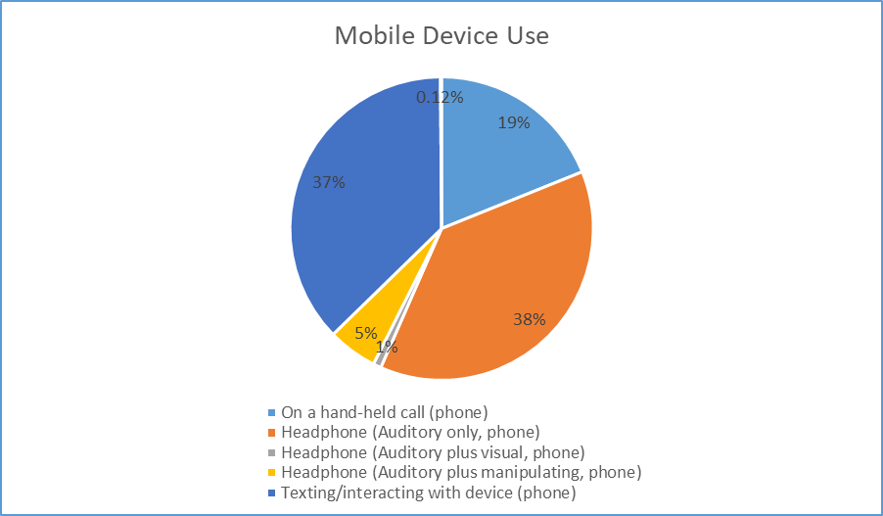

*Figure 14. Mobile device use*

### Individual site locations

Results from each of the eight observation sites presented differing cohorts of smartphone use (Figure 15).

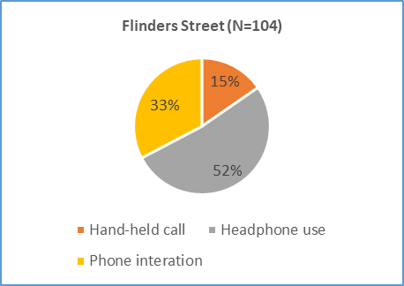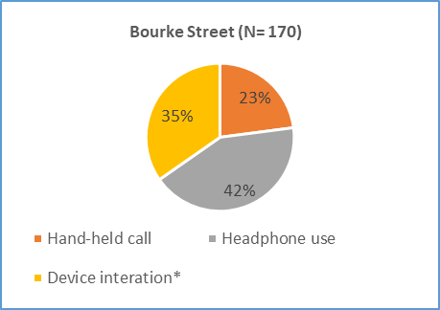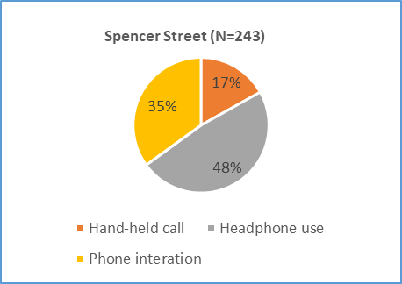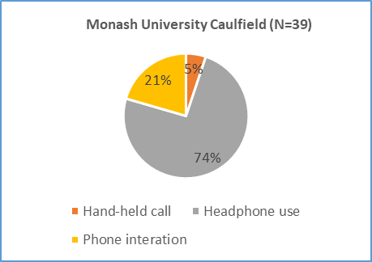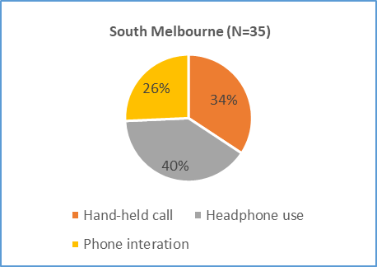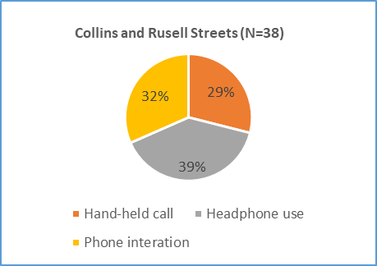

* Device interaction = phone and smart watch

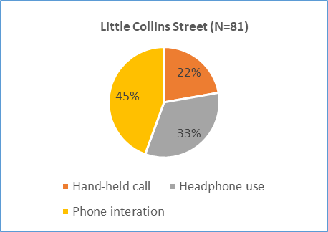 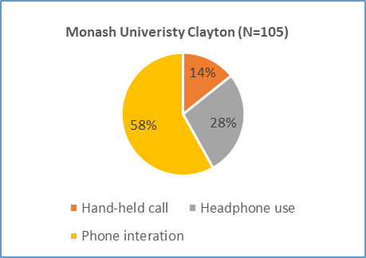

*Figure 15. Smartphone use at individual observation site locations*

Headphone use was defined as incorporating all three elements of headphone use (auditory only, auditory plus manipulation and auditory plus visual). If a pedestrian was observed talking on the phone using headphones this was coded as the pedestrian being on a hand-held call, otherwise if it was unclear all other headphone use was coded accordingly (auditory only, auditory plus manipulation and auditory plus visual).

### Critical Events Data

The second research objective was to assess the extent to which pedestrians were distracted whilst using a smartphone/portable device leading to a critical event. Of the 4,129 pedestrians observed, 872 critical events were detected for both smartphone users and non-smartphone users combined (21%), refer to Figure 16. For the 815 smartphone users there were 256 critical events: that is, 31% of the total observations for that group.

Conversely, for the 3,314 non-smartphone users there were 616 critical events: that is, 19% of the observations for that group. This difference in critical events between the pedestrian smartphone users and non-smartphone users was statistically significant (χ  = 39.58, *p*<0.01). The higher percentage of pedestrian smartphone users having critical events compared with non-smartphone users suggests additional risks whilst using a smartphone in a busy city location.

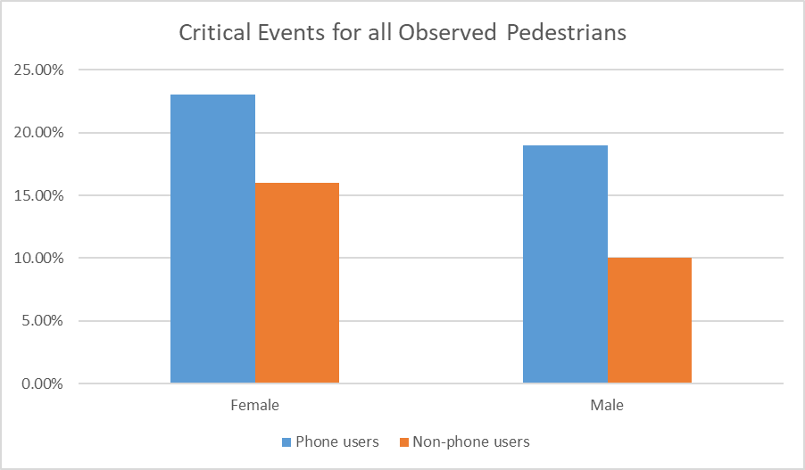

*Figure 16. Critical events for smartphone and non-smartphone users*

It should be noted that results should be reviewed with caution as, of the 4,129 pedestrians observed, not all were in full view at each video frame to determine accurate observation results. For example, whether all pedestrians ‘head checked’ before stepping out on road could not be accurately determined for all observed pedestrians in the data collected. This was because when viewing the video some pedestrians were obscured by other pedestrians at busy intersections (such as in the vicinity of Flinders street station, Melbourne CBD and Spencer Street and Southern Cross Station, Melbourne CBD). For example, the pedestrians at the rear of the footage (Figure 17) were obscured by those in front. As such critical events were only recorded for pedestrians where there was clear vision and accurate observation could be reported.

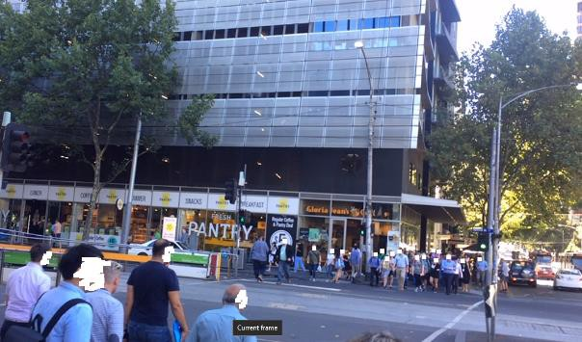

*Figure 17. Spencer Street (signalised pedestrian crossing)*

Of the pedestrian critical events observed ‘crossing at the wrong time’ was one of the highest incident events observed for both smartphone users (34%) and non-smartphone users (49%). For smartphone/device users specifically, ‘Not looking/head checking’ before stepping out onto a crossing (either signalised or non-signalised) was the largest observed critical event with 42% of pedestrians observed displaying this behaviour. In contrast, only 26% of non-smartphone users displayed this behaviour (refer to Figure 18).

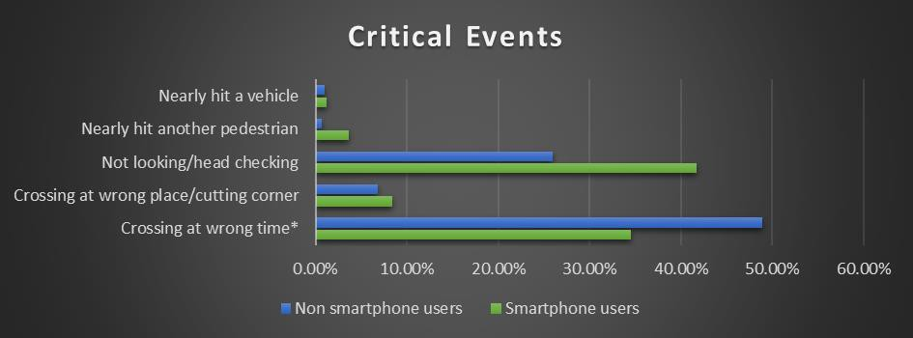

*Figure 18. Critical Events for smartphone and non-smartphone users*

With regards to the age demographics, the largest proportion of all critical events observed was undertaken by 31-60 year olds pedestrians (Figure 19).

|  |  |  |  |
| --- | --- | --- | --- |
|  |  | Age group |  |
|  | 18-30 years old | 31-60 years old | 61+ years old |
| **Phone/device user** | 48% | 52% | 0.40% |
| **Non-Phone user** | 28% | 66% | 6% |

*Figure 19. Critical events observed for smartphone and non-smartphone users by age group*

Critical events for smartphone users specifically, once broken down according to gender, revealed that the male age group 31-60 years had the highest proportion of critical events noted (35%) and for females it was the age group 18-30 years old (29%). As for the non-smartphone users, both the male and female age group 31-60 years had the highest proportion of critical events noted (35% and 32% respectively) (Figure 20).

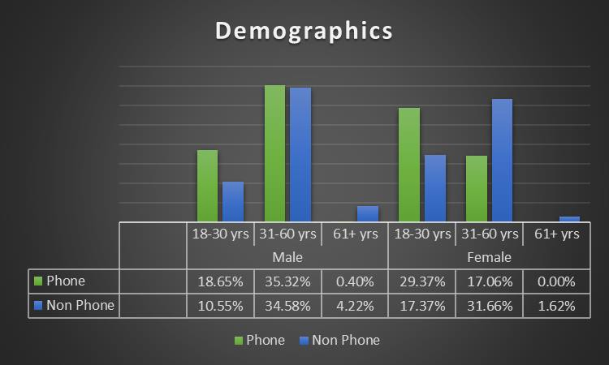

*Figure 20. Demographics for smartphone and non-smartphone users*

With specific regard to the type of behaviour the pedestrians were engaged in leading to a critical event, it was found that there was also a variation in activities for gender and age demographics. For males aged 18-30 years old, headphone use was the highest observed proportion (56%), whereas for females it was texting/interacting with the device (43%). For males in the age range 31-60 years old, there was a similar number of pedestrians on a hand-held call (37%) or texting/interacting with a smartphone/device (34%), whereas for females talking on a hand-held call (37%) was mostly observed, followed by texting/interacting with the device (35%) (Figure 21).

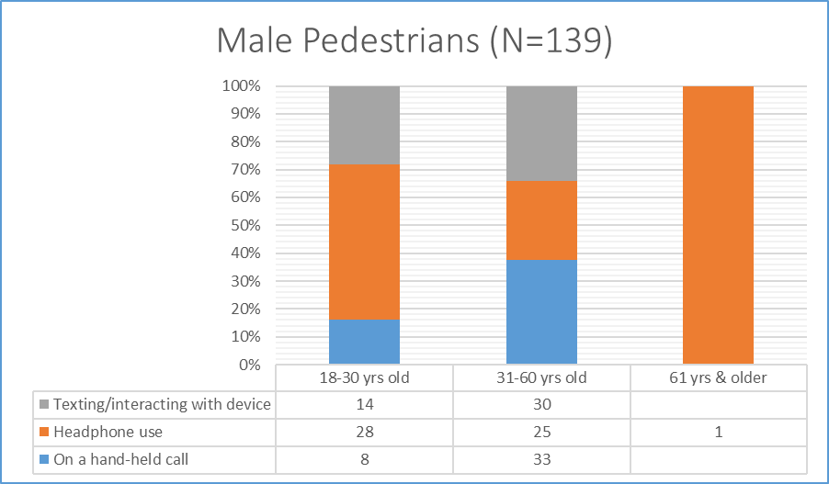

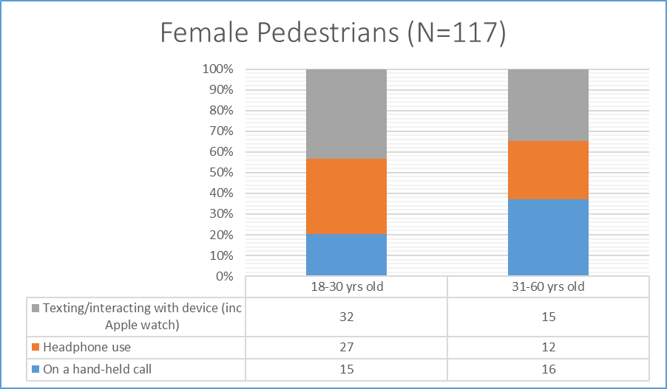

*Figure 21. Gender specific smartphone use by age demographics*

At the signalised and unsignalised crossings observed, female pedestrians using a smartphone/device (23%) were the least likely cohort to look or do a head check before crossing compared with female non-phone user pedestrians (16%), male smartphone device users (19%) or male non-phone users (10%). As can be seen in Figure 22.

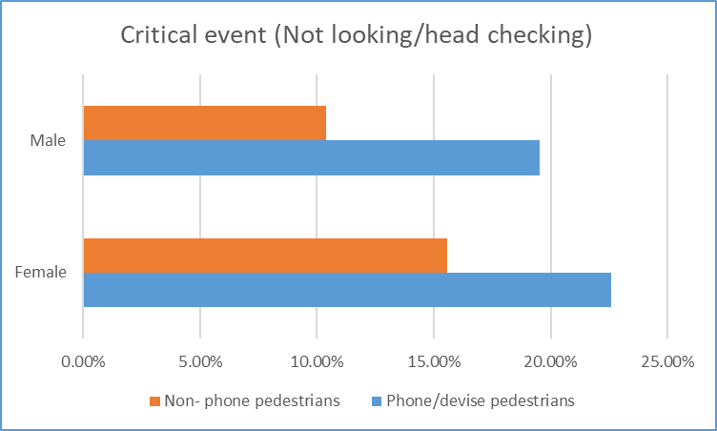

*Figure 22 Percentage of pedestrians not looking/head checking prior to crossing*

With specific regard to the type of behaviour the pedestrians were engaged in leading to a critical event for the 815 smartphone users “crossing at the wrong time” and “not looking/head checking” were the two highest instances of occurrences as can be seen in Figure 23. Also, with regards to the number and type of critical event instances for the total 4,129 pedestrians observed again “crossing at the wrong time” and “not looking/head checking” were the two highest instances of occurrences as can be seen in Figure 24.



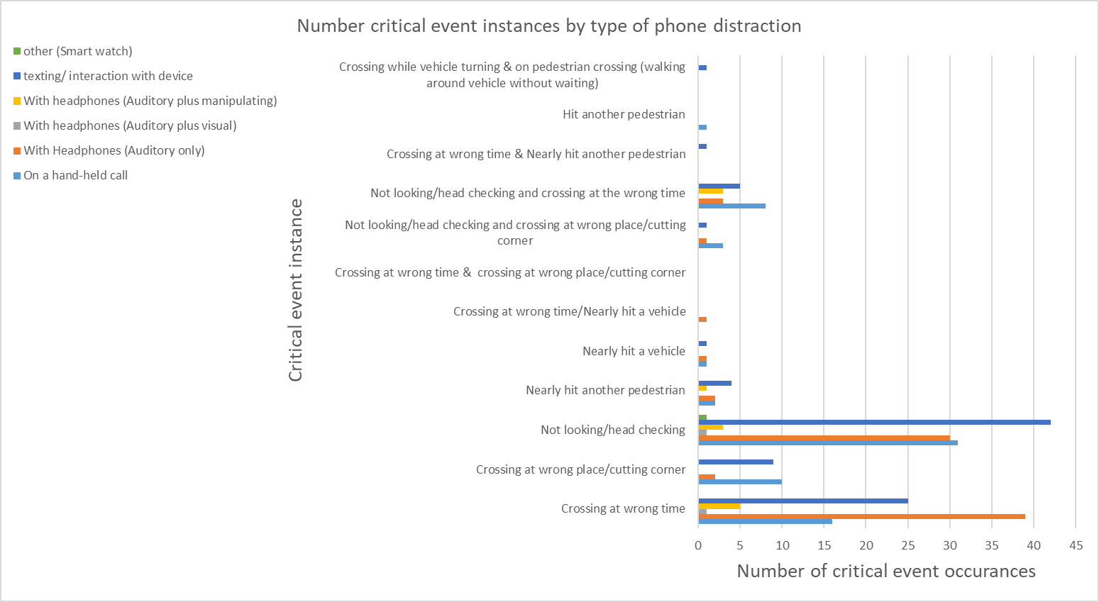

*Figure 23. Number of critical events instances by type of phone distraction*



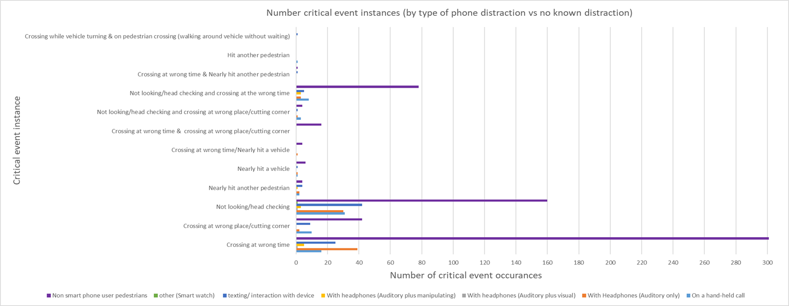

*Figure 24. Number of critical event instances for all pedestrians observed*

## SUMMARY AND DISCUSSION OF THE OBSERVATIONAL STUDY

This section of the research focused on the incidence of pedestrian smartphone use at busy city locations and its potential safety impact, as evidenced by critical event situations. It was found on average 20% of pedestrians were observed to be using a portable device (this included smartphones and smart watches) at the eight sites examined. This result is broadly similar to results previously found by Russo et al. (2018), Nasar and Werner (2008) and Bungum et al. (2005) for pedestrians using similar technologies (talking on mobile phone, texting on mobile phone, listening to headphones etc.). The results of the current study also indicated that headphone use (auditory only) and texting/interacting with a device (38% and 37% respectively) were the two highest observed use functions of smartphone devices by pedestrians. This was followed by 19% of observed pedestrians on a hand-held call. This was similar to Hamann et al.’s (2017) findings that the most common type of pedestrian distraction was using an electronic device (rates per 100 observed pedestrians: hand to head 4.6; followed by manipulating an electronic device, e.g. texting, 1.1 and headphones 0.1).

As might be expected, the proportion of pedestrians using a portable device varied by location. For instance, at a university site, over half of all the pedestrians observed were using a smartphone. Conversely, at a leisure location (streets around an indoor market) only 12% were found to be using a portable device (this included smartphones and smart watches). This could be partially due to the demographic population observed at each of the sites: for example the university sites typically had a younger population observed. This is supported by the DEKRA Accident Research (2016) international observation study findings (for pedestrian smartphone use in six European capital cities), which concluded younger pedestrians tended to use their smartphone more frequently than the older age groups (19% of those aged 15-25 years; 22% of those in the 25-to-35 age group; 16% for the 35-45 age group and 11% for those aged 45-60 years).

In terms of critical events, the study found that significantly more critical events occurred with smartphone users (31%) compared with non-smartphone users (19%). Of the critical events observed, “crossing at the wrong time” was the highest incident events observed for non-smartphone users (49%). For smartphone users, “Not looking/head checking” before stepping out onto a crossing (either signalised or non-signalised) was the largest observed critical event (42%), followed by ‘crossing at the wrong time’ (34%). In contrast, the figure for this critical event type was 26% for non-smartphone users. This suggests that the pattern of critical events is different for smartphone and non-smartphone users. For example, there was less head checking by smartphone users due to more immersion with their phones, whereas there was more wrong time crossing by non-smartphone users potentially due to having perceived spare capacity. These are broadly in line with Basch et al. (2014) where one in four pedestrians were observed to be distracted by technology-related interactions while crossing during the ‘walk’ (28.8%) and ‘don’t walk’ (26.3%) intersections. The use of headphones was the most frequently observed distractor for both the ’walk’ and ‘don’t walk’ signals, 16.3% and 15.6% respectively. It may be argued that using headphones per se is not distracting if the pedestrian is still actively engaged in their environment. However, the results of the current study found that 18% of the pedestrians using headphones crossed at the crossing at the wrong time (defined as crossing any time other than starting to cross during a green "walk" signal for signalised crossings) and this was higher than the other two observed distractions (talking on a hand held phone 6% and texting/interacting with device 8%).

Regarding gender differences, previous work by Thompson et al. (2013) found there to be a gender discrepancy for displaying unsafe crossing behaviour, with females found to be twice as likely to exhibit unsafe crossing behaviour as males. The results of the current study also found that female pedestrians utilising a smartphone device were less likely (23%), than non-phone users (16%), male smartphone device users (19%) or non-phone users (10%) to look or do a head check before crossing (at either signalised or non-signalised crossings).

Likewise, DEKRA Accident Research (2016) found gender-specific differences, and reported it was more common for female pedestrians to be texting, whereas males were more likely to be wearing headphones/earphones. The findings of the current study concurred, with observation results for the type of behaviour pedestrians were engaged in during a critical event indicating 78% of females were texting or interacting with a device compared with 63% of males; and 84% of males were wearing headphones compared with 64% of female pedestrians. Specifically, for males aged 18-30 years old, headphone use was the highest observed device use (56%), whereas for females it was texting/interacting with the device (43%).

An obvious criticism of such an observational study is that the data collected are limited. For example, no night- time observations were made. It should be noted, however, that the smartphone-use frequency rates found here were broadly similar to other research. Additionally, as the study was non-invasive, it cannot be established what the pedestrians were doing on their smartphones: for example, for those wearing headphones it was unclear if they were listening to music or simply had their headphones in place from an earlier phone conversation.

Interrogating pedestrians about what they were doing with their devices would require a very different study design and would fundamentally change the nature of the non-invasive study that was employed.

# MUARC PEDESTRIAN DISTRACTION STUDY: INTERVIEWS

## BACKGROUND

Cooper et al. (2012) proposed that future research studies could conduct surveys and interviews to understand what motivates certain types of pedestrians to exhibit particular behaviours in different roadway environments. Williamson & Lennon (2015) also suggested that in addition to the intercept interview questions conducted it may also be beneficial to ask participants if they were crossing at a signalised or unsignalised location as perceived risk from location may have an effect on smartphone use. As such, this type of questioning was incorporated into the interview.

## AIMS

The aim was to conduct interviews with pedestrians to ascertain their perception of pedestrian smartphone use in busy locations, in the same vicinity as the observation data collection, as these areas had high potential participant numbers.

## INTERVIEW METHOD

Short (five-minute approximately) questions were asked to ascertain pedestrians’ perceptions of smartphone use whilst walking in busy locations. Responses were transcribed, using pen and paper method, in real time. Interview questions were read as a script to ensure consistency and inter-rater reliability between the data collectors.

### Participants

Reponses were obtained from a sample of 84 pedestrians, deemed to be 18 years of age and over, targeting diverse age and gender demographics as possible. Data collectors categorised the recipients into three predetermined categories (18-30 years, 31-60 years and over 61 years old) utilising estimated ages, as no personal information was collected. The 84 respondents were comprised of 61% males and 39% females and 39% were estimated to be 18-30 years old, with approximately 26% between 31-60 years old and 35% aged 61 years or over.

The response acceptance rate was 79% with 23 declinations (male N = 10; female N = 13). The reasons given for not participating were: being too busy/in a hurry (N = 10); no specific explanation given, just “no” or “sorry” (N=4) and lack of English language (N=7).

### Procedure

Two experienced research data collectors approached pedestrians if they were deemed to be over 18 years old, regardless of whether they were in obvious possession of a smartphone or not. One researcher interviewed the participant whilst the other researcher transcribed, to ensure the interview questioning process was quick and flowed. The researchers also concurred after completing the interview with the participant to ensure all information had been transcribed. Interviews were conducted at a safe location and without obstructing the footpath. The interviews again took place on week days (either a Tuesday, Wednesday, Thursday or Friday) on a weekly basis for the month of February and first two weeks of March between 9 am and 3 pm with the intention of capturing, not only commuters but a wider demographic population.

### Interview questions

Questions focused on the participant’s perceptions of pedestrians’ use of smartphones in busy locations. The open questions asked were:

* + - * What are your thoughts about people using their smartphones whilst walking in a busy location e.g. city centre?
      * Are there any specific situations where you feel it might be more risky (to use a smartphone)?
      * Do you think it is more risky for people to use a smartphone at a signalised or unsignalised crossing?
      * Have you ever seen any occurrences from a pedestrian using a smartphone? For example, a near miss involving a car whilst a pedestrian was using their smartphone?
      * Have you physically bumped into another person or object (e.g. lamp post) while you were distracted by talking or texting on your phone?
      * What could be done to promote safer smartphone use in busy locations?

If response prompting was required examples were given: e.g. education (posters), technology, engineering or regulations?

Demographic information was also collected (estimated by the data collectors), responses were anonymous and no personal information was requested. The results of these responses were then collated to determine the perceived risks, if any, and suggestions in which to promote safer smartphone use in busy locations. Interviews were approximately 5-minutes in duration. The interview schedule is included in Appendix C.

### Analysis

Once all the data was collected the intercept questions were categorised according to recipients’ responses:

* + - * *What are your thoughts about people using their smartphones whilst walking in a busy location e.g. city centre?*
        + Risk perception: Risk or No risk
      * *Are there any specific situations where you feel it might be more risky (to use a smartphone)?*
        + Categorised accordingly into situations e.g. type of location or situation (also whether a crossing or intersection was mentioned)
      * *Do you think it is more risky for people to use a smartphone at a signalised or unsignalised crossing?*
        + Perceived difference: Perceived difference or no perceived difference (both as risky)
      * *Have you ever seen any occurrences from a pedestrian using a smartphone? For example, a near miss involving a car whilst a pedestrian was using their smartphone?*
        + Responses: Yes or No
      * *Have you physically bumped into another person or object while you were distracted by talking or texting on your phone?*
        + Responses: Yes or No
      * *What could be done to promote safer smartphone use in busy locations?*
        + e.g.: education (such as posters etc.), technology, engineering or regulations?
        + Categorised accordingly: education/advertising; technology; engineering; regulations/legislation; Not sure what can be done or nothing is necessary (this question could facilitate more than one response from a participant and all responses were recorded)

## INTERVIEW DATA RESULTS

Eighty-four pedestrians, estimated to be between the ages of 18 years old and 61 plus years old, comprised of male (N=51) and female (N=33), were interviewed across the sites to obtain their perception of the level of pedestrian distraction from using smartphones whilst walking. The responses to the questions can be seen in Figure 25.

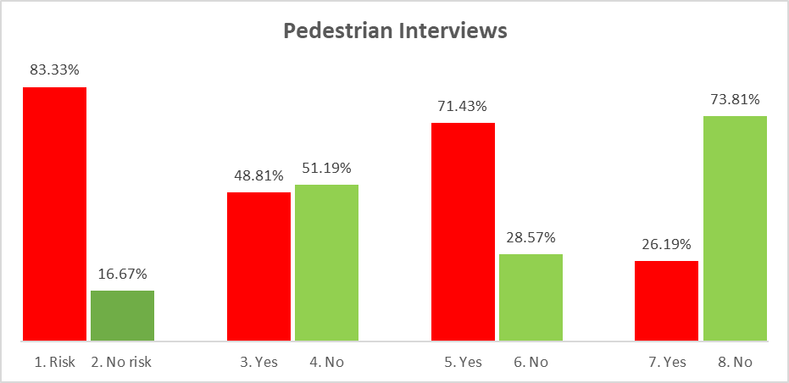

|  |
| --- |
| 1=Perceive risk of using a smartphone whilst walking in a busy location |
| 2=No perceived risk of using a smartphone whilst walking in a busy location |
| 3=Perceived difference using signalised versus unsignalised crossings |
| 4=No perceived difference using signalised versus unsignalised crossings |
| 5=Have seen a pedestrian incident whilst using a smartphone |
| 6=Have not seen a pedestrian incident whilst using a smartphone |
| 7=Have personally had an incident whilst using a smartphone |
| 8=Have not personally had an incident whilst using a smartphone |

*Figure 25. Results from the pedestrian interviews*

Participants’ responses to the six interview questions about their perceptions of pedestrian smartphone use are outlined below.

### What are your thoughts about people using their smartphones whilst walking in busy locations e.g. city centre?

Eighty three percent of people interviewed believed there was a risk involved with pedestrians using their smartphones in busy locations e.g. city centres. Of those 38% who believed there was a risk involved, there was little difference in risk perception between age groups for males (15% of 18-30 years, 17% of 31-60 years and 15% of 61+ years). However, for females there was a slightly larger percentage of those aged 18-30 years (18%) than those aged 31-60 years or older (6% and 9% respectively) who believed there to be a risk involved for people using their phones.

### Are there any specific situations that you feel it may be more risky (to use a mobile phone)?

Most of those interviewed (73%) suggested they thought using a phone while crossing roads/intersections/pedestrian crossings to be more risky to be using a smartphone whilst walking elsewhere. Other suggestions of perceived increased risk were: intersections near shopping centres; in the city where there are cars and trams; at night (where people may not be aware of who is around them when they are on their phones); going up and down stairs; when using headphones (as not aware of surroundings); or the possibility of phone theft (aware of increased occurrences overseas). A small proportion of participants thought that all

locations; anywhere outside the house or public areas were risky to use your phone. Only two of the people interviewed believed there was no risk to pedestrians to use their phones and there were no situations that would make it any more risky.

### Do you think it is more risky for people to use a smartphone at a signalised or unsignalised crossing?

Fifty one percent of those interviewed believed there was no significant difference to the risk of using a smartphone whilst crossing at a signalised or unsignalised crossing and that both locations were just as risky. For this response there was a fairly even distribution in responses across the ages and genders: 19% of females and 16% of males (aged 18-30 years old) and 19% for both genders (aged 61 years old and over). However, for those aged 31-60 years old there was a higher difference in opinion between males (23%) and females (7%).

Of those 49% of pedestrians interviewed who believed that there was in fact a difference between the two types of crossings, 93% believed unsignalised crossings posed a greater risk for pedestrians using their smartphones while crossing than signalised crossings.

### Have you ever seen any occurrences from a pedestrian using a smartphone? For example, a near miss involving a car whilst a pedestrian was using their smartphone?

Seventy one percent of people interviewed said they had seen some sort of occurrence involving a pedestrian using a smartphone (whether it be a minor incident such as bumping into a person or an object; or a near miss or worse involving a vehicle etc.).

### Have you physically bumped into another person or object while you were distracted by talking or texting on your phone?

When asked about personal experiences, 74% of people interviewed said that they had never experienced someone bumping into them while they themselves were distracted on their smartphone, with the majority stating they do not use their phone whilst walking. Of those 26% that said they had actually had an incident the majority were, not surprisingly due to their high mobile phone use, in the 18-30 year age group (females 32% and males 27%). However, there was a surprisingly high number of females aged 61 or over (14% compared with zero males) that stated they had physically bumped into another person or object whilst distracted talking/ texting on their phone.

### **What could be done to promote safer smartphone use in busy locations? e.g. education (posters), technology, engineering or regulations?**

When the respondents were asked what they believed could be done to promote safer smartphone use in busy locations, some participants had multiple responses whereas others had only one. One hundred and nine suggestions were received (as displayed in Table 7):

* + - * The majority of suggestions (N=51) called for more education/awareness or publicity campaign/advertising (47%), with some of the respondents suggesting this should be aimed at the younger generation.
      * Thirteen (12%) suggestions were for engineering initiatives, these included ideas such as: markings or pavement lighting technology (anything that flashes/distracts the phone user to look up); better separation of pedestrians and trams in areas such as Bourke street mall, barrier/boom gate to the road - although cost and feasibility of such implementations was mentioned by many respondents).
      * Fifteen of the respondents suggestions (14%) indicated regulatory actions, such as banning phones whilst crossing and/or fines, penalties or a blitz with a minor infringement (like jaywalking) for

Non-compliance or for being distracted whilst using crossings (either signalised or unsignalised) could be a possible cause of action. Some believed a fine was too extreme and pedestrians should just be cautioned. A combination of engineering and regulations was also suggested such that a camera could be located at crossings that views phone users and then pings back to the phone tower to obtain users details and fines them accordingly.

|  |  |  |  |
| --- | --- | --- | --- |
| TABLE 7. PARTICIPANT INTERVIEW COUNTERMEASURE SUGGESTIONS TRANSCRIPT | | | |
| Education | Engineering | Regulations | Technology |
| Education -advertising and publicity campaigns probably would not stop people but may make them more wary | Engineering -Warning signs Reminders at intersections | Regulations - Fines to discourage people in high traffic areas | Technology-In phone itself- technology to alert people a warning/indicator –like on glasses or contact lenses so people can use their peripheral vision.  Hands free typing with the old type keypads where people could intuitively type by feel as they knew where  the keys were and could still be looking where they were going |
| Education is key but advertising not always effective long-term. | Engineering-Pedestrian separation- a different lane for smartphone users. | Regulations- but I can’t think of anything in particular | Technology- A lot of people I see have these phones that talk to you – Siri, so they can be looking while  walking. |
| At Swinburne University there were ‘no phones’ signs on steps into Swinburne – re-enforcement [this can  be powerful] | Engineering-Markings on roads might help. | Regulations/Legislation- a law to stop crossing the road on phones-maybe? | Technology- Phones could flash a warning at a crossing (GPS). |
| Education - for younger generations (4 respondents). | Engineering-Some pavement technology- e.g. lights- possible | Engineering and Legislation-a camera at the crossing the views phone use that  pings back to the phone tower to get the persons details and fine them | Technology- where smart phones could be connected to street signs to warn people to stop |
| Education-younger generation (16 year olds especially) | Engineering-lights on the footpath | Regulations - fine people for using phone [at crossings]. | Technology -Headphones with voice directions; voice recognition so that you don’t have to use [occupy] your vision.  -Texting via voice recognition.  -Using technology based on voice recognition. |
| Ads on the ground | Engineering initiative may be helpful but I can’t think of anything | Regulation- a blitz | Technology- disruption/blocking of phone signal while crossing the road |
| Education- Publicity campaigns may work a bit, but there is balance between costs and how effective  these are. | Engineering Bourke St trams [around the mall area] would deserve better separation of the tracks. | Regulations- fines for people who are on their phones and not looking where they are going | Technology  An App when walking- a warning about crossing. But wouldn’t be used if it slowed the pedestrian down too much |



|  |  |  |  |
| --- | --- | --- | --- |
| Education (cont.) | Engineering (cont.) | Regulations (cont.) | Technology (cont.) |
| Education - such as Yarra trams campaign | Engineering- Light system – light on the ground effective. Anything that flashes/distracts is useful | Regulations- fines | Technology -block the signal in busy pedestrian areas |
| Education - warning posters at Identified risky roads | Engineering- paving lights. Barrier on the road | Regulations- Penalties for crossing while on their phones-being distracted at unregulated crossings (non-signalised)  and minor infringement, like jaywalking | Technology -chip that flashes messages on the phone |
| Education-e.g. TAC campaigns of road crossings | Engineering- flashing pavement lights. | Regulations-Banning people from using phones at crossing and then fines apply for non-compliance | Technology-Put a movement detector on the phone – so that it can only be used when standing still. |
| Can’t regulate need to educate the parents | Engineering- boom gate where you need to press a button to open it at crossings | Regulations- law |  |
| Educating the young in primary schools; their families have to tell  them to stop. | Engineering-like lights on the pavement, at eye level | Regulations- law that phones cannot be used at road crossings |  |
| Educating the young in primary schools; their families have to tell  them to stop. | Engineering-like lights on the pavement, at eye level | Regulations- law that phones cannot be used at road crossings |  |
| Educating the young in primary schools; their families have to tell  them to stop. | Engineering-like lights on the pavement, at eye level | Regulations- law that phones cannot be used at road crossings |  |
| More awareness/publicity campaigns (5 respondents) | Engineering/infrastructure but may be too costly | Regulation-fines |  |
| Education- Publicity campaigns especially around the use of headphones while crossing. Target  the younger generation |  | Regulation-fines |  |
| Education-posters at crossings |  | Regulation-caution people-not fines-too extreme |  |

|  |
| --- |
| Education (cont.) |
| Education- campaigns/ posters |
| Education- campaigns from an official  stance (government ) |
| Education - could be cost effective as  this behaviour could be costing lives |
| Education-advertising campaign by  the government |
| Education -In Thailand there are adverts in train stations – ‘Look out for  your safety, look for your health’. |
| Education-advertising campaign |
| Education - not specified (25  responses) |

* Ten respondents suggestions (9%) were for some technology based initiatives in the phone itself where there is a warning or alert for users when at a crossing (a GPS app that is connected to the street signs) or something that blocks the phone signal in busy pedestrian areas or with a motion detector so pedestrians can only use the device when they are stationary (this is problematic for phone use on public transport or as a vehicle passenger). Alternatively, more voice recognition technology was suggested so that pedestrians’ vision is not disrupted whilst using their phones.
* Ten of the responses received (9%) were that they were unsure what could be done and a further ten believed that nothing was necessary - the onus was on the user and that there should be self-regulation and responsibility.

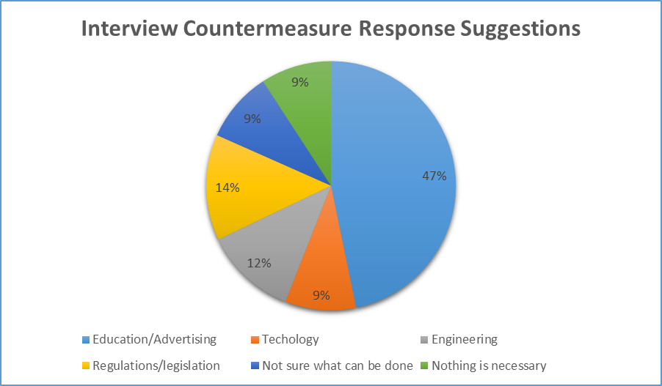

*Figure 26. Interview countermeasure response suggestions*

In conclusion, from the responses received the majority (47%) of those interviewed believed that education initiatives or advertising campaigns would be of benefit to enlighten vulnerable road users of the risks distracted walking. In addition of those respondents that suggested education/advertising, several (14%) suggested it be aimed at the younger generation.

# END-USER FOCUS GROUP

To further explore pedestrian distraction from smartphone use, a focus group with smartphone end-users was conducted at Monash University, Clayton campus on Thursday 23rd August 2018.

## AIMS

The aim was to build on the above-described interviews and to better explore countermeasures from a smartphone end- user perspective. The focus group predominantly focused on younger end-users given that pedestrian smartphone injuries have been found to be higher for those under 31 years old (Nasar & Troyer, 2013). This was also reiterated with the field interview data collection where it was found that a greater awareness of the risks and countermeasures was found amongst the 18-35 age group. However, to ensure a reasonably representative population sample, participants aged 40-50+ were also recruited.

## METHOD

### Participants

Twelve participants, aged 18 years plus, were recruited. All participants were smartphone users. The age range of the focus group participants was 19-58 years (mean age 30 years).

### Procedure

The focus group ran for approximately 90 minutes, and participants were paid $20 each for their time. The focus group procedure was:

1. Introductions, participant ethics forms signing, and playing a video of distracted people on their smartphones as an opener.
2. The MUARC focus group moderator gave a five-minute summary of the project work done to date (without leading them).
3. Group had a general discussion of the issue and what broadly can be done.
4. The group were split into four teams of three people to discuss countermeasure types in more detail (in relation to acceptance, barriers to implementation, likelihood to follow (as can accept but not follow) and other issues:
   1. Infrastructure
   2. Publicity/education campaigns
   3. Smart technology/lights
   4. Regulations
5. The whole group reconvened, and each team presented their findings to all for additional feedback.
6. Close, the MUARC focus group moderator gave contact details if participants want to provide further views.

### Materials

Three experimenters were used: a moderator, and two assistants to take notes and organise the session. The focus group took place in a large quiet room. Initially all participants sat at a large table. Then for the break-out sessions, the four teams moved to separate areas in the room. The main materials used were large sheets of ‘butchers’ paper for the teams to write on. Audio recordings were taken, and the two experimental assistants wrote notes during the session.

## RESULTS

The raw outcomes are presented, according to the focus group agenda, in Appendix E as a verbatim discussion. The key themes emerging are presented below by types of countermeasures.

### Group Discussion of Four Countermeasures

#### Infrastructure

**Ground signage**- For example “big stickers” placed on the ground to remind you to stop looking at your phone/remind you to look up – there are already tactile bumps at crossings, so this is a similar concept. Suggestion from group feedback: This was perceived as a really good idea, but with the problem being that people get used to seeing what they see all the time/these types of signs, so it loses its effectiveness after a while. If it is permanent, it was believed that pedestrians would pay attention to it for a bit but then stop looking at it. It was suggested that stickers could be change every so often to make them funny and engaging and this may overcome the loss of effectiveness.

**Interactive tool at the intersection/traffic light**- Such that when you press the button at the traffic lights there is some sort of screen that comes on with a voiceover or playing a funny little game on it to attract attention/distract you from looking at your phone – similar idea to the advertisements at petrol stations.

**Billboards** – A billboard campaign on a big screen in the city with a loud voice to attract pedestrians’ attention to get off their phone– Feedback from the group: 1) there was a feeling it was like a dictatorship or something out of a movie. 2) Also, if people were listening to music on headphones they might not hear it so might not work.

**Pathways** – Make a separate pathway but also a pull over areas dotted along the footpath for pedestrians to use their phone out of flow of foot traffic. Feedback from group – the pull off areas may get congested at times.

**Barriers** – To prevent pedestrians from veering onto the road. Other respondents said they liked this as it would stop jay walking too and would provide more places to lock up bikes. It was also suggested that the barriers could incorporate seats, like they have at cafes, to prevent people walking across the street in that area (like Swanston Street).

**Barriers and ground signage** rated the highest (in that order of ranking)

#### Education/awareness campaigns

**School programs** – Designed to educate young people about dangers of phone use while walking. Make an education component as part of the school program. Feedback from the group: - if videos were shown in schools then people may see it is more of an issue than they realise. It was also suggested that maybe not making the videos as comedy/funny ones but maybe some a little more graphic (of people actually getting in trouble). Showing graphic video may increase awareness and let the students know that it is more of a problem than they think. The group discussion was that this could be aimed at grade 8 up (14 year olds +).

**General advertising/pop-ups on the phone** – Something that comes up on phone to warn pedestrians that they are approaching a crossing or congested area or an audible warning-voice on the phone that knows when you are about to cross in an area with a lot of congestion. Feedback from the group: -This would be annoying, but if persistent it could train people to not use phone or people may just work out how to avoid the pop-up warnings. An example could be an audible annoying noise every time a pedestrian goes near a lamp post that would train the distracted person not to walk near the lamp post.

**Advertisements** – on TV and radio, advertising like PTV/tram safety on Yarra trams. Feedback from the group:- The majority of the group liked the PTV Dumb ways to die campaign, and though it was REALLY good, even when it is still seen it today (3-4 years on). Also, the tram advertisements (weighs as much a 30 rhinos) and rhino on the skate board was seen as a really iconic image by the group– The consensus was that these can be effective if they really well thought out and are novel and funny (the group agreed they worked).

**Signs** – in areas of high risk (where there are a lot of people and traffic-like the city centre), such as at top of stairs, crossings, tram stops.

General consensus was that: - All were useful, in fact most useful in conjunction with each other.

#### Regulation, Enforcement

This group looked at punishment vs reward, but decided to get rid of reward was they believed it would be really hard to reward people for doing the right thing but it is easier to punish people for doing the wrong thing.

**Fines** – They concluded that people should be fined if they were putting themselves or others at risk because of how you were using your mobile in the streets. The pros were:-it would raise money to do other interventions, it helps protect the user and other pedestrians-it was seen an incentive. Cons were:-it would need to be enforced and they were unsure how that would happen. It was discussed that if manpower was not used, then using facial recognition cameras may be used. However, the group concluded that possibly people, when they knew where the cameras are, may just do the right thing in front of the camera (like speed cameras) but not elsewhere. Also, it was discussed how the person would be identified and that there is a chance that they could be identified incorrectly. In general, it was thought it would just make people annoyed (and the group believed that governments try not to do that if they can). It was also agreed that fines could probably disproportionally effect people on different incomes, so someone on a higher income just would not react to a $50 fine, so then it was suggested that people could possibly be fined based on their income or that they could have community service as alternative to fines.

**Group discussion**: - is there another punishment other than fine/community service? Like removing or restricting phone use?

The group agreed that removing or restricting phone use was pretty unrealistic and that people need their phones, e.g. for their jobs too.

Other punishments seemed like overkill:-It was concurred that a jail term would be too harsh and it would not be justifiable to overturning a person’s visa- the punishment should be relative to amount of damage the person cause (based on outcome-so if a person caused a traffic accident (e.g. a crash) because they walked into the street while on their phone it is the same as negligent driving in your car, which would be different to if they bumped into someone and broke their phone. Even if they were not breaking a specific law they could get a bigger punishment progressively based on the damage they had done).

**Feedback from the group**:-How do you enforce this? It is not possible to have police everywhere. However, a blitz has been shown to be effective. It is like speeding – you may not get caught all the time, but you will get caught sometimes.

It was discussed that maybe it could be made law to have to stop whenever you use your phone, but this was seen as being inconvenient to have pedestrians stopping to use phones on paths.

The MUARC focus group moderator asked for a show of hands who would actually want this implemented and would they support it-the response was that no one wanted it. Group feedback: - it would be so inconvenient, for example if someone was trying to find someone in the shopping centre or in the CBD having to stop and sit down every time to text them/read the text get up again and keep doing that every time.

Another suggestion was that if someone does something that they were liable for then they should lose their rights, but that the person should be punished just for the action itself / if they do something that causes a problem then they should be punished for that, otherwise it is not an issue

It was discussed that administering this would be an issue because what organisation would administer all of these fines- if it was up to the police to do a blitz, who would pay for all of this?

#### Technology

**Car bumper technology** – For example if a pedestrian gets near something like a hazard or intersection or pedestrian crossing then an audible warning on their phone would get increasingly more urgent as they got nearer the danger (like when backing up a car, the beeps get shorter and more intense). (Group rating was given as 3/5)

\***Voice recognition** – headphone interaction/direct feed, where by the phone automatically reads the texts when a person is walking – through headphones or a speaker. (Group rating was given as 3/5)

\***Volume control** – automatically lowering maximum volume on phone headphones when the person is walking so they can still hear surrounding traffic noise and events. Phone does it for you (not self-regulated). (Group rating was given as 4/5- this is probably the only one that would be easy to do)

**Transparent images** – To have camera feed of path or road with other phone information as transparent overlay. (Group rating was given as 3.5/5)

**Location lockout**- To lock/restrict phone use in certain areas. (Group rating was given as 2/5)

(The ratings were given by the group completing task based on their perception of acceptability, feasibility/viability and the most realistic that they believed people would not be too much against-*are the top two)

**Group feedback**: - One participant suggested that there could be computer information system technology inbuilt in phones as cars have inbuilt GPS so when pedestrians are walking in the streets their phone will remind them that there is a car behind them or coming towards them or there are traffic lights ahead that have a right arrow etc. The group feedback to this suggestion was- that there are always flaws in technology, so it may be possible that a person may get a lot of false alarms when they were within a metre of a road etc.

**Movement sensor technology so phone stops when you’re moving?** – The group concluded that this was a bit too much, especially if a pedestrian was jogging and listening to music-it was though this would be really frustrating.

### Overall group general discussion: key themes emerging

* + - * “We need something that will focus the attention of the pedestrian to where they are going”.
      * “Self-regulation. Users know the costs, but it is a necessity to use their phones – you yourself should be careful.”
      * “Often there are notifications continually coming up on your phone, so it would be hard to stop all notifications- maybe people could change to just the important notifications-that’s more of a behaviour change though.”
      * “Aren’t teenagers more the issue? -I am surprised it mentioned that it was the older age range.” Figure 27 illustrates the themes emerging from the focus group countermeasure discussion.

Countermeasures

Infrastructure

Education

Regulation/ Enforcement

Technology

Ground signage

School programs

Fines/ Community service

Pop ups on phone

Interactive tool

Advertisements

Audio warnings

Billboard

Signage

Voice recognition technology

Pathway

Volume controls

Barriers

Phone screen transparency

*Figure 27. Key themes obtained from focus group discussion*

Phone lock out

The most effective countermeasures noted by the focus group for each of the four broad categories are presented below.

#### Infrastructure:

* **Barriers** – prevent pedestrians from veering onto roads / barriers with seats, like they have at cafes, so people can’t walk across the street in that area (like Swanston Street).
* **Ground signage** - to remind you to stop looking at your phone/ to look up – need to be changed every so often to make them funny and engaging may overcome the loss of effectiveness.

#### Education:

* **Some sort of campaign**. TV and radio advertising, like PTV (dumb ways to die) / tram safety on Yarra trams (rhino).
* **Education as part of the school program** (like sex education) showing graphic videos to increase awareness and advise it is more of a problem than they may be aware of aimed at grade 8 up (14 years old

+).

#### Regulation/enforcement:

* **Banning phones is not realistic** -jaywalking is illegal, but people still do it.
* **Maybe ban people when they cross the roads**, like bans on smoking-that is in place and works so maybe banning while walking across the road may work too.

#### Technology:

* **Voice recognition** – headphone interaction/direct feed-phone automatically reads texts when walking – through headphones or speaker (like Siri reading out messages or writing messages).
* **Volume control** – automatically lowering maximum volume on phone headphones when the person is walking so they can still hear surrounding traffic noise and events. Phone does it for you (not self- regulated).

In summary, the focus group found that no single countermeasure was the total solution to this issue, but a combination of measures from the four types of countermeasures was the preferred approach amongst focus group participants. This approach is compatible with the Safe System framework of an integrated approach and a shared responsibility for road safety.

# ROAD SAFETY EXPERT WORKSHOP

To better explore countermeasures, including implementation practicalities and priorities, a road safety expert workshop was held at the Monash Conference Centre, Melbourne CBD on 23rd October 2018.

## AIMS

The aim of the expert workshop was to build on the countermeasures and regulations found following the literature review and to better explore countermeasures, including implementation practicalities and priorities from a road safety perspective.

## METHOD

### Participants

Sixteen road safety expert attendees (and two MUARC workshop facilitators) including current baseline stakeholders and other interested expert parties attended the workshop.

### Procedure

The road safety expert workshop ran for approximately 120 minutes. The road safety expert workshop procedure was:

1. welcome, coffee, ethics approval and introductions (15 minutes)
2. MUARC workshop moderators give a 15 minute summary of the project work done to date (literature reviews, interviews, focus group observations and countermeasure review)
3. group discussion of countermeasures (60 minutes). Utilising each of the four broad categories of countermeasures in term of:
   1. what can be done?
   2. by whom?
   3. how, when and what?
   4. potential benefits
   5. barriers, issues
   6. costs
   7. overall priority
4. summary, actions, next steps and meeting close (5 minutes).

Two facilitators presented, took notes and organised the session. The workshop took place in one of the Monash Conference Centre boardrooms. All delegates sat at a large table and all representatives contributed towards the discussion. Audio recordings were taken, and the two facilitators also wrote notes during the session.

## RESULTS

The outcomes are presented, according to the road safety expert workshop agenda, in Appendix F. The key themes emerging are presented by types of countermeasures.

### Group Discussion of Four Countermeasures

The workshop participants agreed to discuss the countermeasures and strategies around the themes and categories that had previously been developed (compatible with, but not presented within a typical safe system approach). The following is a summary of the key themes to emerge from the discussions.

#### Infrastructure

* + Simple infrastructure changes could be made in areas with high pedestrian traffic instances: For example, creating a physical barrier between the footpath and the roadway, such as planter boxes with seats. This would filter and slow pedestrians down forcing them to consider what they are doing as they approach an intersection or provide somewhere to stop and sit whilst texting. However, type of barrier is important and fixed structures such as fencing could be viewed as an outdated solution with their own safety concerns; for example, barriers may create crowding issues; could be seen as a hurdle; and could present a risk if pedestrians become trapped between the barriers and road traffic. As such, benches and planter boxes, which may detract pedestrians from crossing, should be considered in preference to blocks/fencing. Encouraging pedestrians to cross at crossing points could also be considered e.g. instantaneous signal call up, low wait times, full width crossing time, etc.

(i.e. preventing pedestrians congregating in the centre of the road due to them being unable to cross the entire road in one signal phase).

* + Physical ‘keep left’ wire barrier down the centre of the pavement to stop pedestrians bumping into each other.
  + A more cost effective alternative to embedded footpath lights, such as laser lights or projected warning signs (which are mobile/temporary rather than permanent features).
  + An auditory message broadcasted saying “eyes up” or similar.
  + Tactile strips, which equates to an intersection for a pedestrian (a physical change in the footpath such as tactile bumps).
  + Universal designs such as Puffin crossings (a pedestrian crossing where infrared detectors and mats detect pedestrians on the crossing and the traffic lights only change to green when no more pedestrians are detected near the crossing).
  + Amendments to signal timings, e.g. reviewing when there is a green signal for vehicles at the same time as green for the pedestrians. An additional consideration could be giving pedestrians advanced crossing times, before the vehicle turn signal activates.

#### Education/awareness campaigns/Behavioural initiatives

* + Education in a school setting (possibility incorporated into a community grant).
  + An awareness or advertising campaign with a good slogan that would have high recall.
  + Strategies incorporating social norms or peer pressure may be beneficial, involving a cultural change. Such as an education/publicity campaign presenting a model commuter saying this should be the social norm. This could be in combination with other initiatives not as a standalone countermeasure concept (such as education about distraction in general and the health implications around using phones in general as well as about influencing the culture of always needing to be connected – so there are links outside road safety per se).

#### Regulation, Enforcement

* + Regulation/enforcement as part of a holistic approach could be considered. Such as enforcement in conjunction with advertising and social norms (cultural change). For example, a campaign, with legislative back up, that relays the inconvenience created by people slowing down and reducing crossing to all others in traffic flow during peak times and how this behaviour is unacceptable.
  + Possibly incorporate pedestrian related changes into road rule changes. For example, with the National Transport Commission review of road rules 299 and 300 – there could be an opportunity to incorporate pedestrian-related changes to the distracted road rules for drivers changes.
  + Possibly the focus could be on managing, not necessarily stopping, phone distraction, using a variety of methods for example incorporating aspects of methods discussed in this section.
  + Another important aspect to also be considered is the economic overlay, as those pedestrians that are taking longer to cross the road may end up crossing at the wrong time, then traffic flow is impeded which then restricts the cross flow of traffic.

#### Technology

* + Apps generally have a very low up-take as they are voluntary, for example the driver “do not disturb” app. A non-voluntary option where the phone is use is limited/affected when the user is mobile/moving could be considered.

# OVERALL DISCUSSION

## KEY FINDINGS

The research undertaken by MUARC used a wide range of approaches to examine the issue of pedestrian distraction from smartphone use. In the observational study it was found that, on average, 20% of pedestrians were using a portable device at any one time while walking. The study found that significantly more critical incidents occurred with smartphone users compared with non-smartphone users. As a result, pedestrians are at greater risk of an accident or near miss when interacting with their smartphones than when they are fully attending to the road and surrounding environment.

The interviews, focus group and road safety expert workshop also confirmed that there was a growing awareness of the safety impacts of pedestrian distraction from an end-user perspective. Similarly, the review of research literature on the topic, including countermeasures and a road safety expert countermeasure workshop showed the increasing concern with the issue of pedestrian distraction from smartphone use, by researchers and road safety professionals. A wide range of countermeasures have been identified including additional separation and other infrastructure initiatives, encouraging safe walking and mobility, greater use of ground signage, and better education in schools and the wider community about the risks of walking whilst being distracted by a smartphone. These countermeasures, within a safe systems framework, will be discussed further below.

## FUTURE WORK WITHIN THE SAFE SYSTEM FRAMEWORK

Given the probable increases in smartphone functionality in the future, the busyness and complexity of daily life, and the growth in city centre population density, pedestrian distraction is likely to remain a safety concern for years to come.

Further work on this topic is well-advised to further examine the efficacy of countermeasures to both reduce the occurrence of pedestrian distraction and to manage its impact.

Taking into consideration that the focus of the project was pedestrian smartphone use, it is important to consider other interacting factors within the road safety context and to incorporate a safe system approach when reviewing risk factors and proposing countermeasures leading to a systematic approach. The safe system approach for improving road safety involves a holistic view incorporating all road users’ interactions with the road system. It recognises that people make mistakes and take risks and these mistakes should not result in serious injury or fatalities. In transportation, risks are sometimes only identified in retrospect, for example, analysing collision data to help identify design flaws which in turn leads to infrastructure changes (intersection or road changes etc.); or as a result research. The principles in the safe system approach address risk factors and interventions for road users, vehicles and the road environment. It incorporates four components: safe roads and roadsides; safe vehicles; safe speeds and safe road users/people.

With specific regard to vulnerable road user groups (pedestrians), The National Road Safety Strategy 2011-2020 (NRSS) identified that a large proportion of the crashes (death or serious injuries) among this group was due to mistakes. The aim of the strategy interventions for “safe people” component (of the four cornerstone components: safe roads; safe vehicles; safe speeds and safe people) is to “Encourage safe, consistent and compliant behaviour through well-informed and educated road users. Licensing, education, road rules, enforcement and sanctions are all part of the safe system” (Australian Transport Council, 2011. p 41). The NRSS (2011) identified the expected benefits (of the four cornerstone components of strategy interventions) for the road user group of pedestrians specifically were identified as: safe roads (substantial benefit); safe speeds (substantial benefit); safe vehicles (moderate benefit) and safe people (some or indirect benefit only).

Pedestrians are vulnerable road users and as such any possible actions should incorporate a safe system approach to accommodate any possible errors in behaviour. The International Charter for Walking has eight strategic principles (Figure 28) to understand the needs of pedestrians that integrates a list of actions to provide safe, sustainable, healthy and efficient communities. With the aim to eliminate fatalities and reduce serious injury, policies focusing on road infrastructure, safe vehicles, safe speeds and safe road users in combination with support from a range of other

initiatives such as education/campaigns, behavioural change, regulation/enforcement etc. may be seen as the best approach. This approach considers unreliability, shared responsibility/accountability (between road users and system designers), and contributes towards/promotes societal values and human error (which do not result in serious injury or death). All key risk factors facing pedestrians should be taken into consideration, not just focusing on one or two factors. Pedestrian safety is a multi-dimensional problem which needs a multi-factor, integrated approach with collaboration and shared responsibility between government, pedestrians and other road users and wider stakeholder groups (such as those encouraging mobility). Pedestrian smartphone distraction could be targeted with education/awareness campaigns in conjunction with policy-makers/engineers modifying the environment and road infrastructure to accommodate and protect this population (WHO, 2013).

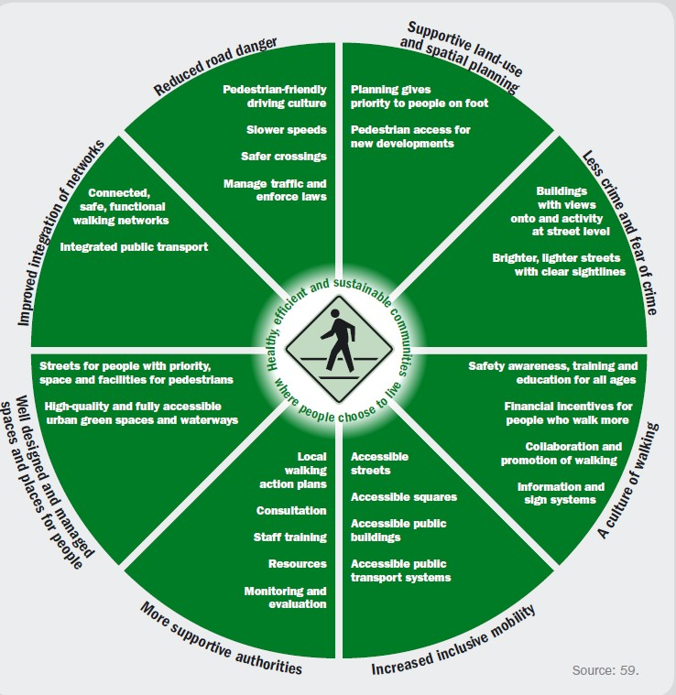

*Figure 28. A comprehensive framework for safe walking*

Source: WHO 2013.

Reports and findings from Australia and around the world have demonstrated that safe system strategies present some encouraging findings. Outcomes from the NRSS Implementation Status Report (2017) revealed that all jurisdictions in Australia have implemented lower speed limits in areas of high pedestrian activity: South Australia has introduced 40 km/h speed limits at locations with high pedestrian use. Areas of high pedestrian activity in New South Wales, including Sydney CBD, continue to roll out 40km/h speed zones. Evaluation of the permanent 40km/h zones resulted in a 38% reduction in causality crashes. In the Northern Territory, speed limits at school zones have been reduced to 30 km/h.

ACT has implemented 40 km/h speeds in town centres, 20 km/h shared zones in the city and 30 km/h in school zones. Pedestrian countdown timers have been trialled (or are planned) in some areas of New South Wales, Victoria, Western Australia and Tasmania. The joint VicRoads and Spencer Street pedestrian safety project, in Melbourne’s CBD, included raised pedestrian crossings (increasing pedestrian visibility to traffic as well as slowing traffic) and installing pedestrian countdown timers-indicating the time available for pedestrian to safely cross the road. Queensland has developed smart crossing guidelines including pedestrian countdown timers that detect pedestrians in traffic signals for safety and efficiency. Results from 2016 indicated that, relative to baseline (2008-2010), there was a 2.3% reduction in pedestrian fatalities. In South Australia, raised intersection platforms have been introduced to areas with high pedestrian crash rates. Also in South Australia, the Darlington Upgrade project has implemented two-way paths for cyclists and pedestrians (NRSS Implementation Status Report, 2017).

However, this was below the benchmark targets set out in the NRSS (for at least a 30% reduction by 2020). The Australian Automobile Associational (AAA) (2018) reported there was a 4.7% increase in pedestrian deaths on Australian roads in the twelve month period to June 2018, representing fatalities above the NRSS set targets. One of the recommendations from the AAA (2018) included reinstating the Federal Office Road Safety, to assist in the reporting the benchmark targets outlined in the NRSS, as currently Australia has no national system to measure serious road crash injuries. An inquiry into the effectiveness of the NRSS reported that reduced speed limits of 50 km/h are in fact in excess of the biomechanical tolerances of pedestrians and that 30 km/h would be beneficial in pedestrian injury reduction (Inquiry into the NRSS, 2018). A report by the NSW Government (2017) revealed a reduction in pedestrian fatalities (from 71 in 2016 to 54 in 2017) after the introduction of the “Look before you step out” campaign. Seventy four percent of respondents said the “Look before you step out” campaign emphasised the importance to be alert and present when crossing roads.

The New York Department of Transportation “Vision Zero Program” safe system approach has seen a decline in traffic fatalities over a four year period (ending 30th June 2018) with implementations such as: city default speed limits lowered to 25 mph (40 km/h); 2,000 new Leading Pedestrian Intervals (LPIs)-giving pedestrians a head start, over-turning vehicles, when entering an intersection; street redesign projects and calming dangerous left-turns (redesigning intersections including a rubber speed bump to slow drivers and discourage them from cutting corners, flexible plastic posts to buffer the pedestrians from the traffic and hardened centreline) and increased police enforcement of traffic laws, including speed cameras (The official website of the City of New York, 2018).

Associated conceptual models such as the Visionary Research Model, which look at pedestrian and vehicle conflicts, should also be taken into consideration (Corben et al., 2004). There is a need for the system to accommodate imperfect performance (in this case phone using pedestrians making road crossing errors), mainly through speed moderation or genuinely effective pedestrian-road separation: it is unrealistic to expect pedestrians to not make mistakes (Corben, 2018, personal communication). It is also important to take into consideration that not all solutions will work in all areas with differing traffic conditions (e.g. a solution that may work well in Melbourne CBD, may not work as well in the suburbs or in a rural location).

## POSSIBLE ACTIONS FOR FUTURE WORK

From the research undertaken in this project, the following possible actions for future work are made:

* **Use the safe system framework**. Road users, the road environment, vehicles and pedestrians should be considered in an integrated manner as the interaction of these elements occurs in most road traffic contexts. The safe system approach addresses risk factors and interventions in an integrated manner. For pedestrian safety, it is important to promote safe speeds, have a shared responsibility for road safety, recognise that humans make errors and have physical vulnerabilities and limits, and to develop a road environment that is forgiving of errors. To this end, a number of the potential countermeasures raised by the general public in the interviews and focus groups and the stakeholders in the road safety expert workshop adhere to safe system principles. These include: strategies aimed at developing a more error tolerant road environment through safe speeds and improved high quality pedestrian infrastructure (e.g. high quality footpaths-or providing footpaths where non currently exist, three way crossings at T intersections, raised platforms at roundabouts, reduced use of slip lanes), providing improved education on the dangers of smartphone use while walking, and using innovative technological solutions to alert distracted pedestrians of imminent threats (such as results from evaluation of embedded LED pedestrian lights being trialled in various locations around the world).
* **Apply an integrated approach**. The safe system framework requires consideration of vehicle design, infrastructure, traffic control and effective enforcement of traffic laws and regulations: as such, there are multiple factors addressed in pedestrian safety and pedestrians should be viewed as vulnerable, with smartphone-using pedestrians treated as being particularly vulnerable. Both the focus group and the road safety expert workshop panel opined that no single countermeasure could address pedestrian distraction; rather a combination of measures was the preferred approach. As an example, a policing ‘blitz’ of jaywalking involving both phone and non-phone using jaywalkers may be more effective if accompanied by a publicity campaign about the dangers of phone use whilst crossing a road. There seems to be little appetite for additional regulations or legislation on their own; thus, whilst necessary, it is unlikely that an approach that solely focuses on regulatory initiatives would be sufficient and it may be beneficial to utilise a systematic approach for new enforcement measures that are coupled with education and publicity. In addition, improved pedestrian infrastructure initiatives (provision of high quality footpaths, improved safety at pedestrian crossings – more time to cross, reduced crossing road width, advance start lights, puffin crossings) and reduced vehicle speed limits are important aspects of improving pedestrian safety.
* **Additional separation at key locations**. As part of an integrated approach, further use of separation and barriers to prevent pedestrians from veering onto roads in high-risk locations could be an option. This could be combined, for example, with safe vehicle speed limits in these locations and effective enforcement of road rules. For example, the concrete blocks/fencing at Swanson Street could be brought closer to the road to filter and slow pedestrians. Blocks/fencing could also be aesthetically pleasing, if designed as planter boxes with seats around them. They would possibly discourage pedestrians from walking whilst using smartphone technology by creating smartphone waiting places where pedestrians could finish texting etc. (special standing or sitting locations). In areas where children frequently cross, physical barriers such as fences or shrubs could be used to guide children towards safe crossing locations (Barton & Schwebel, 2007). However, this is a contentious issue as it could be argued that traffic calming negates the need for additional separation – best practice suggests that calming streets may be a better strategy than providing separation, and doing both does not make sense. Also, barriers/fencing may also be viewed as dangerous (as stepping out between them may make it harder for pedestrians to see and for vehicles to see them). As such, implementation of this would need to be reviewed with careful consideration to weigh up the implications and side-effects that may be present.
* **Possible additional infrastructure initiatives around public transport facilities**. Consideration should be given to extending the infrastructure initiatives that are currently in place at some tram stops, such as Jolimont station and Collins and Swanston streets, where pedestrians have facilities to remain separated from the road way as they enter/exit the tram. In addition, countermeasure initiative upgrades at some Victorian rail level crossings have seen manual magnet locks installed so the gates cannot be forced open (unless the train signal is inactive, and it is clear to cross). Manual magnet locks can be designed so that it is only possible to go through the gate from the opposite, with the release button is far enough away so it cannot be reached from the usual exit side.
* **Encouraging safe walking and mobility**. It is vital that pedestrian mobility is encouraged and that the safety messages attached to smartphone use do not discourage initiatives to encourage more walking. Good design standards and the further application of universal design principles (such as setting crossing times to allow pedestrians to cross before allowing vehicles to turn) may further encourage walking. The Transport for Victoria website stated that two thirds of all trips in the city of Melbourne are on foot and that Active Transport Victoria is focused on increasing the number of people walking and cycling as a form of transport. Targeting investment in infrastructure that keeps cyclists and pedestrians safe (for example as previously implemented with the Victorian Government's Safer Cyclists and Pedestrians Fund) is essential.
* **Greater use of ground signage**. Similarly, ground signage (e.g. “big stickers” placed on the ground to remind pedestrians to stop looking at their phones and to look up) is recommended. Combining these with publicity campaigns may be effective, but they may need to be changed regularly, also to make them funny, engaging and memorable and to overcome the loss of effectiveness that comes with habituation (such as the PTV “Dumb ways to Die” campaign). Similarly, in line with the safe system principle of shared responsibility, additional signage for vehicles and reducing speed limits at high pedestrian use sites is also recommended. In addition, warning signs for vehicles could be displayed as a projected image or variable sign rather than a fixed sign. However, the effectiveness in different lighting conditions would need to be investigated in such a way as to not cause street clutter and driver distraction. Also, an alternative to pavement embedded pedestrian lights, which would involve a substantial cost, laser lights of projected images onto the pavement, could be trialled with images changed periodically to avoid pedestrians becoming habituated and increase potential effectiveness.
* **Education for schools**. Education initiatives should be implemented as part of the school program (with other traffic education safety programs), which makes use of educational methods (including videos) to increase student awareness of the dangers of distracted walking. Interventions should focus on positive messages that demonstrate good pedestrian behaviour rather than focussing on highlighting distracted pedestrians and the aftermath of unsafe behaviour. A range of other educational initiatives would be worth investigating. For example the RACV “Safemates” is a secondary school initiative where students have the opportunity to work with road safety experts to design a road safety social media campaign. For the future generations starting at an early age, prior to unsafe behaviours being established, may implement behavioural changes for the long term. The Victorian Road Safety Education website has a variety of mediums that are designed for age specific demographics, including the national practices for early childhood Road Safety Education Guide. Other programs include the RACV “Street Scene” which aimed at primary aged students and incorporates pedestrian safety elements and the VicRoads RoadSmart program which is designed to build on road knowledge and skills for older students (Year 10 or equivalent) provides a range of methods that could be informative to a pedestrian distraction education campaign. Intervention programs designed with children’s age specific developing cognitive abilities in mind may be beneficial. For example, programs aimed at younger children (under 7 years old) choosing safe pedestrian locations to cross and only accept safe gaps in traffic is an important educational consideration as these, and other roads safety skills, may not be developed until about 12 years of age (Barton, 2006; Barton & Schwebel, 2007).
* **Public education/behaviour change strategies**. Public awareness campaigns and community education messaging that places an emphasis on remaining visually alert as a pedestrian is warranted. For example, public education could provide information about when and when not to text such as finishing texting before alighting from public transport.
* **Develop clear educational messages for the community**. A series of educational messages for the community to raise awareness of the issue and to present the emerging findings to phone end-users is recommended. Alternatively, targeting road safety educators, teachers, community organisations, road safety coordinators, Victoria Police, road safety officers at councils and other road safety influencers who can then pass on pedestrian distraction safety messages that will influence behaviour change.
* **Support technology, but not at the expense of other initiatives**. Most of the technology-based countermeasures (such as smartphone apps) are voluntary and unlikely to have a major impact upon pedestrian distraction on their own. The uptake of these initiatives may be very low, as was found with the “do not disturb” while driving app (such as implemented as part of the iOS 11, and later, updates on the Apple iPhone). This app on the phone senses that a user may be driving and prevents notifications as well as sending an automatic reply to the sender of a message that notifies them that the recipient is driving. The Android free app equivalent, “driving detective”, is available on Android 4.1 and above.
* **Additional inter-agency workshops and collaboration**. As a fundamental part of the safe system approach, workshops on the topic are recommended to share broader learnings across the road safety community. As an example, integrating the findings from the level crossings work being undertaken by Metro Trains and PTV within the work undertaken for this project.

The following areas for further research are suggested:

* **Effective implementation of countermeasures**. As a follow-on to this research it is suggested that further work be carried out to prioritise and effectively implement countermeasures be undertaken. Such work would ideally evaluate the effectiveness of the countermeasures within the safe system framework. For example, education campaign evaluation is an important aspect to see what actually works. The focus should be on educating pedestrians about where it is appropriate to use mobile phones and where it is inappropriate to use mobile phones. For example, stopping distraction in particular locations via specific educational initiatives. In

addition, an evaluation should be conducted of the effectiveness of the pilot schemes such as the six-month NSW trial conducted in December 2016, with in-ground traffic light technology installed in pavements at five points in Sydney’s CBD. An evaluation of the 12-month trial of the pavement lights at the corner of Swanston and Little Collins streets in Melbourne would also be helpful.

* **Further research using conceptual models, such as Visionary Research Model (VRM)**. This model was developed to identify what is needed to create safe traffic environments and the concept has been used in numerous applications since it was published. It identifies countermeasures and approaches that, if applied, could effectively reduce the risk of pedestrians’ death, serious injury, or risk of being struck by a vehicle. A pedestrian struck by a vehicle may experience first and secondary kinetic energy impacts, from speed of the vehicle itself and from landing on the road surface. The conceptual VRM identifies simultaneous countermeasures, for road-transport system designs, that could be effective in reducing injury and death on Victorian roads. For example: lowering vehicle speeds and incorporating and utilising an array of aspects such as:
  + road infrastructure (e.g. traffic claiming measures, traffic management initiatives)
  + system operation (e.g. speed reductions in pedestrian areas (e.g. potentially improving vehicle stopping distances, perception-reaction times and impact speed of pedestrian/vehicle interactions)
  + in-vehicle technology/car designs (e.g. intelligent speed adaptation).

For example, infrastructure changes in areas where there is a mix of pedestrians and vehicles, would provide effective separation of pedestrians and vehicles in conjunction with reduced vehicle speed limits (around 30-40 km/h). Also, traffic management initiatives e.g. encouraging traffic flow away from pedestrian areas e.g. with traffic signal technology (timing, phases); vehicle turning bans etc.; congestion pricing levees; and targeting particular locations and/or particular times (times of the day or days of the week) in areas of high risk.

Behavioural change and enforcement programs (e.g. education and publicity) may potentially be of assistance but not in changing the levels of risk in the physical/traffic environment. It also important to note that any behaviour change initiatives must be carefully targeted so as not to discourage walking. It was noted that the most effective countermeasures may be different than the perceived risk source; that is, pedestrian’s inability to select safe gaps in traffic (poor gap selection) may be best addressed with implementations of median/central refuges (simplifying the gap selection process) or traffic calming measures rather than by education or skills training, as these take into consideration human error.

Possible actions from the previous VRM study included medians, road narrowing or widening footpaths and lower speed limits. In addition, fencing or physical barriers (e.g. landscaping or planting) to help separate pedestrians and vehicles and guide pedestrians towards designated crossing areas were recommended. This could be particularly important around Melbourne trams stops where large numbers of pedestrians potentially alight/board trams in a hazardous manner near or on roadways. However, with tram stops increasingly being made Disability Discrimination Act 2005 (DDA) compliant and step free, this may not be applicable. Further work on the VRM was also recommended to develop and validate the quantitative aspects of the model.

* **Investigating under 18s**. The scope of the current research was restricted to adults (over 18 years) for ethical reasons. However, given the popularity of smartphones amongst children and younger teens, it is suggested that further work with these groups be undertaken. This may include observations, interviews and focus groups with pedestrians covering a range of age groups under 18. Identify suitable messages for a range of under 18 age groups.
* **Examine non-city centre locations**. The current work was conducted mainly at city locations. Further work to establish the extent of the issue in suburban, regional or rural locations (including near busy highways connecting major population centres) could be undertaken. There are vast differences in pedestrian traffic congestion and the road environment between the Melbourne CBD and the outer areas of metropolitan Melbourne and rural areas/cities and towns. As such, it is important to investigate if there is a pedestrian distraction issue elsewhere and acknowledge that some solutions may be more successful in certain areas where the traffic demand/road environment is quite different.
* **Explore phone user motivations and health issues**. From a human factors perspective, looking at human behaviour and gaining insight of pedestrians’ perception from the interviews and focus groups has given a good

understanding of pedestrian smartphone distraction in the areas observed in Melbourne. However, for future research, contributing factors (e.g. phone user motivations) and other risk factors (e.g. driver behaviour) should also be considered within a wider systems framework. The current research did not focus explicitly on phone user motivations. Further research to better understand motivations for using a phone, even in potentially hazardous situations - such as crossing a road, would be valuable in asserting why people engage in such activities even when known to be dangerous.

Also, although not directly related to pedestrian distraction, if people are made more aware of the wider health implications of smartphone use, such as phone addiction and screen time issues, there could be flow on effects to things like mindful walking. Examining screen addiction treatment regimens may prove informative, if such health initiatives are available. Further research could also explore what types of pedestrian critical events are linked to particular types of phone use or the level and type of distraction experienced. The current study did find headphone use and texting were associated with increased critical incidences, so this aspect could be investigated further with a larger sample population study solely focusing on reviewing critical instances. Also, issues that may arise from pedestrians having their hands occupied by a phone could be investigated e.g. inability to steady walking, reach out if falling, not seeing trip hazards, etc.

## CONCLUSIONS

Pedestrian distraction from smartphones is a growing issue and is a risk factor when crossing roads (as evidenced through the number of critical incidents experienced by phone-using pedestrians). A range of countermeasures do exist around the world, but no single initiative is fully effective on its own. It is unrealistic to expect pedestrians to be suddenly free of mistakes such as making road crossing errors. As such, a key component of managing pedestrian safety and smartphone use should be to focus on reducing the risks associated with smartphone devices when walking, not on trying to eliminate phone distraction altogether. Interventions should complement each other, not be developed in isolation and try to address all key aspects of the safe system approach.

Whilst it is still important to work to reduce the incidence of pedestrians crossing roads while distracted from their smartphones, it may not be possible to rely solely on this being effective. In reality, as seen in the observational component, a sizeable proportion of people may continue using phones in a risky way in the road environment, no matter what is done or how much they are aware of the risks. As such, in order to succeed, a system is needed that accommodates imperfect human performance that is designed around vulnerable users who may be at increased risk of injury or fatality. This may be primarily through speed moderation and/or a more extensive footpath network (genuinely effective separation, as mentioned earlier, is a contentious issue and should be viewed with caution). Interventions (countermeasure or regulation etc.) should, ideally, be evidence-based.

# APPENDIX A. PEDESTRIAN OBSERVATIONAL SITE LOCATIONS

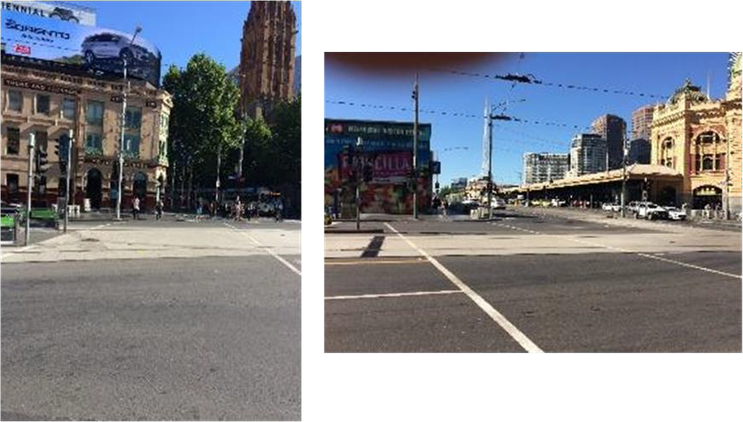

*Appendix A-1 Signalised crossings at Flinders Street (incorporating the tram stop to the West and signalised crossing to the East), Melbourne CBD*

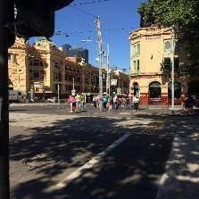

*Appendix A-2 Swanston Street and Flinders street (Signalised crossing), Melbourne CBD*

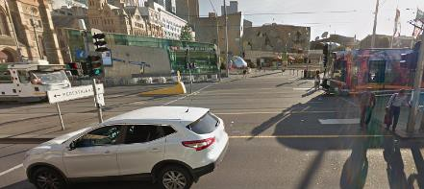

*Appendix A-3 Signalised crossing at St Kilda Road & Flinders Street (incorporating the tram stop to the south), Melbourne CBD*

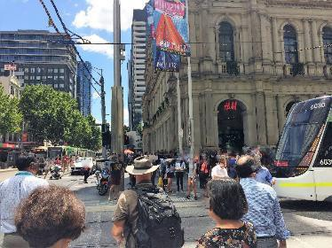

*Appendix A-4 Signalised crossing at Bourne Street and Elizabeth Street (incorporating the tram stop), Melbourne CBD*

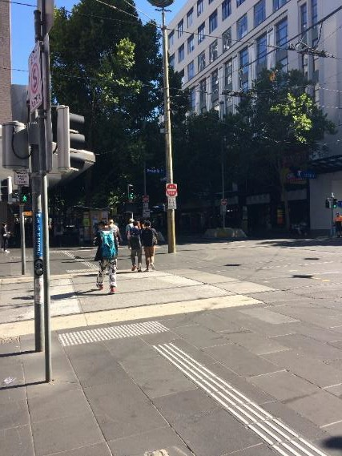

*Appendix A-5 Signalised crossing at Bourke Street & Swanston Street, Melbourne CBD*

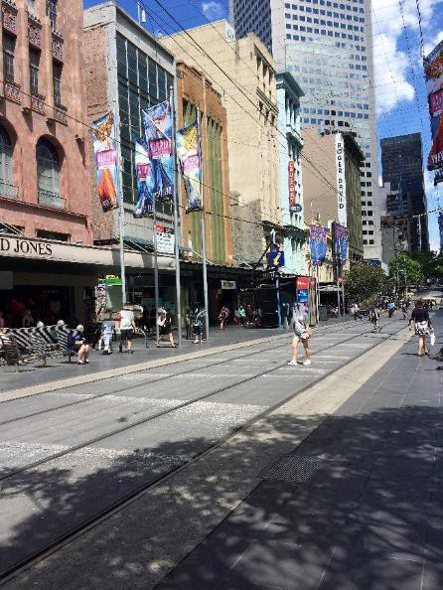

*Appendix A-6 Bourke Street mall pedestrian precinct and tram route, Melbourne CBD*

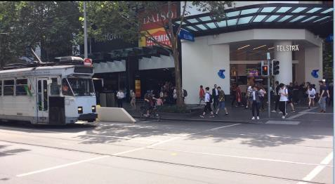

*Appendix A-7 Bourke Street and Swanston Street (incorporating tram stop to the West), Melbourne CBD*

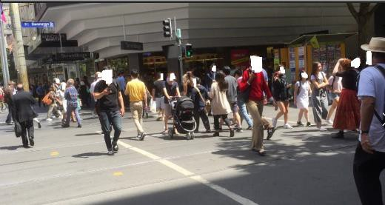

*Appendix A-8 Bourke Street and Swanston Street signalised crossing (incorporating tram stop to the North), Melbourne CBD*

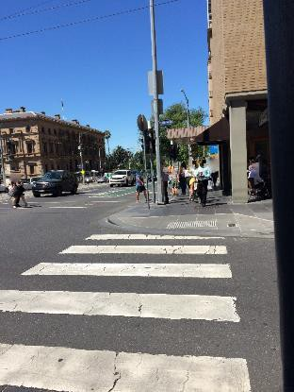

*Appendix A-9 Little Collins Street and Spring Street, Melbourne CBD (un-signalised crossing)*

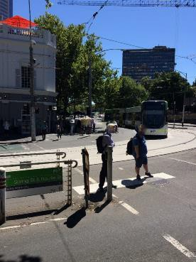

*Appendix A-10 Spring Street and Bourke Street signalised crossing (incorporating the tram stop), Melbourne CBD*

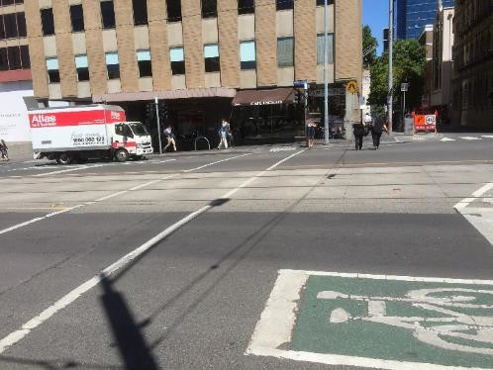

*Appendix A-11 Spring Street and Little Collins Street (signalised crossing), Melbourne CBD*

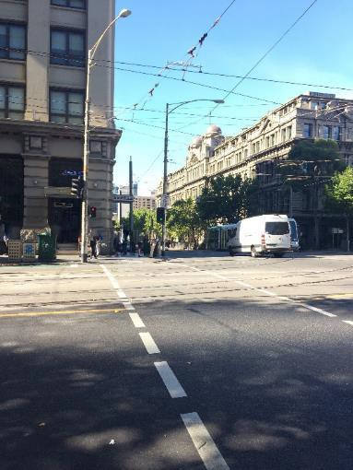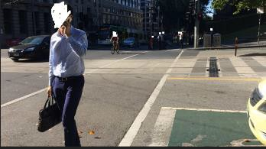

*Appendix A-12 Collins Street and Spencer Street (signalised crossings to the East and West), Melbourne CBD*

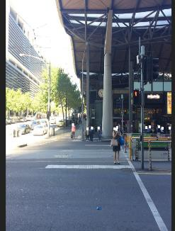 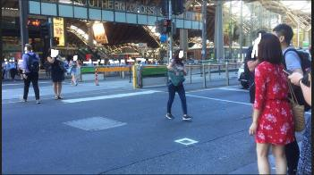

*Appendix A-13 Spencer Street (signalised crossings), Melbourne CBD*

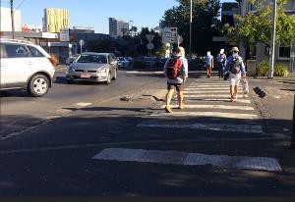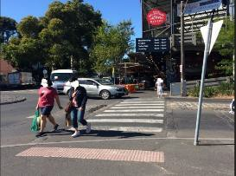

*Appendix A-14 Cecil Street and York Street (un-signalised crossing), South Melbourne*

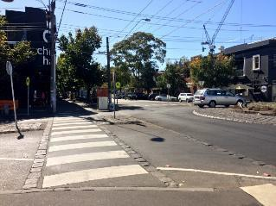 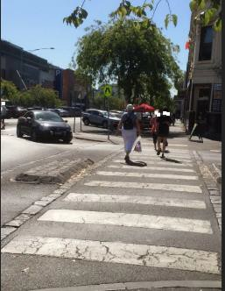

*Appendix A-15 Cecil Street and Coventry Street (un-signalised crossing), South Melbourne*

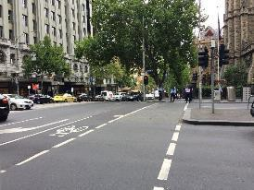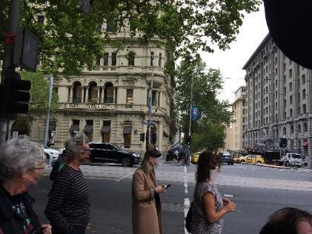

*Appendix A-16 Collins Street and Russell Street (signalised crossing), Melbourne CBD*

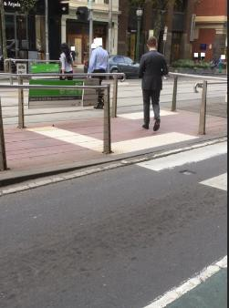

*Appendix A-17 Collins Street (101 Collins Street and tram stop un-signalised crossing), Melbourne CBD*

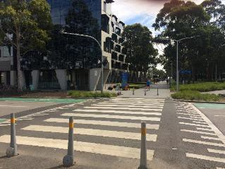

*Appendix A-18 -Scenic Boulevard and Sports Walk (un-signalised crossing), Monash University Clayton*

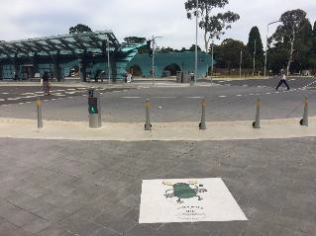

*Appendix A-19 Bus loop (signalised crossing), Monash University Clayton*

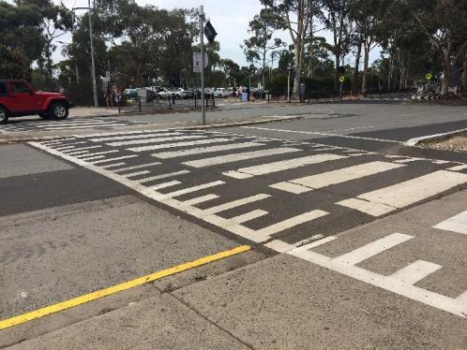

*Appendix A-20 Scenic Boulevard (un-signalised), Monash University Clayton*

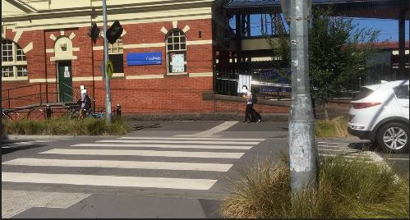

*Appendix A-21 Monash University (un-signalised crossing), Caulfield Campus, Sir John Monash Drive, Caulfield*

# APPENDIX B. PEDESTRIAN OBSERVATION DATA COLLECTION SHEET

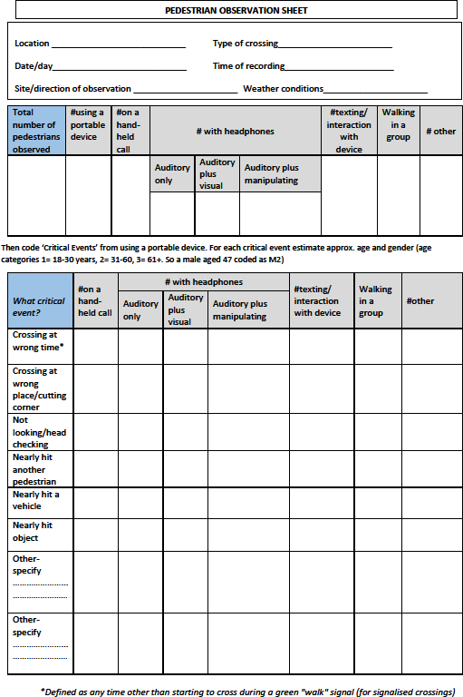

# APPENDIX C. INTERCEPT INTERVIEW SCHEDULE

I am from Monash University and we are conducting a study on people’s perception of pedestrians using Smartphones whilst walking in busy locations. Would you have five minutes to answer a few short questions? Yes (continue) No (Thank and terminate-data was also collected on the number of declinations and reason, if any, that was provided).

Questions were read from the sheet by the interviewee (to enable continuity and reliability of data collected) and answers recorded by another interviewee to effective time management of verbal communication and scribing

#### Questions

1. What are your thoughts about people using their smartphones whilst walking in a busy location e.g.: city centre?
2. Are there any specific situations where you feel it might be more risky?
3. Do you think it is more risky for people to use a smartphone at a signalised or non-signalised crossing?
4. Have you ever seen any occurrences from a pedestrian using a smartphone? For example, a near miss involving a car whilst a pedestrian was using their smartphone?
5. Have you physically bumped into another person or object while you were distracted by talking or texting on your phone?
6. What could be done to promote safer smartphone use in busy locations? e.g.: education (posters), technology, engineering or regulations?

# APPENDIX D. COUNTERMEASURES AND REGULATIONS

|  |  |  |  |  |  |
| --- | --- | --- | --- | --- | --- |
| Australia | | | | | |
| Category of Regulation/Countermeasure | |  | Where and when implemented | | Citation Details |
| **Overall Category** | **Specific category** | **Authority & date** | **State** | **Regulation/Counter measure initiative** | **Source** |
| Behavioural countermeasures | Publicity campaign | City of Melbourne (2007) | VIC | City of Melbourne (2007) “Share the road” campaign | Austroads Research Report (2016) |
| Behavioural countermeasures | Publicity campaign | Pedestrian Council of Australia (PCA) December 2010 | All | LAMBS TO THE SLAUGHTER - WAIT FOR THE  GREEN pedestrian safety awareness campaign | Pedestrian Council of Australia (PCA) 2010 |
| Behavioural countermeasures | Publicity campaign | State of Queensland (2015) | QLD | State of Queensland (2015) “Share the road” campaign | Austroads Research Report (2016) |
| Behavioural countermeasures | Publicity campaign | RACT (2016) | Tasmania | A public education campaign to warn pedestrians about the dangers of crossing the road while using a mobile phone should be considered following the recent publication of pedestrian safety research by Austroads. Countermeasures to combat the issue should include education and engineering interventions at high pedestrian activity locations | Media release 18/3/2016 |
| Behavioural countermeasures | Publicity campaign | TAC (2016) | All | TAC # get the look this summer campaign | TAC website |
| Behavioural countermeasures | Publicity campaign | NSW government transport for NSW Centre for road safety (2016) | NSW | "Look before you step out" campaign: Look Out Before You Step Out was launched in October 2016 and aims to improve pedestrian safety, particularly on higher risk urban roads. The campaign targets metropolitan areas with higher pedestrian volumes, including Sydney, Newcastle and Wollongong | [http://roadsafety.transport.nsw.gov.au/campai](http://roadsafety.transport.nsw.gov.au/campaigns/look-out-before-you-step-out/index.html) [gns/look-out-](http://roadsafety.transport.nsw.gov.au/campaigns/look-out-before-you-step-out/index.html) [before-you-step-out/index.html](http://roadsafety.transport.nsw.gov.au/campaigns/look-out-before-you-step-out/index.html) |

|  |  |  |  |  |  |
| --- | --- | --- | --- | --- | --- |
| Australia continued | | | | | |
| Behavioural countermeasures | Publicity campaign | Pedestrian Council of Australia (PCA) in conjunction with the NSW Centre for Road Safety.  01/02/2017 | NSW | Campaign across TV and social media entitled "Don't Tune Out." Its aim is to shock pedestrians into understanding the deadly dangers of talking, texting and listening to music (often with noise cancelling earphones) while crossing the road | PCA media release |
| Infrastructure | Roads/power supply- lighting | New South Wales government. December 2016 (6-month trial) | NSW | In-ground traffic-light technology (traffic lights) installed in pavements in Sydney at five key crossings in the central business district to prevent accidents caused by pedestrians distracted by their phones | The Guardian 13/06/2016 & [http://roadsafety.transport.nsw.gov.au/staying](http://roadsafety.transport.nsw.gov.au/stayingsafe/pedestrian) [safe/pedestrian](http://roadsafety.transport.nsw.gov.au/stayingsafe/pedestrian) s/index.html |
| Infrastructure | Pedestrian crossing & pedestrian crossing lights | VicRoads & TAC (2018) | VIC | Raised pedestrian crossing at Spencer St (Southern Cross vicinity) & reprogramming signal timers to increase crossing times and installing pedestrian light countdown timers | Vic Roads media release |
| Regulation | Infringement | Victoria Police | VIC | Victoria Police inspector for road policing Jason McGregor said police were out in force and would be handing out $76 on- the-spot fines to jaywalkers | The Age 20/01/2016 |

|  |  |  |  |  |  |
| --- | --- | --- | --- | --- | --- |
| International | | | | | |
| Category of Regulation/Countermeasure | |  | Where and when implemented | | Citation Details |
| **Overall Category** | **Specific category** | **Authority & date** | **Country** | **Regulation/Counter measure initiative** | **Source** |
| Legislation | City council regulation | The City of Rexburg, Idaho. | USA | There is no texting while using a crosswalk in the City of Rexburg. The first offense fine is $101.50, the second offense is $201.50, and any other offense after that will have a $51.50 court cost added to the previous amount. | Governors Highway Safety Association (GHSA) report 2016.  Rexburg Police department webpage: <http://rexburgpolice.com/info/CityOrd.cfm> (accessed 10/01/2018) |
| Legislation | Borough State regulation | Fort Lee, New Jersey. New York City May 2012 | USA | Fort Lee, New Jersey have banned texting while walking. USD85 jaywalking ticket. "Walking and using such devices is not against the law. Failing to use a crosswalk or walking against the signal is against the law." | Safety.com https:/[/www.safety.com/distracted-walking-a-](http://www.safety.com/distracted-walking-a-) major-pedestrian-safety-concern/#gref |
| Legislation | State legislation | Utah Transit Authority (UTA)-Salt Lake City. March 2012 | USA | UTA adopted an ordinance that prohibited pedestrians from distractions including talking on cell phones, listening to music with headphones, texting, attending to personal hygiene or reading newspapers or magazines while crossing the UTA rail tracks on the streets of Salt Lake City. Distracted walkers are subject to $50 civic fine & repeated offenses could cost $100. Efforts to make it a state-wide law failed in July 2012. Further, UTA officials reported that the ordinance was working and that pedestrians were doing it the right way more often | Cortez (2012) and Davidson (2012). Cited in Mwakalonge J, Siuhi S and White J. (2015) paper |

|  |  |  |  |  |  |
| --- | --- | --- | --- | --- | --- |
| International continued | | | | | |
| Legislation | State legislation | Hawaii, Honolulu | USA | Distracted walking legislation makes it illegal for a pedestrian to view any mobile electronic device while crossing a street or highway. The law fines violators up to $35 for a first offense, up to $75 for a second offense, and up to $99 for a third offense if cited during the same year | Mynorthwest news report |
| Infrastructure | Roads/power supply- lighting | Augsburg, Munich | Germany | Traffic lights installed at ground level. At Haunstetterstraße station, 16 red LEDs are embedded in the pavement next to a tram crossing | The Guardian 29/04/2016 |
| Infrastructure | Roads/power supply- lighting | Cologne | Germany | Equipped three tram crossings with ground traffic lights | The Guardian 29/04/2016 |
| Infrastructure | Street signage | Stockholm | Sweden | 2015, road signs appeared in Stockholm warning cars about texting pedestrians. | The Australian 02/03/2016 |
| Infrastructure | Road ways | Chongqing | China | A theme park experimented with a special “phone lane” for pedestrians | The Guardian 29/04/2016 |
| Infrastructure | Roads | Austrian Road Safety Board (Kuratorium für Verkehrssicherheit - KFV) | Austria | Making the country's streets safer for so-called smartphone zombies. Lampposts on busy pedestrian streets across the nation were outfitted with cushioned airbags. The provocative slogan "Will the next car be so well padded? Look where you're going, not at your mobile phone!" printed on all the 'lamppost airbags' sought to remind pedestrians - and all other road users as well – how important it is to pay attention on the roads. | Kuratorium für Verkehrssicherheit: |

|  |  |  |  |  |  |
| --- | --- | --- | --- | --- | --- |
| International continued | | | | | |
| Infrastructure | Roads | Living streets charity- London | UK | Brick Lane, London UK has been made the country's first “Safe Text” street | Daily mail article 04/03/2008 |
| Infrastructure | Roads/Pedestrian crossings | St Petersburg Florida & Boulder Colorado USA | USA | Engineering technology initiatives to alert divers of pedestrians and to alert pedestrians to cross the road with care. | Time article 21/03/2008 |
| Infrastructure | Rail level crossings | Kiwirail | New Zealand | KiwiRail initiated a programme to evaluate whether LED visual warning devices installed on the ground – illuminated in- ground pads – are an effective innovative solution to combat pedestrians’ complacency and inattention at level crossings. This study focuses on evaluating the effects of this new signage on pedestrians who are distracted by a mobile device. It will assess how visual scanning and looking for train behaviour change with the introduction of the illuminated in-ground pads as a way to confirm whether the activation of the lights are effective at attracting the attention of pedestrians distracted by mobile devices or headphones. The evaluation combines objective data measurements from an eye tracking system (where pedestrians are looking when approaching level crossings), with qualitative information to understand and contextualise gaze behaviour. | https://research.qut.edu.au/carrsq/projects/lc 18-pedestrian-led-visual-warning-device/ |
| Behavioural countermeasures | Publicity campaign | NHTSA-Everyone is a Pedestrian campaign. 2013 | USA | New York City, Philadelphia and Louisville. THE U.S. DEPARTMENT OF TRANSPORTATION (USDOT)-  Safer People Safer Streets Initiative-unveiled in Sep 2014 | Governors Highway Safety Association (GHSA) report 2014 |
|  |  |  | International continued | |  |

|  |  |  |  |  |  |
| --- | --- | --- | --- | --- | --- |
| Behavioural countermeasures | Publicity campaign | Montgomery County Dept of Transportation | USA | #YOLOwalksafe campaign.  Montgomery’s public awareness campaign asks high school students sign a pledge that they will cross streets safely. Posters in school hallways will show teenagers with black tire tread marks across their faces with slogans such as: “If you text, you’re next” and “Smart phones can make you do stupid things.” | [www.montgomeryschoolsmd.org/safety/](http://www.montgomeryschoolsmd.org/safety/) |
| Behavioural countermeasures | Publicity campaign | Lausanne Police department & AEC (2015) | Switzerland | Video broadcast in French and German cross Switzerland mixes shocking images and black humour to reach the young generation on the dangers of pedestrian distraction whist crossing the road | [https://www.lematin.ch/suisse/Un-clip-choc-](https://www.lematin.ch/suisse/Un-clip-choc-pour-lutter-contre-l-inattention-des-pietons/story/25519316) [pour-lutter-contre-l-inattention-des-](https://www.lematin.ch/suisse/Un-clip-choc-pour-lutter-contre-l-inattention-des-pietons/story/25519316) [pietons/story/25519316](https://www.lematin.ch/suisse/Un-clip-choc-pour-lutter-contre-l-inattention-des-pietons/story/25519316) |
| Behavioural countermeasures | Publicity campaign | Auckland Transport (2011) | New Zealand | Auckland Transport (2011) “Check before you step” | Austroads Research Report (2016) |
| Behavioural countermeasures | Publicity campaign | Auckland City Council | New Zealand | Auckland City Council “Don’t step into danger”. | Austroads Research Report (2016) |
| Behavioural countermeasures | Publicity campaign | Wellington City Council | New Zealand | Wellington City Council “Cross the road with a clear head” | Austroads Research Report (2016) |
| Regulations | Private enterprise | Parking garages –San Francisco | USA | Guards have been hired to guard the entrance to a garage in San Francisco to stop cars from hitting pedestrians who are so engrossed in screens they don’t notice they’re stepping into traffic | The Wall street journal 02/03/2016 |
| Regulations | State regulation (2017) | Toronto, Ontario | Canada | Private bill is to be submitted to create a law to fine pedestrians who use their mobile phone whilst crossing the streets | https://ici.radiocanada.ca/nouvelle/1064168/p rojet-loi- zombies-rues-pietons-telephone- distraction |

|  |  |  |  |  |  |
| --- | --- | --- | --- | --- | --- |
|  |  |  |  | Technology |  |
| Category of regulation/Countermeasure | |  | Where and when implemented | | Citation details |
| **Overall Category** | **Specific category** | **Authority & date** | **Country** | **Regulation/Counter measure initiative** | **Source** |
| Technology | Smart phone application | N/A | N/A | Using software that reads out messages to you, and voice recognition typing so that you can give commands with your voice instead of having to continually look at your screen. Type n Walk is available on the iOS App Store and the free Walking Text from the Google Play  Store. | Safety.com report dated 18/07/2017 |
| Technology | Alerts | Portland, Seattle & Cleveland | USA | Experimented with talking buses that alert pedestrians during turns | The Guardian 29/04/2016 |
| Technology | Smart phone application | Various | N/A | Walk Safely: Walk Safely prevents the user from walking and using smartphone’s screen at the same time (screen is disabled when walking). The warning screen returns if the user continues walking. -  Google play App | Android software app |
| Technology | Smart phone application | Leadconn Technology | N/A | Look ahead: The application will issue a caution message to prevent accidents causing from “Texting While Walking”. Google play App | Updated 5/12/2017 |
| Technology | Smart phone application | CGactive LLC iOS devices Maulik Shah  Alexander Kaessner | N/A | Type n Walk - available on the iTunes App store Type while walk -available on the iTunes App store  Walkie (messenger) -available on the iTunes App store | Last updated 6/11/2014 Version 3.0.1  Version 2.2.5 |
| Technology | Smart phone application | Megapps Ventures Inc. Andpi xylefus.com Nebojša Božić Trutech  Aditya Balwani  A1 Brains Infotech | N/A | Walk and Text -Google play App Walking text -Google play App  Walk N Text Window -Google play App Walk and Text -Google play App  WalkApp : walk while you text -Google play App WAT - Walk And Text  -Google play App  Walk Type Share-Google play App | Updated 2013  Updated 6/01/2014 Updated 27/05/2015 Updated 22/08/2014 Updated 20/06/2015 Updated 12 October 2014  Updated 21 December 2013 |

|  |  |  |  |  |  |
| --- | --- | --- | --- | --- | --- |
| Technology (Continued) | | | | | |
| Category of regulation/Countermeasure | |  | Where and when implemented | | Citation details |
| **Overall Category** | **Specific category** | **Authority & date** | **Country** | **Regulation/Counter measure initiative** | **Source** |
| Technology | Smart phone application | Brothers In Motion-Finland | N/A | Walk Safely: Walk Safely prevents the user from walking and using smartphone’s screen at the same time. The app detects if the user is walking or running and shows a warning screen that blocks the normal view. The phone’s other functions or ongoing calls are not disturbed. Warning screen can be removed by pressing the hide sign or by stopping walking. The warning screen returns if the user continues walking. -Google play App | Updated 28 March 2017 |
| Technology | Smart phone application | UbiComp-UK | N/A | Walk Safely-Google play App (screen is disabled when walking) | Updated 4 November 2017 |
| Technology | Smart phone application | Morihiro Soft | N/A | Texting While Walking Block: Display block screen (semi- transparent) to the front, so that you can't operate a smartphone while you are walking. -Google play App | Updated 29 October 2013 |
| Technology | Smart phone application | theSOULwithin apps | N/A | Sidewalk Buddy: is a free app that will allow you to safely use your other apps with a clean and resizable pop-up which shows a live video feed from your rear facing camera as you walk and type.  Texting and walking safety issues are gone! Navigate busy streets with ease, get more work done and be able to multi-task with safety in mind. Unlike transparent screen-based apps, this app provides a clean separation between the video and the app you are using without getting too busy. This app is for entertainment purposes only. -Google play App | Updated 30 October 2014 |
| Technology | Smart phone application | Leadconn Technology | N/A | Look ahead: The application will issue notice to prevent accidents of causing from “Texting While Walking”. Google play App | Updated 5 December 2017 |

|  |  |  |  |  |  |
| --- | --- | --- | --- | --- | --- |
| Technology (Continued) | | | | | |
| Category of regulation/Countermeasure | |  | Where and when implemented | | Citation details |
| **Overall Category** | **Specific category** | **Authority & date** | **Country** | **Regulation/Counter measure initiative** | **Source** |
| Technology | Smart phone application | DGApps | N/A | WalkCam: is a productive way to continue walking safely while using your phone. DGApps has created an adjustable floating window that shows where you are going on a resizable floating camera window that shows you the road in real time. | Updated 31 May 2017 |
| Technology | Smart phone application | [sg-help@safely.com](mailto:sg-help@safely.com) [On google play](mailto:sg-help@safely.com) | N/A | “Digital wellness”  -Practice “digital wellness” by being in control of your phone, not “compelled” by it  - Work and play better, by concentrating on being where you are, while effortlessly letting contacts know you’ll get back to them soon | Last updated 3/05/2013 Version 1.2 |

# APPENDIX E. END USER FOCUS GROUP: RAW OUTCOMES

#### What are your thoughts about people using their smartphones whilst walking in a busy location

[*participant in their 20-30’s*] There is a risk yes, especially seeing the video you showed, but I am guilty of doing it myself.

[*participant in their 40’s*] It wasn’t an issue 20 years ago (when I was 21) but now because mobile phones have improved, and the technology has advanced since 2008, phones have the internet on them there is more involvement in the mobile now. Also, people use the phone more as a navigator to get around rather than using their own knowledge

[*participant in their 40’s*] Our generation have grown up without mobile phones, so we are not as dependant, I personally don’t use it when I am out and about. When I am walking I come across numerous people on their phones-watching things on their phones (walking and watching) not looking at the environment around them I find it really curious

People are not focused on the external environment, just internal (on their phones) [*participant in their 40’s*]. Not focusing on their surrounds but focusing on their phones [*participant in their 50’s*]

[*participant in their 20’s*] If I am walking to some where I walk every day (like the supermarket), it is boring to look at the same houses when I could be looking at something else, it’s probably when I do it the most somewhere old, if its somewhere new then I am trying to find my way so I don’t use the phone, I’m looking around. I do not think it is an issue if I walk somewhere every day and are familiar with the area, but probably not a good idea if it’s somewhere new.

[*participant in their 40’s*] Used to be everyone was using a Walkman, not everyone is distracted by their phones, so people are still using headphones today. Headphones are a bad distraction for audio but visually it’s ok

[*participant in their 20’s*] I have walked into someone myself. I believe it’s not a good thing but it’s a mixture of habit and addiction

#### Is pedestrian smartphone distraction a problem?

People need to be more updated nowadays they need to use their phone more/all the time. You see everyone focused on their phones – their focus is internal

Using a phone as a pedestrian is not good. It is now habit and an addiction for a lot of people. People have to constantly feel connected, so cannot get off their phones, even when walking.

#### What broadly can be done about it?

Behavioural change intervention so people set their phone so they only get more crucial phone calls or texts that actually need you attention messages/only respond to really urgent information from their phones.

[*participant in their 20’s*] Banning phone use is pretty ineffectual, actually it may have an effect but it’s pretty unrealistic. Jaywalking is illegal, but people still do it, so I think it would be like that. [*spoken by someone in their 50’s*] Perhaps banning just while crossing the road/intersection would work better. Just like then ban smoking in most places now.

[*participant in their 40’s*] Education programs, such as through media campaigns might work. That seems to get people watching and listening. Then someone else [*participant in their 40’s*] suggested what if the advertisement is on the mobile? Could be on both as someone in their 20’s may be watching on their phone whereas someone like me would be watching on the TV.

[*participant in their 20’s*] Need to somehow transfer pedestrian’s attention from the phone to vehicles – so focus on how to do that?

[*participant in their 40’s*] We have technology in cars that block phones when it is determined it is in a car it will shut down, so perhaps extend that to pedestrian situation to block phones while walking (immobiliser when you are out walking as you should be aware of your environment). [*spoken by someone in their 20’s*] it may actually be a step backwards as sometimes you actually need to do something while you are walking e.g. use a map when you are in an unfamiliar location or if you are lost you need to call/text someone while you are walking trying to find them (having to

stop and stand still waiting for your phone to reboot up it would make people switch to other types of phones it would not work it would just inconvenience people-there would be so much back lash.

[*participant in their 20’s-30’s*] People are on the phone because they are constantly getting notifications (e.g. news.com)– the phone is actively trying to distract people. So perhaps turning off notifications for a whole bunch of apps while walking and just set to the more important ones (but this is a real behaviour change intervention)– user does this, or automatically if phone detects movement?

[*participant in their 20’s*] Have dedicated distracted pedestrian pathways or areas where people can pull off the path to use their phone. Make pathways where people on their phones can walk.

[*participant in their 20’s*] Use voice activation/recognition to speak to the phone or have messages read rather than looking at phone.

[*participant in their 40’s*] As people are always looking down maybe have something on ground (illuminated) near traffic lights etc. to alert peds that their head is down and should be up.

[*participant in their 20’s*] People are aware of the risks, but their phone is a necessity (they use it every day) so need to take ownership and you yourself should be careful, not watch videos when you are crossing the street for example.

People being made aware of dangers of phone use while walking and encouraging people not to use phone. [*participant in their 40’s*] I thought it wasn’t just teenagers taking this risk I was surprised it was older people too

# APPENDIX F. GROUP DISCUSSION OF FOUR COUNTERMEASURES: RAW OUTCOMES

It was consensually agreed to discuss the countermeasures and strategies around the themes and categories that had previously been developed (compatible with, but not presented within a typical safe system approach). The following is the raw outcomes from the discussions.

#### Infrastructure

* + Areas with high traffic instances (such as Flinders street and Swanston Street) and around the station could be viewed with combined lens of road safety and CT and simple infrastructure solutions could be made. As an example, the concrete blocks/fencing outside Spencer Street could be brought closer to the roadside verge and be made into plant pots creating a physical barrier for pedestrians, filtering and slowing them down and forcing them to consider what they are doing as they approach the intersection.
  + The barriers could also be turned into seats, as a suggestion outcome from the focus group discussion. This may encourage pedestrians to stop walking while they text. However, consideration would need to be made as to the height of these barriers, so people do not trip over them – for example they could be made into planter boxes with seats around them. This would be aesthetic and practical – with the visual look of the trees and the greenery.
  + At rail crossings there is a concern that red lights on the ground, aimed at warning pedestrian of the crossing, may in fact impede the train drivers - as they are trained that when they see red they stop.
  + In New Zealand, a study to evaluate the effectiveness of the embedded LED pedestrian lights, with a chicane to slow people down, at a pedestrian railway crossing was conducted. As far as the authors of this paper are aware the results of this evaluation are yet to be published
  + Embedded lights is not a cheap prospect so some sort of alternative like laser lights (red flashing lights) reflected on footpath may be an alternative. These could be positioned so they are only visible to those on the footpath and as such does not distract drivers.
  + Projected warning signs are being trialled at road work sites to warn drivers approaching to reduce their speed and proceed slowly. This could possibly be used in all sorts of other applications. Consideration should be given to the effectiveness in day time. An alternative could be lasers but these could possibly be a problem.
  + Placing a physical ‘keep left’ wire rope barrier down the centre of the pavement with breaks along the route so pedestrians could access the shops etc.
  + Puffin crossings are a universal design. Amendments to signal timings could be considered, e.g. reviewing when there is a green signal for vehicles at the same time as green for the pedestrians. This leads to pedestrians having to do a lot of head checks as vehicles may not necessarily give way to the pedestrians, as per the road rules. An additional consideration could be giving pedestrians advanced crossing times, before the vehicle turn signal activates. Many signal changes could be considered that could cater to a diverse pedestrian cohort.
  + Tactile strips, which for a pedestrian equates to an intersection, could be considered. This would give pedestrians perceptual input about their surroundings, potentially making them look up. If pedestrians are engaged in a visual task, such as looking at a smartphone, this initiative could be more beneficial than a visual input as that may be less effective than an auditory or tactile alert.
  + Some sort of auditory/beeping type message being broadcasted saying “eyes up” or something similar could also be a consideration.
  + A universal concept such as the holding bay type set ups, currently in place at some Melbourne tram stops (for example Jolimont station tram stop cross roads).

#### Education/awareness campaigns/Behavioural initiatives

* + Strategies incorporating social norms or peer pressure may be beneficial, involving a cultural change. For example, in Japan you cannot use your mobile phone on a train, it is just not acceptable. So a model commuter saying this should be the social norm in an education/publicity campaign could be very useful (this would need to be in combination with other initiatives not as a standalone countermeasure concept). However, visual and audio distractions are quite separate issues. It would be very hard to make it socially unacceptable for people to use headphones.
  + Another suggestion could involve getting into schools, ideas could be incorporated into a community grant initiatives.
  + The focus could be about attention not necessarily distraction, focus on what paying attention means or what being present at a signal means.
  + Taking a more multifaceted approach. When targeting campaigns at children (e.g. walking to school) one of the most influential things is role modelling by parents etc. This could possibly be more beneficial than trying to incorporate something into the curriculum. Parents are a big influence and their actions could detrimentally override anything that was taught in the classroom.
  + The Transport Accident Commission (TAC) have road safety education information available on their website. Resources could be made available for teachers but there needs to be additional information too.
  + Any awareness or advertising would require a good slogan, something that would stick in people’s minds.

#### Regulation, Enforcement

* + This type of initiative would need to be used as part of a holistic approach, enforcement is important but requires support.
  + An important aspect to also be taken into account would be the economic overlay as those pedestrians that take longer to cross the road may end up crossing at the wrong time which then in turn impedes the traffic flow which then impedes the crossing flow of traffic.
  + If it is possible to harness the feelings of those people that were inconvenienced by people using their mobile devices. Some people in the pedestrian flow walk more slowly than necessary because they are managing something on their phone. So it may be possible to make using a phone while walking socially unacceptable. This may need to have a legislative back up, but a campaign that relays the inconvenience that is created by people slowing down and reducing the capacity to cross a crossing during peak times, to all others in traffic flow this may be pertinent.
  + This idea could also incorporate quiet carriages on trains, which are policed by the public. Enforcement in conjunction with advertising and social norms (cultural change).
  + There could be an opportunity to incorporate pedestrian related changes into road rule changes being implemented.
  + However, the focus should be on managing, not necessarily stopping, phone distraction.

#### Technology

* + Apps generally have a very low up take as they are voluntary.
  + An initiative such a phone interface that flashes red at key times/locations (such as when it is unsafe to cross the road). This may be linked to red lights on the ground



Further information

Monash University Accident Research Centre 21 Alliance Lane

Clayton, Victoria 3800 Australia

T: +61 3 9905 4371

E: [muarc-enquiries@monash.edu](mailto:muarc-enquiries@monash.edu)

**monash.edu.au**

CRICOS provider: Monash University 00008C

PEDESTRIAN DISTRACTION FROM SMARTPHONES | 106