**[Melbourne's Metro Rail Tunnel budget blows out by $837 million, with state government blaming global factors](https://www.abc.net.au/news/2024-09-26/melbourne-metro-rail-tunnel-project-budget-blow-out/104400512)**

**Thursday, 26 September 2024**

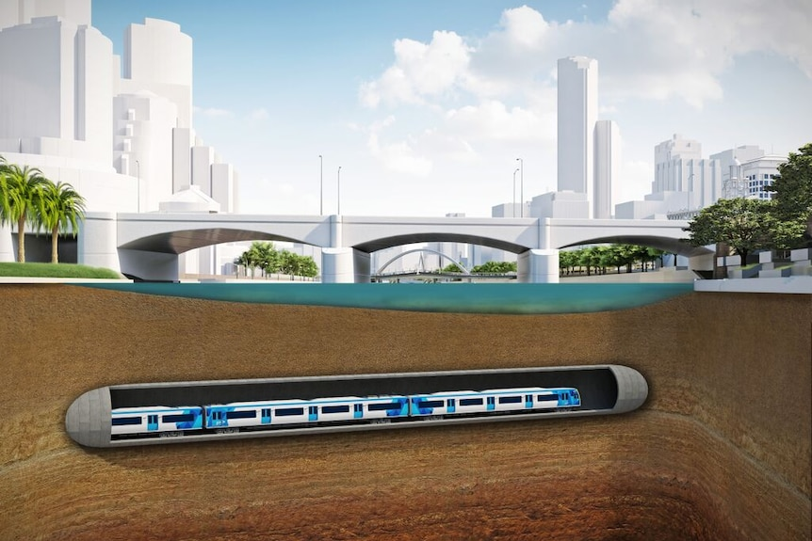

The Victorian government says global factors mean the Metro Rail Tunnel will now cost more than $13 billion. *(Supplied: Victorian Government)*

**In short:**

The Victorian government has announced the Metro Rail Tunnel will now cost $13.48 billion, which is $837 million more than previously budgeted.

The Transport Infrastructure Minister Danny Pearson says the cost increase was caused by the global pandemic, conflict in Ukraine and Gaza, and interest rate rises.

**What's next?**

He says the project is still on track to be completed in 2025.

The Victorian government has conceded an almost billion dollar blowout in Melbourne's Metro Rail Tunnel project.

In a snap mid-afternoon press conference on the eve of the AFL Grand Final public holiday, Transport Infrastructure Minister Danny Pearson announced the project was now estimated to cost $13.48 billion — $837 million more than previously estimated.

Mr Person attributed the rise to unpredictable global issues.

"Nobody could have predicted a once-in-100 year global pandemic, nobody could have predicted conflict Gaza and in Ukraine and nobody could have predicted interest rate spikes," he said.

"These are just the realities of what we've had to deal with."

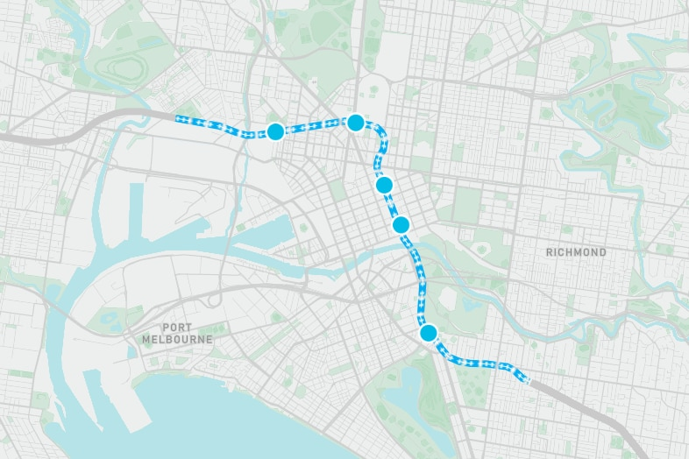

The Metro Rail Tunnel features five new underground stations around Melbourne's CBD

The nine-kilometre twin train tunnel project will run under Melbourne's CBD, with five new underground stations.

The government has said it would provide greater capacity for Melbourne's growing population, which it expects will almost double by 2066.

Mr Pearson said there had been a 22 per cent increase in building material and labour costs in eastern Australia and pointed towards other budget blowouts, saying the budget for Sydney's Metro Tunnel increased by $9 billion last year, inland rail has almost doubled to $30 billion and the $12 billion Snowy Hydro 2.0 was also twice as first predicted.

**"The reality is it is just costing more to build anything anywhere in the world."**

Mr Pearson said the project remained on track to be finished in 2025, with three of the five new underground city stations already built.

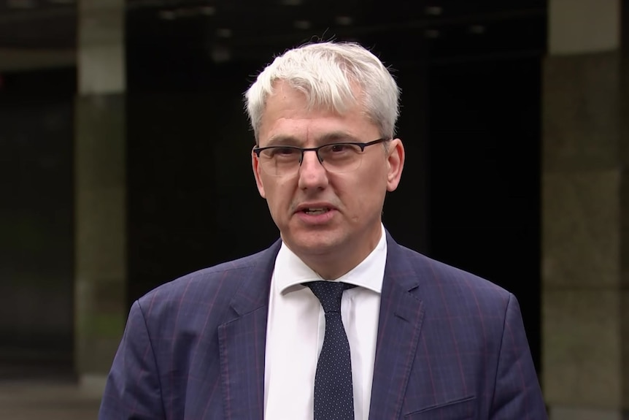

Transport Infrastructure Minister Danny Pearson says the global factors leading to increased construction costs could not have been predicted

He could not rule out but further budget overruns.

"I cannot guarantee that there won't be a one-in-100 year event next year," he said.

"What I am saying to you is here and now, we've got an investment into this project which will ensure that the project has the resources that it needs."

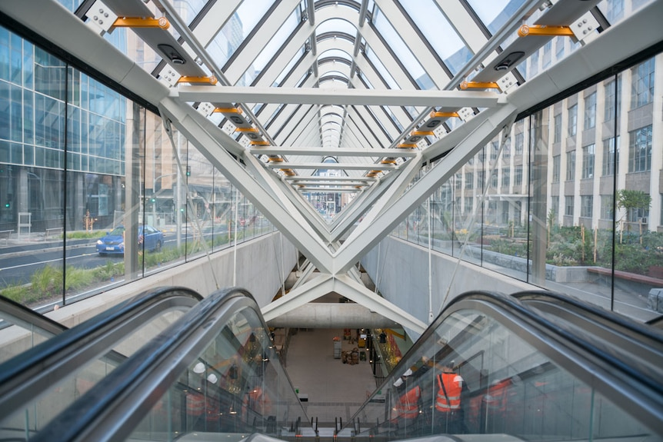

The new stations are due to open next year

He said the project was the single biggest investment in public transport in Melbourne in more than 40 years and was now at its most complex phase of testing and trialling new technology.

Shadow Transport Infrastructure Minister David Southwick said the timing of the disclosure was appalling.

**"The government has literally taken out the trash on the eve of grand final holiday to literally just say 'well bad luck, it's another blowout',"**

**he said.**

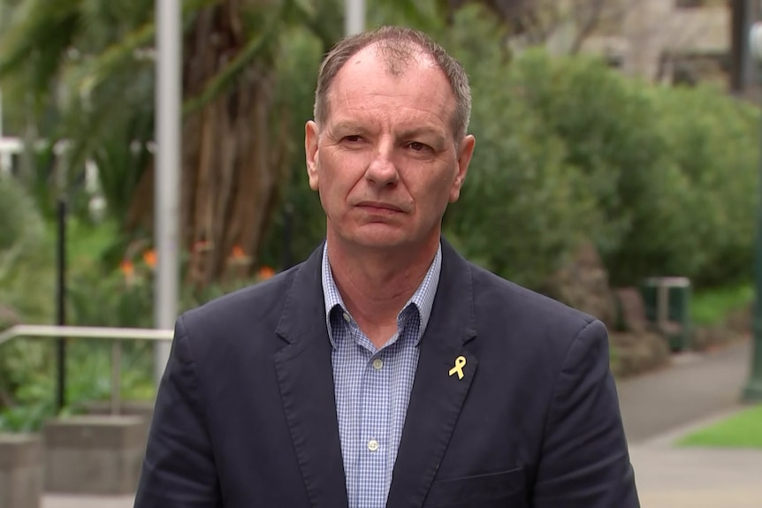

The Opposition's David Southwick says it's another example of the Labor Government mismanaging projects

Mr Southwick said the Metro Rail Tunnel was already billions of dollars over budget and that Victorian taxpayers would pay the price.

"I just can't believe that the Transport Infrastructure minister would come out today and blame everybody else but themselves for a budget blowout," he said.

Mr Southwick called on the Premier Jacinta Allan to explain where it would find the extra money required.

"We already know that there's been cuts to hospitals, cuts to roads, cuts to education.

"Is it more taxation, is more debt?"

There have been repeated warnings in recent months the project will cost more than expected.

In June, the Victorian Auditor-General's Office (VAGO) released a report warning the Metro Tunnel Project budget was strained.

"The project will not meet its contracted completion date of 17 September, 2024, and the state will need to spend more than the revised budget to complete it," VAGO found.

"It may still be on track to open to take passengers by the end of 2025, which accords with the government's public commitment.

"The government will need to pay more than the revised budget to finish the project on time."

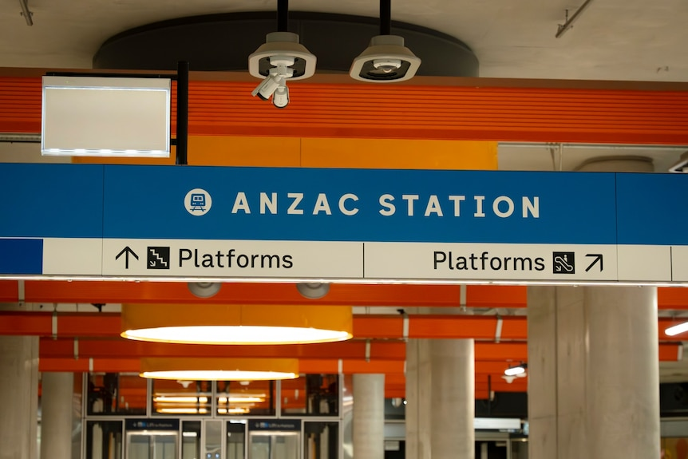

Construction has already finished on three of the five new stations

A government report leaked last month warned of delays and problems with trains interfering with sensitive equipment, like MRIs, in the Parkville hospital precinct.

"The MTP budget has minimal available contingency to manage known and emerging risks," the report written for the government's Infrastructure Delivery Committee noted.

**"Further funding may be required to complete the project to the extent that these challenges and risks crystallise time and cost impacts on the project."**

Of particular concern has been trains interfering with hospital equipment, like MRIs, at the Parkville precinct, which could see further budget blowouts.

The relocation of MRIs has already cost $128 million in capital works alone, with operational costs exceeding $35 million.

The leaked Infrastructure Delivery Committee report noted it might be impossible to mitigate electromagnetic interference caused by trains running through the area, in addition to the existing trams.

"There is no provision for additional relocations or significant infrastructure mitigation in the [Metro Tunnel Project] and Sunbury Line Upgrade budgets," it reported.