Australia’s billion dollar infrastructure boondoggles - Benedict Brook May 1, 2018
THEY’RE the billion-dollar projects that should never have been built — and there’s a risk the same mistakes are about to be repeated all over again.

Victorian government to inject $40 billion into infrastructure
Victoria's state government is set for a building blitz ahead of the state election, with $40 billion allocated towards infrastructure projects. State Treasurer Tim Pallas will announce the plans in tomorrow's budget, with the Labor government expected to deliver a growing surplus up until 2022. However, that forecast may change, with Mr Pallas saying the Treasury is nervous about the international trade environment and the possibility of a downturn in the real estate market.
AUSTRALIA is being buttered up for a multi-billion dollar infrastructure bonanza in next week’s budget. Road and rail projects are expected to be showered with taxpayer funds courtesy of Canberra.
But economists have warned that grand infrastructure projects can become billion-dollar wastes of money.
One highway upgrade in Victoria has returned just 8c for every dollar of public money invested in it. A proposed rail link could cost a motza and still be slower than the bus.
Earlier this month, Prime Minister Malcolm Turnbull announced the Federal Government would chip in half of the $10 billion cost of a rail link to Melbourne’s Tullamarine Airport.
“The time for talk is over … Melbourne is still waiting for a service almost all of the world’s great cities take for granted,” he said on April 12.
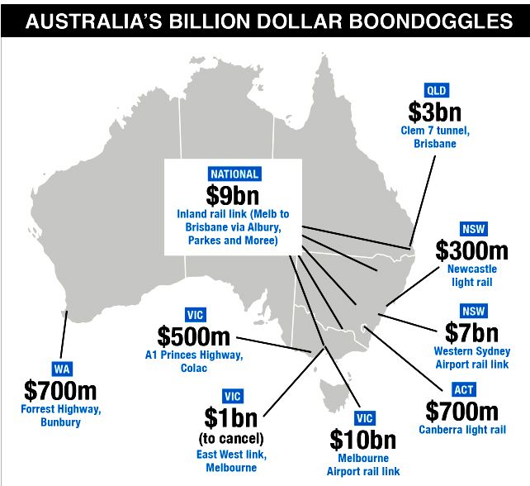
But for Grattan Institute transport expert Hugh Batrouney, it is still not certain that a Melbourne airport rail link is really worth it.
“My first reaction (when the announcement was made) was to look at whether the project was included on any of the infrastructure bodies’ priority lists and then to have a look to see if a detailed business case had been prepared,” Mr Batrouney told news.com.au.
“The answer to both of those questions was ‘no’.”
On the most recent priority list drawn up by Infrastructure Australia, a government body that assesses big projects, the rail link barely rates a mention. Infrastructure Victoria said the link wasn’t needed for 30 years.
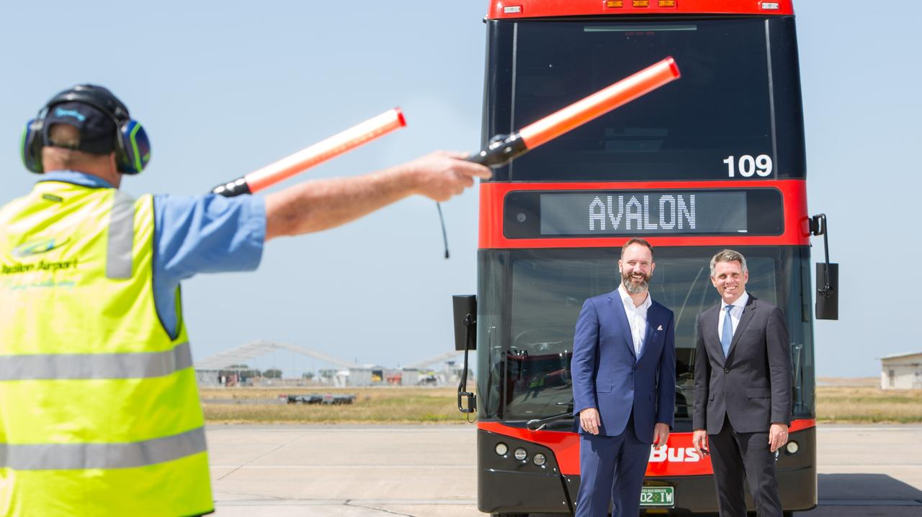
Co-CEOs of SkyBus, Adam Begg and Michael Sewards. The service could actually be quicker than a $10 billion rail link to Melbourne Airport.
Amazingly, the billions spent could actually make travel to the airport worse.
Infrastructure Victoria has said an alternative plan, of spending up to $100 million on traffic priority measures, could speed up trips on the existing SkyBus to just 20 to 25 minutes. In contrast, the expensive new train would take 30 minutes to go between Southern Cross and Tullamarine.
But the urge to build is hard to resist.
“The issue, particularly in Melbourne where there is such strong population growth, is there’s a perception the city is under developed in infrastructure. There’s a feeling we need to make up for that perceived infrastructure deficit,” he said.
It’s not that Melbourne doesn’t need an airport rail link; it just doesn’t need a train right now. And money spent on this train, can’t be spent on a train somewhere else.
Backers of big projects, with close-to-the-bone budgets, say the benefits aren’t just economic. They can enhance safety and revitalise neighbourhoods.
But what other questionable infrastructure projects are being — or have been — built?
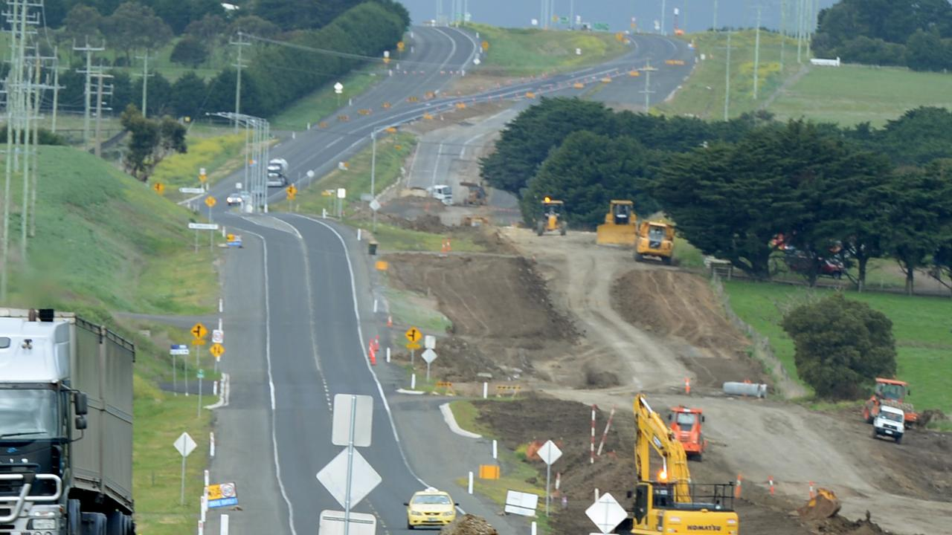
The duplication of the Princes Highway, in southwest Victoria, returns only 8c to the economy for every $1 invested.
A1 PRINCES HIGHWAY, GEELONG-COLAC
Economists have long questioned the financial sense of expensive infrastructure that is not within Australian cities, or provides a link between them.
The A1 Princes Highway duplication in Victoria, which is still being built, does neither. Rather, it connects a regional city, Geelong, to a regional town, Colac.
The upgrade costing $500 million, is not included on Infrastructure Australia’s priority list, and has a return of just 8c on every dollar invested, according to the Grattan Institute. By some measure, over the period of a decade, taxpayers have subsidised every vehicle on the road to the tune of 13.7c per kilometre travelled.
Only the Forrest Highway, between Perth and Bunbury — which went five times over budget — has a higher cost per vehicle kilometre.
“A project can have merits beyond the economic case, there is no doubt about that,” Mr Batrouney said. In the A1’s case, that included easier access for tourists to the Great Ocean Road, the elimination of accident black spots and the opening up of southwestern Victoria.
But it’s been a high price to pay for those benefits.
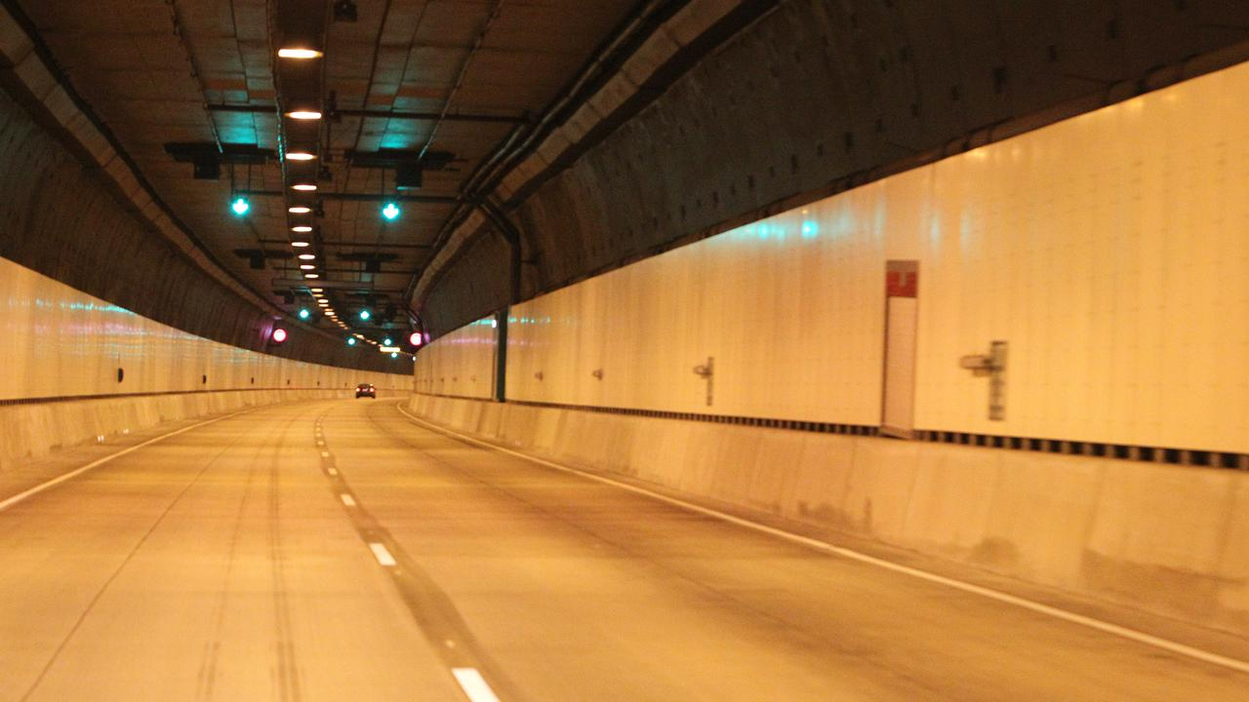
The M7 ‘Clem 7’ tunnel looking very empty at 1pm in the middle of the day.
M7 ‘CLEM 7’ TUNNEL, BRISBANE
The M7 Tunnel is one of a number of expensive road tunnels, including Sydney’s Lane Cove Tunnel, that never fulfilled its promise.
The $3 billion tunnel under Brisbane’s CBD saw three times less traffic than was expected and ended up sending its private owner bankrupt.
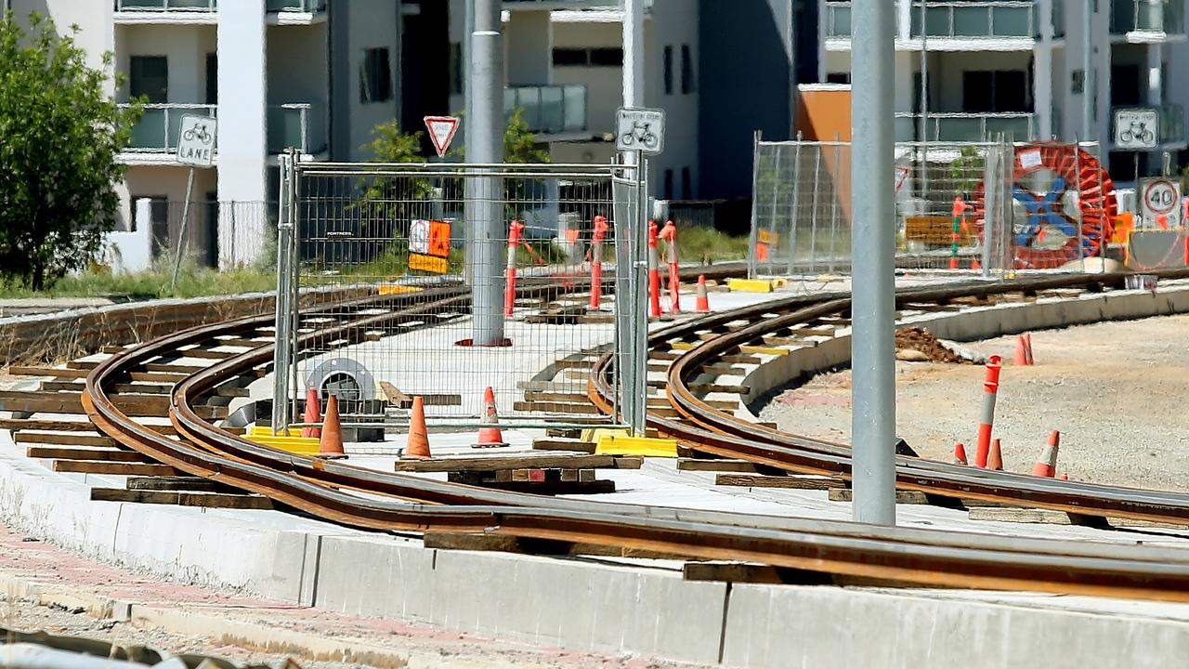
Tracks for the Canberra light rail under construction.
CANBERRA LIGHT RAIL
The 12km tram project to link the CBD to Gungahlin is well under way with a price tag of about $700m. The Grattan Institute has previously found it will provide no more benefits than an alternative bus rapid transit project but will cost twice as much.
But the ACT Government has said a bus can’t compete with the urban development and property price hikes that a tram line brings.
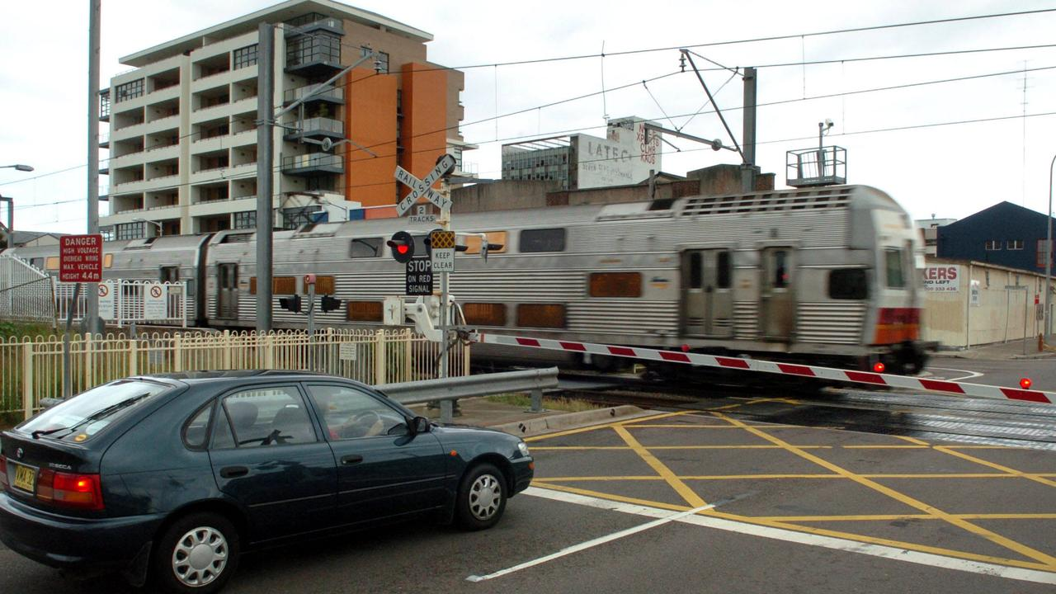
Keeping the rail line through Newcastle’s CBD would have had more financial benefit than ripping it up and replacing it with a tram on neighbouring streets.
In Newcastle, where a light rail line is also on the way, the justification is even more dubious. The less-than-3km tram line will cost about $300m and will replace a curtailed commuter train line.
A leaked NSW Government report found its return is expected to be less than one dollar to the dollar. But if the train line had remained in place and development had occurred alongside it, the return would have been $2.40 per dollar invested, Fairfax reported.
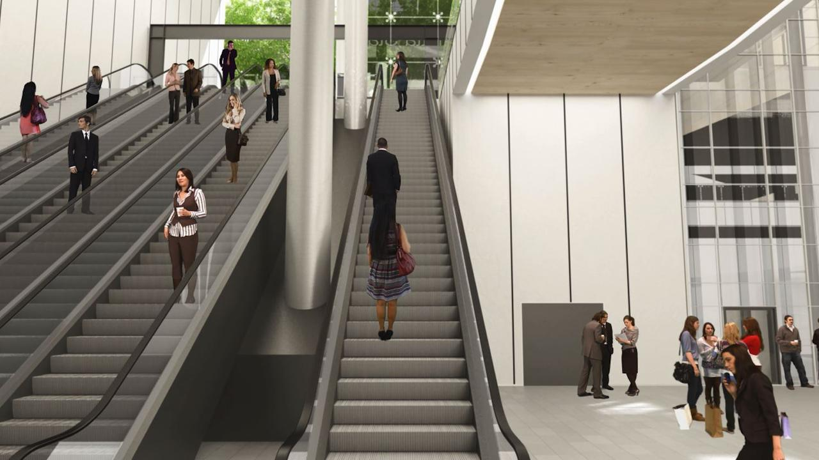
The proposed Western Sydney Airport metro station: A case of too much, too soon?
WESTERN SYDNEY AIRPORT RAIL LINK
According to Mr Batrouney, the proposed western Sydney airport rail link falls squarely into the Melbourne rail link category of building too much way too soon.
The new airport at Badgerys Creek is right at the top of Infrastructure Australia’s to-do list. But a rail link, speeding people from the surrounding areas to the terminal costing as much as $7b, is not. Yet both the federal and NSW governments have signed up for it.
“The airport is due to open in 2026 but the Western Sydney Rail Needs Study found rail wasn’t needed for at least the first 10 years of operation so that puts it out to at least 2036,” he said.
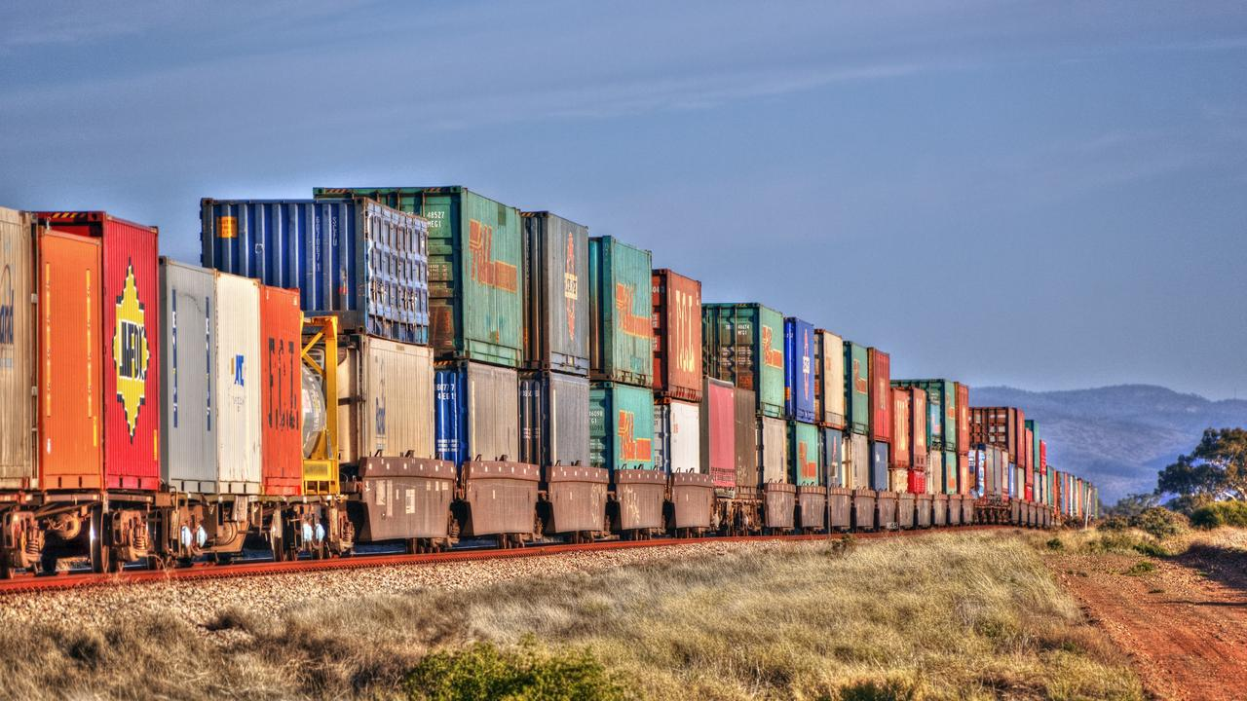
Backers of the Inland Rail project say it will take many trucks off the road.
INLAND RAIL
It’s the $9b railway the vast majority of us will never see. Snaking its way 1700km from Melbourne to Brisbane, its backers say it will take masses of freight from congested highways, create 16,00 jobs and pump $16 billion into the economy. But the Grattan Institute said it would “never add up”, that traffic projections were hazy and a cost overrun — likely on a mammoth project — could wipe out any benefits.
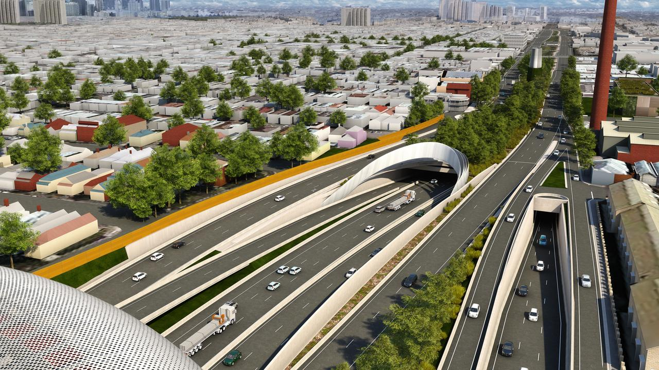
An artist’s impression of the Melbourne East West Link, which was cancelled by Labor at a cost of $1 billion.
EAST WEST LINK MOTORWAY, MELBOURNE
The crowning glory of uneconomical infrastructure, however, is Melbourne’s inner-city East West link, which cost $1.2 billion NOT to build.
The road was controversially signed off by the then Victorian Coalition government weeks before the 2014 state election, after criticism the project did not have a rigorous cost-benefit analysis in place.
Labor, which had campaigned against the project, won the election and cancelled it. But, said Labor, to build would have cost at least $6b.
In a piece for The Conversation, Mr Batrouney said governments shouldn’t splash out on big projects until they had looked in detail at the economic impacts and opened the results up to public scrutiny.
“We shouldn’t be fooled into thinking any spending is good spending. There are many examples where the opposite is more likely true: where poorly targeted infrastructure wastes resources and weakens economic growth,” he said.
benedict.brook@news.com.au
Originally published as Australia’s billion dollar infrastructure boondoggles

