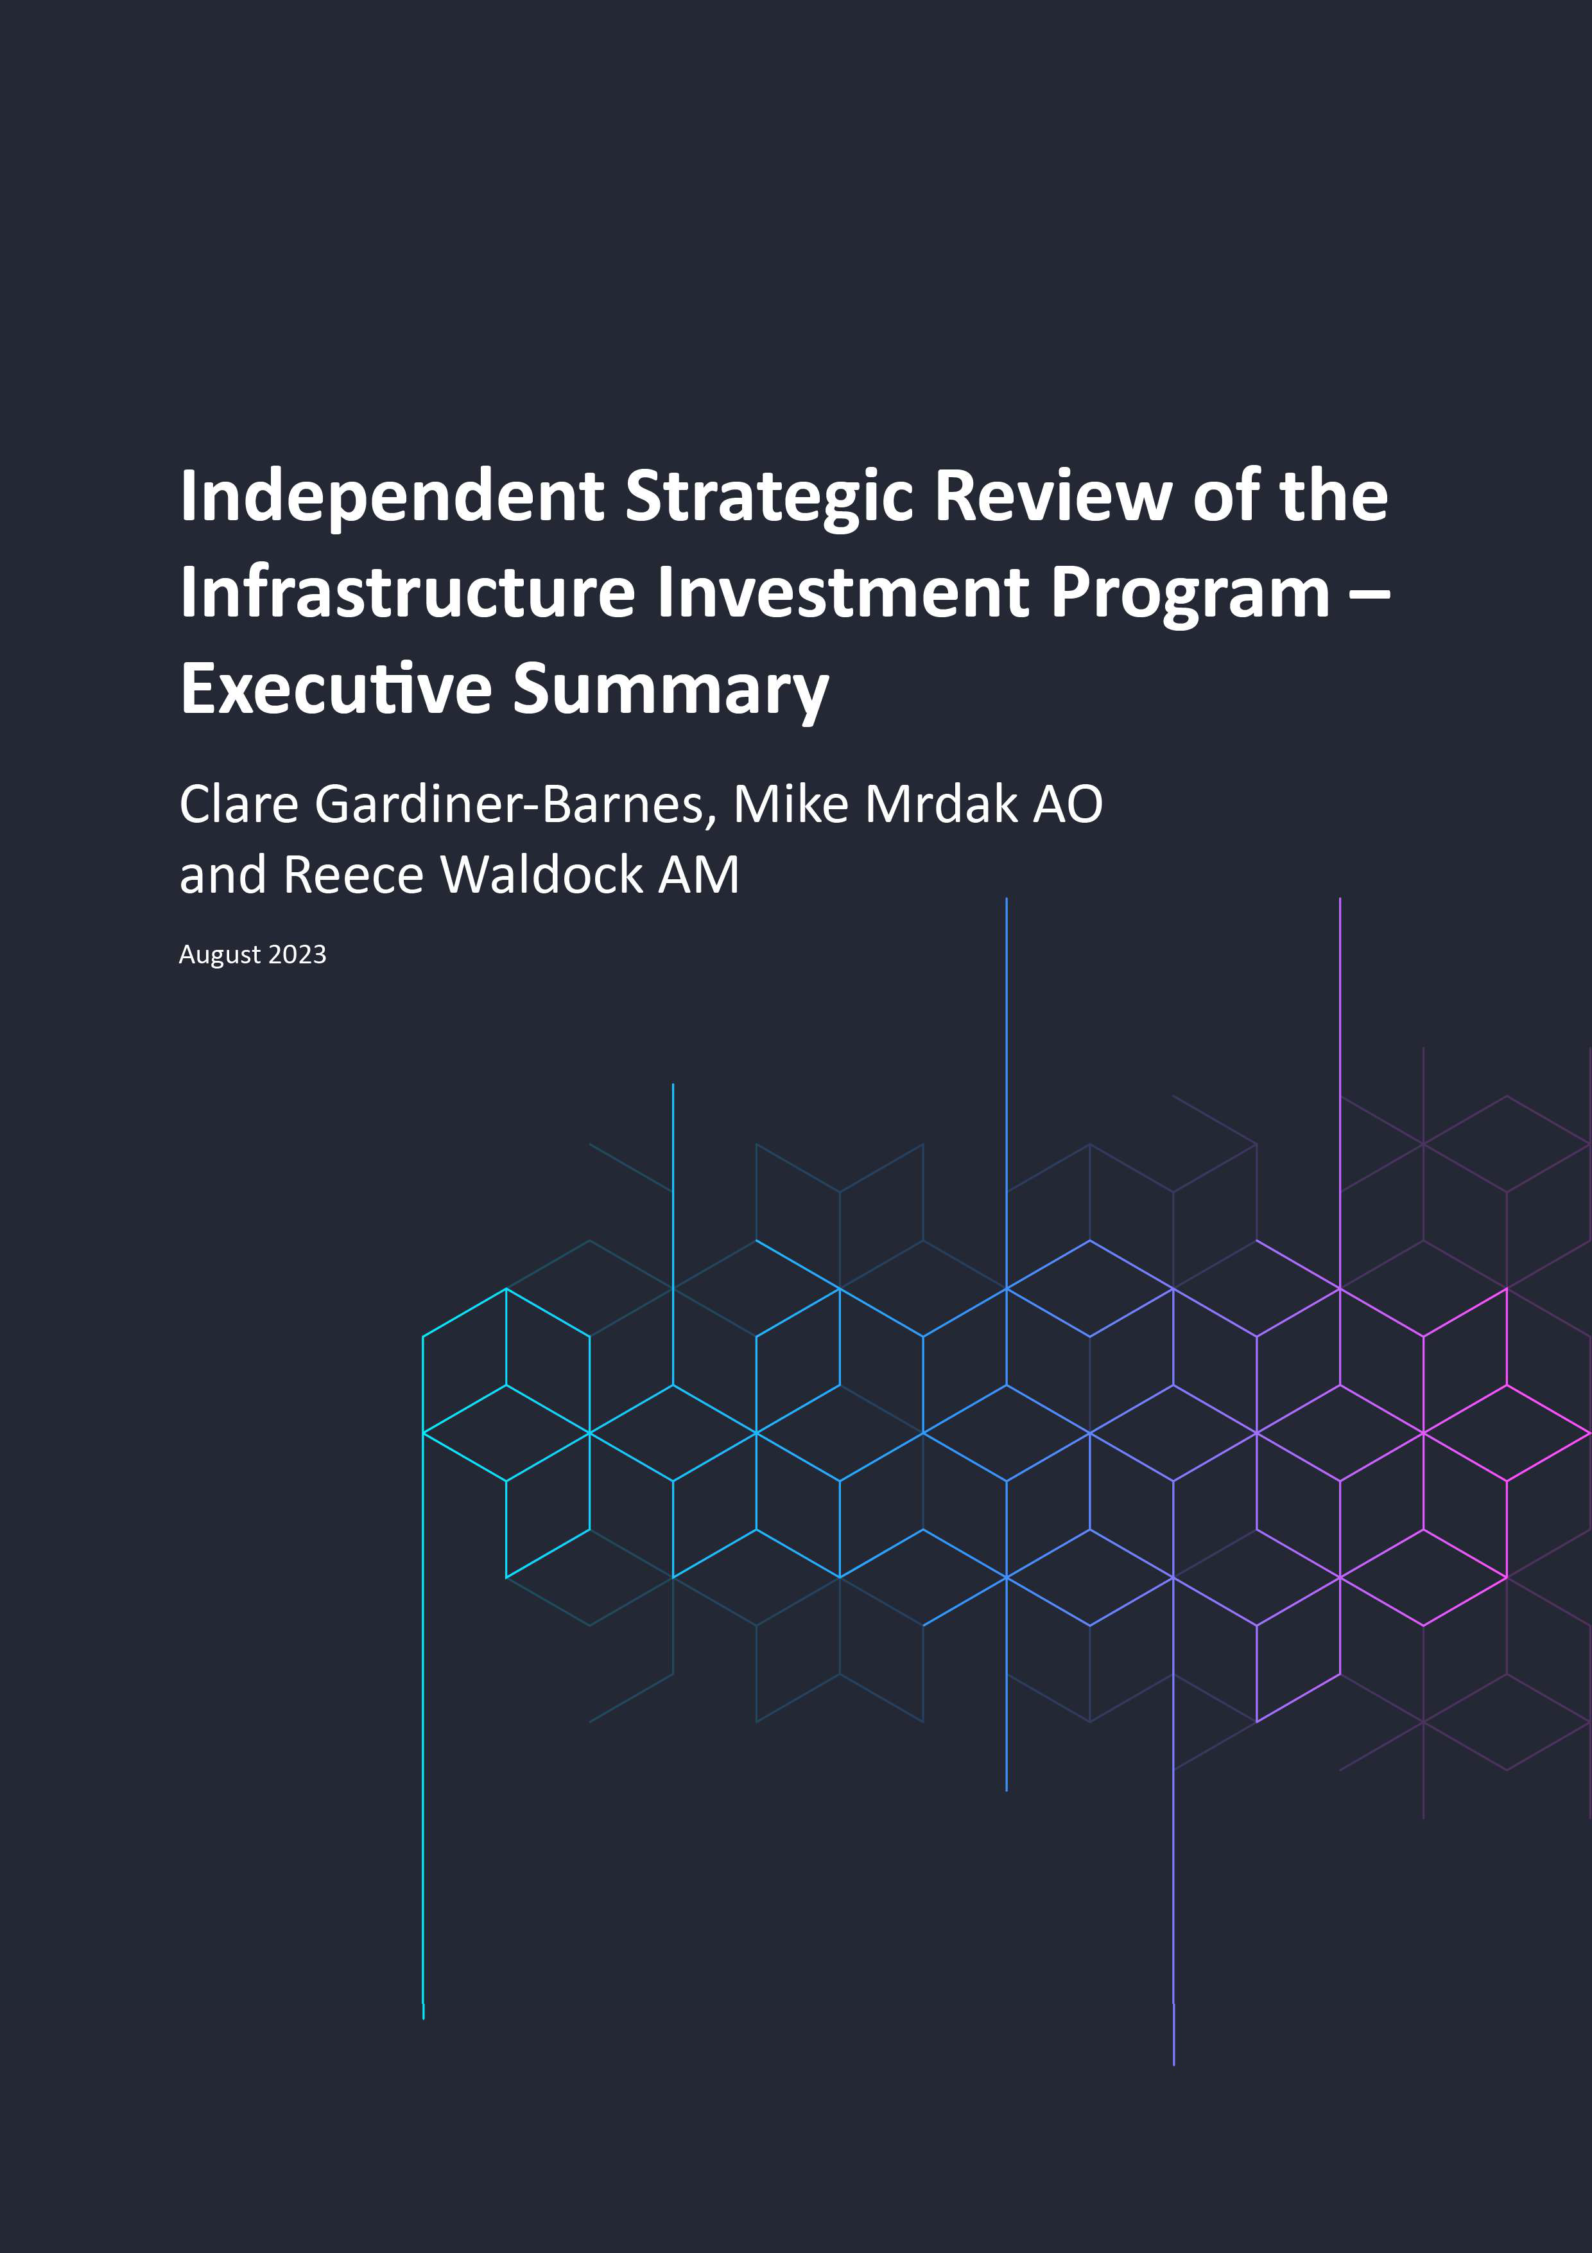

© Commonwealth of Australia 2023

#### Ownership of intellectual property rights in this publication

Unless otherwise noted, copyright (and any other intellectual property rights, if any) in this publication is owned by the Commonwealth of Australia (referred to below as the Commonwealth).

#### Disclaimer

This publication is an executive summary of a review which has been prepared by, or on behalf of, the Commonwealth in accordance with the Terms of Reference for the Independent Strategic Review of the Infrastructure Investment Program (Review). The material contained in this publication is made available on the understanding that the report of the Review has been provided to the Minister for Infrastructure, Transport, Regional Development and Local Government and implementation of any of the recommendations contained in the Review are subject to future government decision. The publication of this material does not constitute a representation of any kind whatsoever that any particular course of action will be taken in relation to the Review.

Key findings and recommendations contained in the Review are based on advice, data and information provided by jurisdictions and information and analysis by the Department of Infrastructure, Transport, Regional Development, Communications and the Arts which has not been independently verified. The Commonwealth and its contractors make no representations or warranties as to the contents or accuracy of the information contained in this publication. To the extent permitted by law, the Commonwealth and its contractors disclaim liability to any person or organisation arising directly or indirectly from anything done, or omitted to be done, in reliance upon information contained in this publication.

#### Creative Commons Licence

With the exception of (a) the Coat of Arms; and (b) any third party material, and where otherwise stated, copyright in this publication is licensed under a Creative Commons Attribution-Noncommercial-NoDerivs 3.0 Australia Licence (CC BY-NC-ND Licence).

The **CC BY-NC-ND** Licence allows you to copy and distribute this publication in any medium or format in unadapted form only, for non-commercial purposes only, provided that you attribute the publication to the Commonwealth, and that you abide by the other licence terms:

https://creativecommons.org/licenses/by-nc-nd/3.0/au/.



Further information on the licence terms is available from https://creativecommons.org/licenses/by-nc-nd/3.0/au/legalcode

This publication should be attributed in the following way:

© Commonwealth of Australia 2023.

#### Use of the Coat of Arms

The Department of the Prime Minister and Cabinet sets the terms under which the Coat of Arms is used. Please refer to the Commonwealth Coat of Arms - Information and Guidelines publication available at [http://www.pmc.gov.au.](http://www.pmc.gov.au/)

#### Contact us

This publication is available in PDF format/Word format. All other rights are reserved, including in relation to any departmental logos or trademarks which may exist. For enquiries regarding the licence and any use of this publication, please contact:

IIP Review Secretariat

Email: [iipreview@infrastructure.gov.au](mailto:iipreview@infrastructure.gov.au)

# Overview

The Independent Strategic Review (the Review) of the Infrastructure Investment Program (IIP) was announced on 1 May 2023 by the Hon Catherine King MP, Minister for Infrastructure, Transport, Regional Development and Local Government.1 As part of the announcement, the Australian Government committed to a ten-year, $120 billion infrastructure pipeline and ensuring that land transport infrastructure projects are nationally significant and nation-shaping.

The impetus for the Review, as set out by the Minister, was that the IIP contained a large number of projects which did not have sufficient funding or a strong enough business case to justify Australian Government investment. This has led to a clogged infrastructure pipeline that does not reflect current market capacity, particularly when considering that forecast IIP expenditure is projected to continue growing over the forward estimates, and that the current pipeline of projects carries over $32.8 billion in identified cost pressures (refer Figure 1).

The states and territories agreed to support the Review at the 28 April 2023 National Cabinet meeting.2 This was after an initial review of the IIP was done in the October 2022-23 Budget, in light of market capacity issues and an inflationary environment. The Australian Government considered that a further review of the IIP, in consultation with states and territories, was necessary to ensure a credible and sustainable pipeline of projects.

#### Figure 1: Impact of cost pressures on current Infrastructure Investment Program

20.0

18.0

16.0

14.0

12.0

10.0

8.0

6.0

4.0

2.0

0.0

IIP expenditure

Cost Pressure

**$ Billion - Estimates as at 2023-24 Budget**



Notes:

1 C King, *Securing Australia’s $120 billion nation-building infrastructure pipeline,* [media release], Australian Government, 1 May 2023, accessed 1 May 2023.

2 A Albanese, *Meeting Of The National Cabinet - A Better Future For The Federation*, [media release], Australian Government, 28 April 2023, accessed 28 April 2023.

IIP Expenditure includes project funding, funding for a specific purpose or headroom, sub-program funding and research and evaluation.

As set out in the Terms of Reference (ToR), the purpose of this Review was to:

1. assess projects (not yet under construction) funded under the IIP and make recommendations on the merits of projects continuing
2. make recommendations for transitioning the IIP to a sustainable ten-year rolling pipeline that targets appropriately costed, nationally significant infrastructure projects
3. make recommendations on reforms to ongoing and terminating infrastructure investment sub-programs
4. consider other relevant projects or matters.

The Review was undertaken in close consultation with stakeholders, including state and territory governments which are the delivery partners for most projects under the IIP. Meetings were held with each jurisdiction and a number of councils to understand the merits of projects continuing and where cost pressures and delays were appearing. Consultation was also undertaken with Infrastructure Australia, industry bodies, local council associations, some state, territory and federal Ministers, Government agencies and other relevant stakeholders. The Review relied on advice provided by stakeholders to inform its analysis.

The Review was tasked with working within a very tight timeframe. Accordingly, key findings and recommendations are based on advice, data and information provided by jurisdictions, Infrastructure Australia and information and analysis by the Department of Infrastructure, Transport, Regional Development, Communications and the Arts (DITRDCA). Given the time constraints, it has not been possible to independently verify all elements of individual projects including project cost pressures or the delivery issues identified. The variable market conditions in each jurisdiction and regions also makes it difficult to apply market indicators and trends easily to individual projects.

*IIP is a window dresser to conceal negligence*

# Key Findings

The Review has found strong jurisdictional support for improvements in collaboration and the way the Australian Government manages its infrastructure investment pipeline.

The key findings of the Review under part a) TOR - assess projects (not yet under construction) funded under the IIP and make recommendations on the merits of projects continuing:

* + Based on the information provided to the Review, there is an estimated $32.8 billion in known cost pressures on all IIP projects, with a high risk of future, not-yet-quantified cost pressures. Of these, there are an estimated $14.2 billion in known cost pressures on projects not yet under construction, noting that many of these projects have not yet completed detailed cost estimates.
  + The ten-year pipeline of projects cannot be delivered within the $120 billion allocation, even with current contributions from jurisdictions.
  + The Australian Government cannot afford within the current program settings, to meet the identified cost pressures, nor add any new projects for delivery to the pipeline in the next ten years, without significant changes taking immediate effect.
  + There are projects in the IIP that do not demonstrate merit, lack any national strategic rationale and do not meet the Australian Government’s national investment priorities. In many cases these projects are also at high risk of further cost pressures and/or delays.
  + A number of projects were allocated a commitment of Australian Government funding too early in their planning process and before detailed planning and credible design and costing were undertaken.
  + The Australian Government can cease or pause the allocation of federal funding to projects, to create IIP headroom for reallocation to merit based projects, to fund construction once planning, design and detailed costings are complete or to relieve some of the estimated cost pressures on current projects.

Key findings under part b) of the ToR - make recommendations for transitioning the IIP to a sustainable ten- year rolling pipeline that targets appropriately costed, nationally significant infrastructure projects:

* + There is no current requirement for projects to be allocated federal funding based on alignment with long- term national priorities – in fact, there is no requirement for jurisdictions to have a costed and sequenced transport plan for the Commonwealth to use as a starting point for funding decisions.
  + The varying governance and assurance frameworks are insufficient to reassure the Australian Government, the transport industry and other stakeholders (including all Australians) that projects in the pipeline have been appropriately selected, designed, costed and delivered to achieve their stated outcomes.
  + Cost pressures, cost escalations, delivery delays and changes to project scopes are addressed by the Australian Government in a manner that is ad hoc, often not responsive to evidence of looming cost increases or aligned with long-term plans and strategies, and lack transparency and consistency.
  + The number of projects in the IIP tripled between 2015 and 2022, with the majority of new projects added before the COVID-19 pandemic (see Figure 2). Too many large-scale projects are receiving funding commitments without adequate planning, costings and programming to sufficiently manage the significant increase in delivery costs within a volatile market.
  + Although the IIP was intended to fund projects that predominantly contribute to national productivity and growth,3 many small-scale and local projects were urgently funded as job stimulus measures in response to the COVID-19 pandemic. In addition to the large-scale projects underway and demand from other sectors, this is creating an unprecedented peak in demand for materials and skilled labour.

3 Australian Government, *National Partnership Agreement on Land Transport Infrastructure Projects (2019-2024)*, Federal Financial Relations website, 2019, accessed 18 May 2023.

#### Figure 2: Historic growth of the IIP

Total IIP Value Number of projects

120,000 1000



100,000

900

800

80,000

Total IIP Value ($m)

700

600

Number of projects

60,000 500

40,000

400

300

20,000

200

100

0 0

2012-13 2013-14 2014-15 2015-16 2016-17 2017-18 2018-19 2019-20 2020-21 2021-22 2022-23

The key findings under part c) of the ToR - make recommendations on reforms to ongoing and ceasing infrastructure investment sub-programs:

* + Sub-programs provide critical funding to councils to build and maintain local infrastructure.
  + Councils require additional funding to manage rising costs and increased pressure on transport infrastructure due to climate change and extreme weather events.
  + Sub-programs are not designed for local governments seeking funding for major road project upgrades or for strategic sequencing of projects along corridors impacting multiple shires and councils.
  + Current sub-programs are delivering positive outcomes for councils and value for money for the Australian Government, but could be improved with program design adjustments.
  + States and territories also require additional maintenance funding for the National Land Transport Network.

The key findings of the Review under part d) of the ToR – consider other relevant projects or matters as agreed in consultation with relevant jurisdictions:

* + Better data will drive better decision-making.
  + The draft Infrastructure Policy Statement communicates the Australian Government’s intent, but further work is needed to refine and practically apply it.
  + The *National Land Transport Act 2014* must reflect modern transport and infrastructure needs.

# Recommendations

The recommendations of the Review require a commitment to long-term reform in how the IIP is managed, but the benefits, including greater transparency and certainty, will be significant for governments, industry and communities. If the recommended reforms are implemented and adhered to by all levels of government, over the long term, the pipeline will be sustainable as well as credible; the projects will be better managed for delivery within agreed timelines and budget allocations.

The full recommendations of the Review are as follows.

## Terms of Reference (a) – Project List Assessment

The Review’s recommendations for individual projects that are not yet under construction are set out in the full report of the Review. A summary of the recommendations is provided below.

### Recommendation 1a

100 projects, which are not yet under construction, proceed.

### Recommendation 1b

56 projects, which are not yet under construction, proceed, noting the Review has identified risks, to be satisfactorily addressed prior to delivery.

### Recommendation 1c

36 projects, which are not yet under construction, to complete planning, detailed costings, rescoping and the allocated delivery funding is used to create headroom in the IIP.

### Recommendation 1d

82 projects which are not yet under construction, are ceased, and the allocated funding is used to create headroom in the IIP, following any payments necessary to fulfil contractual obligations.

## Terms of Reference (b) – A Sustainable Pipeline

### Recommendation 2

Beginning in 2024-25, states and territories, in consultation with local governments, develop and provide the Commonwealth with an annual infrastructure plan, including priority projects that have or are seeking a federal funding contribution over the next ten years and how they will be sequenced. The plan will include how the jurisdiction will manage cost pressures, and other related impacts, for example, population growth, carbon emissions, regional development or housing.

### Recommendation 3

Based on the state and territory plans and other relevant input, DITRDCA prepare national infrastructure advice for the Australian Government annually. The advice will include analysis of the existing infrastructure investment pipeline, future challenges, and the sequencing and prioritisation of projects. This advice will inform Australian Government decisions on managing cost pressures for existing projects and new projects to be funded

The Australian Government implement a mandatory gateway assurance process for any projects seeking an Australian Government funding contribution prior to any funding commitment being finalised and added to the IIP. The gateway process should continue for the life of the project to ensure key delivery milestones are met as agreed.

### Recommendation 5

For projects in delivery, the Australian Government implement an independent assurance review process that has the authority to transparently examine all project risks including commercial agreements, accounts, safety standards, designs, timelines, governance and plans when the project is identified as a high delivery risk.

### Recommendation 6

The process of setting proposed project escalation rates to be used in business cases and project funding be approved by the Secretary of DITRDCA following advice from industry, Infrastructure Australia and jurisdictional agency heads.

### Recommendation 7

The Australian Government adopt a policy of 50:50 (Australian Government: State/Territory/Local Government) as the standard funding split for all new projects. The Australian Government will retain the flexibility to apply other funding splits (where supported by evidence), particularly in smaller jurisdictions and remote locations.

### Recommendation 8

The Australian Government fund multi-year rolling programs targeted towards nationally significant outcomes, informed by the state and territory ten-year plans. The rolling programs will target specific outcomes or corridors, and will sequence priorities across local government and jurisdictional borders where appropriate.

## Terms of Reference (c) – Sub-programs

### Recommendation 9

The Australian Government significantly increase funding available to local councils through the Roads to Recovery (R2R) program, with the majority of the increase directed to non-urban councils. Councils should receive rolling notice of their funding allocation, and R2R funds should enable a multi-modal approach to the use of road corridors to achieve the best outcome for infrastructure investment.

### Recommendation 10

The Australian Government support road safety outcomes by increasing funding for the Black Spot Program and provide greater flexibility by widening the scope of projects, in cost, time and nature.

Create a targeted application-based infrastructure rolling program over ten years that allows local governments the flexibility to apply for funding against key government priorities which could include freight productivity, bridge upgrades and road safety.

### Recommendation 12

The Australian Government work with states and territories to review the National Land Transport Network maintenance formula and agree a process to determine the total funding amount on an ongoing basis, including indexation of the funding to be implemented from 2024-25.

## Terms of Reference (d) – Other Matters

### Recommendation 13

The Australian Government increase the investment in data systems and practices, to reflect contemporary approaches to manage and report data, in accordance with the level of risk evident in the total pipeline funding and the spread of the budget allocation.

### Recommendation 14

The Australian Government incorporate the Infrastructure Policy Statement into the project planning process and the assurance framework in collaboration with states, territories and Infrastructure Australia.

### Recommendation 15

The Australian Government review the *National Land Transport Act 2014* within the next two years, to ensure the Act is fit for purpose to meet contemporary legislative drafting standards, includes requirements for carbon emissions and changing investment needs based on an integrated approach across transport modes and land use planning.