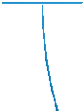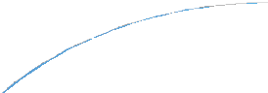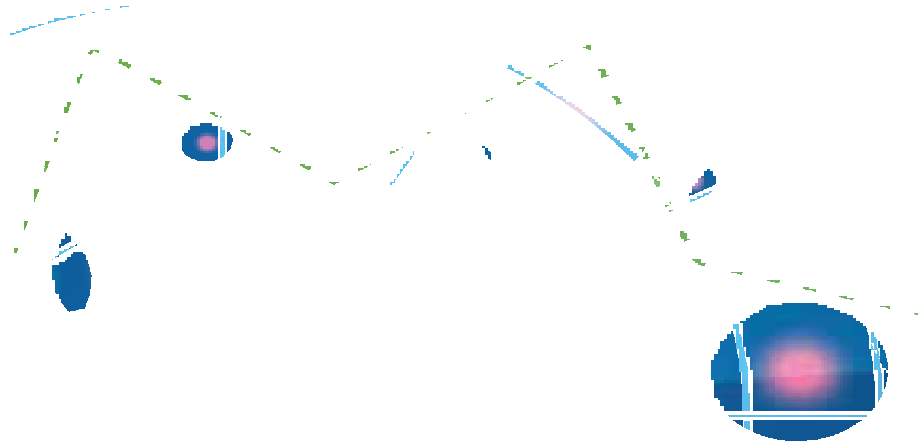

**Navigating with confidence** Australia and New Zealand’s Bribery & Corruption Report 2020

March 2020

About this report

Every two years the Deloitte Australia and New Zealand Bribery and Corruption Report collects data from Australasian risk leaders on their perceptions and experiences of bribery and corruption.

The data in this report is informed by a survey conducted

by Deloitte Australia and New Zealand between October and December 2019. The survey was completed anonymously

by 159 senior leaders including CEOs, CFOs, CROs, General Counsel, risk and investigation managers from a cross section of industries. These included ASX200 and NZX50 companies, Australian and New Zealand subsidiaries of foreign companies, public sector organisations, not for profit organisations and other listed private companies.

That data is complemented by interviews with other risk leaders across Australia and New Zealand, insights from Deloitte’s own subject matter experts, and perspectives from Deloitte partners across Asia Pacific.

Unless otherwise stated, all percentages refer to the results from the survey responses. They are anonymous and confidential, with only aggregate responses reported.

Deloitte compiled the information into a series of graphs with commentary based on the answers received in the survey.

**Navigating with confidence** | Bribery & Corruption Report

## Contents

Introduction 5

Executive summary 6

Perception of risks 8

Risk assessment 11

Prevention 13

Detection and response 18

Culture 22

Navigating with confidence: Towards ABC resilience 26

Our respondents 27

3

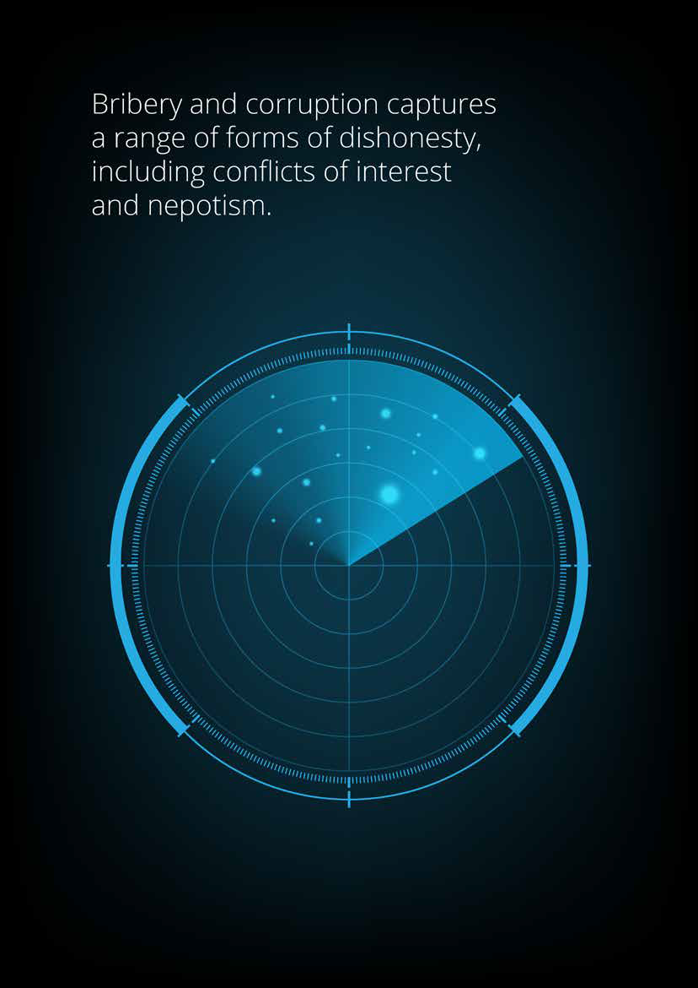**Navigating with confidence** | Bribery & Corruption Report

4

**Navigating with confidence** | Bribery & Corruption Report

## Introduction



**Chris Noble**

**Managing Partner, Forensic, Australia and APAC**

**Lorinda Kelly Partner, Forensic, New Zealand**

**Australia:** This year’s Australia and New Zealand bribery and corruption survey leaves no doubt that Australia’s reputation has slipped over the last two years.

Surveyed risk leaders confirmed the criticality of the ‘reputation economy’ and the imperative that their organisations ensure their integrity balance sheet is healthy and they can defend it.

Australia’s reputation has also dropped down the Transparency International’s Corruption Perceptions index. And we have also seen an historic joint communiqué from Australia’s anti-corruption commissioners, the changes to strengthen the whistleblower protection legislation, and a proposed ‘failure to prevent foreign bribery’ offence.

While some Australian companies are leading the anti- corruption way, others need to change. And although our respondents were based in Australia and New Zealand, many operate across the Asia Pacific region. Risks, obligations and operating contexts vary hugely throughout our diverse and dynamic part of the world. Australian organisations must understand and react to these local environments.

Even though corruption hides in the shadows, there is much we can do. This report considers ways to move organisations from making their ‘best guess’ towards reality. They can do this by leveraging better due diligence, new data analytics technologies, and begin to navigate with confidence.

**New Zealand:** Since the release of Deloitte’s last bribery and corruption survey in 2017, the Serious Fraud Office in New Zealand has successfully secured prosecutions that placed Bribery and Corruption on our front pages.

Unfortunately, it is not surprising that 35% of the participants in this year’s survey reported suffering a bribery or corruption incident in the past five years.

Of most concern is that 17% of these occurred in the past twelve months. As bribery and corruption is too often only considered when the damage is done, this edition of the survey focuses on planning and prevention.

An organisation’s bribery and corruption risk assessment and internal integrity culture are central to these efforts. Leading organisations recognise this and are increasingly focussing on culture, technology and data to prevent them from suffering an incident and the negative impact of these events.

It is clear that there is still much work to do to continue to make New Zealand a safe place to operate for our local and overseas organisations.



5

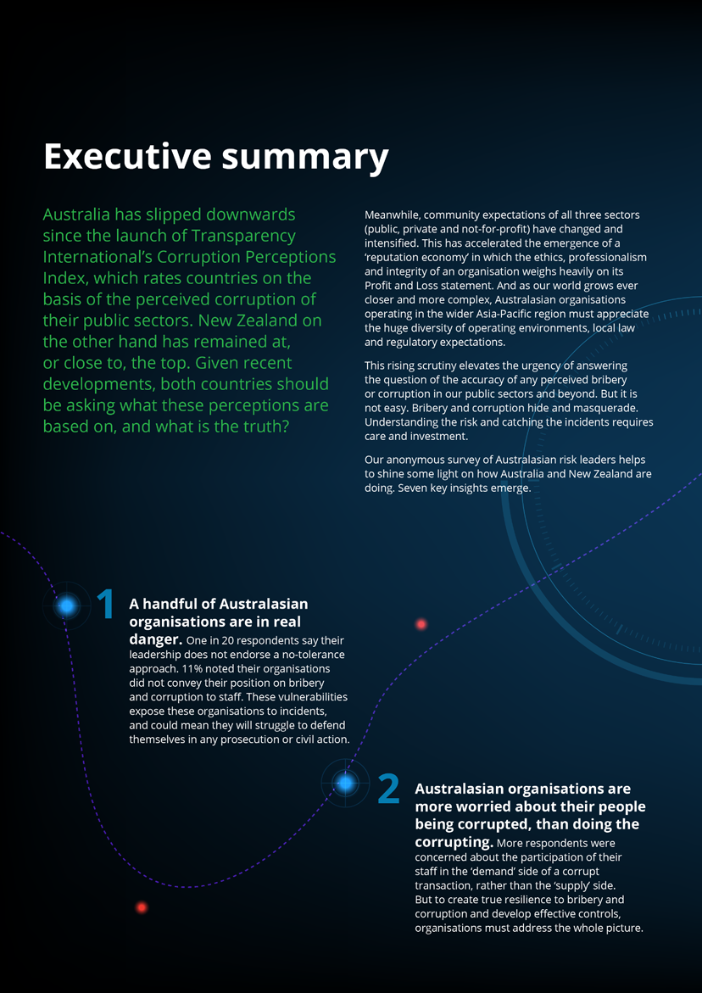**Navigating with confidence** | Bribery & Corruption Report

6

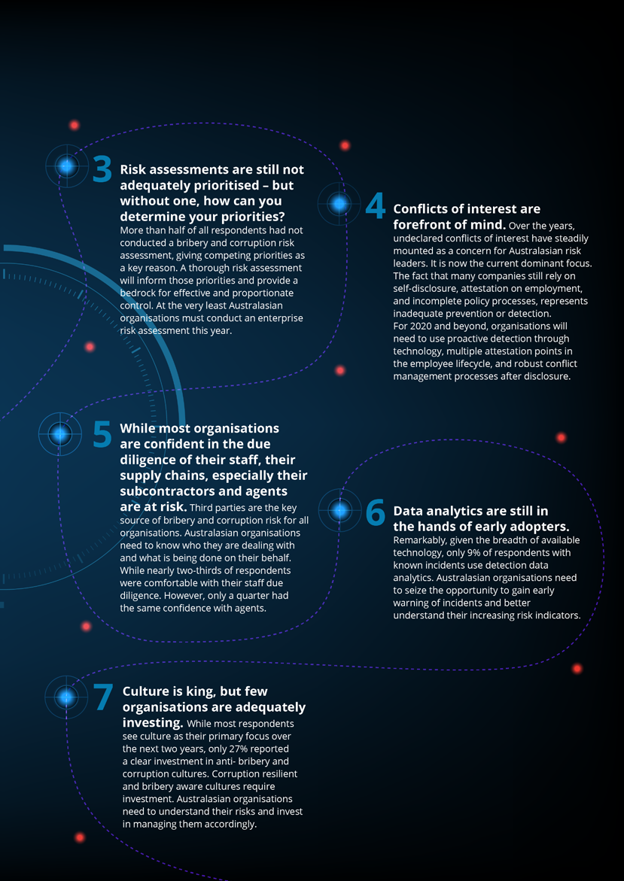**Navigating with confidence** | Bribery & Corruption Report

7

**Navigating with confidence** | Bribery & Corruption Report

### Perception of the risks

As bribery and corruption become risks wherever people, value and interests intersect, two thirds of the survey’s respondents perceived their organisation to be at risk of bribery and corruption.

Of those that did not, most were in the private sector, and their organisations

had neither detected a known incident nor completed a risk assessment. This clearly indicates there is scope for improved visibility and awareness.

The public sector accepted their bribery and corruption risks most, reflecting its ongoing investment in anti-fraud and corruption capability development, while undisclosed conflicts of interest topped this year’s list of concerns and has emerged as an area of increased focus over the last five years.

Overall respondents tended to be more concerned about their employees being on the ‘demand’ side of a corrupt transaction than on the ‘supply’ side.

It is critical that all organisations ensure their people recognise both risks, and implement thorough assessments to determine the scale of the threat. Anti- Bribery and Corruption (ABC) programs need to consider all sides of a corrupt transaction and ensure that the awareness of both managers and employees matches the risk. Relying on self-disclosure of conflicts is insufficient.

**Augment your conflicts of interest policy with:**

* Clear, risk-based processes for managing the perceived, possible or actual conflict transparently and accountably
* Internal and external data to proactively detect conflicts
* Embedding conflict attestations into promotions, job changes and project onboarding, not just yearly assessments or when first employed.

***Do you perceive bribery and/or corruption to be a risk to your organisation?***

**69%**

**30%**

**Yes**

**No**



**Public sector**

**Private sector Not for proﬁt sector**

**3% 1% 0%**

**33%**

**33%**

**21%**

**67%**

**66%**

**76%**

**1% Don’t know**

8

**Navigating with confidence** | Bribery & Corruption Report

###### What do you consider to be the top three bribery and corruption risks faced by your organisation?

Undisclosed conﬂicts of interest

**38%**

**30%**

**28%**

**21%**

**8%**

**8%**

**7%**

**4%**

**2%**

**2%**

**56%**

Receiving out-of-policy gifts, entertainment

and/or hospitality

Favouritism in recruitment, procurement or contracting

Bribes paid to your employees/owners

Providing conﬁdential information to a third party

Facilitation payments paid to the public oﬃcials

Giving out-of-policy gifts, entertainment

and/or hospitality Improperly inﬂuencing a public oﬃcial

Bribes paid by your employees/owners

Using a position of power or knowledge to demand compensation as a result of coercive threats

Other

##### Each country’s focus will increase as the awareness and understanding of ethics and compliance matters improves and matures.

**Manufacturing industry respondent | Australia**

**91%**

of respondents

perceive bribery and/or corruption to be a risk in large organisations

9

### Focus on…China

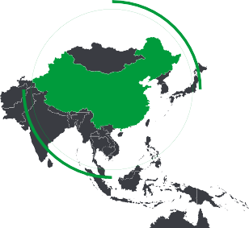

In its efforts to combat corruption, China has provided a comprehensive legal framework in the public and the private sector to criminalize corrupt actions with bribery of public officials as well as

corruption of foreign public officials being regulated under the PRC Criminal Code (the Criminal Code) and private bribery being regulated by both the Criminal Code and the PRC Anti-Unfair Competition Law.

In addition, China has several institutions with mandates to address different aspects and levels of corruption. Institutions

with the mandate to investigate criminal violations of laws related to anti-corruption are the Supreme People’s Procuratorate (SPP) and the Ministry of Public Security.

The Administration for Industry and Commerce has the power to investigate and sanction companies for private bribery, while the National Audit Office inspects the accounts of state-owned enterprises and government entities.

In 2018, the National Supervision Commission was established as a newly consolidated anti-corruption watchdog to take over the functions of the Ministry of Supervision and the anti-corruption units of the SPP and the National Bureau of Corruption Prevention to implement a more preventive approach to corruption,

which includes enforcing ethics guidelines, improving transparency in the government, and coordinating anti-corruption efforts among different institutions. Since 2012, the Communist Party of China (CPC) has also launched an anti-corruption campaign to fight against state bribery with the slogan that neither high-ranking “tigers” nor low-level “flies” can avoid punishment. The CPC has since investigated more than 240 senior officials and punished more than 1.14 million party members

or government officials

**Chen Zhou**

**Partner, Financial Advisory/Forensic**



**Navigating with confidence** | Bribery & Corruption Report

10

**Navigating with confidence** | Bribery & Corruption Report

## Risk assessment

***Does your organisation conduct a risk assessment?***

**Yes**



**Public sector Private sector**

**Not for proﬁt sector**

**3% 5% 13%**

**33%**

**37%**

**61%**

**47%**

**53%**

**48%**

 **No**

**Don’t know**

More than half the respondent organisations had not conducted a bribery and corruption risk assessment. This was almost two thirds in the public sector. In the private sector, of the 47% of respondents that had not conducted a risk

assessment, a third had an annual revenue of $500m or more.

Overall, a third of all respondents without a risk assessment had experienced a known incident of bribery or corruption. This had mostly occurred in the last 12 months. Even among respondents that did conduct a risk assessment, the results were not always used to inform the scope and resourcing of their ABC program.

This picture is not dissimilar to our results in previous years. But when we asked why business managers do not carry out bribery and corruption risk assessments, competing priorities and access to expertise dominated the responses.

There is a tension here. Without risk assessment, we cannot be sure that bribery and corruption is correctly prioritised, or that resources are appropriately allocated, or controls proportionate and effective. We cannot even be sure we know what the risks are.

**This is a dangerous place to be. Instead:**

* Risk assessment must be the starting point to understand the risk profile of an organisation, and to stand up its ABC program.
* If organisations do not have in-house financial crime capability, they should seek external help.
* Every organisation should assess its risks of financial crime, including bribery and corruption, in order to prioritise preventative actions and be recognised as a good global citizen.

What is most likely to prevent your business managers from carrying out bribery and corruption risk assessments?

|  |  |  |  |  |
| --- | --- | --- | --- | --- |
| Competing priorities |  |  |  | **41%** |
|  |  |  |  |  |
| Lack of in-house expertise |  |  |  | **26%** |
|  |  |  |  |  |
| s do not see the value in a bribery  and corruption risk assessment | | | **16%** |  |
|  |  |  |  |  |
| Resource and budget constraints |  |  | **16%** |  |
|  |  |  |  |  |
| Other |  | **1%** |  |  |

Manager

11

### Focus on…India



**Navigating with confidence** | Bribery & Corruption Report

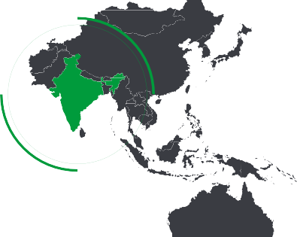

India remains a key investment destination for many foreign companies and overseas investors due to its vast, underserved,

yet aspirational population. The Indian government has recognised this and undertaken several initiatives to improve the business climate in the country.

These include regulatory and economic reforms, infrastructure development to aid connectivity and digitisation, and large scale reskilling and human development initiatives. All of these have contributed

to improving India’s ranking in the ‘Ease- of-Doing-Business Index’ – moving the subcontinent up from 134 in 2014, to 63

in 2019.

However, despite these successes,

India continues to be affected by bribery and corruption, posing a serious threat

12

to economic progress. India has had many large scale fraud and corruption cases recently, forcing regulators and enforcement agencies to rethink how they address the root cause of these issues. With this backdrop, the Indian government has introduced various regulatory and legislative measures.

These include efforts by the Ministry of Corporate Affairs of India (‘MCA’) to strike off names of shell companies that have not been in business for two years and have not applied for dormant status. More than 100,000 companies were struck off by the MCA in 2018 as part of clamping down on illicit funds.

The Lokpal and Lokayuta Act was enacted in 2016 to establish anti-corruption ombudsmen to inquire into allegations

of bribery and corruption against public functionaries. The Act also requires public servants to declare their assets and liabilities, as well as those of their spouses and dependent children. Meanwhile, the Whistleblower Protection (Amendment) Act 2015 was enacted to protect anyone disclosing corruption, wilful misuse of power or discretion by any public servant,

from harassment. It was also about keeping the identity of whistleblowers secure.

India also demonetised the INR 500 and 1000 currency notes in November 2016. This was in order to curtail the shadow economy and reduce the use of illicit and counterfeit cash for illegal activity and terrorism.

Perhaps the most significant change was the Prevention of Corruption (Amendment) Act 2018 (‘PCA 2018’). PCA 2018 directly

brought bribe givers under its purview. It introduced the concept of ‘corporate criminal liability’, which brought both the officers of and the commercial organisation, whether public or private, incorporated in or outside India, but carrying out business in India, under its veil. This means that the number of

prosecutions and convictions will increase. Businesses now need to watch out for a likely rise in the enforcement activity.

**Sumit Makhija**

**Partner, Financial Advisory, South Asia**

**Rajat Vig**

**Partner, Financial Advisory, South Asia**

**Aakash Sharma**

**Director, Financial Advisory**

**Navigating with confidence** | Bribery & Corruption Report

## Prevention

Respondents were overwhelmingly confident in the effectiveness of their own organisations’ preventative controls. While this is positive, the caveat may be that nearly a third of all respondents did

not have a schedule of work to manage the risks of bribery and corruption. The critical question for executives, then, is are you confident that your controls match your organisation’s specific risks?

And although almost two thirds of organisations were confident in their due diligence of staff, confidence dropped off in respect of third parties, and significantly for subcontractors and agents.

This is important, because many legislative instruments (such as the UK Bribery Act, or the US Foreign Corrupt Practices Act) consider an organisation liable for the behaviour of those acting in its name or interests. Australasian organisations

need to know a lot more about who they are engaging.

Not everybody had full confidence in respect of their staff. Non-profit

respondents were the least comfortable, perhaps reflecting greater focus on integrity and conduct in that space in recent years.

In the information age, a wide array of tools, techniques and technologies are available to help organisations understand who they are dealing with and the risks they present. Organisations need to:

* Take a risk-based approach, matching the proportionality of their due diligence to the risks of their products, services, sectors and jurisdictions.
* Be consistent, applying standardised and reliable approaches to evaluating the risks of second and third parties.
* Recognise that they work in a reputation economy in which the long-term benefit of being a good global citizen may outweigh shorter term gains.

How comfortable are you that your organisation’s key prevention controls are eﬀective and proportionate to your bribery and corruption risk?

**3%**

Do you have a schedule of work to manage risk of bribery and corruption, such as a strategy or program?

**2%**

**12%**



**28%**

**70%**

**25%**

**60%**

Extremely comfortable Comfortable

Slightly comfortable Not comfortable

# 11%

of respondents will make implementing or improving risk assessment their most relevant ABC focus area over the next two years

Yes No

Don't know

# 28%

of respondents stated that they do not have a schedule of work to manage the risk of bribery and corruption

13

**Navigating with confidence** | Bribery & Corruption Report

###### How conﬁdent are you in your organisation's ABC due diligence checks in respect of the following:

Due diligence checks on staﬀ

**Public sector**

**Private sector Not for proﬁt sector**

**0% 1% 7%**

**33%**

**32%**

**32%**

**60%**

**67%**

**68%**

**64%**

**35%**

**1%**

**Conﬁdent or Extremely conﬁdent**

**Not conﬁdent or Slightly conﬁdent**

**Don’t know /**

**Not applicable**

Due diligence checks on third parties

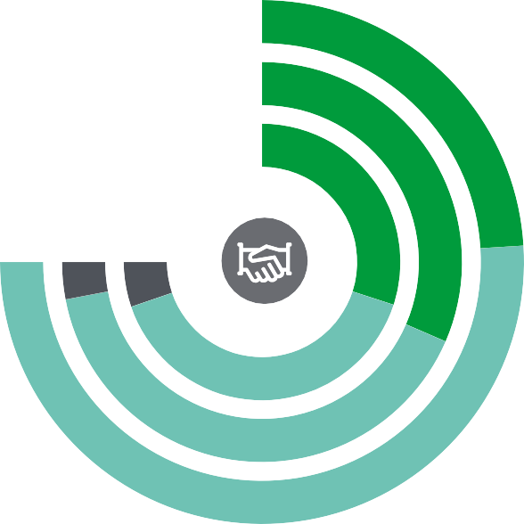

**Public sector**

**Private sector Not for proﬁt sector**

**0% 4%**

**68%**

**54%**

**7%**

**32%**

**40%**

**53%**

**42%**

**40%**

**57%**

**3%**

**Conﬁdent or Extremely conﬁdent**

**Not conﬁdent or Slightly conﬁdent**

**Don’t know /**

**Not applicable**

14

**Navigating with confidence** | Bribery & Corruption Report

Due diligence checks on sub-contractors

**Public sector**

**Private sector Not for proﬁt sector**

**27% 29%**

**0%**

**68%**

**9% 7%**

**32%**

**67%**

**61%**

**30%**

**64%**

**7%**

**Conﬁdent or Extremely conﬁdent**

**Not conﬁdent or Slightly conﬁdent**

**Don’t know /**

**Not applicable**

Due diligence checks on agents

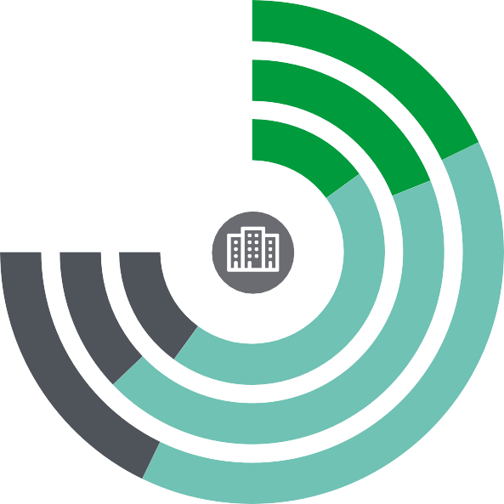

**Public sector**

**Private sector Not for proﬁt sector**

**24%**

**20% 25%**

**24% 16% 20%**

**60%**

**58%**

**53%**

**25%**

**57%**

**18%**

**Conﬁdent or Extremely conﬁdent**

**Not conﬁdent or Slightly conﬁdent**

**Don’t know /**

**Not applicable**

15

# 16%



of respondents reported that development or uplift of ABC program would be the most relevant focus area for them in relation to ABC in the next 24 months

##### Resources and corruption seem to go hand in hand.

**Public Sector respondent | New Zealand**

##### There is a need to constantly review practices and processes – both internally and with an independent view.

**Public Sector respondent | New Zealand**

**48%**

of organisations believe that internal training courses are the most effective way to build the capabilities of employees to manage bribery and corruption risk

**Navigating with confidence** | Bribery & Corruption Report

### Focus on…Indonesia

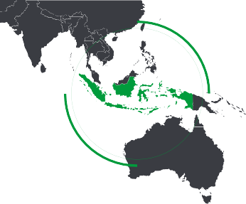

Indonesia’s Anti-Bribery and Corruption is mainly based on:

* Law No. 31 of 1999 on Eradication of Corruption Crimes as amended by Law No. 20 of 2001
* Law No. 11 of 1980 on Bribery
* Law No. 7 of 2006 on Ratification of the United Nations Conventions against Corruption.

The laws govern the seven types of corruption crimes that cause loss to the state’s finances. They are bribery, gratuity, malfeasance, extortion, fraud and conflict of interest in procurement. The laws only govern corruption within government sectors that involve state officials, i.e. judges, advocates and contractors

that render services to public projects. Corruption in the private sector, where the

organisations do not deal with government entity or officials, is not subject to these laws.

The Indonesian Criminal Code covers corruption in the private sector and such cases would be reported under embezzlement or fraud activity.

Furthermore, the Supreme Court of Republic of Indonesia issued Regulation No. 13 of 2016 on Procedures for Handling Criminal Acts by Corporation. Under the Regulation, a corporate is convicted of a crime by the judge, if the corporation:

* Can make a profit or benefit from a criminal act or it was carried out for the benefit of the Corporation.
* Allow a criminal act to occur.
* Does not take necessary steps to prevent and ensure compliance with applicable legal provisions in order to avoid a criminal act.

The Police, the Corruption Eradication Committee (Komisi Pemberantasan Korupsi

/ ‘KPK’) and the Attorney General’s Office (the ‘AGO’) are the three law enforcement bodies involved in combating corruption in Indonesia. Each body is authorised

to investigate with different levels of prosecution authority.

The KPK was established pursuant to Law No. 30 of 2002, which has recently been amended on Law No. 19 of 2019. Its main role is to investigate and prosecute corruption cases committed by public officials. In the past year, the KPK has led numerous enforcement activities across the country and has been working closely with law enforcers and international regulators in investigating a record number of bribery and corruption cases.

However, the recently passed amendment was controversial nationally, particularly because it was viewed as stripping KPK of its authority and independence. Although this may not have direct implications on business operations, companies should nevertheless be aware of any future developments regarding this issue.

**Widiana Winawati**

**Partner, Deloitte Indonesia**

17

**Navigating with confidence** | Bribery & Corruption Report

## Detection and response

A significant 35% of respondents had experienced instances of bribery and corruption within their organisation, with 17% in the last 12 months.

Tip-offs continue to be the main way fraud and corruption is detected. But it was encouraging this year that when management review, financial review and direct reports to managers were put together, they outweighed tip-offs.

This might infer greater vigilance and engagement, and even a greater willingness to challenge bribery and corruption.

That said, while 65% of respondent organisations reported never having experienced a known incident of bribery or corruption, the majority also reported confidence in their detective controls.

This might not be as positive as it may seem. As we know now, bribery and corruption is the form of financial crime that hides and masquerades, and absence of evidence, is not evidence of absence.

Organisations should not fear detection. Detection is an indicator of increased diligence and commitment, not an increased problem.

Unfortunately, data analytics technologies still seem under-utilised, with only 9% of organisations detecting incidents this way. In our data-driven world, there are huge opportunities to be had by early warning of bribery and corruption through spotting the footprints. Organisations need to leverage this if they want to retain their confidence in their detective capabilities.

Has your organisation experienced any known instances of bribery and/or corruption?

Yes, within the



**17%**

**65%**

**6%** last 12 months

**7%** Yes, more than ﬁve years ago

**4%**

Yes, more than two years ago

Yes, more than a year ago

No known instances

***How many instances of suspected bribery and/or corruption has your organisation experienced in the past twelve months?***

**63%**

**30%**

**7%**

**Fewer than 5**

**6 – 10**

**Public sector**

**Private sector Not for proﬁt sector**

**0% 7% 0%**

**40% 50%**

**27%**

**50%**

**67%**

**60%**

**11 – 50**

18

**Navigating with confidence** | Bribery & Corruption Report

Percentage of respondents that detected corruption through the following methods:

Tip through a conﬁdential reporting mechanism

**35%**

**29%**

**27%**

**16%**

**15%**

**9%**

**9%**

**5%**

Management or ﬁnancial review

**51%**

Internal audit

Direct report to a manager

Other

Notiﬁed by law enforcement/regulator

IT controls or electronic monitoring

Data analytics

External audit

How comfortable are you that your organisation's key detection controls are eﬀective and proportionate to your bribery and corruption risk?

**16%**

**31%**

**52%**

Extremely comfortable

Comfortable

Slightly comfortable/ Not comfortable

How comfortable are you that your organisation's key response controls are eﬀective and proportionate to your bribery and corruption risk?

**27%**



**15%**

**2%**

**57%**

Extremely comfortable

Slightly comfortable/ Not comfortable

Comfortable Don’t know

19

# 9%



stated that implementing or improving detective data analytics will be the most relevant focus area in relation to anti-bribery and corruption in the next 24 months

##### Using a whistleblower service has resulted in an increased ability to improve reporting capability to detect fraud, bribery and corruption.

**Energy industry respondent | Australia**

##### There is a perception that the problem is getting worse, but I don’t think so; it’s that we are better at detecting incidents.

**Engineering industry respondent | Australia**

**Navigating with confidence** | Bribery & Corruption Report

### Focus on…Malaysia

Come 1 June 2020, Section 17(A) of the Malaysian Anti-Corruption Commission (Amended) Act 2018 will take effect.

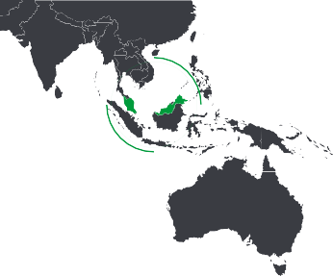

This introduces corporate liability for corruption offences. It means that a commercial organisation commits an offence if any person associated with that commercial organisation corruptly gives, agrees to give, promises, or offers any person any gratuity for the benefit of the commercial organisation. In these cases, the top management – including directors and/or their representatives

– may be liable, regardless of whether they had knowledge of the corrupt acts committed by their employees or any associated persons.

The implication of this new amendment is wide reaching. It has an extra-territorial application given the broad definition of ‘person associated with the commercial organisation,’ which includes persons who perform services on behalf of

the organisation, such as agents, sub- contractors and joint venture partners.

The offence carries a penalty of no less than 10 times the sum of gratification or MYR1 million (whichever is higher), and/or 20 years imprisonment or both.

If charged, the onus is on the organisation to demonstrate that it had ‘adequate procedures’ in place to prevent such corrupt acts from taking place. These adequate procedures should be aligned

to guidelines issued by the Malaysian Prime Minister’s office based on the five principles of ‘TRUST’:

1. Top Level Commitment
2. Risk Assessment
3. Undertake Control Measures
4. Systematic Review and Monitoring and Enforcement
5. Training and Communication.

In addition, in December 2019 Bursa Malaysia (Malaysia’s listed stock exchange operator) introduced requirements for listed issuers to establish and implement policies and procedures on anti-corruption and whistleblowing.

These are to be reviewed at least once every three years to assess their effectiveness and be published on its

website. They also require that corruption risk be included in the annual risk assessment of the issuer. The amended listing requirements will also take effect on 1 June 2020.

It is vital for Australasian companies

and individuals with interests in Malaysian companies to understand whether these companies have in place or have started to take steps to develop and implement their anti-corruption policies and procedures, taking into account the

five principles of TRUST.

**Oo Yang Ping**

**Director, Deloitte South East Asia**



21

**Navigating with confidence** | Bribery & Corruption Report

## Culture

As in previous surveys, respondents once again saw internal culture as the key to tackling bribery and corruption. They reported strong leadership commitment, expressed primarily through training programs, corporate communications, contracts and policy.

Notably, however, only 27% of respondents reported clear evidence of investment

in anti-bribery and corruption. This is important, because perception of action is critical in driving desired behaviour.

.To truly manage the risk, positive steps need to be both seen and taken to control it. While most respondents acknowledged the use of reviews and audits, leaders must break out of the cycle of review

only, and establish meaningful overt anti- bribery programs.

Some respondents do report being at a much higher level of vulnerability.

More than one in 20 respondents described a leadership that did not endorse a no-tolerance approach.

And 11% noted that their organisation’s position on bribery and corruption was not conveyed to employees. This is not a responsible position in the reputation economy. Should an incident take place,

regulators and law enforcement agencies assess the role played by an organisation’s tone at the top, incentive structures and wider culture.

Top ﬁve most relevant focus areas for ABC in the next 24 months

**9%**

**9%**

**1%**

**33%**

**1**

**16%**

Maturing the internal culture

Development or uplift of anti-bribery corruption program Implementing/improving bribery and corruption risk assessments Implementing/improving detective data analytics Implementing/improving third management and due diligence

How is the organisation's position on bribery and corruption conveyed to all employees?

Training programmes

Anti-bribery and corruption messaging is embedded in employee communications and /or website

Anti-bribery and corruption clauses are included in contracts and agreements

Publications such as annual reports

Event and meetings, such as sales conferences and town halls

Organisation’s position is not conveyed

Other

**13%**

**11%**

**11%**

**21%**

**52%**

**60%**

**58%**

22

**Navigating with confidence** | Bribery & Corruption Report

How does leadership actively demonstrate its commitment to a no-tolerance approach to bribery and corruption?

The leadership’s commitment is embedded in policy

**83%**

Management reviews, audits and/or external reviews

**77%**

Responsibility for managing B&C is clearly articulated

**53%**

Incorporation into training programs for staﬀ

**52%**

Statements by internal communication channels

Management is appropriately and proportionately resourced to properly manage the risk

Bribery and corruption risk assessments There is clear evidence of investment in

anti-bribery and corruption

The leadership receives regular information on the performance ABC program

Responsibility architecture has been assessed

to ensure that gaps do not exist Other action by leadership

The leadership does not endorse a no-tolerance approach

**14%**

**6%**

**33%**

**27%**

**25%**

**25%**

**45%**

**52%**

***What do you perceive to be the most eﬀective way to build the capabilities of employees to manage bribery and corruption risk?***

**4% 3% 3% 1%**

**11%**



**30%**

**48%**

Internal training courses Leadership example Guidance to staﬀ Workshops

Policy attestations Other

External training courses and accreditation

23

##### It is important to regularly measure the culture in organisations – to get a temperature check of things.

**Public sector respondent | New Zealand**

**33%**

stated that *‘Maturing*

*the internal culture’* will be the **most relevant focus** area for ABC in the next 24 months

##### You have to give staff the confidence to ask the right questions.

**Public sector respondent | New Zealand**

##### The hard edge is effective in bringing about change.

**Manufacturing industry respondent | Australia**

##### Telling your own stories is a powerful way of engaging with staff.

**Public sector respondent | New Zealand**

##### Cultural norms play into what is permissive.

**Public sector respondent | New Zealand**

# 30%

of respondents

perceived the most effective way to build the capabilities of employees to manage bribery and corruption risks was through leadership example

##### The framework and controls can be best practice, but you require a culture of management and people to speak up and do the right thing.

**Agriculture industry respondent | Australia**

### Focus on…Thailand

**Navigating with confidence** | Bribery & Corruption Report

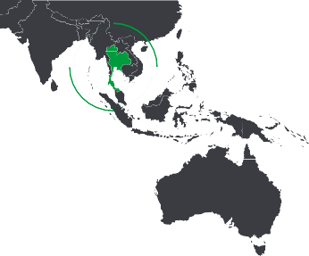

Over the past decade, Thailand has sought to strengthen its ABC legislation and enforcement founding Thailand’s Private Sector Collective Action Coalition Against Corruption (CAC) in 2010, and amending the Organic Act on Counter Corruption (OACC), Thailand’s primary anti-corruption legislation, several times. The new OACC regime has been in place since 2015.

Under the new OACC, private companies can be criminally liable for bribes given to Thai and foreign state officials, as well as officials in intergovernmental organisations. Companies are liable when the bribe is given by an ‘associated individual’, which includes representatives, employees, agents, subsidiaries, or any person acting on behalf of the company regardless of their authority.

Punishments include imprisonment and fines for the government official, bribe- giver and associated company. Bribe-givers can be imprisoned for five years and/or fined up to THB100,000. The maximum fine is one to two times the damage or benefits gained.

Recent enhancements to the authority and responsibility of the National Anti- Corruption Commission (NACC) over the past three years include:

* In 2016, the law empowered the NACC to appoint a Chief Investigator. In the same year the Central Criminal Court for

Corruption and Misconduct cases (CCCM) separated from the general criminal court.

* In 2017, the NACC issued internal control guidelines for anti-corruption, based

on international guidelines including ISO 37001.

* In 2018, the OACC also established a national anti-corruption fund to promote anti-corruption, providing protection measures and rewards to whistleblowers, as well as subsidising the expense of protecting the NACC’s committee and investigators.

Another important change in the new OACC is that the NACC can seek international cooperation in their

investigations. The NACC now has authority to send the alleged corruption incidents of foreign officials to the responsible foreign authority and investigate corruption incidents of foreign officials when requested by foreign countries.

These changes are important given the number of key corruption cases in Thailand. In such circumstances, NACC

can cooperate with the foreign responsible parties to investigate and help build a criminal case against the bribe giver and bribe taker in Thailand. NACC chairman Watcharapol Prasarnrajkit said the NACC aims to complete 2,200 cases in 2020 having only investigated 500 last year.

**Surasak Suthamcharu Partner, Deloitte Thailand**

25

**Navigating with confidence** | Bribery & Corruption Report

**Navigating with confidence:** Towards ABC resilience

Require management and staff commitment

Integrate ABC program with broader risk management

Establish an ABC committee

Risk-based ABC training customised to participant role and level

Clearly defined management accountability and responsibility

Adopt risk-based approach to controls

Regular internal and external audits Regular and integrated risk

assessment

Due diligence of staff and third parties

Third party management

Clear and accessible policies Conflict of Interest management



Incident register

Clear and articulated methods for staff to report concerns

Framework for management of sanctions on staff and third parties

Response plan and investigation doctrine



Independent 24/7 confidential whistle-blower system

Detection and risk – focused data analytics



Proactive review of high-risk processes for red flags



26

**Navigating with confidence** | Bribery & Corruption Report

## Our respondents

The insights and analysis of this report are based on

**159** survey participants, which are broken down by:

#### 21%



**Size by headcount:**

**Geography:**

#### 60%

of respondents were from Australia

#### 40%

of respondents were from New Zealand

**Sector:**

#### 67%

private sector

#### 24%

public sector

#### 9%

not-for-profit sector

had 5,000 or more

#### 26%

had 1,000 to 4,999

#### 8%

had 500 to 999

#### 32%

had 50 to 499

#### 12%

had less than 50

**Size by value:**

**Revenue, spend or budget for organisations**

$500m or more

**21%**

**11%**

**15%**

**7%**

**45%**

$100m to $499m

$50m to $99m

$10m to $49m

Less than $10m

27

**Navigating with confidence** | Bribery & Corruption Report

## Deloitte Forensic in Asia-Pacific

Deloitte Forensic helps clients react quickly and confidently in a crisis, investigation or dispute. We use our global network,

deep industry experience and advanced analytical technology to understand and resolve issues. And we deliver the proactive advice clients need to reduce the risk of future problems.

Our services include:

**Financial crime advisory**, assisting our clients to proactively manage risks such as bribery, corruption and other financial crime.

**Forensic digital**, using our global digital transformation platform and networked ecosystem to deploy our current leading edge solutions and create new ones for clients.

**Discovery**, leveraging our global industry and technical experience to create a more intelligent approach to discovery. In turn, this allows us to help address matters in a more cost-effective and robust way.

**Disputes and litigations**, working with organisations and their lawyers in complex judicial and alternative dispute resolution matters. Our work includes deep expert witness, financial analysis, damage quantification and discovery capabilities.

**Investigations and remediations**, in which our global network allows us to combine an understanding of local business cultures and regulatory issues to find a path to a successful resolution, and leave the client better prepared to protect their assets and reputation.

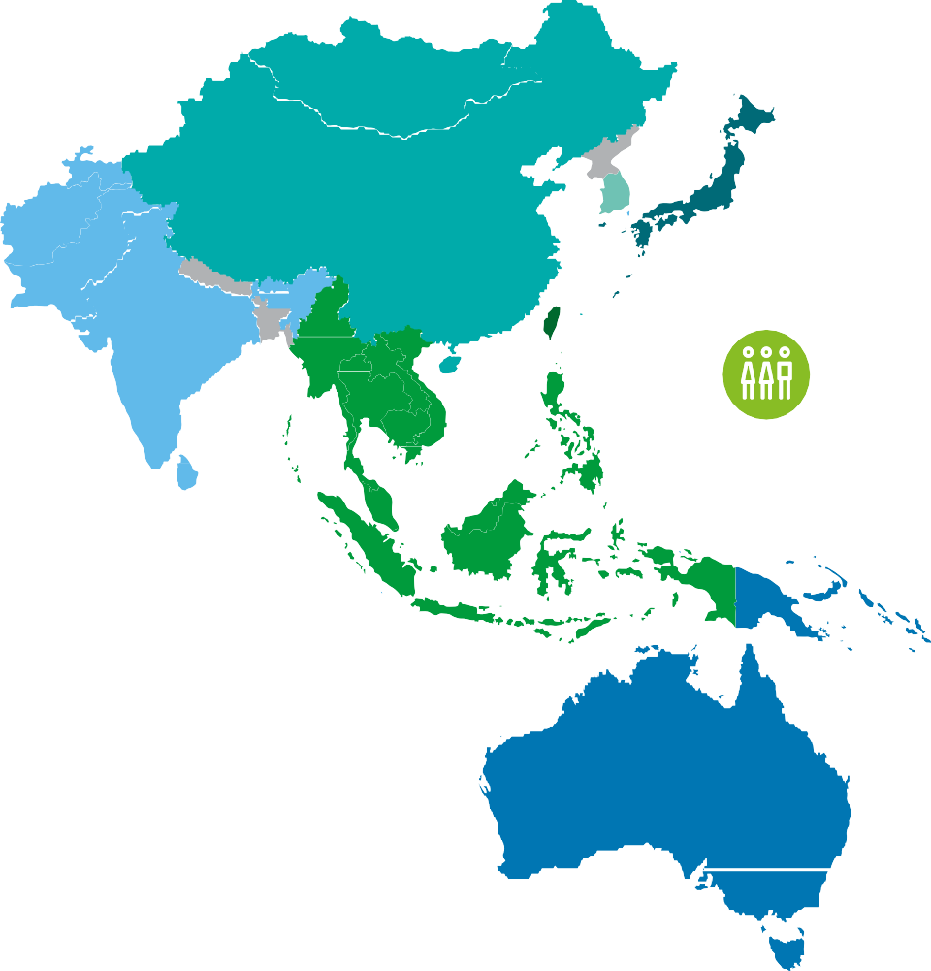

**Asia Pacific**

More than **30** forensic partners and **800** practitioners



28

Contacts

**Australia**

**New Zealand**

**Chris Noble**

Managing Partner, Forensic Australia and Asia Pacific

P: +61 7 3308 7065

E: [cnoble@deloitte.com.au](mailto:cnoble@deloitte.com.au)

**Lorinda Kelly** Partner, Forensic P: +64 44 703749

E: [lorkelly@deloitte.co.nz](mailto:lorkelly@deloitte.co.nz)

**Oliver May** Director, Forensic P: +61 2 9322 3662

E: [olmay@deloitte.com.au](mailto:olmay@deloitte.com.au)

**Jason Weir** Partner, Forensic P: +64 9 3030966

E: [jasweir@deloitte.co.nz](mailto:jasweir@deloitte.co.nz)

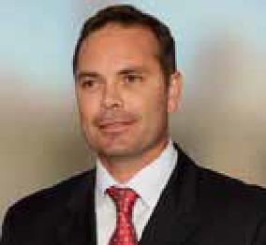

Deloitte refers to one or more of Deloitte Touche Tohmatsu Limited (“DTTL”), its global network of member firms, and their related entities (collectively, the “Deloitte Organisation”). DTTL (also referred to as “Deloitte Global”) and each of its member firms and related entities are legally separate and independent entities, which cannot obligate or bind each other in respect of third parties. DTTL and each DTTL member firm and related entity is liable only for its own acts and omissions, and not those of each other. DTTL does not provide services to clients. Please see [www.deloitte.com/about](http://www.deloitte.com/about) to learn more.

Deloitte is a leading global provider of audit and assurance, consulting, financial advisory, risk advisory, tax and related services. Our global network of member firms and related entities in more than 150 countries and territories (collectively, the “Deloitte Organisation”) serves four out of five Fortune Global 500® companies. Learn how Deloitte’s approximately 312,000 people make an impact that matters at [www.](http://www/) deloitte.com.

Deloitte Asia Pacific Limited is a company limited by guarantee and a member firm of DTTL. Members of Deloitte Asia Pacific Limited and their related entities, each of which are separate and independent legal entities, provide services from more than 100 cities across the region, including Auckland, Bangkok, Beijing, Hanoi, Hong Kong, Jakarta, Kuala Lumpur, Manila, Melbourne, Osaka, Shanghai, Singapore, Sydney, Taipei and Tokyo.

In Australia, the Deloitte Network member is the Australian partnership of Deloitte Touche Tohmatsu. As one of Australia’s leading professional services firms. Deloitte Touche Tohmatsu and its affiliates provide audit, tax, consulting, and financial advisory services through approximately 8000 people across the country. Focused on the creation of value and growth, and known as an employer of choice for innovative human resources programs, we are dedicated to helping our clients and our people excel. For more information, please visit our web site at https://www2.deloitte.com/au/en.html.

Deloitte Australia’s liability is limited by a scheme approved under Professional Standards Legislation.

Deloitte New Zealand brings together more than 1400 specialist professionals providing audit, tax, technology and systems, strategy and performance improvement, risk management, corporate finance, business recovery, forensic and accounting services. Our people are based in Auckland, Hamilton, Rotorua, Wellington, Christchurch, Queenstown and Dunedin, serving clients that range from New Zealand’s largest companies and public sector organisations to smaller businesses with ambition to grow. For more information about Deloitte in New Zealand, look to our website [www.deloitte.co.nz.](http://www.deloitte.co.nz/)

Both Deloitte New Zealand and Deloitte Australia are members of Deloitte Asia Pacific Limited and the Deloitte Network.

This communication contains general information only, and none of Deloitte Touche Tohmatsu Limited (“DTTL”), its global network of member firms or their related entities (collectively, the “Deloitte Organisation”) is, by means of this communication, rendering professional advice or services. Before making any decision or taking any action that may affect your finances or your business, you should consult a qualified professional adviser.

No representations, warranties or undertakings (express or implied) are given as to the accuracy or completeness of the information in this communication, and none of DTTL, its member firms, related entities, employees or agents shall be liable or responsible for any loss or

damage whatsoever arising directly or indirectly in connection with any person relying on this communication. DTTL and each of its member firms, and their related entities, are legally separate and independent entities.

© 2020. For information, contact Deloitte Touche Tohmatsu Limited.