The Coalition’s carpark announcements before the 2019 election are among the best-known cases of pork-barrelling.

Pork-barrelling is unfair and wasteful. Here’s a plan to end it
August 22, 2022

Authors
Kate Griffiths Deputy Program Director, Grattan Institute
Anika Stobart Associate, Grattan Institute
Danielle Wood Chief executive officer, Grattan Institute

Disclosure statement
The Grattan Institute began with contributions to its endowment of $15 million from each of the Federal and Victorian Governments, $4 million from BHP Billiton, and $1 million from NAB. In order to safeguard its independence, Grattan Institute’s board controls this endowment. The funds are invested and contribute to funding Grattan Institute's activities. Grattan Institute also receives funding from corporates, foundations, and individuals to support its general activities as disclosed on its website.
Anika Stobart and Danielle Wood do not work for, consult, own shares in or receive funding from any company or organisation that would benefit from this article, and have disclosed no relevant affiliations beyond their academic appointment.

From sports rorts to regional slush funds and commuter carparks, it’s been one scandal after another in Australian politics in recent years. But what can we actually do to stop politicians pork-barrelling?
A new Grattan Institute report, released today, shows the problem isn’t confined to one side of politics: both Coalition and Labor governments, at federal and state levels, use government grants for political purposes. But there is a way to stop them from doing it again.

Pork-barrelling is common
Pork-barrelling is the use of public resources to target certain voters for partisan purposes – for example, by spending public money in particular electorates to try to win more votes rather than spending those funds where they are most needed.
Using grants to buy votes is one of the most visible forms of pork-barrelling. Grants processes often allow substantial ministerial discretion with little transparency, making them what one researcher described as “an ideal vehicle for delivering pork”.
The figures show that pork-barrelling has been blatant in many federal and state government grant programs. More grant money is received by seats held by the government of the day and marginal seats receive disproportionately more funding.
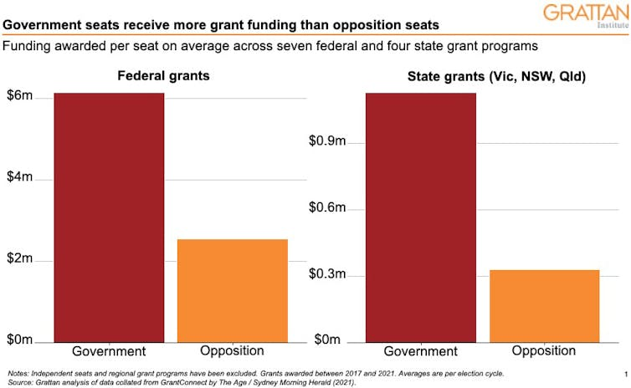
Pork-barrelling has been especially shameless in certain grant programs. For example, the federal Community Development Grants program allocated government-held seats more than four times more per seat, on average, than opposition seats. For the NSW Stronger Communities Fund, the figure was almost six times as much.

Support expert insights and fact-based journalism in chaotic times.
Become a donor
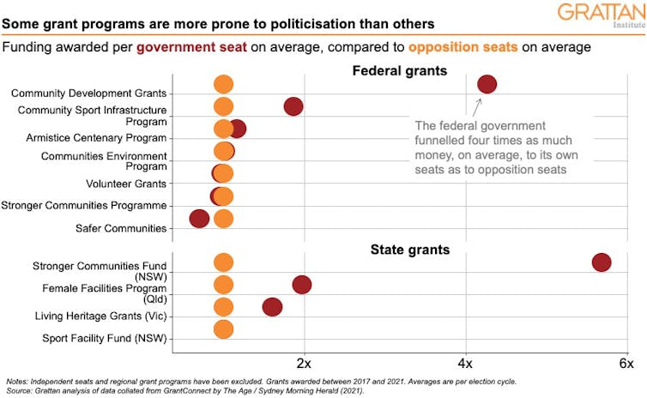

Yet some politicians defend pork-barrelling
While pork-barrelling isn’t new, there’s been a worrying trend in recent years towards normalising it. Instead of offering apologies and resignations, some politicians have ramped up their excuses and are now openly defending this misuse of public money. Justifications include: “It’s not unique to our government”; “It’s what the elections are for”; and even that pork-barrelling accompanied by giant cheques featuring government MPs’ faces is “a feature of Australian democracy”.
Revelations of large-scale pork-barrelling should prompt ministerial resignations and government reforms to make it harder to do it again. But state and federal ministers don’t often fall on their swords over pork-barrelling these days, despite evidence that 77% of Australians believe they should.
The decision to brazen it out might be driven by short-term political interests, or it might show our politicians don’t understand or respect the rules and norms on spending public money.
Either way, politicians’ behaviour has drawn attention to the ineffectiveness of Australia’s current rules on pork-barrelling.

How to prevent pork-barrelling
Pork-barrelling, by definition, is not in the public interest. It has real costs.
Channelling taxpayer’s money into projects to benefit friends and supporters, or to win votes, means less money for more valuable projects, and less core spending on health, education and other programs that can improve the lives of all Australians and lift the productive capacity of the economy.
Pork-barrelling also undermines trust in governments, promotes a corrupt culture, and risks entrenching power and skewing elections.
So how can we put a stop to the seemingly irresistible temptation to roll out ever more grants? Let’s start with an open, competitive, merit-based process for allocating government grants that establishes clear guardrails around ministerial discretion.
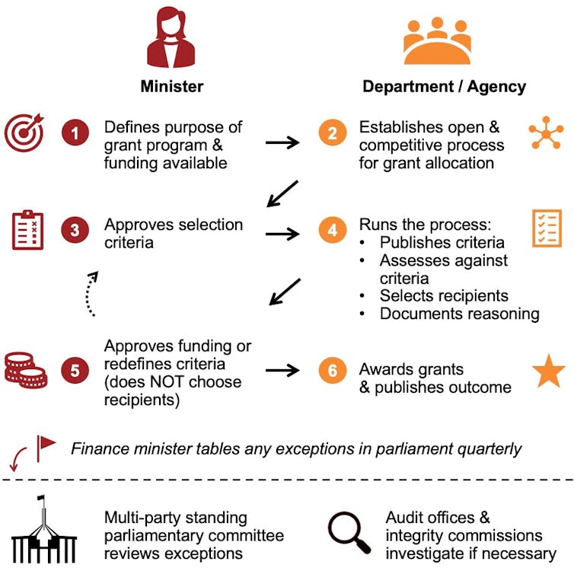
A better process for allocation and oversight of grants.

Ministers should be able to establish grant programs and define the selection criteria, but they should not be involved in choosing grant recipients. Shortlisting and selecting grant recipients is an administrative function for the relevant department or agency. Ministers should have bigger fish to fry.
A multi-party standing parliamentary committee should oversee compliance and interrogate any minister or public official who deviates from the rules. And funding for federal and state auditors-general should be increased to enable wider and more frequent auditing of grant programs.

Here’s a simple way to stop governments giving jobs to mates

A strong and well-resourced integrity commission is the last line of defence against pork-barrelling. Better processes and oversight should significantly reduce the opportunities and incentives for governments to engage in pork-barrelling in the first place.
If pork-barrelling continues, an integrity commission may choose to investigate. A recent report from the NSW Independent Commission Against Corruption concluded that pork-barrelling “can under certain circumstances involve serious breaches of public trust and conduct that amounts to corrupt conduct”.
It’s time to take the pork off the table. Better processes and oversight of grant funding, alongside the other recommendations in our New Politics series of reports, would lay the foundations for a new way of doing politics in Australia – one that safeguards the public interest from political interests.

