
Trends in Australia’s productivity growth:
further research
and findings
KPMG research paper

KPMG Economics, June 2024
KPMG.com.au

Contents
Executive summary 3
Chapter 1: Introduction 5
Chapter 2: Is the current slowdown ‘normal’? 9
Chapter 3: Do Australia’s labour market dynamics influence productivity? 17
Appendix 1 26

Executive summary
Productivity is a fundamental driver of economic growth and essential for a nation’s prosperity. Productivity growth is the principal mechanism by which real wages can grow sustainably.
When productivity growth starts to fall or achieves low levels of growth for a protracted period of time, there is a tendency for politicians, economists and industry analysts, to brand the situation a ‘productivity crisis’.
Australia, according to some, currently finds itself in such a ‘productivity crisis’, with real GDP per hour worked having fallen from its peak at the end of 2022 and is still at levels last recorded at the end of 2019.
The purpose of this paper is to present analysis and findings on the current productivity growth performance of Australia. In doing so, it considers if the use of the term ‘crisis’ appropriately describes the current situation or whether it is an outcome driven by measurement issues or other factors.
The Federal Reserve Bank of San Francisco found over the past 70 years that the United States has had extended periods of relatively high productivity growth followed by relatively low productivity growth; and that it is not unusual for the US economy to experience long- lasting, but not permanent, ‘regimes’ of high or low productivity growth.
KPMG’s analysis of Australia’s productivity outcomes (using the same analytical framework as the US Federal Reserve), suggests that Australia is not in a ‘productivity crisis’, as commonly characterised. Rather, our research confirms our productivity tends to move between long-lasting, but not permanent regimes of high or low growth, with the expected duration of being in a high-growth regime being around 8 quarters while it is closer to 12 quarters for a low productivity growth regime.
Periods of high productivity or low productivity growth do not last forever, although it appears periods of low productivity growth last marginally longer in Australia than periods of high productivity.
Australia, Canada, and the US exhibit similar, but not identical, patterns in experiencing periods of high and low productivity growth.
Recent data from the US is indicating a resurgence in productivity and given the
numerous economic parallels between the two countries, it is not unreasonable to anticipate that Australia will follow suit and experience a similar productivity growth rebound in the near future.

KPMG completed a further piece of econometric analysis using aggregate quarterly data to identify whether specific labour market factors play a deterministic role in influencing Australia’s productivity. Our analysis shows that slightly more than half of non-mining labour productivity growth in Australia can be explained by three factors:
- The productivity that occurred in the last quarter – a momentum effect.
- How many new workers entered the labour force – they are likely to be relatively lower skilled or more inexperienced than the current workforce. Adding foreign workers helps because they boost the productivity of native-born workers and bring in specialisation, new skills, ideas, or innovation. This effect occurs with a lag.
- When the labour market is tight, the marginal new worker comes from a pool
of long-term unemployed, who may require additional supports to be as productive as other employees.
Our findings demonstrate that the labour market plays an important role in explaining the slowdown in productivity in Australia. While part of the problem comes from the cyclical movement of the economy, there exist many avenues for labour and migration policy levers to improve the structural aspect of the labour market, while mitigating its cyclicality.
KPMG suggests further attention be devoted to the following key pillars to lift productivity growth:
- Improve education and training for unemployed people.
- Redesign migration programs.
- Ensure sufficient flexibility to allow for labour mobility.

5 | Trends in Australia’s productivity growth: further research and findings

Chapter 1: Introduction

©2024 KPMG, an Australian partnership and a member firm of the KPMG global organisation of independent member firms affiliated with KPMG International Limited, a private English company limited by guarantee. All rights reserved. The KPMG name and logo are trademarks used under license by the independent member firms of the KPMG global organisation.
Liability limited by a scheme approved under Professional Standards Legislation.

Introduction

Background
Productivity has been acknowledged for decades as a fundamental driver of economic growth and essential for a nation’s prosperity. For Australia, productivity growth has been responsible for almost all the increase in Australia’s prosperity since Federation.1
When productivity growth starts to fall or achieves low levels of growth for a protracted period of time, there is a tendency for politicians, economists and
industry analysts, to brand the situation a ‘productivity crisis’.
Australia, according to some, currently finds itself again in such a ‘productivity crisis’, with real GDP per hour worked – a broad measure of labour productivity calculated by the Australian Bureau of Statistics and presented within the National Accounts – having fallen from its peak at the end of 2022 and is still at levels last recorded at the end of 2019.
Figure 1
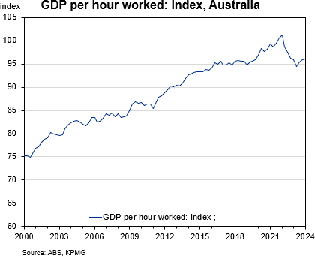

1 PC Productivity Insights 2020: Australia’s long term productivity experience, Australian Government Productivity Commission, 2020.
KPMG has previously contributed to the policy discussion relating to productivity through a number of economic research reports2 and various submissions to government reviews. The findings from our research remain relevant today, and include these findings and recommendations:
- Adopting universal policy settings to target an aggregate increase in productivity is unlikely to yield outcomes that will achieve our full economic potential. KPMG supports the adoption of tailored policies for capital and labour on an industry-by- industry basis, such as highly customised education and training, tied industry-specific grants, and a more micro approach in the deployment of publicly funded capital.
- Labour productivity remains the key factor influencing wages growth outcomes across all industries. The mix of capital and labour that an industry employs is also influential in the wage outcome for workers.
- There is an inverse relationship between the rate of growth of the real producer wage (RPW) and the rate of growth in employment. KPMG research suggests that strong employment growth is difficult to achieve with strong growth in the RPW unless it is backed up by strong productivity growth.

2 The Role of Capital and Labour in Driving Economic Growth in Australia, KPMG, April 2016; Wages, Productivity and Technology: Adding one more piece to the wage growth puzzle, March 2019.

- Technology assets may have become more influential in driving wages growth than has been the case in the past. This has potentially important implications because industries that fall behind in the use of high-tech assets in their production processes will not be able to sustain wage growth and retain workers.
- It is important to ensure policy settings do not constrain productivity growth or inappropriately skew the sharing of returns between labour and capital, otherwise we are likely to experience underinvestment, fewer jobs and lower wages.

Purpose of this paper
The monitoring of productivity in Australia only started during the 1960s, and in practice, it is recognised as a challenging concept to measure.
While the debate on productivity has mainly focused on the negative multifactor productivity (MFP) growth and the decline in capital productivity, various economists have argued against the existence of a ‘productivity crisis’.
Productivity cycles can only be measured ex-post, with productivity growth tending to be cyclical and often following the business cycle; although this is not always the case as there are examples where productivity falls during economic expansions and rises during contractions.
For example, analysis of ABS data on MFP for the mining industry suggests that annual productivity growth has been negative for more than half of the period between 1995–96 and 2022–23. However, rather than interpreting the data at face value and concluding the mining industry’s productivity performance is poor, it is important to understand the statistical ‘cause’ of the negative outcome and then seek to understand whether the decline is

3 The Harrod-Domar Model
real or whether it is because of a measurement issue.
In this case, the decline in MFP for the mining industry is likely to be a result of the significant investment that occurred within the mining industry during this period; with Dolman and Gruen (2012) arguing that while measured productivity in the mining industry has been estimated as negative there has not been ‘any real decline in productive efficiency within the industry’ (Shahiduzzaman, Layton and Alam, 2015, p.285).
The purpose of this paper is to present analysis and findings on the current productivity growth performance of Australia. In doing so, it considers if the use of the term ‘crisis’ appropriately describes the current situation or whether it is an outcome driven by measurement issues or other factors. To the extent there is an issue with Australia’s current productivity growth, we will seek to identify the cause of the problem and propose solutions that we believe will help lift productivity growth and boost Australian living standards.
However, before we delve into whether Australia is in a crisis or there are other forces at play, we believe it is useful to remind ourselves of the definition of productivity and review the technical issues surrounding its calculation and interpretation.

What is productivity and how is it measured?
The concept of productivity as a key component to the theory of economic growth was initially developed3 in the 1940s and refined in the 1950s by Australian economist Trevor Swan.4
Productivity is the efficiency with which a set of inputs can be combined to produce a unit of output, be it a service or a good.

4 In conjunction with Nobel Prize winning economist Robert Solow (known as the ‘Solow-Swan exogenous growth model’)

The sets of inputs can include primary factors, such as various types of fixed capital (i.e. plant, equipment and buildings) and labour, and produced inputs (i.e. intermediate inputs). Productivity growth occurs from innovation that allows firms to produce a unit of output with fewer inputs (or to produce more or a higher quality output with the same inputs).
In their submission to the House Standing Committee on Economics 2010 Inquiry into raising the level of productivity growth in the Australian economy, the Australian Bureau of Statistics noted:
In a very general sense, the best way to think about productivity is by thinking of production. You can have increased production from an increase in inputs, you can have increased production due to a more efficient use of those inputs or a combination of both of those things. In a growth accounting framework you can in simple terms measure productivity by looking at the ratio of output to one or more inputs. When you decompose it, in a sense, productivity is actually the residual of that calculation.5
Productivity is usually measured as:
- partial factor productivity, such a labour productivity6 and capital productivity,7
- total factor productivity, which is an aggregate measure incorporating all inputs and outputs, and
- multifactor productivity, which is a residual measure of the difference between output growth and the growth in capital and labour inputs.

5 Ibid
6 Measured as the volume of output per hour worked.
Of the measures noted above, multifactor productivity (MFP) is considered a better measure of an economy’s relative efficiency as it shows the amount of output generated beyond the directly attributable inputs.
However, measuring productivity can be problematic, and given there are different approaches and methodologies that can be applied to estimate productivity, comparisons across time and jurisdictions can be difficult even if it appears that the same principles are broadly employed in different studies.
It is recognised that there is sometimes a delay between the commissioning and installation of new capital assets and equipment and the maximising of their contribution to output. These delays in new assets becoming fully operational to ‘boilerplate’ specifications relate to the ‘bedding in’ of new processes, systems and/or skills, and in terms of the production function equations above, suggest a need to incorporate a lag(s) in the data to reflect this ‘bedding in’ process.

7 Measured as the volume of output per unit of capital employed.

9 | Trends in Australia’s productivity growth: further research and findings

Chapter 2:
Is the current slowdown ‘normal’?

©2024 KPMG, an Australian partnership and a member firm of the KPMG global organisation of independent member firms affiliated with KPMG International Limited, a private English company limited by guarantee. All rights reserved. The KPMG name and logo are trademarks used under license by the independent member firms of the KPMG global organisation.
Liability limited by a scheme approved under Professional Standards Legislation.

Is the current slowdown ‘normal’?

Introduction
While it is relatively easy to observe fluctuations in productivity growth, determining whether the economy is currently in a high or low productivity growth regime remains challenging as it involves distinguishing between temporary surges and sustained shifts in the underlying growth regime of the economy. Analysing whether the economy is in a high or low-growth regime involves examining longer-term trends and structural factors rather than focusing on quarterly or annual fluctuations. For instance, a single quarter of robust growth doesn’t necessarily signify a long-term trend; it could merely be a transient spike within a period of overall slower growth.
A high-growth regime is characterised by sustained and robust increases in productivity, reflecting structural improvements in the economy’s capacity for innovation. Conversely, a low-growth regime is marked by persistently sluggish growth, often due to structural impediments. It is worth noting that cyclical factors such as favourable economic conditions (interest rate or commodity booms) or government interventions (targeted investments or fiscal stimulus) can also influence the duration and intensity of each regime.
Analysing regime growth not only helps identify whether the economy is currently in a high or low-growth state but also provides valuable insights into the typical duration of each regime. By examining historical patterns, we can determine the average time spent in high-growth and low-growth regimes. This information serves as a useful benchmark that allows us to assess the current state of the economy. A prolonged low-growth regime relative to the historical patterns, for instance, could signal the need for policy intervention.
Work undertaken by Foerster and Matthes at the Federal Reserve Bank of San Francisco in 2020 shows over the past 70 years the US has had extended periods of relatively high productivity growth followed by relatively low productivity growth;8 and that it is not unusual for the US economy to experience long-lasting, but not permanent, ‘regimes’ of high or low productivity growth. US Federal Reserve’s analysis also finds that regime changes in the US are relatively infrequent, and for a change from a low-growth regime to a high-growth regime to happen, it requires consistent and sustained strong productivity growth before concluding that a shift to a higher-growth regime has occurred. The model also recognises that the transition between high-growth and low-growth regimes is not deterministic and predetermined, and that the expected duration in each regime is not identical.

8 A. Foerster, C. Matthes & L. M. Seitelman, The Highs and Lows of Productivity Growth, Federal Reserve Bank of San Francisco Economic Letter 2020-21, 3 August 2020.

KPMG has replicated this analysis for Australia, using labour productivity growth instead of multifactor productivity growth due to the limited availability of data for Australia and Canada.9 We have also included the same modelling for the US and Canada to understand whether Australia’s productivity outcomes are idiosyncratic to our economy or whether similar patterns exist globally.

Australia’s experience
Figure 2 shows the model-implied probability that the Australian economy was in the high-growth regime for each quarter since 1992. The model shows that the average annual productivity growth rate is 2.8% in a high-growth regime versus 0.4% in a low-growth regime.
The graph appears binary because the model assumes there are only two distinct regimes: high-growth and low-growth.
As a result, when the line is close to one the economy is most likely in the high- growth regime, whereas when the line is close to zero the economy is most likely in the low-growth regime, with intermediate values indicating varying degrees of productivity growth.
Figure 2
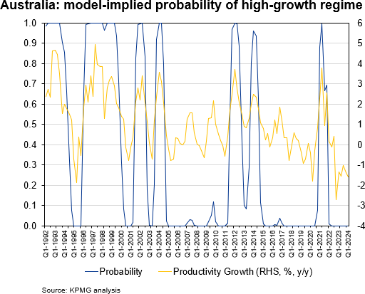

9 See Appendix A for technical modelling framework.
Australia’s productivity growth throughout the 1990s was largely characterised by a high-growth regime but interrupted briefly by a shift to a low-growth regime between 1994 and 1995.
In the early 2000s (between 2002 and 2004), there was some uncertainty about whether the high-growth regime dominated because of the quick fluctuations between high-growth to low- growth and then high-growth. The modelling results indicate a higher degree of certainty that the Australian economy was operating in a low-growth regime from 2005 and lasting until the end of 2010.
Following a period of high growth from 2010 to 2014, Australia transitioned back into a low-growth regime that persisted until the onset of the COVID-19 pandemic. Briefly, in early 2021, the economy experienced a temporary surge in growth likely influenced by the pandemic.
However, by early 2022, Australia settled back into a low-growth productivity regime, which continues to this day.
Consistent with US Federal Reserve’s analysis for the US, which concluded that productivity tends to move between long-lasting but not permanent regimes of high or low growth, KPMG’s analysis of Australia’s productivity outcomes reveals the expected duration of being in a high-growth regime is about 8 quarters while it is closer to 12 quarters for a low-productivity regime. Simply, neither periods of high productivity nor low productivity last forever, and
seemingly periods of low productivity last for longer in Australia than do periods of high productivity.

International comparison
Australia, Canada, and the US exhibit similar, but not identical, patterns in experiencing periods of high and low productivity.
The chart below highlights the fact that Australia, Canada and the US have all experienced extended periods of operating within a low productivity growth regime since around 2015, albeit the analysis shows there has been a short-lived upswing in productivity during the opening period of the COVID-19 pandemic. This ‘blip’ is most likely to reflect a measurement issue or an abnormal response by businesses in outputs, inputs or both due to heightened short-term uncertainties associated with the global health crisis. This low-growth regime period has been longer in the US than in either Australia or Canada, with low productivity growth essentially set in place for the US since 2011.
Figure 3

Model-implied probability of high-growth regime
Australia
The expected duration of being in each regime has also been calculated across the different countries, with the model for:
- Canada suggesting that the expected duration of a high-growth regime is about 11 quarters, with an average growth rate of 1.95%: while it is closer to 10 quarters for a low-productivity regime with an average growth rate of to 0.07%.
- US revealing that the expected duration for a high-growth regime is around 9 quarters, with an average growth rate of 2.7% and 18 quarters for a low-growth regime, accompanied by an average growth rate of 1%.

Is there an explanation behind the international similarities and differences?
Over the last 30 years, there have been several periods where productivity high and low-growth regimes coincided in the US, Canada and Australia.
Figure 4

1

0.8

0.6

0.4

0.2

0

Canada
6

4
2 1

0 0.8
-2
0.6
-4
0.4

0.2
1

0.8

0.6

0.4

0.2

0
4
3
2
1
0
-1
-2
-3
US
1

0.8

0.6

0.4

0.2

0
7
6
5
4
3
2
1
0
-1
-2
-3
Source: KPMG analysis

0

1
0.8
0.6
0.4
0.2
0

1
0.8
Q1-1992 Q4-1992 Q3-1993 Q2-1994 Q1-1995 Q4-1995 Q3-1996 Q2-1997 Q1-1998 Q4-1998 Q3-1999 Q2-2000 Q1-2001 Q4-2001 Q3-2002 Q2-2003 Q1-2004 Q4-2004 Q3-2005 Q2-2006 Q1-2007 Q4-2007 Q3-2008 Q2-2009 Q1-2010 Q4-2010 Q3-2011 Q2-2012 Q1-2013 Q4-2013 Q3-2014 Q2-2015 Q1-2016 Q4-2016 Q3-2017 Q2-2018 Q1-2019 Q4-2019 Q3-2020 Q2-2021 Q1-2022 Q4-2022 Q3-2023
0.6
0.4
0.2
0
Q1-1992 Q2-1993 Q3-1994 Q4-1995 Q1-1997 Q2-1998 Q3-1999 Q4-2000 Q1-2002 Q2-2003 Q3-2004 Q4-2005 Q1-2007 Q2-2008 Q3-2009 Q4-2010 Q1-2012 Q2-2013 Q3-2014 Q4-2015 Q1-2017 Q2-2018 Q3-2019 Q4-2020 Q1-2022 Q2-2023
High-productivity regime switching
Australia

Canada

US

Source: KPMG analysis
Common High Common Low

There could be various reasons driving the common timing of high and low productivity, including factors such as greater access to capital due to relatively favourable debt arrangements, increased availability of labour due to higher global mobility of skilled foreign workers, demographic changes, and realignment
of the composition of a country’s economic structure towards more capital-intensive industries. Additionally, economic reforms that largely focused on opening markets to increased competition in the trade and finance sectors can further influence productivity trends.
KPMG has investigated a number of these factors, including the following:
Timing of capital deepening
The following chart shows over the last 40 years the US, Canada and Australia experienced corresponding periods of capital deepening (as measured by the ratio of capital to output), although the volatility associated with capital investments relative to GDP has been much higher in Canada than compared to the US and Australia.
Figure 5
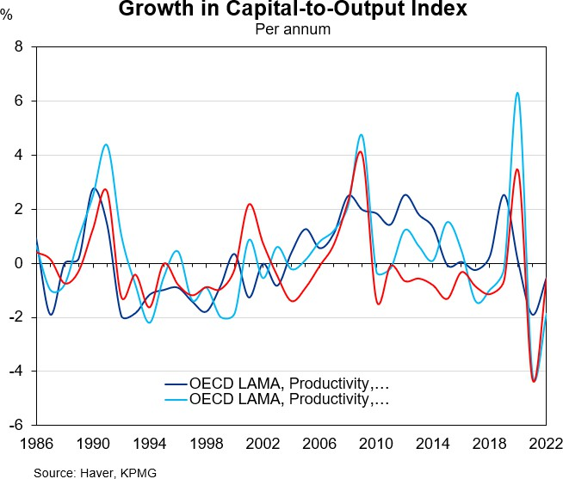
While the timing of the capital deepening across the US, Canada and Australia has been reasonably coincident it also appears that the timing of changes in capital stock across all three countries shows no correlation to periods of sustained growth in labour productivity. In other words,
it appears that simply increasing the amount of capital in an economy does not guarantee a corresponding increase in productivity or long-term economic expansion.
Table 1

GROWTH IN RATIO OF CAPITAL TO OUTPUT DURING PERIODS OF HIGH-GROWTH REGIME

 | Period of High Growth Regime | Growth1 in Capital Deepening During Period of High Growth Regime (%)
Australia | Q1-96 – Q4-99 | -0.8%
 | Q1-01 – Q4-04 | 0.2%
 | Q1-11 – Q4-15 | 1.2%
Canada | Q1-97 – Q4-99 | -1.3%
 | Q3-04 – Q1-06 | 0.3%
 | Q4-09 – Q2-15 | 0.4%
United States of America | Q1-96 – Q4-99 | -0.8%
 | Q1-01 – Q4-05 |  | 0.0%
Compound average annual growth rate Source: Haver, KPMG

This finding suggests that the mere quantity of capital is not the sole determinant of sustained labour productivity growth; rather the effectiveness of capital allocation is likely to play a much more crucial role in securing a high productivity growth outcome for a country.

Industry composition
The similarities in growth regimes in Australia, Canada, and the US may be a result of similar changes in their industry structure over the past 15 years, with all countries experiencing a downward shift in the importance of the manufacturing sector’s contribution to their total output (albeit more pronounced in Australia and Canada) and an upwards shift towards service-oriented industries, such as education and finance.
Figure 6
Change in Industry Structure by Country, 2005 to 2020
-6% -4% -2% 0% 2% 4% 6%
The increase in trade openness also allowed access to imported goods for investment and consumption at lower costs due to the comparative advantage of East Asian manufacturing. Furthermore,
the manufacturing industry, while shrinking in size, has become more productive and export-oriented in response to increased international competition.11
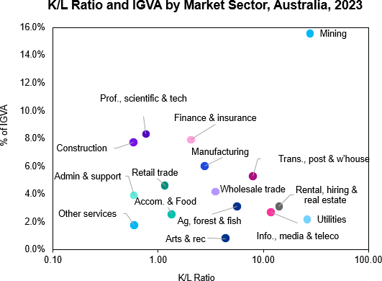
Figure 7

Agriculture, Forestry, Fishing and Hunting
US
Canada Australia
Mining Utilities Construction Manufacturing Wholesale Trade Retail Trade
Transportation and Warehousing
Information Finance, Insurance, Real Estate, Rental and Leasing
Professional and Business Services Educational Services, Health Care & Social Assistance Arts/Entertainment/Recreation/Accommodation/Food Svcs
Other Services, Except Government
Government

Source: ABS, KPMG

The above analysis shows over the 15 years to 2020, Australia’s industrial
structure became more heavily weighted to the mining sector, whereas the industrial structure in the US and Canada became even more heavily weighted towards the finance, insurance and real estate sectors (and represents about twice the level of industry gross value added (IGVA) compared to Australia).
Conversely, the analysis also shows that the relative importance of manufacturing across all three jurisdictions fell by broadly similar levels. This trend has in fact continued since the wave of reforms in the late 1980s that reduced protection for the manufacturing industry and lowered trade barriers.10

10 L. Berger-Thomson, J. Breusch & L. Lilley, Australia’s Experience with Economic Reform, Treasury Working Paper, October 2018.

When these compositional changes across the three jurisdictions between 2005 and 2020 are considered in the context of how capital and labour are typically employed to produce industry outputs – with Figure 7 providing a summary of the K/L ratio and IGVA by sector for Australia for FY23 – it could be argued that the low-growth regime during the 2000s was more pronounced for Australia than for the US or Canada due to the significant capital investment that was occurring in the mining sector at the time (i.e. increases in capital inputs).
During this period, and also pushing into the next decade, measured productivity within the mining industry was negative ‘because of the massive capital spending by mining companies during that time
in response to the huge upswing in Australia’s terms of trade (resulting in more mining projects becoming economically viable due to higher world minerals’ prices), along with the necessarily considerable lags between

11 E. Connelly & C. Lewis, Structural Change in the Australian Economy, Reserve Bank of Australia, September 2010.

capital spending and subsequent actual increases in mining production’ (Shahiduzzaman, Layton and Alam, 2015, p.285).
Net Overseas Migration
Net overseas migration as a share of changes in the population has grown steadily in Australia increasing from mid- 20% levels in the early 1990s to nearly 70% by the start of the COVID-19 pandemic, while an even more pronounced migration story occurred within Canada over the same period with its share of NOM as a proportion of total population growth increasing by nearly 40% over the past 30 years.
Figure 8
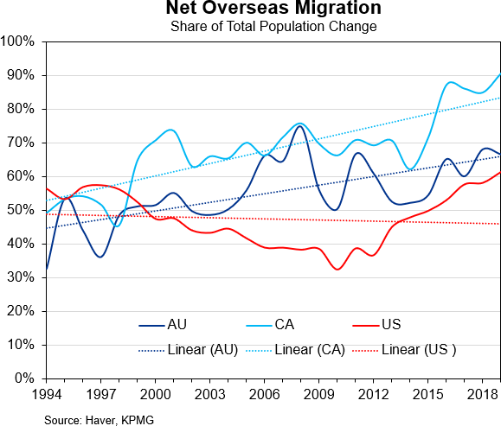

In comparing this element across the three jurisdictions what is noticeable is the US experienced a declining trend in NOM as a proportion of population growth, falling from around the mid-50% mark in the early 1990s to low-30% levels by 2010. Further, previous research using the OECD International Migration Database suggests that of the total number of international migrants, Australia and Canada attracted a much higher proportion of skilled foreign workers than the US did.12

12 High-Skilled Workers: Stagnating in the United States, Rising Fast in Other Countries?, Petersen Institute for International Economics, 2007.
This divergence in both migration patterns and the skill level of those migrants potentially explains, at least partially, why the US experienced slightly longer periods within a low productivity growth regime over the past 20 years compared to both Canada and Australia.
However, it is also important to recognise that the impact of net migration on labour productivity is not uniform, as evidenced by the diverging experiences of Australia, Canada, and the US during the COVID-19 pandemic. While Canada was the only country to record a positive contribution from net overseas migration during this period, it paradoxically suffered from low productivity growth. In contrast, both Australia and the US experienced net migration losses, yet they witnessed better labour productivity outcomes. One possible explanation for this could be that the net migration losses experienced in Australia and the US disproportionately affected low-skilled workers or those in sectors less relevant to productivity growth,13 resulting in a relatively stronger concentration of high-skilled workers remaining in these countries causing a boost in overall productivity. This suggests that the mere presence of net migration inflows does not automatically translate into higher productivity.

What does the KPMG analysis suggest?
While politicians and policymakers should rightly be concerned about periods of weak productivity, this analysis suggests that fluctuations in productivity growth are a ‘normal’ part of economic cycles across nations. Concern should be raised, however, when those periods of weak productivity become extended and stretch beyond what history tells us is a typical downswing cycle.

13 Professor A. Graycar & G. Tan, A global battle for low-skilled workers looms after COVID. Australia needs to be part of it, Stretton Institute, University of Adelaide, accessed 24 June 2024.

KPMG’s assessment of Australia’s productivity outcomes using the same analytical framework recently employed by the US Federal Reserve shows our low- growth regimes typically span around three years. Given Australia has endured such a slowdown for over two years now, it would be reasonable to expect productivity growth should start to naturally swing upwards.
Encouragingly, recent data from the US is also indicating a resurgence in productivity and given the numerous economic parallels between the two countries, it is reasonable to anticipate that Australia will follow suit and experience a similar productivity rebound in the near future.
However, there are also reasons to be cautious about predicting a productivity rebound in Australia. While some positive
indicators, like increased demand for skilled workers, offer some hope, other signs are less encouraging. Technology investment remains low, potentially hindering the adoption of productivity- enhancing tools and processes.14 Additionally, unit labour costs remain elevated and are only expected to fall gradually, suggesting that efficiency gains may be slow to materialise. Furthermore, business sentiment remains subdued, indicating a lack of confidence that could impede investment and innovation.
Therefore, while the possibility of a productivity upswing in Australia cannot be ruled out, it is premature to definitively predict such a rebound given the conflicting signals present in the current economic landscape.

14 R. Mizen, Slowing tech investment complicates Chalmers’s growth goal, Australian Financial Review, 25 March 2024.

17 | Trends in Australia’s productivity growth: further research and findings

Chapter 3:
Do Australia’s labour market dynamics influence productivity?

©2024 KPMG, an Australian partnership and a member firm of the KPMG global organisation of independent member firms affiliated with KPMG International Limited, a private English company limited by guarantee. All rights reserved. The KPMG name and logo are trademarks used under license by the independent member firms of the KPMG global organisation.
Liability limited by a scheme approved under Professional Standards Legislation.

Do Australia’s labour market dynamics influence productivity?

The COVID-19 pandemic and the period since have highlighted the great extent to which the labour market can influence productivity growth in Australia and other advanced economies. Early in the pandemic, headline labour productivity, measured as GDP per hour worked, rose at a stronger rate than in the preceding period as the fall in hours worked outpaced that of output.
Cross-country evidence from the International Labour Organisation (ILO) study suggests the surge was underpinned by a compositional effect of employment as smaller firms reduced their hours worked substantially compared to larger firms, which on average have higher labour productivity (Kapsos, 2021).15 In addition, when hours were cut, less productive workers were the first to be impacted. The compositional effect also occurred at the industry level when hours worked in low-productivity industries involving high-contact services were reduced by significantly more than in higher productivity industries where the work-from-home practice was available (Bruno et al, 2023).16
When restrictions were eased, the labour market recovered rapidly with hours worked in Australia rebounding from
Q3 2020, outpacing the growth of output,

15 S. Kapsos, Why would labor productivity surge during a pandemic?, ILOSTAT, 14 December 2021.
and returning to its pre-pandemic levels by Q2 2021 (Figure 9).
Figure 9
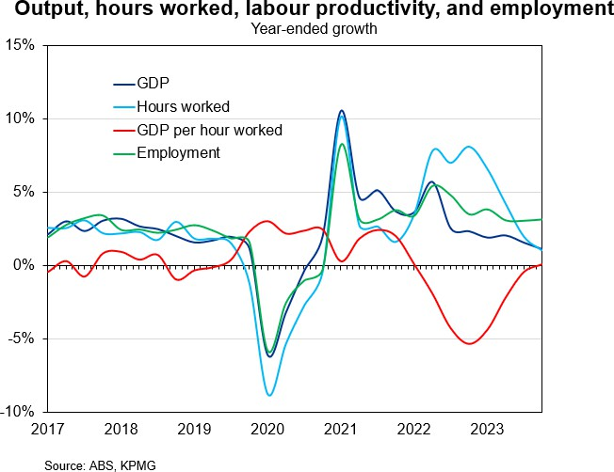

The border closure during the pandemic impeded Australia’s access to skilled migrants, who were critical to many industries, creating broad-based labour shortages amid recovering demand due to strong stimulus from the Reserve Bank and governments. This excess labour demand was then absorbed by workers increasing their hours worked substantially – the growth in hours worked exceeded employment growth in 2022–23. As hours worked grew much faster than output, labour productivity growth tumbled and went into negative territory during 2022–
23. The reopening of borders and influx of immigrants have alleviated some of the labour shortages, leading to a rebound in labour productivity growth; yet the pace of growth has remained sluggish.

16 A. Bruno, J. Dunphy & F. Georgiakakis, Recent trends in Australian productivity, Reserve Bank of Australia, 21 September 2023.

Pre-pandemic productivity growth had already been lacklustre across the market sector in Australia, driven by widespread declining competition and the slowdown in regulatory and economic reform.17 Australian regulatory procedures are also considered relatively complex, while the licensing and permit system is complicated as opposed to other OECD countries.18 Apart from those factors that still persist to date, the post-pandemic productivity landscape has further emphasised the role of labour market dynamics and friction in the productivity growth slowdown.
In this chapter, we have examined several labour market factors that could be contributing to the occurrence of low productivity growth in Australia and proposed policy interventions aimed at ameliorating these issues.

Identifying which labour market factors play a deterministic role in productivity
In considering whether specific labour market factors play a deterministic role in influencing Australia’s productivity, KPMG completed an econometric analysis using aggregate quarterly data in Australia from the Australian Bureau of Statistics and the OECD, including:
- non-mining labour productivity (measured as non-mining GVA per hour worked)
- labour force participation rate
- share of new migrant workers (arriving within the last five years) in total employment
- share of existing migrant workers (arriving more than five years ago) in total employment

17 Ibid.
18 Ibid.
19 We have estimated the natural rate of unemployment from Q4 1998 to Q4 2023.
- labour market pressure (measured as the difference between our estimated natural rate of unemployment and the actual unemployment – we define the value to be higher when the labour market is tighter).19
While our regression is not causal, it does reveal the channels through which the labour market affects productivity.
Specifically, we apply the following specification to understand the raw linkage between labour market characteristics and aggregate labour productivity:
∆𝑌𝑌𝑡𝑡 = 𝛽𝛽1∆𝑌𝑌𝑡𝑡−1 + 𝛽𝛽2∆𝑃𝑃𝑡𝑡 + 𝛽𝛽3Δ𝑀𝑀^{𝑁𝑁} +
𝑡𝑡−1
𝛽𝛽4Δ𝑀𝑀^{𝑂𝑂} + 𝛽𝛽5𝑈𝑈𝑡𝑡 + 𝜀𝜀𝑡𝑡 (1) where:
𝑡𝑡

∆𝑌𝑌𝑡𝑡−1 | refers to the through-the-year growth in non-mining labour productivity,
∆𝑃𝑃𝑡𝑡 | the change in participation rate,
Δ𝑀𝑀^{𝑁𝑁}  𝑡𝑡−1 | the lagged change in the share of new migrants in total employment,
Δ𝑀𝑀^{𝑂𝑂}  𝑡𝑡 | the change in the share of existing migrants in total employment,
𝑈𝑈𝑡𝑡 | the labour market pressure,
𝜀𝜀𝑡𝑡 | the error term.

The autoregressive term of labour productivity growth is included to take into account the potential that explanatory factors may have an ongoing effect on productivity growth. This approach is consistent with the study done by Belorgey, Lecat and Maury (2006).20

20 N. Belorgey, R. Lecat & T. P. Maury, Determinants of productivity per employee: An empirical estimation using panel data, Economics Letters, 91(2), 153-157.

Table 2: Regression Output

VARIABLE | COEFFICIENT (FULL SAMPLE) | COEFFICIENT (PRE-COVID SAMPLE)
Lag of labour productivity growth | 0.556*** (0.073) | 0.528*** (0.093)
Participation rate | -0.707*** (0.177) | -0.916*** (0.286)
Lag of new migrant worker share | 1.284*** (0.227) | 1.554*** (0.447)
Existing migrant worker share | 0.611* (0.362) | 0.04 (0.311)
Labour market pressure | -0.645*** (0.176) | -0.832*** (0.268)
R2 | 0.564 | 0.53
Sample | 1998Q4 –  2023Q4 | 1998Q4 –  2019Q4
N | 102 | 85
Robust standard errors in parentheses
*** p<0.01, ** p<0.05, * p<0.1

Our analysis shows that slightly more than half of non-mining labour productivity growth in Australia can be explained by three factors:21
- The productivity that occurred in the last quarter – a momentum effect.
- How many new workers entered the labour force – they are likely to be relatively lower skilled or more inexperienced than the current workforce. Adding foreign workers helps because they boost the productivity of native-born workers and bring in specialisation, new skills, ideas, or innovation. This effect occurs with a lag.22
- When the labour market is tight, the marginal new worker comes from a pool of long-term unemployed, who may require additional supports to be as productive as other employees.
For completeness, KPMG also carried out the modelling analysis without the autoregressive term, with this different specification still suggesting the labour market variables account for 30% of the growth in labour productivity, confirming these factors emanating from the labour market play a considerable role in driving productivity.
Table 3: Regression Output: No Autoregressive Term

VARIABLE | COEFFICIENT (FULL SAMPLE) | COEFFICIENT (PRE-COVID SAMPLE)
Participation rate | -0.499 (0.305) | -1.452*** (0.414)
Lag of new migrant worker share | 1.556*** (0.405) | 2.629*** (0.655)
Existing migrant worker share | 1.244** (0.547) | 0.195 (0.445)
Labour market pressure | -1.429*** (0.357) | -1.73*** (0.43)
R2 | 0.281 | 0.279
Sample | 1998Q4 –  2023Q4 | 1998Q4 –  2019Q4
N | 102 | 85
Robust standard errors in parentheses
*** p<0.01, ** p<0.05, * p<0.1

21 We find similar results when considering economy-wide labour productivity instead of non-mining labour productivity, with these factors account for three- quarters of economy-wide labour productivity growth. Without the autoregressive term, labour market variables explain more than 40% of variation in productivity growth.
22 The share of migrant workers who arrived in Australia more than 5 years ago is found to not have a statistically significant effect on labour productivity growth. This suggests the positive effect of foreign workers may wane over time – further research into the matter is therefore recommended.

A more detailed commentary on these individual labour market factors and how they have the capacity to influence productivity is discussed in the following section.

Labour market contributors to slow productivity
Tightness in the labour market
Labour market conditions tend to lag economic growth as it takes employers time to assess the change in economic activity to adjust their hiring or layoff decisions. Therefore, it had been found that productivity tended to decline during economic downturns and increase during recoveries as output changed by more than employment growth (Reserve Bank of Australia, 2019; Lester, 1999).23
The post-pandemic situation emphasised another relationship: the tightness of the labour market also played a role in influencing labour productivity.
Specifically, as the labour market becomes tighter, it is more likely that the marginal worker is less productive. A study shows this labour demand and supply composition effect is responsible for a 1.5% fall in measured labour productivity, even when total factor productivity stays constant (Doornik et al, 2023; Ravenna & Walsh, 2022).24 That said, this effect can be offset when lowest value-adding activities get displaced in a tight labour market as underperforming businesses may not survive because they have to offer higher wages to attract the workers they need.

23 Statement on Monetary Policy – November 2019, Reserve Bank of Australia;
Labour Demand and the Economic Cycle, Reserve Bank of Australia, February 1999.
Low efficiency in skill-matching
The border closure during 2020–21 impeded the usual intake of skilled migrants in Australia, creating widespread labour shortages when the economy entered the recovery phase. The matching rate has been well below historical standards since September 2020 (Figure 10), coinciding with the lacklustre growth in labour productivity over the period, due to the difficulty in matching skilled workers with labour demand.
Figure 10
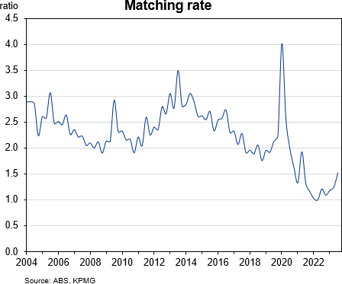

The Beveridge Curve during the 2020s cycle shifts outward from its pre-pandemic position (Figure 11), indicating a higher degree of job matching inefficiency. That is, for a given level of unemployment, the vacancy rate needs to be higher – in other words, employers need to post more vacancies to fill a given number of roles due to a mismatch in applicants’ skills and employers’ demands.

24 B. Doornik, D. Igan & E. Kharroubi, Labour markets: what explains the resilience?, BIS Quarterly Review, 77, 4 December 2023; F. Ravenna & C. E. Walsh, Worker Heterogeneity, Selection, and Unemployment Dynamics in a Pandemic, Journal of Money, Credit and Banking, 54(S1), 113-155, 29 December 2021.

Figure 11
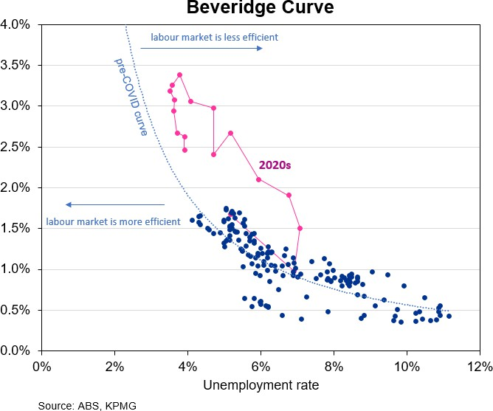

The strong return of immigrants since border reopenings has helped alleviate the shortage issues in some sectors, improving the skills matching process to an extent as the matching rate has picked up gradually since late 2022 (Figure 10).
However, evidence continues pointing to the prevalent skills mismatch in the labour market.
The SEEK Labour Market Mismatch Indicator (LMMI) reveals the difference between the occupations in most demand from employers and occupations to which jobseekers are applying is actually rising, which suggests the patterns of supply and demand are becoming less similar over time. While this indicator is partly affected by the cyclical movement of the labour market, with mismatch generally rising when demand is loosening, the recent cooling in the labour market is not affecting all occupations and types of jobseekers equally. Occupational groups requiring higher levels of education and training, including Professional, Technicians and Trades Workers, Managers; and some individual occupations within the broader groups (e.g. Registered Nurses in Community and Personal Services Workers), are more likely to experience excess demand.25

25 SEEK Labour Market Mismatch Indicator, SEEK, 2024.
All these data confirm the fact that the boost to labour supply is uneven as a large proportion of migration intake has been driven by low-skilled visa holders, who have been directed towards low- skilled vacancies in industries such as Accommodation and Food Services, Retail Trade, and Administrative and Support Services. High-skilled industries such as Healthcare and Social Assistance, Education and Training, and Construction continue to see a significant mismatch between supply and demand.
Impact of overseas immigration on labour productivity
The stopping of migration intake during the pandemic has highlighted the importance of migrant workers in meeting domestic labour demand. The impact of immigration on labour productivity in Australia, however, remains uncertain with mixed evidence.
An analysis by the e61 Institute (2023) suggests migration has played some role in the productivity slowdown in Australia through the reallocation channel.26 This is because migrant workers tend to work in lower productivity industries such as hospitality or administration, and within industries, they are more likely to work at lower-productivity firms, which is only partly offset by an increase in within-firm productivity benefits from specialisation or innovations brought by migrants.
Nonetheless, more encouragingly, they find this impact is heterogeneous across visa types as workers on more targeted visas (permanent and temporary skilled) allocate to more productive firms than non- migrant workers, hence creating positive effects on productivity.

26 D. Andrews, E. Clarke, L. Vass & A. Wong, Misallocated migrants: Immigration and firm productivity in Australia, e61 Research Note No. 5, March 2023.

On the contrary, the OECD (2023) finds a positive link between migration and labour productivity.27 Examining the contribution of international migration to regional differences in labour productivity in Australia, the research shows a region with a 10% larger migrant share (e.g. 33% instead of 30%) has a 1.3% larger regional wage difference as the presence of migrants boosts the productivity of natives with different skill levels residing in all types of regions. The positive effects are even more pronounced for higher-skilled migrants – specifically, a region with 10% larger share of higher-skilled migrants has a 1% higher regional productivity difference.
In addition to boosting the productivity of native workers, the impact of migrant workers on productivity also occurs through other channels as they bring in new skills, ideas, and innovation. The OECD (2024) suggests one percentage point rise in the regional employment share of higher-educated migrants relative to total employment results in a 4.8% increase in regional patent applications within five years.28
The common ground of these studies is that skilled and higher-educated migrants add positively to labour productivity. It is therefore vital that migration policies are well-designed to increase the quality of migrant intake and thus enhance the quality of labour market matching.
Labour hoarding
Labour hoarding has also been identified as an important factor contributing to low productivity growth. This occurs when firms hold on to more workers than necessary, leading to labour underutilisation and weighing on productivity. Drivers of the behaviour may

27 Migration and regional productivity: Evidence from individual wages in Australia, OECD, 4 December 2023.
28 Migration and regional innovation in Australia, OECD, 4 January 2024.
29 A. Caggese, O. Güler, M. Mariathasan & K. Mulier, Firing Costs and Productivity: Evidence From a Natural Experiment, 9 September 2023. 30 Ibid.
include tight conditions in the labour market, staff shortages, friction in employment frameworks, hiring costs, and loss of human capital when people leave a firm.
Apart from the cyclical contributors to labour hoarding behaviour, employee relations frameworks can have a complex impact on labour productivity. Onerous laws that impede labour mobility reduce firm-level total factor productivity by distorting firms’ optimal hiring and firing policies, without spurring investment in productive physical or human capital (Caggese et al, 2022).29 To mitigate costs and increase flexibility for employers, this can lead to firms hiring fewer workers under a permanent contract, relying more on outsourced workers, and increasing hours worked per worker.30 This also lowers the economy-wide productivity
as it hinders the reallocation of labour from low-productivity firms to high-productivity firms (Moscoso & Mukoyama, 2012; Lama et al, 2022).31
Accordingly, it is important that employment frameworks provide for sufficient labour mobility, whilst also ensuring workers are treated fairly at times of economic shocks.
Labour market regulation
Compared with other economies, Australia tends to be positioned towards the moderate or low end of the spectrum in terms of employment regulation strictness. The OECD indicator of employment protection shows in 2019 Australia ranked 4th as one of the advanced economies with the lowest regulation, behind the United States, Switzerland, and Canada. In contrast, according to the Fraser Institute’s worldwide ratings, Australia ranked 28th out of 165 countries in terms

31 H. J. Moscoso Boedo & T. Mukoyama, Evaluating the Effects of Entry Regulations and Firing Costs on International Income Differences, Journal of Economic Growth, 17, 143-170, 5 January 2012;
R. Lama, G. Leyva & C. Urrutia, Labor Market Policies and Business Cycles in Emerging Economies, IMF Economic Review, 70(2), 300-337, 14 January
2022.

of flexibility in labour market regulations.32 Across both measures, the United States consistently came out on top with the highest level of labour market regulation flexibility.
While these outcomes indicate a low level of restrictiveness in Australia’s employment frameworks, an examination of the history of the OECD indicator reveals the strictness of employment frameworks for regular workers has increased from where it was in 2009 (Figure 12). The Productivity Commission (2015) pointed out some remaining flaws in the Australian system: parts of the process are overly legalistic with too much focus on procedural fairness in some instances, and the consistency of arbitrated decisions is still of concern.33 This means there remains scope for Australia to refine its system and learn from other international jurisdictions where appropriate.
Figure 12
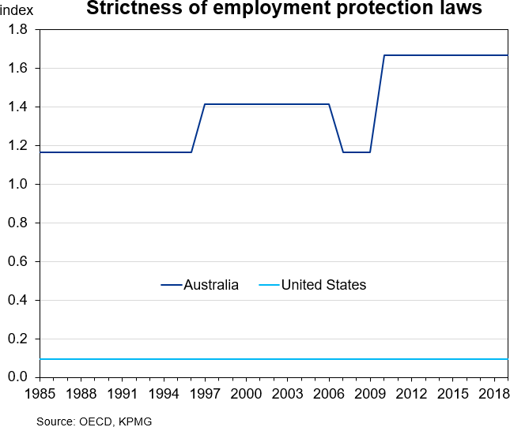

We have not established the relationship between the restrictiveness of employment frameworks and labour productivity in Australia using econometric tools due to the lack of variation associated with its measures. Nonetheless, this relationship should not be disregarded, as labour laws

32 Economic Freedom of the World: 2023 Annual Report, Fraser Institute, 19 September 2023.
that reduce flexibility are likely to influence productivity to some extent, as evidenced by existing literature on dismissal costs and productivity. When the financial or legal burden associated with dismissal is high, firms are more likely to hold on to workers even when they are not well- suited for the role, creating friction in the labour market and hampering productivity growth. A visual examination of cross- country data shows the level of restrictiveness of employment frameworks is negatively correlated with labour productivity in OECD countries
(Figure 13).
Figure 13
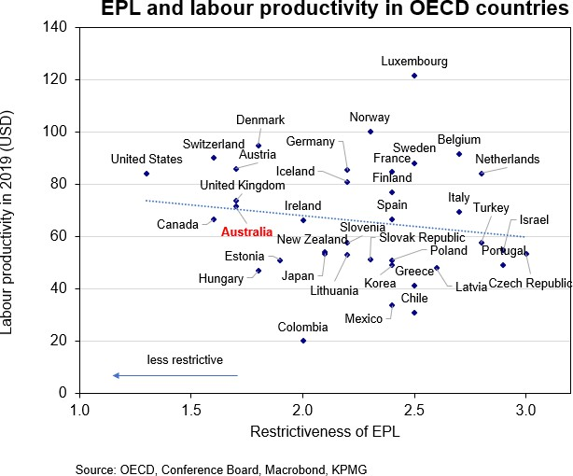

Anecdotally, discussion with KPMG clients reveals businesses, particularly small and medium enterprises, do not perceive our employment frameworks in Australia as flexible as the objective OECD measure suggests. This is aligned with the international comparison of the Fraser Institute’s indicator, which is based on business surveys. While perceptions do not reflect reality, this is worth attention because perceptions can still influence firms’ hiring and firing decisions, particularly for small and medium enterprises.

33 Productivity Commission inquiry report: Workplace relations framework, Productivity Commission, 76(2), 21 December 2015.

What does KPMG’s analysis suggest?
Our findings demonstrate that the labour market plays an important role in explaining the slowdown in productivity in Australia. While part of the problem comes from the cyclical movement of the economy, there exist many avenues for labour and migration policy levers to improve the structural aspect of the labour market, while mitigating its cyclicality.
Having identified the potential causes, we suggest the following pillars for lifting productivity growth.
Pillar 1: Improve the quantity and quality of education and training
Education and training are essential to improve human capital and to ensure the marginal workers added to the workforce have work-ready skills. Reforms should be considered across sectors, from schools to Vocational Education and Training (VET) and universities to improve the quality of teaching, leverage digital technology, and increase access for students. A data- driven approach is recommended to influence the skills outcomes through the education and training system.
When the labour market is tight, unemployed people, including those who experience long-term unemployment, are more likely to find work. It is worth considering education and training programs, both in the VET and Higher Education sectors, tailored to this group, and placement arrangements for them to have an opportunity to work – which is aimed at preparing them with the right skills in demand and lowering the barriers to their re-entering the workforce.
Pillar 2: Redesign migration programs
A more targeted skilled migration system is necessary to bolster the positive effect of migrant workers on productivity.
The whole visa system should be thoroughly investigated to identify visas that do not work as intended (e.g. the Business Innovation and Investment visa will be replaced from July 2024 as it was found to be associated with negative fiscal outcomes) and migration agents who take advantage of loopholes in the system. The design of Skilled Independent visas should be adjusted to remove point items that are not linked with better fiscal and employment outcomes. Anecdotal evidence also suggests several English tests are not well-designed to reflect the accurate English proficiency of visa applicants – these loopholes should be examined for further tightening. Similarly, reforms to the accreditation of overseas qualifications to support temporary and permanent visas will assist with expediting the mobility of skilled foreign talent in demand. The current systems to recognise overseas qualifications are slow and cumbersome and can act as a deterrent to incentivising talent in demand to choose Australia to build their career.
Pillar 3: Ensure sufficient flexibility to allow for labour mobility
The Productivity Commission (2015) has outlined three key areas where reforms are possible to further enhance Australia’s employment framework, including:34
- the continued presence of ‘go away’ money
- the arrangements as they apply to small businesses
- the role and performance of the Fair Work Commission.
The recommendations they put forward would generate incremental benefits to the flexibility of employment frameworks in Australia.

34 Ibid.

Appendix 1
We create a model that calculates the probability of being in each regime in a given quarter. The model is a regime-switching model that we use to study the tendency of productivity growth to move between periods.
Technical appendix
The model we estimate is similar to Foerster et al (2021). Based on our testing of different model specifications, we allow for two regimes for the constant terms and only one regime for the variance. The model is:
Δ log 𝑧𝑧𝑡𝑡 = 𝜇𝜇(𝑠𝑠𝑡𝑡) + 𝜎𝜎𝜖𝜖𝑡𝑡
where the parameter 𝜇𝜇 denotes the average growth rate and the unobserved state variable,
𝑠𝑠𝑡𝑡 follows a Markov process with transition probability:
�𝑝𝑝𝑝𝑝𝑝𝑝𝑝𝑝(𝑠𝑠_{𝑡𝑡} = 𝐻𝐻, 𝑠𝑠_{𝑡𝑡−1} = 𝐻𝐻) 𝑝𝑝𝑝𝑝𝑝𝑝𝑝𝑝(𝑠𝑠_{𝑡𝑡} = 𝐻𝐻, 𝑠𝑠_{𝑡𝑡−1} = 𝐿𝐿)� = � 𝑝𝑝𝐻𝐻𝐻𝐻 1 − 𝑝𝑝𝐻𝐻𝐻𝐻 �
𝑝𝑝𝑝𝑝𝑝𝑝𝑝𝑝(𝑠𝑠𝑡𝑡 = 𝐿𝐿, 𝑠𝑠𝑡𝑡−1 = 𝐻𝐻) 𝑝𝑝𝑝𝑝𝑝𝑝𝑝𝑝(𝑠𝑠𝑡𝑡 = 𝐿𝐿, 𝑠𝑠𝑡𝑡−1 = 𝐿𝐿) 1 − 𝑝𝑝_{𝐿𝐿𝐿𝐿} 𝑝𝑝_{𝐿𝐿𝐿𝐿}
We focus on annual labour productivity growth (growth in GDP per hours worked) from 1991-Q1 to 2024-Q1. Due to the COVID-19 pandemic, we only estimate the model parameters using data up until 2019-Q4. We estimate the model using Eviews using the SWITCHREG function.

Key authors and contacts

Dr Brendan Rynne
Chief Economist & Partner T: +61 3 9288 5780
E: bjrynne@kpmg.com.au

Dr Michael Malakellis Senior Economist & Principal Director
T: +61 7 3233 9592
E: mmalakellis@kpmg.com.au

Dr Brian Tran
Economist
T: +61 3 8614 5625
E: btran7@kpmg.com.au
Thu Hoang
Economist
T: +61 3 9288 6440
E: thoang3@kpmg.com.au





The information contained in this document is of a general nature and is not intended to address the objectives, financial situation or needs of any particular individual or entity. It is provided for information purposes only and does not constitute, nor should it be regarded in any manner whatsoever, as advice and is not intended to influence a person in making a decision, including, if applicable, in relation to any financial product or an interest in a financial product. Although we endeavour to provide accurate and timely information, there can be no guarantee that such information is accurate as of the date it is received or that it will continue to be accurate in the future. No one should act on such information without appropriate professional advice after a thorough examination of the particular situation.
To the extent permissible by law, KPMG and its associated entities shall not be liable for any errors, omissions, defects or misrepresentations in the information or for any loss or damage suffered by persons who use or rely on such information (including for reasons of negligence, negligent misstatement or otherwise).
©2024 KPMG, an Australian partnership and a member firm of the KPMG global organisation of independent member firms affiliated with KPMG International Limited, a private English company limited by guarantee. All rights reserved.
The KPMG name and logo are trademarks used under license by the independent member firms of the KPMG global organisation.
Liability limited by a scheme approved under Professional Standards Legislation.
June 2024. 1384057542E

