***[And the winner is … #StadiumSplurge](https://www.smh.com.au/sport/and-the-winner-is-stadiumsplurge-20250325-p5lmdv.html)***

[**Peter FitzSimons**](https://www.smh.com.au/by/peter-fitzsimons-hvemu) **- SMH - March 26, 2025**

Another fine mess you’ve got us into, Oly.

In this case, it is the latest mess of the Brisbane Olympics.

For those who’ve joined us late, four years ago our cousins north of the Tweed won the right to host the 2032 Olympic Games. The Brisbane bid was quite unlike Sydney’s in 2000. In our case, we were one of six serious host cities going after it, and when we won, there was widespread euphoria – followed quickly thereafter by the sounds of jackhammers going at it and concrete trucks roaring forth as we started building.

[[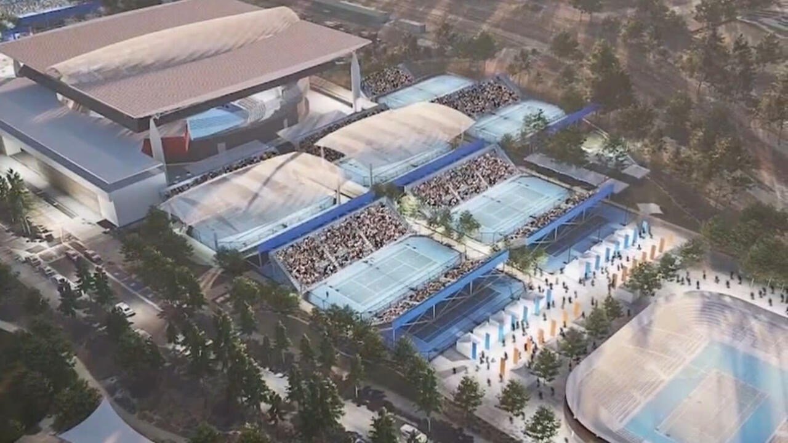](javascript:void(0);)](javascript:void(0);)

The Brisbane 2032 venues plan has been confirmed, and with it, a major political backflip by Queensland Premier David Crisafulli.

*We’ve got just seven years to get it done, so let’s get stuck in!* *Positions, everyone!*

And yes, we had our strong squabbles over how the Games should be conducted – this correspondent so enjoyed it, I turned pro – but by and large our winning bid included detailed plans of where each sport would be staged and how it would be run that the arguments were contained within fairly tight parameters of financing and such things as who would actually open the Games on our behalf. (Some people like John Coates said the Queen should do it – no really – but don’t get me started.)

That has not been the case with Brisbane. For starters, there was little euphoria over their winning bid – at least not compared to Sydney’s, for the simple reason that Brisbane didn’t actually beat anyone to get it as theirs was the only serious bid left.

**An artist’s impression of the main stadium for the 2032 Olympic and Paralympic Games, to be built at Victoria Park in Brisbane’s inner north.**

Why? Well, once every other potential host city crunched the numbers and questioned the sanity of spending billions of dollars to host a two-week sports carnival, they ran screaming from the room and burnt the clothes they were wearing at the time. (Just a couple of years ago, then Victorian Premier Dan Andrews did much the same *after* Melbourne had won the right to host the 2026 Commonwealth Games ... which was a little problematic.)

But Brisbane got it, signed the contracts and had the better part of a decade to get it done. And, say, can you see, by the dawn’s early light . . . can you hear . . . the jackhammers and the concrete trucks roaring forth?

Me neither.

I have only heard shouting and endless arguments since.

The arguments have come because after having committed to the same insanity of spending so much money just to hold a sports party, successive governments have tried – and failed – to make those numbers work. And they don’t.

The first idea, was to go with mostly existing infrastructure with then premier Annastacia Palaszczuk saying Queensland could get by using over 80 per cent of its existing venues. The Gabba, she said, could be spruced up for just a lazy billion dollars between friends, out of a total budget of $4.45 billion for the Games.

In response, an economics researcher by the name of Rodney Bogaards [**wrote an academic treatise**](https://www.aph.gov.au/About_Parliament/Parliamentary_Departments/Parliamentary_Library/pubs/rp/rp2122/BrisbaneOlympicGames2032NetBenefitAustralianCommunity) for the federal parliament on whether Brisbane could indeed buck history by basing its bid on the “New Norm” principle of using existing infrastructure. The short answer?

No.

“The history from cities that have hosted Olympic Games,” he wrote in his report, “suggests a common tendency for overly optimistic estimates of the benefits, and underestimation of the significant direct and indirect costs, which has frequently resulted in large cost overruns.”

Bogaards went on to detail how Montreal took 30 years to pay off the debt incurred by the 720 per cent cost blowout of the 1976 Olympics. He also said the costs overrun of the 2004 Athens Games had weakened the Greek economy to the extent it might have contributed to the subsequent economic crisis that engulfed the country. And so on.

**Queensland Premier David Crisafulli announces plans for the Brisbane Olympic Games venues on Tuesday**.

In Brisbane, he was soon proved right.

Within 18 months, the original estimate to spruce up the Gabba had blown out to $2.7 billion at a cost per spruced-up seat of $54,000 – which was cheap compared to the $147,058 per seat for the new drop-in pool at the planned $2.5 billion Brisbane Arena. The overall cost for the Games was reckoned at $7 billion.

Nevertheless, the [**federal government soon announced that it would put in about $3.5 billion**](https://www.smh.com.au/link/follow-20170101-p5clac)to help cover it. But the anomalies and blow-outs were becoming ever more horrifying and still there was no sound of jackhammers and no agreement from the Queenslanders on even something as basic as where the opening ceremony would be held, or the athletics staged.

**Not everyone in Brisbane is happy about the plans to build a new stadium at Victoria Park.**

Premier Palaszczuk stepped down, to be replaced by her ever-smiling deputy, Steven Miles – who announced an urgent review of how the Games would be conducted.

(Sounds like a plan!)

Alas, when that review came back, it said the plan to spruce up the Gabba should be abandoned, and instead a new stadium built at Victoria Park. Premier Miles immediately rejected that, on the grounds that the $3.4 billion price tag could not be justified in the middle of a cost-of-living crisis.

(This, in my view, was sanity asserting itself.)

Lang Park, he said, could host the opening and closing ceremonies, while the existing Queensland Sport and Athletics Centre – which hosted the Commonwealth Games as the Queen Elizabeth II Jubilee Sports Centre back in 1982 – could host the athletics.

Still no jackhammering.

Leading into last year’s state election, and the Olympics was a big issue. Opposition leader David Crisafulli pledged that if he won, the athletics would not be held at the old QEII Stadium.

“When I speak with Queenslanders about the Olympic and Paralympic Games,” he said, “they use the word that they don’t want to be embarrassed.”

But, he was equally clear that he would not blow the budget, and there would be no new stadium built at Victoria Park.

Tell them what you said, David, in the election campaign: “I do not believe the city needs a new stadium, I don’t.”

No #StadiumSplurge on his watch!

On such promises, Crisafulli won the election and duly launched a 100-day review, [**the results of which he announced on**](https://www.smh.com.au/link/follow-20170101-p5lmbn)Tuesday. Let’s cross to him now:

“In the end,” he says, “the choice was clear: The games must be held at a new stadium at Victoria Park.”

I know. What has changed? That is not clear.

Equally unclear is what he means by saying the new stadium at Victoria Park is “fully funded.”

Sorry, what?

You’ve got the money in the account and can write the cheque to see it built – the usual meaning, for the rest of us, when we have the funds to buy something.

In government, the alternative meaning for “fully funded” is that we’ve crunched the numbers and reckon this new project will pay for itself. The most memorable example of this was our own Gladys Berejiklian announcing that spending $2 billion to knock down the Sydney Football Stadium and rebuild it would “pay for itself in two years.” (Fair effort that, as I noted. $3 million profit every day! Let’s build a dozen of them!)

And that’s where we are.

Along with the new Victoria Park, a slew of Olympic events will now suddenly be leaving Brisbane and going to regional Queensland instead – likely a function of the fact that while just four members of the 15-person cabinet of the Labor government were from the regions, there are now 11 who answer that description.

Cairns and Townsville will now be hosting the soccer, while the latter also gets to co-host the sailing, and the Gold Coast will be getting the hockey.

But instead of moving the rowing “super-regional” to our own Nepean rowing centre at Penrith, as was suggested, and the tennis to the Rod Laver Arena in Melbourne, as is only sensible, they will build their own at Rockhampton on the Fitzroy River, complete with crocs. And they’ll build the new whitewater rafting centre at Redlands, amid critical koala habitat. Stand by for more protests.

Still no jackhammering.

Friends?

It is just another #StadiumSplurge like the one we faced in Sydney, like the one Hobart is currently wrestling with, and indeed like those all over the western world. The numbers never have stacked up, and never will stack up. But it will more or less go ahead anyway. For while the Greeks invented the Olympics, it was the Romans who established that there are “two things only the people anxiously desire, bread and circuses”.

And when it comes right down to it, the fact that the Olympics is ever and always the biggest circus there ever was, gives it a notably dynamic dynamic that will see public money found for this insanity regardless. We’ll all no doubt enjoy those Olympics when they’re on. But not as much as Queenslanders might have enjoyed the hospitals, schools and housing to which the money should have gone.