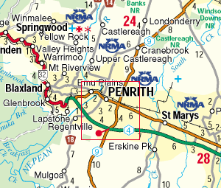
Central Mangrove
Peats Ridge
Kulnura
Start: 0700 at Lindfield Station (Pacific Highway side).
Be there by 0645 for registration, bike inspection.
Fees: $5 members, $15 non-members (covers registration of brevet card, ride insurance)
200 km route is shown in yellow
300km route leaves 200km route at Dural (Old Northern Rd) and heads north through Wisemans Ferry to Peats Ridge
Both rides terminate at Hornsby station.
Ride is unsupported – food /water available at plenty of locations on route. Two bidons are advisable as there are some long sections (esp Windsor – Wisemans Ferry) without water.
Ride organizer: Chris Walsh 0401 055 494.

