67 Coronga Crescent
Killara NSW 2071
scribepj@bigpond.com
0434 715.861 mob
9498.3684 home ph
2 Aug 2011

Cerebos (Australia) Ltd 0414 530.425
2 Costello Place LindyH@cerebos.com.au
Seven Hills NSW 2147 02 8881.4445
Dear Ms. Lindy Hickey

Australian Cadel Evans has won the most prestigious road cycling event in the world, Le Tour de France, which will evidence a lot more cyclists in cafes
Invitation to align Cerebos products, in particular Mocopan and Toby’s Estate coffees, with the burgeoning bicycle sport -
- with a Cerebos bicycle jersey prominently featuring Mocopan and Toby’s Estate logos, but also smaller Cerebos, Saxa, Gravox, Fountain and Foster Clark’s logos, appearing on 50 bicycle jerseys purchased and worn by Muggaccinos.com Cycle Group which also displays -
* ‘Team Muggaccinos’ across the top of the front and back; and
* ‘Hornsby Cycles’ (bicycle shop) across the top of the back,
- the Cerebos bicycle jersey would be the property of Cerebos (Australia) Ltd to sell to other interested bicycle groups across Australia with their bicycle group’s name prominently appearing on the jerseys.
Cerebos NZ could naturally also market the jersey
The writer offers to ‘phone and email up to 100 ride groups/clubs across Australia and inform them how to order the Cerebos bicycle jersey
- display in Cerebos Seven Hills office a 500mm x 400mm photo of 30+ cyclists wearing the Cerebos bicycle jersey; and
d) hang a Perspex framed bicycle jersey in large cafes that serve Mocopan Coffee which are frequented by cyclists
Cerebos (Australia) Ltd would not pay the $500 one-off Sole Coffee Sponsorship Fee until all the Conditions Precedent in Annexure “B” are achieved

1. Background
Saeco sponsored an international road cycling team which won the Giro d'Italia in 1997, 2003 and 2004 and merged into Lampre in 2005 with a large annual budget.
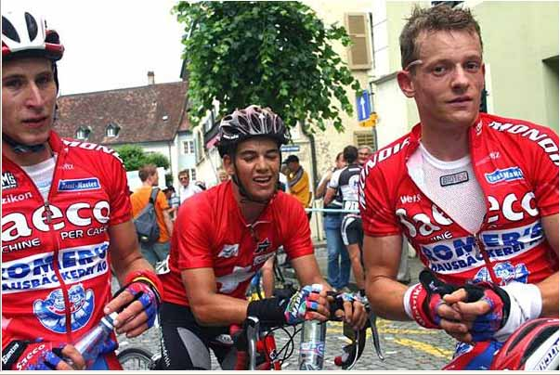
Muggaccinos.com is a recreational road bicycle group which has conducted +100km recreational road rides each Sunday since 1996 which attracts between a dozen and 15 road cyclists on fine weather Sundays. Muggaccinos is an Incorporated Entity, Muggaccinos Inc.
Its recreational Sunday bicycle rides cover the entire perimeter of Greater Sydney visiting over 50 different cafes each year.
Muggaccinos cyclists want their own dedicated bicycle jersey which epitomises that their riders are a coffee drinking, cake eating, cycle group which marches on its stomach.
Due to our name and ethos, we would like to attract a leading coffee brand to agree the design of an initial order of 50 jerseys which prominently display their logos on the front and back of the jersey in their marketing colours.
Muggaccinos cyclists are happy to have Hornsby Cycles prominently displayed across the top of the back of its initial order of 50 jerseys, because –
(a) the owners, Peter and Cathy, are friendly, ethical bicycle retailers – feel free to ‘phone Cathy at their shop 9477.3738 about this invitation, as Peter only works there on weekends; and
(b) Hornsby is central to many Muggaccinos ride starts.
2. Why align Mocopan and Toby’s Estate with cycling?
Cyclists who ride with Muggaccinos are proud of their ride group which has existed since 1996, with some cycling 300km a week. Cyclists like to wear a jersey which has bright vivid colours which display recognized brand names. Many cyclists like drinking fresh coffee whilst visiting cafes either during their rides, or after them, because the social element within a community group is integral to cycling.

3. Description of the Cerebos bicycle jersey
This letter invites Cerebos (Australia) Ltd to have its Mocopan and Toby’s Estate logos prominently appear on the front and back of an initial order of 50 bicycle jerseys (paid for by the writer and then purchased by 50 Muggaccinos cyclists) with the jersey being white or cream. Team Muggaccinos (in black text) would appear across the top of the front and back and Hornsby Cycles also appearing across the upper back (in black text) which would facilitate greater sales as the bicycle shop receives publicity and enables easier collection by purchasers.
FRONT OF JERSEY | BACK OF JERSEY
Team Muggaccinos | Muggaccinos.com  Hornsby Cycles
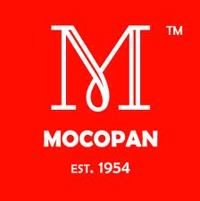 |  |  | 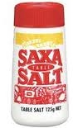
 | 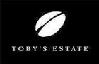

Upper right sleeve | Upper left sleeve
 | 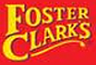

4. Importing jerseys directly from China is almost half the cost of purchasing from Australian garment makers
I have purchased and imported two Litespeed bicycle framesets air freight from the Tucson USA and two bicycle framesets sea freight from Xi’an China, the later necessitated me purchasing Digital Certificates from VeriSign to lodge a Self Assessed Clearance with Australian Customs. I then collected the Framesets from CEO Global Logistics at Port Botany which was a big learning curve.
An order of 50 jerseys from Australian garment manufacturers such as Hot Design, Netti or Cannibal cost approx $75 for short sleeve and $90 for long sleeve, with one-off
‘art-work’ design costs of up to $500. See attached spreadsheet Jersey quotes.xls. I can purchase the same quality jerseys directly from madebyjoyride.com in China at approx 50% of those item prices with only a USD$60 ‘art-work’ design costs which would be delivered air freight by DHL in 3 to 4 days for USD$110 in a parcel up to 25 garments. Happy to show you one of their sample jerseys and other sample materials of their heavier Winter fabric. The synthetic fabric is identical to that used by Australian cycle jersey garment makers.
5. Cerebos (Australia) Ltd could sell the Cerebos bicycle jersey to other local ride groups and make a tidy profit, but importantly get 500 or more Cerebos bicycle jerseys in cafes across Australia within 6 months
Ten years ago lots of cyclists purchased and wore the Seaco jersey. If your company opted to display as a product a Cerebos bicycle jersey on your website to other ride groups/clubs with a mark-up above manufacturer in China and freight to Australia of 65%, it would be price competitive to some of 200 small bicycle groups/clubs across Australia (which I have communication details with) that would want to order between 15 and 30 jerseys, who would not normally contemplate getting a jersey with their own name on it because of the $400 to $500 one-off cost charged by Australian garment manufacturers to prepare a dedicated design with their ride group’s name on it. | 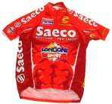
As explained in clause III. of Annexure “A” Eight Benefits To Sole Coffee Sponsor, Cerebos (Australia) Ltd could display the Cerebos bicycle jersey on its website where ride groups who purchased it could order with their ride group’s name on the upper front and back. They could opt to display their local bike shop on the back also.
6. If it suited you, I could ‘phone and email up to 100 bicycle ride groups across Australia and attach photos of a Cerebos bicycle jersey worn by Muggaccinos cyclists and inform them how cheap it was to purchase a Cerebos bicycle jersey with their ride group’s name on it
I am a retired infrastructure banker who is fortunate enough not to have to work for a living and to be able to administer two bicycle websites Muggaccinos.com and KOMpm.com and ride bikes, camp, hike, kayak, swim with my like-mined friends. Muggaccinos ride group is 16 years old. It will be around for many more. Muggaccinos.com website evidences my diligence to provide >100km hilly road rides each Sunday and long weekends cycling away, with a high emphasis on risk management with no membership cost to cyclists.
Each Australian state provides a cycling organisation such as Bicycle NSW. There are over 100 mountain bike clubs across Australia registered with Mountain Bike Australia.
In retirement, and because I enjoy chatting with other bicycle group organisers about the types of rides they provide, I am able to ‘phone and email around 100 ride groups which attract between 5 and 25 riders to their regular recreational road and mountain bike rides, and possibly source orders for between 300 and 500 Cerebos bicycle jerseys within 3 months, if the mark-up put on by Cerebos (Australia) Ltd did not exceed 65% of the manufacture and freight cost from China (ie. $54 + GST = $60 circa for short sleeve and $70 + GST = $77 for long sleeve). See attached “3 different jersey orders.xls” which uses a 65% mark up from USD cost to AUD sale price pre GST addition.
If you are attracted to the prospect of up to a thousand circa Cerebos bicycle jerseys being worn by cyclists across Australia in the next 6 months, but did not want to sell it as a product, Phil Johnston could ‘phone and explain to interested ride groups, how to order it directly from madebyjoyride.com in China, where on an order up to 25 jerseys would mean the ride group/club would not incur GST, as the total cost, incl. air freight by DHL, would be less than the current $1,000 GST threshold which would be even more appealing to ride groups.
If you wanted me to email and ‘phone up to 100 ride groups across Australia and attach photos of the above described Cerebos jersey worn by Muggaccinos cyclists and inform them how cheap it was to procure a top class Cerebos bicycle jersey, with their own ride group’s name across the front and back, I would charge you $10 for ‘phoning each ride group/club and following up with an email and pictures which I would c.c. to you. If purchase orders followed shortly thereafter from the ride groups/clubs that I had spoken to and emailed, then you may wish me to continue ‘phoning and emailing more ride groups/clubs. I could start with 10 bicycle groups = $100 to ‘phone and email pictures explanation to each of them and c.c. you and you could monitor demand. Being an ex-banker and familiar with making International Money Transfers to China, I could perform back-office administration for orders taken, if that suited you.
Alternatively, you could pay me a success fee of $5 per Cerebos jersey sold in the first four months after I commenced ‘phoning ride groups/teams for orders placed by those groups/teams. My attached spreadsheet “3 different jersey orders.xls” shows that Cerebos would make the following net profits:
- 15 short sleeve order $103 profit 14% profit
- 15 short & 10 long sleeve order $324 profit 23% profit
- 20 short & 10 long sleeve order $403 profit 25% profit
The reason for the larger profit on larger orders is because the flat USD$110 DHL freight cost to air freight from China to Sydney is defrayed over larger number of jerseys.
Based on a 65% mark-up between the item cost price and its sale price, orders become profitable upon reaching the threshold of 15 jerseys. However, importantly, getting 500, to 1,000 Cerebos jerseys onto cyclists in cafes in the next 6 months would seem highly cost-effective marketing.
I would be happy to help you set up the procedures which would include an Order Form for interested cycle groups/clubs to download, complete and e-mail to Cerebos and remit 10% of the order cost with the remaining 90% paid by the purchaser on receiving the stock order. I would be prepared to remit a $500 cash surety into
Cerebos (Australia) Ltd’s nominated bank account to cover it against any loss from this invitation, should you want me to administer all orders and payments.
However, I would much prefer to restrict my role to ‘phoning up to 100 road, mountain and triathlon clubs/groups, and explain how easy it is to order a classy jersey with their ride group’s name on it and email photos showing how good the jerseys look.
Providing an accurate sizing chart is paramount to ensure that interested ride groups/clubs order the correct jersey sizes and not blindly rely on M, L, XL etc. which is fraught with danger when buying cycle jerseys, because one garment makers XL could be another garment makers XXL.
Because of the nexus between cycling and drinking coffee at cafes, due to the publicity created by Cadel Evans winning Le Tour de France, it may not be too long before another coffee supplier emulated this marketing strategy of sourcing a jersey from China with their coffee logo prominently appearing in their colours, which the garment supplier could readily replace ride group names and bike shop names to deliver the same jersey, so time would be of the essence to alert around 100+ on-road and off-road cycle groups across Australia that have not previously purchased their own dedicated cycle jersey how cheap and easy it is to purchase Cerebos jerseys with their ride group/club name prominently displayed.
7. Conditions Precedent which must be achieved before Cerebos (Australia) Ltd would pay the $500 Sole Coffee Sponsorship Fee

Annexure “B” is “Conditions Precedent which must be achieved” to Cerebos (Australia) Ltd’s satisfaction prior to it paying Phil Johnston the once only $500 Sole Coffee Sponsorship Fee.

8. My credentials
Prior to retiring in 2007, I held various senior positions in Commonwealth Bank. I have an Undergraduate Degree and a Master Degree in Applied Finance from Macquarie University. I am adept at documenting agreements so that all parties know their duties, rights and obligations.
9. Risks of the sponsorship
There are over 30 different risks which a bank evaluates before embarking on a partnership venture. These include credit, market, professional indemnity/3rd party liability and reputation risk. Reputation risk is about the only pertinent risk. The calibre and track-record of the management associated with any business venture is a high priority. I invite you to meet a few of our working party for this jersey project.
10. Summary
Compared to the cycle promotion costs that Saeco funded, $500 for a minimum of 50 jerseys is low for the “Eight Benefits To Sole Coffee Sponsor” listed in Annexure “A”. I welcome any of your Sydney office employees, or their friends, cycling with Muggaccinos on a Sunday +100km hilly ride or participating in our cycle weekends away.
I would appreciate your ‘phone call to me 0434 715.861 to discuss this unique offer, predicated on material synergies existing between a recreational road bicycle group determined to promote road cycling with a coffee theme and a food wholesaler which includes two coffee brands.

Yours sincerely
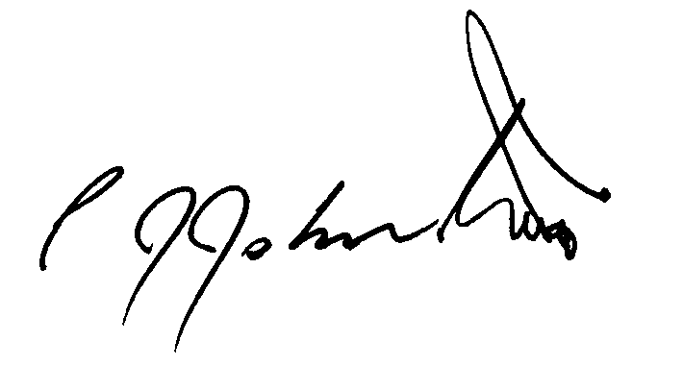
Phil Johnston
President of Muggaccinos Inc. Bicycle User Group, affiliated with Bicycle NSW

