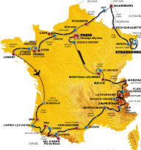 | 
6th Stage of 2006 Tour de France
Lisieux to Vitré – 189km
Live from 10pm this Friday, 7 July
Asquith Leagues Club
100m Nth of Waitara train station
Big screen in Auditorium
SBS coverage with Phil Liggett and Paul Sherwen
Phil Johnston from www.Muggaccinos.com is doing his darndest to encourage local cyclists to attend because Asquith Leagues may provide its big screen regularly for cyclists if we attend in numbers
Opportunity to network amongst local cyclists

