5 Ronald Ave, Harbord NSW
0412 045.224
(02) 9114.6689
ScribePJ@TPG.com.au
2 April 2008
Ms. Verity Firth, MP. 02 9228.5488 office@firth.minister.nsw.gov.au
Minister for Climate Change, Environment and Water
Level 35 Governor Macquarie Tower,
1 Farrer Place, SYDNEY NSW 2000
Ms. Lisa Corben
Director General
Department of Environment and Climate Change (NSW)
PO Box A290, Sydney South NSW 1232
Dear Ms. Firth and Ms. Corben
Business Plan for Youthful Exuberance Lifestyle Programme -
A. to reduce the >$100b annual cost of Seven Problems which each impact Health and Lifestyle Behaviour; and
B. to immediately enact IPCC's edict for a "dramatic shift in lifestyles" to mitigate Climate Change
On 3 March 2008 the Writer posted the enclosed Revised Invitation Letter dated 3 March 2008 together with 2 CD ROMs titled Youthful Exuberance Lifestyle Programme, which -
i) automatically open at my letter dated 3 March 2008; and
ii) provide 3,500 URLs to Defined Terms and related materially in my Business Plan to enable Department of Environment and Climate Change (NSW) to easily review my Business Plan.
I sent it to both of you because of InterGovernmental Panel on CC's edict last May for a "dramatic shift in lifestyles" to mitigate Climate Change.
Could you please acknowledge receipt of my Revised Invitation Letter dated 3 March (copy enclosed) and the 2 x CD ROMs which provided my Business Plan.
Mindful of the likely consequences of ignoring IPCC's afore-mentioned announcement, could you please inform me which division/section within Department of Environment and Climate Change (NSW), or perhaps another NSW State Government department or agency, is responsible to encourage the good people of NSW to Materially Alter Lifestyle to leave a small Personal Carbon Footprint.
The Writer welcomes an early opportunity to discuss the Revised Invitation Letter and the Business Plan.
Yours sincerely
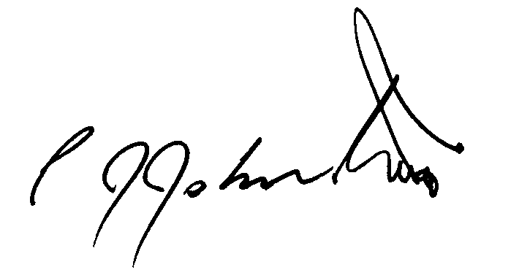
Phil Johnston
Ride Organiser and President Muggaccinos Bicycle User Group
Director of KOMpm Pty Ltd

