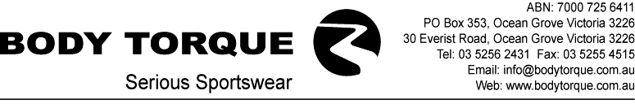

ART & DESIGN REQUIREMENTS

Body Torque offers a creative design service to help clients create new, distinctive designs for their clothing. Our designers are happy to work with you to create the best look for you and your team, to do this there are some requirements that will help to streamline the process.

Requirements

The Body Torque design department is set up on a Mac system, however we can accept PC files. We request that all digital files be sent to us as early as possible. The more you can do to prepare logos and digital artwork the faster we can get your job going.

Digital Files

We prefer that all files, logos and designs be created as vector art in Adobe Illustrator. These can be saved as Illustrator EPS or Illustrator files. Please make sure that fonts are made into outlines or converted to curves.
Adobe Photoshop files are difficult to work with, jpeg’s, tiff’s and psd’s. If you are to supply these please make sure they are high quality images at least 300 dpi, a logo from a website is not sufficient. Please refer to our Acceptable & Unacceptable Artwork section for more information.
Send your artwork to; design@bodytorque.com.au or mail your CD to Body Torque, Design Department. 30 Everist Road, Ocean Grove, Victoria 3226 Australia.
For further information on design requirements please call us on 03 5256 2431.

Pattern Templates

These are available on request for certain garment styles. They are in Adobe Illustrator format.

Colours

If a specific colour/s are required for your job please supply the Pantone swatch numbers and we will do our best to match this colour. Pantone numbers can be found in a Pantone Formula Guide, the international printing, publishing and packaging colour language guide. These can be purchased from any graphic arts supplier.

Acceptable and Unacceptable artwork

We accept files in the following formats;
Adobe Illustrator, Adobe Acrobat & Adobe Photoshop, in either Mac or PC format.

Internet graphics cannot be used due to their low resolution. A logo may look ok small but when it is enlarged for professional artwork use the result is void of clarity and detail. Internet files are useless for print reproduction.
Word or other desktop publishing files are incompatible with our system and logos cannot be extracted from them.

This information is supplied to ensure that you receive the best possible result from the logos/artwork that we are given. We appreciate your help in these matters.

BTADR-0304

